Editing tools

30.1. Introduction
To redo or undo the editing commands.
These tools are available from the “Edit” menu and from the relevant command bar.
Menu | Button bars
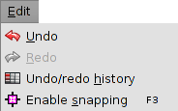
Let´s see all the options:
Icon | Tool | Shortkey | Description
 | Undo |  | To undo the last action in edition
 | Redo |  | To redo the last undone action in edition
 | Undo/Redo History |  | Edition commands history. It allows to undo or redo various edition orders in the same action

30.2. Undo/Redo history
Edition commands history. It allows to undo or redo various edition orders in the same action. It gives information about the made orders with the name and time.
This tool is available from the “Edit” menu and from the relevant command bar.
The interface is:
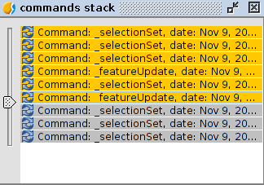
- With the slide bar the orders to undo can be selected. The bar can be moved up and down.

