attributes editor

31.1. Introduction
It allows you to edit the alphanumeric attributes of the layer elements from the View. When you click on any element of the current layer, a form will be shown with all the attributes of that element, allowing users to modify them.
It is available in the “Layer/Derivative Geometries” menu or in the right button bar.
Menu | Button bars
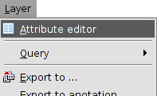
The tool interface has the following elements:
- First. It allows users to go to the first register of the attributes table.
- Previous. It allows users to go to the previous register.
- Next: it allows users to go to the next register
- Last. It allows users to go to the last register on the attribute table.
- Save. It allows users to save changes.
- Close. It closes the attributes editor window.

