DERIVED GEOMETRIES

32.1. Introduction
It allows to create polygonal or linear elements from a point layer. From this layer the user can indicate elements which form a polygon or line, and it can automatically create the new elements.
It is available in the menu “Layer/Derivative geometries” or in the right button bar
Menu | Button bar
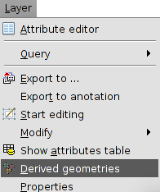
The tool interface is the following one:
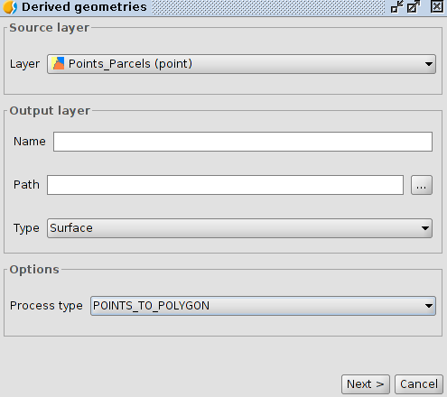
- Source layer. It allows users to select the point layer they want to use. This layer must be loaded in the View.
- Output layer: It allows users to indicate the name of the new layer we want to create and the path where it will be saved. The type of the output layer is automatically selected based on the type of process we indicate.
- Options. Type of process. It allows users to choose between to convert from points to polygons or from points to lines.
Once we define the different options, we must click “Next” button to start the operation to create the elements.
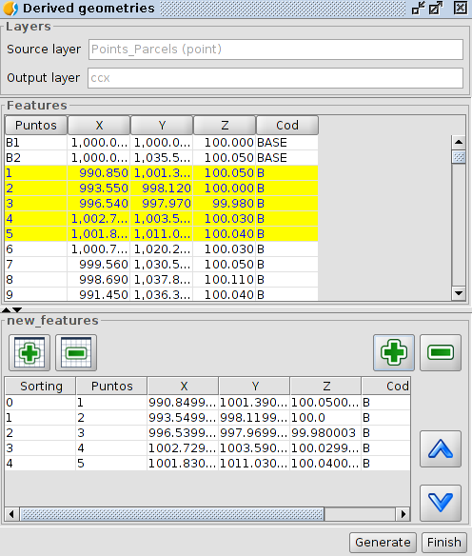
- Objects: It shows the attribute table of the source layer. It allows you to select elements in it. The elements selection will be used to indicate which points form a geometry.
- “+” and “-” buttons on the left add all elements from the attribute table from the top pannel to the bottom panel.
- “+” and “-” buttons on the right add the selected elements in the attribute table from the top pannel to the bottom panel.
- The “move up” and “Move down” buttons (^) allow users to move the element in the bottom panel. In order to do so the element must be selected in that panel.
- Create: It starts the process of creating a new polygonal or linear element from the punctual elements in the bottom panel and in the order they appear in it.

