RASTER TOOLS

33.1. Introduction
Raster tools allow users to analyze, to create and to process raster data.
These tools are available from the dropdown buttons bar of raster tools. Some of these tools are available in the “Tool Box” of geoprocessing. Some raster tools are also available in the contextual menu of raster layer which appears by right-clicking on the layer on the TOC and in the menu “Layer”. The tool “Information by point” is also available as a button.
Main buttons bar | Secondary buttons bar
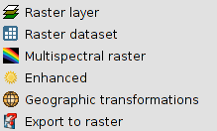 | Raster layer  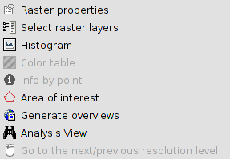
 | Raster dataset
Multispectral raster
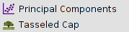
Enhancement
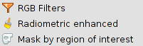
Geographic transformations
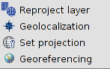
Export to raster
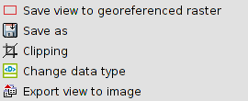
Tool Box | Contextual menu of layer
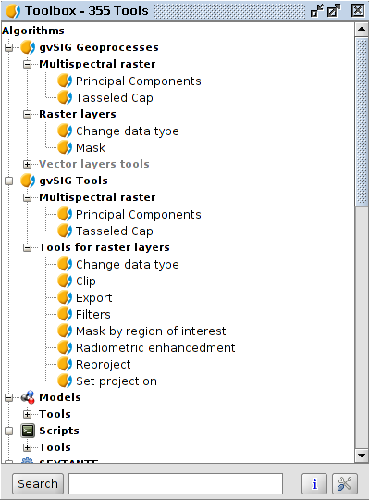 | 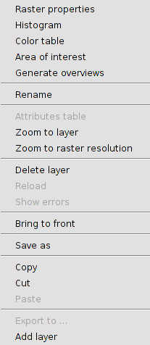
Menu
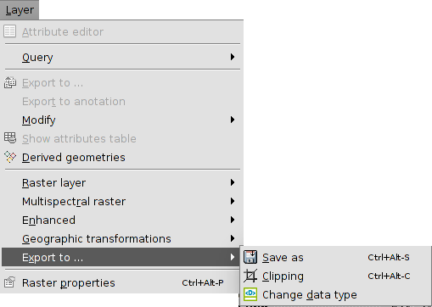
Let's have a look at every available tool:
Icon | Tool | Shortcut | Description
 | Raster properties | Ctrl+Alt+P | It allows to access to the raster properties.
 | Select raster layer |  | It allows users to enable a raster layer by clicking on it in the working area.
 | Histogram | Ctrl+Alt+H | It allows to consult and modify the raster histogram.
 | Color tables | Ctrl+Alt+T | It allows to assign color tables to a raster in a single band image.
 | Information by point. |  | It gives associated information to a pixel.
 | Area of interest | Ctrl+Alt+A | It allows to define regions of interest (ROIs) over a raster layer.
 | Generate overviews | Ctrl+Alt+O | It allows to generate pyramids. The pyramids are lower resolution versions of the original image which allow a quick load of very big images.
 | Analysis view |  | It is a tool used for a quick inspection. It has two efects. It loads the same image in the locator map and opens a new window where there is a higher zoom level and where users can see the image values in real time.
 | Go to the next/previous resolution level |  | It allows to navigate between the levels of resolution of the raster.
 | Create layer multifile |  | It creates a multifile layer.
 | Principal components |  | It allows to apply a transformation to the raster using the method of the principal components.
 | Tasseled cap |  | It allows to apply a transformation to the raster using the method of the Tasseled cap.
 | RGB Filters | Ctrl+Alt+F | It allows users the application of digital filters.
 | Radiometric enhancement | Ctrl+Alt+E | It allows the alteration of the digital levels of the image through functions to adjust them to certain process. It allows the definition of linear, piecewise linear and non-linear functions.
 | Mask by region of interest |  | It allows to generate Masks from ROIs.
 | Reproject layer | Ctrl+Alt+R | It allows the change to the projection of the raster layer.
 | Geolocalization | Ctrl+Alt+G | It allows to apply a related transformation to an image (translation, rotation and inclination) manually, no need of control points. There won't be any information about the precision.
 | Set projection |  | It sets the projection of the view to the raster.
 | Georeferencing |  | It allows to endow coordinates to an image (pixel coordinates).
 | Save view to georeferenced raster |  | It allows to export a clip view as a georeferenced raster.
 | Save as | Ctrl+Alt+S | It allows to save the raster as a new file.
 | Clipping | Ctrl+Alt+C | It allows users to make an extraction of the image.
 | Change data type |  | It allows to change the data type of the image.
 | Export view to image |  | It allows to export the View as a non georreferenced image.
The buttons bar of the raster tools has three components:
- Main button bar. Drop-down button which allows to select the secondary button bar to work with it.
- Secondary button bar: It varies depending on the selection in the main button. It shows a group of raster tools.
- Current raster layer. Drop-down button which allows to select the raster layer you want to work with. You can search/filter between the available layers.
The interface of the tools varies if you access from the geoprocessing toolbox.

