MULTISPECTRAL RASTER

35.1. Principal components
The analysis of principal components is a multispectral transformation that wants to avoid the use of redundant information in the image's bands. This technique allows to transform a series of bands into new variables called uncorrelated components, which absorb part of the variability of the data in a subset of the initial bands. The advantage of the use of this mechanism is that most of the information falls on the three first created bands, which allows to keep most of the information with a drastic reduction of space.
It is available from the raster toolbar (in Multispectral raster) and in the geoprocessing toolbox.
This tool has two dialogue boxes. The interface of the first dialogue box is the following one:
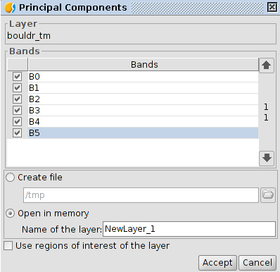
- Bands. It allows users to select bands which will become part of the transformation.
- Output options. The result of the operation can be loaded in the temporary layer (“Open in memory”) or in the file you specify (“Create file”).
- Name of the layer. Name of the resulting raster.
- Use regions of interest of the layer. It allows to use ROIs.
- Accept. Launches the calculation of principal components. When the process is finished the second dialog box appears.
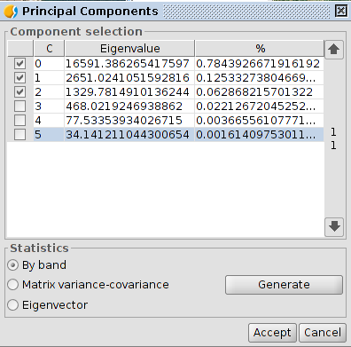
- Component selection. It shows the resulting components of the calculation with the percentage of information that each of them provides to the original raster. It allows to select which of these components will become part of the output raster.
- Statistics. Clicking on “Generate” launches the calculation of the necessary statistics to extract the principal components. It allows to select three kind of statistics: by band, matrix variance-covariance and eigenvector. If there are no selected bands, it is reported and nothing is done. The result of the statistic calculation is shown in a new window.
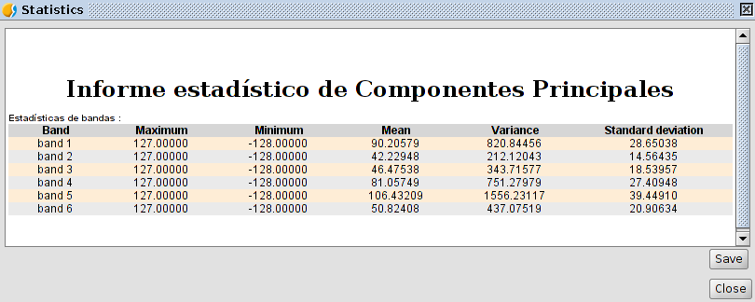
The result of the transformation generates a double type image with the same number of bands as the components choosen in the second dialog box.

35.2. Tasseled cap
The tasseled cap transformation is a more general transformation than the one of the principal components providing indexes with certain physical significance, so that it is possible to determine the brightness value, the greenness and the soil moisture. The tasseled cap transformation focuses on highlighting the relevant spectral features of the plant surfaces during their development, in order to discriminate specific crops, and crops with other plant surfaces using the spectral ranges of the multitemporal Landsat images.
It is available from the raster toolbar (in Multispectral raster) and in the geoprocessing toolbox.
The interface is the following one:
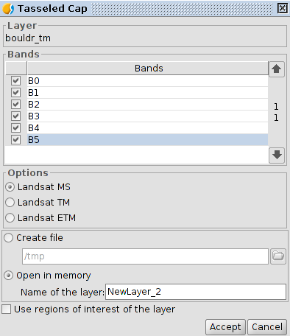
- Bands. List of the raster bands.
- Options. It allows to select the type of image. LandSat MSS, LandSat TM and LandSat ETM. In the case of MSS it is just allowed images with 4 bands. In the case of LandSat TM and ETM it is just allowed images with 6 or 7 bands.
- Output options. The result of the operation can be loaded in a temporary layer (“Open in memory”) or in the file you specify (“Create file”).
The result of the transformation generates a double type image with four bands for the MSS sensor, three bands for the TM sensor and six bands for the ETM sensor.

