Enhancement

36.1. RGB Filters
It allows users to apply digital filters like border detection or softened, to apply masks and basic enhancements.
It is available from the “Layer” menu, from the raster toolbar (in Enhancement) and in the geoprocessing toolbox.
The interface is the following one:
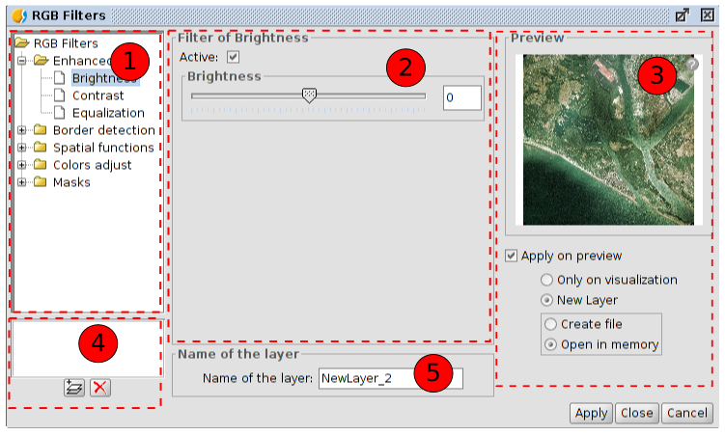
- RGB Filters. List of the available filters classyfied by type. When selecting a filter its configuration panel is shown in number 2. Double-clicking one of the filters or clicking on the “Add filter” button (available in 4) while a filter is selected, we add this filter to the list of filters to apply.
- Filter configuration. Configurable options of the selected filter in 1. All the filters have a check box to enable or disable the filter when it is in the list of added. It is usually at the top of the control panel of each filter with the text “Active”.
- Preview. It allows users to visualize in real time the result of the changes that are being applied. The options in the lower part allow to select the result only on visualization or in a new layer.
- List of filters underway. If a filter is in this list means that it is being executed in the preview. The filters will be executed in the order in which they appear. To delete a filter from being executed double-click on it in the list or click on the “Delete filter” button.
- Name of the layer. It allows to indicate the name of the layer that will be created when clicking on “Apply” creating a new layer.
The number of filters that have been added affects the performance. If it is applied only on visualization, each render that is made of the view will be penalized by the execution of the filters. If a new layer is generated it will just be penalized the execution of the creation of the layer, later the layer will be drawn as quick as if no filters had been applied. In this kind of cases it is adviced to create new layers whenever you can. Other times it can be not so advisable to create a new layer. For instance, if we have a big orthophoto and we need to modify the brightness, to create a new layer will take long time. However, if it is applied only on visualization, the filter will be applied every time but over a smaller dataset so that it will be quicker. The user will decide in which cases to create a new layer and in which cases to apply only on visulization.
The available filters are:
Enhancement
Brightness | 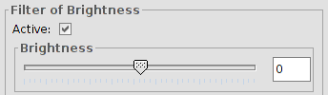
Brightness | It modifies the brihtness value of the layer. It can be varied by moving the position of the slider or by introducing directly the value in the text box and pressing the “Enter” key.
Contrast | 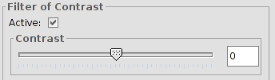
Contrast | It modifies the value of the contrast of the layer. It can be varied by moving the position of the slider or by introducing directly the value in the text box and pressing the “Enter” key. Values from -255 to 255.
Equalization | 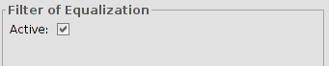
Equalization | It applies an equalization filter.
Border detection
Sobel | 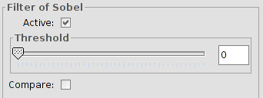
Sobel | It detects the horizontal and vertical borders separately on a greyscale image. The colour images become in RGB with grey levels. The result is a transparent image with black lines and some colour residues.  Threshold values from 0 to 255. “Compare” option.
Roberts | 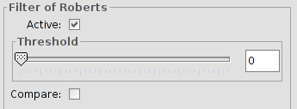
Roberts | It obtains a good response to diagonal border. It has good performance in terms of location. The main disadvantage is that it is extremely sensitive to noise so that it has poor qualities in detection.  Threshold values from 0 to 255. “Compare” option.
Prewitt | 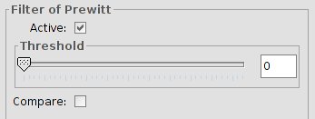
Prewitt | It is really good at defining the borders because its matrix attacks these borders from 8 different sides; this filter has 8 matrixes which are applied to every pixel in the image.  Threshold values from 0 to 255. “Compare” option.
Freichen | 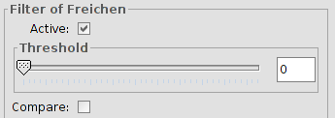
Freichen | It weighs the neigboring pixels depending on the distance from the pixel that is being evaluated. Because of this, there are not privileged directions when detecting the borders.  Threshold values from 0 to 255. “Compare” option.
Funciones espaciales Spatial functions
Median | 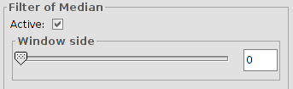
Median | It applies a kernel matrix in which you can select the dimension of its side using the scroll bar or the text box in Window side.  The obtained result is a smoothing of images and the elimination of noise, it analizes the pixel matrix of N x N and the central pixel is replaced by the value of the median of all of them. Its advantage is that the final pixel value is a real value and not an average.
Mean | 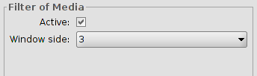
Mean | It applies a kernel matrix in which you can select the dimension of its side using the pull-down button in Window side.  It assigns the mean of all the pixels included in the window to the central pixel. The matrix of filtering is compound by ones and the divider is the total number of elements in the matrix.
Low pass | 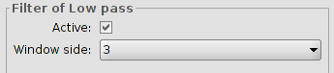
Low pass | It applies a kernel matrix in which you can select the dimension of its side using the pull-down button in Window side.  When the filter is applied the low frequencies are emphasized.
Sharpen | 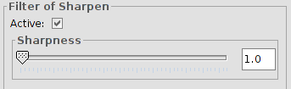
Sharpen | It allows to modify the sharpness and select the contrast (values from 1 to 100). When increasing the contrast, you can also increase the image imperfection and the noise in the gradual areas of colour.
Gauss | 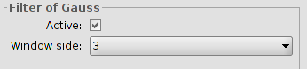
Gauss | It applies a kernel matrix in which you can select the dimension of its side using the pull-down button in Window side.  There is a maximum value in the central pixel and it decreases to the extremes.
Custom | 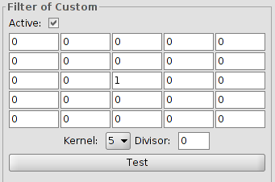
Custom | It is a kernel matrix of 5x5 or of 3x3, introducing directly the value of the boxes.  Divisor. The result of the previous calculation will be divided by this divisor.
Mode | 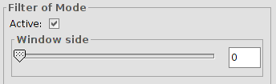
Mode | It applies a kernel matrix in which you can select the dimension of its side using the scroll bar in Window side.  This filter takes the most frecuent value, that is the value that appears more in the neighborhood.
Colour adjust
RGB->HSL | 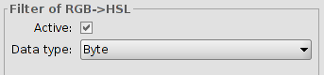
RGB->HSL | Conversion from RGB to HSL. It allows to select the data type (byte or double).
HSL->RGB | 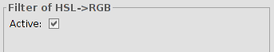
HSL->RGB | Conversion from HSL to RGB.
CMY Balance | 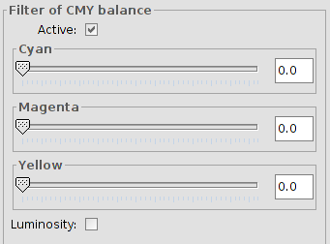
CMY Balance | It allows to modify the balance between Cyan, Magenta and Yellow into an image that needs this type of equalization. To do so, we move the slide bar to increase or decrease the values or we introduce the data directly in the text box which is next to the slide bar. The option of “Luminosity” is used to keep the level of luminosity in every pixel before the variation of CMY.
RGB Balance | 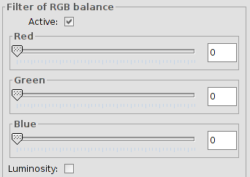
RGB Balance | It allows to modify the balance between Red, Green and Blue into an image that needs this type of equalization. To do so, we move the slide bar to increase or decrease the values or we introduce the data directly in the text box which is next to the slide bar. The option of “Luminosity” is used to keep the level of luminosity in every pixel before the variation of RGB.
HSL Balance | 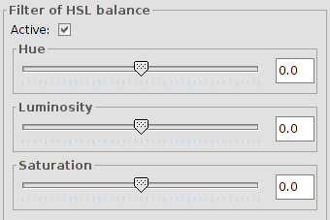
HSL Balance | It allows to modify the balance between Hue, Luminosity and Saturation into an image that needs this type of equalization. To do so, we move the slide bar to increase or decrease the values or we introduce the data directly in the text box which is next to the slide bar.
Grayscale | 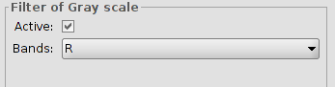
Grayscale | It allows to select bands to which apply grayscale.
Mask
Transparent area | 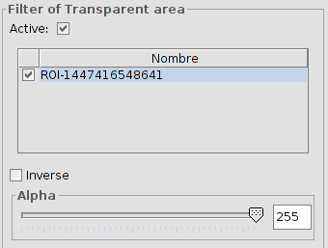
Transparent area | It allows users to introduce a certain level of transparency to a preselected interest area.  When the layer does not have a region of interest a warning message will appear “ It's necesary some ROI to apply this filter. Please, go to the dialog <<Interest regions>> and select the last one”.  Ticking the check box labeled as “Inverse” will result in the opposite effect; all of the image except for the ROI will be set to the specified transparency level.

36.2. Radiometric enhancements
They allow the alteration of digital levels of the image using functions to adjust them to certain processes such as the case of improved visualization. They allow definition of linear, step and nonlinear functions.
Available from the "Layer" menu, the enhancement button bar and the geoprocessing toolbox.
The interface is as follows:
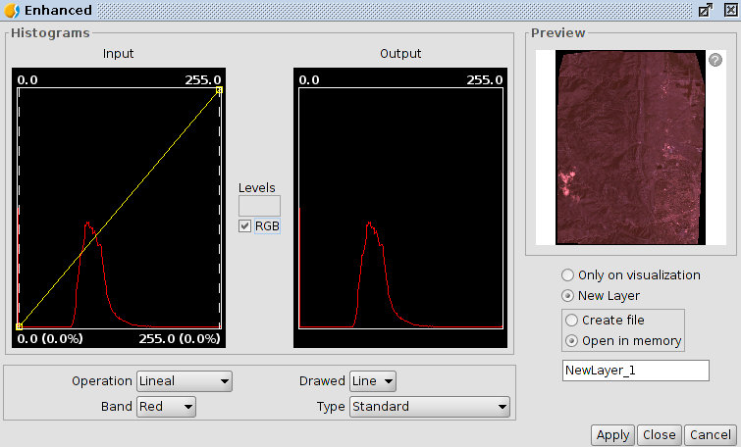
1. In the central part two graphs are shown. The left is the histogram of the input image and the selected graphic.On the right it is the histogram wich will have the output image. The graphs represented with a yellow line, can be modified graphically by clicking and dragging with the primary mouse button.Changing the input histogram graph will get vary the output histogram and the preview.
In the upper corners of the input histogram graph maximum and minimum values for the raster are displayed. At the bottom the maximum and minimum values being applied at that moment for the enhancement function appeas.The value in percentage relative to the total data set appears in parentheses. These values can be modified by clicking and dragging on two vertical dotted lines that are in the sides of the graph. The left line will modify the minimum and the right one the maximum
Breakpoints are inserted by clicking with the mouse on the graph on the point where you want to insert. To delete a point we will stand over it and will press right mouse button. After entering a breakpoint we can change its position by dragging it.
RGB. When this is activated it considers that the displayed raster data are RGB (data type is byte value range 0-255). If this is not selected it is considered that the value range is supported by a data type byte between -127 and 128; this produces significant differences in viewing and the minimum-maximum range that appears at the bottom of the entry graph.
1. Enhancement options. Enhancements replace each input data value by an output value. This substitution is made doing a correspondence between the data in the input range to output range. Tthis correspondence is applied throug a function.
- Operation. Dropdown for selecting the function enhancement.
  - Linear. Linear enhancements apply a correspondence between the input and output data in a linear manner. In the simplest case, a straight line maps each value in the input range with its respective output, completely equidistant. That is, if we have an output range between 0 and 255 and the input data are between 0 and 1 then the input data 0.5 corresponds to an output of 127.5
This behavior can be altered by inserting breakpoints of the graph. The effect is that the linear filter is divided into sections with different inclination. This causes, for a stretch between two breakpoints has a linear function of assigning values defined by the slope of the line in that stretch.
  - Square root. Nonlinear enhancements have the same principle as linear, that is, they replace each input data value by an output value. The difference is that the allocation function of the mapping of values is not linear. In each type of nonlinear function for the output value it will apply a function that corresponds to its name.
  - Logarithmic. Nonlinear enhancement.
  - Exponential. Nonlinear enhancement
  - Split levels. It is a special type of linear enhancement. It divides, the function of the straight in equidistant staggered sections. This causes input values between two existing points of the same horizontal level to have the same output value is assigned. The effect on the image is that color intervals with no transitions appear. The number of intervals existing can be changed with text entry labeled "Levels". 6 levels appear by default.
- Band. It allows to define the band raster on wich the changes made in the chart work. For a proper rolling of the image, it is usually necessary to vary the enhancement of each band separately and with different values.
- Drawed. It allows selection of line and fill. The color of the line or fill depends on the band selected.
- Type . Select from the following:
  - Standard. Displaying the histogram normally. For each possible pixel value in the X axis the number of pixels about that assigned in the axis Y.
  - Cumulative. For each possible pixel value in the X axis the number of pixels about that value is assigned on the Y axis In addition, it is added to the number of pixels of the same or lower value than that position.
Logarithmic. Assigns the logarithm of the histogram at each position. Displays a much more balanced histogram without excessive peaks hiding the rest.
Cumulative logarithmic. It shows the logarithmic histogram, but at each position it accumulates the previous values
2.Preview. It displays in real time the result of the changes to be implemented. The options on the lower part allow to select the result, only on visualization or on a new layer.

36.3. Mask by region of interest
It allows applying a mask of enhancement by region of interest.
Available in the enhancement button bar and in the geoprocessing toolbox
The interface is as follows:
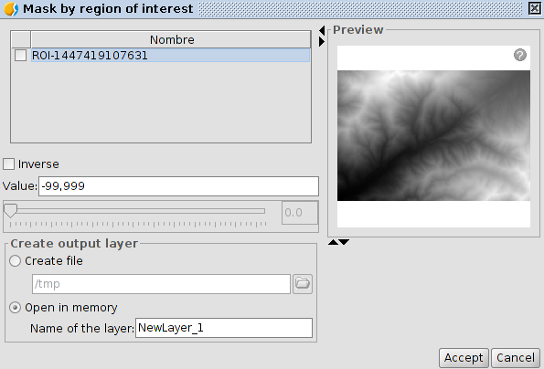
- ROIs. List of regions of interest
- Inverse. If it is activated it applies mask to areas outside the regions of interest and the interior remains totally opaque.
- Value. Select the mask value.
- Preview. Allows to visualize in real time the result of the changes to be implemented. The options on the lower part allow to select the result, only on visualization or on a new layer.

