Geographic Transformations

37.1. Reproject layer
Allows to generate a raster reprojection.
Available on the "Layer" menu, geographical transformations bar buttons and from the geoprocessing toolbox.
The interface is as follows:
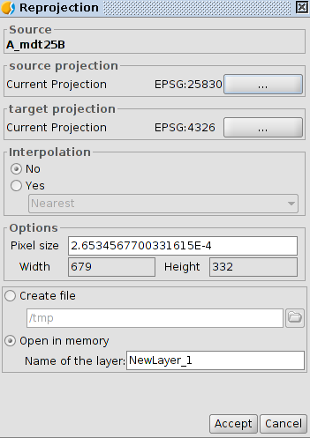
- Source. Source layer
- Source projection. CRS of the view where the source raster is loaded.
- Source. Source layer
- Source projection. CRS of the view where the source raster is loaded.
- Target projection. Select the CRS target . Go to "CRS and Transformation" window
- Interpolation
- Options.Allows to define the pixel size
- Output layer. Allows to select between generating a file on disk or in memory.
By clicking "Accept" the reprojection process finally asked if we want to load the raster redesigned in a View

When performing a raster reprojection, the available transformation is "EPSG Transformation".

37.2.Geolocalization
It allows application of an affine transformation to an image (translation, rotation and tilt) manually, it is without control points, so we will not have achieved accuracy information.
Available from the "Layer" menu and the geographic transformations button bar.
This tool is an option when georeferencing is for presentation purposes and do not need too much precision. As in the georeferencing a file *. rmf text is created with the necessary information for the location of the image.
The interface is as follows:
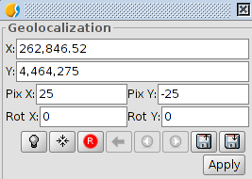
- It allows to define transformation. Text entries labeled X, Y, X Pix, Pix And Rot X, and Rot Y contain the current position data on upper left X coordinate, Y coordinate upper left position, pixel size on X, the pixel size on Y, X and Y rotation respectively. If we change these values from the keyboard these will be updated on the image.
- Buttons (from left to right):
  - Gets the tool focus
  - Center raster layer on View. With this button we focus the raster in the current view, no matter what zoom is selected. The coordenates will be automatically calculated
  - Inicializate with disk transormation. Reset all the transformations that have been applied
  - Go to first transformation. Assign the first transformation it was applied
  - Go to last transformation. Assigns previous transformation to the current.
  - Go to next transformation. Assign the following transformation to the current
  - To load georeferencing coordintaes from tfw. file. The extension must be .tfw or .wild.
  - Save current transformation as default. .rmf file. It saves the currently active transformation in the .rmf file attached to the raster . Each subsequent time the image will be loaded in gvSIG with that transformation
- In addition, the raster layer acquires the capacity to be moved, rotated or transported by clicking and dragging to the right place on the View
- Transformation on View:
- Translation. Mousing over the screen image, the cursor changes to a hand. This means you can move clicking and dragging on the raster view.
- Scaling: Mousing over the edges of the screen image, the mouse cursor will change. Depending on the chosen edge cursor will adopt one shape or another. If placed in the lower or upper edges the cursor will become a vertical arrow. This means you can click and drag to scale the image only on one side. Scaling always keep the proportions of the raster. If we move the cursor around the side edges the cursor will become a horizontal arrow allowing now to scale sideways. For corners the cursor appears as an oblique arrow.
- Rotation. Mousing over the outer corners of the screen image, the mouse cursor will change. It will appear as a circular arrow. This means you can start to rotate the raster from the selected corner.
- Mousing over the outer side edges of the screen image will change the mouse cursor. This appears as an arrow symbol X or Y depending if the mouse is in the horizontal or vertical edges respectively. This indicates that we can begin to deform the raster direction of the X or Y.

37.3. Asign projection
Assigns automatically the projection of the view to the raster
Available from the geographic transformations button bar and in geoprocessing toolbox.

37.4. Georeferencing
Allows provide a reference system (ground coordinates) to a digital image that is in a pixel coordenadades (rows and columns). This process requires a search for homologous points between the reference view or coordinate file and the final map. The result is a transformation involves scaling, rotation and deformation of the original image to fit the final map.
Available in the geographic transformations button bar
The initial interface is as follows:
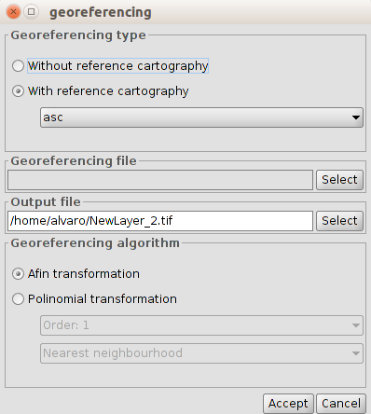
- Initially we must decide what type of georeferencing will be applied with "Without reference cartography" or "With reference cartography". Both types have the same georeferencing working environment, with the difference that in one of them the georeferenced image points are relate to points of a View and in the other to a list of coordinates without reference cartography.
- Georeferencing file. It indicates the file containing the image to be georeferenced.
- Output file. It allows to put path and destination file name in case that the georeferencing is done with resampling. This option can vary from the dialog georeferencing environment options, so it is not necessary to put a proper value at this time, although we will have to do it before the end of the process.
- Georeferencing algorithm. Select the way the output result will be obtained. There are two options:
  - Affine transformation. Applies an related transformation to calculations based on the control points taken The output image is the same as the input. The result of this transformation is a Georeferencing file (.rmf format). Keep in mind that this type of transformation is limited and the user will be in charge of selecting the more appropriated transformation in each case.
  - Polynomial transformation. It involves a resampling of the input image taking into account the checkpoints as a reference. It obtains an output image with the necessary deformations to adapt it to the new geographical location If this option is selected we will be forced to decide the degree of processing and the type of interpolation to be used to calculate new pixels. There are three types of interpolation: nearest neighborhood, bilinear and inverse distance.
  - Depending on whether a degree or another is chosen we will need a minimum number of control points. The number of points required is determined by the formula (order + 1) * (order + 2) / 2, that is, for a one grade polynomial at least three points are required for a two grade polynomial six points are needed, to three grade ten points,...

Interface "Without reference cartography"
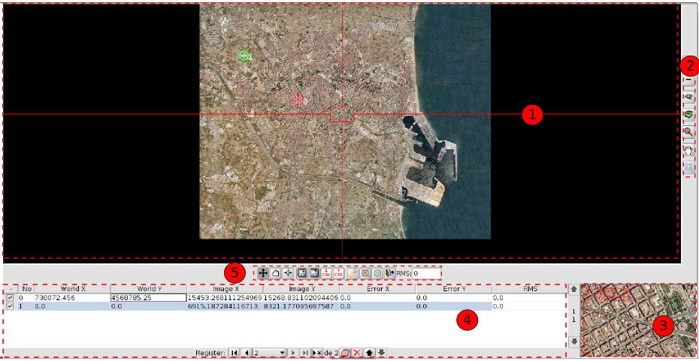
interface "With reference cartography"
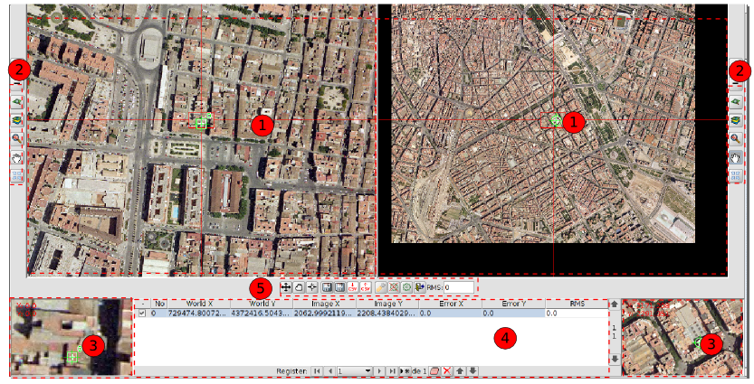
- View. There will be one in the case of "Without reference cartography" and two of "With reference cartography". The left one contains the base cartography loaded in the gvSIG View and the right the image we want georeference.
In the top left corner the coordinates of the mouse cursor are shown. In the reference cartography the coordinates are those of the real world. In the image to be georeferenced the coordinates are in pixel relative to the top left corner.
A cursor with a central window appears in the middle. The cursor window can be resized and moved when the view is active. The contents of the window will display in the magnifying glass windows. By bringing the mouse pointer to the edges of the center window horizontal or vertical arrows will be displayed; clicking and dragging on those arrows the center window is resized. To move the center window we must bring the mouse pointer to the corners of the window until the pointer changes to a crossed arrows; clicking and dragging on those arrows the scroll is performed.
- Navigation tools
Icono | Herramienta | Descripción
 | Increase the zoom level | It allows approaching to the center of the data frame of the View. Multiplied by 2 the zoom level.
 | Decrease the zoom level | It zooms out from the center of the data frame of the View Divide by 2 the zoom level.
 | Zoom to selected area | It allows zoom in on a particular area of the the View
 | Zoom all | this makes a frame of total area occupied by all the layers of the the View
 | Last Zoom | It allows return to previous frame.
 | Move Image | It allows to change the frame of the view by dragging the visualization field in all directions with the mouse. We must keep the mouse button down and move the mouse to the desired direction.
The middle mouse button can increase and decrease the zoom of the View.
- Magnifier window. Expanding the View associated with the central window of the cursor. When the central window cursor moves around the view, it changes the position on wich the lens is focused, and when the window size is changed the zoom level changes. In the upper left corner of the window the coordinates of the mouse cursor appears.
- Control Points. A control point is an entity that provides the correspondence between a geographical coordinate and a pixel coordinate. Control points are represented in the reference view as green squares and in the view of the image as green circles. A control point is associated with a row of the table.
To add a new control point click on the "New" button in the table control. Create a row with coordinates 0, 0 in both views and the tool "Move point" is activated. Now clicking on the View the mark show where we clicked.
The information can be found in the points table relating to each point is:
- Point number
- World X,Y. X, Y coordinates in the reference view. They are automatically generated when you click on the View. They are also assigned when directly typing the value in the table
- X, Y image. X, Y coordinates in the view of the image. They are automatically generated when you click on the View. They are also assigned when writing directly the value in the table
- Error X, Y.
- Root mean square. The quality of the geometric correction can be estimated based on the root mean square RMS and the error contribution of each point.
- When the RMS contribution of a point is high, it may indicate that it the correspondence between points was wrongly selected. It can also indicate the possibility that the geometric model requires some more points.
The available tools are:
Icon | Tool | Description
 | First | Select the first point of the table
 | Pevious | Select the previous point to selected
 | Next | Select the next point to selected
 | Last | Select the last point of the table
 | New | Create a new item in the table
 | Delete selected point | Deletes the selected point
 | Delete all | Deletes all points in the table
 | Up/Down | Select the previous point / next to selected
- Georeferencing-processing tools.
Icon | Tool | Description
 | Move Point | Allows to move a control point
 | Drag Point | Allows to drag a control point
 | Center view to selected point | Center the view in relation to the selected control point
 | Save control points in raster metadata file | Save control points in the metadata file attached to the selected raster
 | Load from XML file (.rmf) | Retrieves the control points from metadata file attached to raster
 | Export table of points into a text file | Exports the table to a .csv file
 | Load control points from .csv files | Import a .csv table
 | Options | Allows access to the georeferencing options window
 | End Test | The test processing is completed. Eliminates the test image loaded in the reference view.
 | Test georeferencing | Run a test with the control points introduced. Apply the transformation and loading the transformed image on the reference view.
 | Extit to georeferencing | Georeferencing finishes. Asked if we want to load on view the result of the last processed.
 | RMS | RMS Global
The interface window "Options" is as follows:
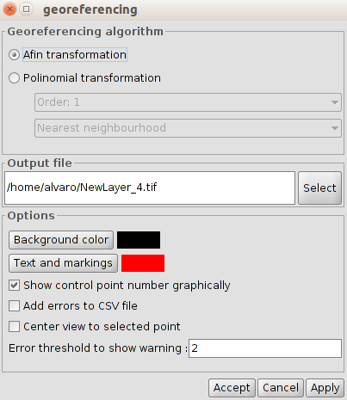
- Georeferencing algorithm. It selects the georeferencing algorithm to be applied.
- Output file. In case of polynomial transformation it allows to select the output file.
- Options. It allows to select the background color, text and trademarks, as well as enable / disable the checkpoint number display, to add errors to the .csv file and to focus the views on the selected point. It also allows to indicate the threshold error warning.

