Export to raster

38.1.Save View to georeferenced raster
It allows to export the view as a image in georeferenced tiff format.
Available from the export raster bar button
When launching the tool we are shown a first message indicating that you must select the area of the View to export. Click the mouse on the first point and drag and drop in the second; the rectangle that will contain the Vista area to be saved is defined. Once the area is defined, a window with the tool options will be displayed.
The interface is as follows:
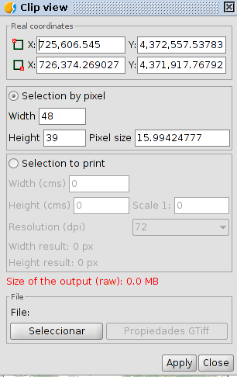
- Real coordinates. Coordinates of the points that define the area selected in the View. It allows to modify these coordinates manually.
- Selection by pixel and to print. It allows to define the characteristics of the image resolution. The maximum size of the output image has been limited to 20,000 by 20,000 pixels, so if we try to save a larger image, gvSIG will show a warning message commanding the user to check the input parameters and try again.
- File. The "Select" button allows to indicate where and in which format the image will be saved. When the output file button is selected, the "Properties" is enabled; this button
- allows access to a new properties window which options depend on the type of selected image format.
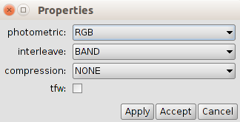
Depending on the size of the output image, this process can be very long, so it is recommendable to control the output image pixel size . When the process is finished, it will appear a table with statistics showing the path of the image that has been saved, the disk size of the output image, the duration of the process and if the image is compressed or not.

38.2. Save as
It allows the change of a raster format.
Available in the "Layer / Export to ..." menu in the export raster bar button raster and the geoprocessing toolbox
The interface is as follows:
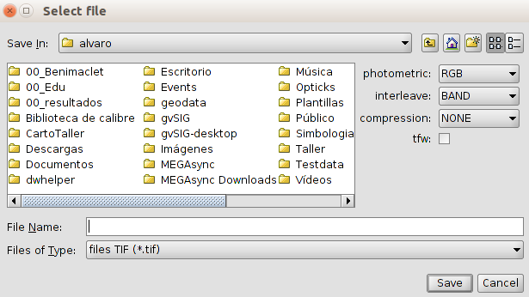
- On the right side there will be a panel with controls with which save options are selected . This panel will have a different appearance depending on the selected output format. In some formats there will be no controls.

38.3. Clipping
It allows to generate a new layer as a raster cut, varying the extension, the level of resolution, order and number of bands of the resulting layer.
Available in the "Layer / Export to ..." menu in the export raster bar button raster and the geoprocessing toolbox
The interface is as follows:
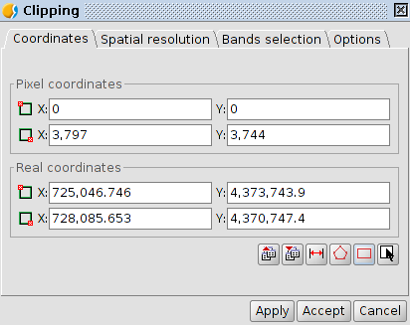
- "Coordinates" tab. It shows the text boxes with the pixel coordinates and real coordinates. The two above text boxes correspond to the coordinates of the upper left corner and the lower text boxes with the lower right corner . When we change the data of a pixel coordinate the real coordinates are calculated automatically and vice versa.
The available buttons are:
Icon | Tools | Description
 | Load parameters | Allows to load the cutting parameters.
 | Save parameters | Allows to save the cut parameters.
 | Round off pixels | Rounding pixels.
 | Adjust to maximun extension defined by layer ROIs | Adjusting to the maximum extension of the layer's ROIs. Calculates the minimum extension where all ROIs are included.
 | Raster layer zoom to full extent | Coordinates are assigned to the extension of the raster
 | Select from the view | Allows to select the clipping area by drawing a rectangle on the raster. The rectangle is drawn by clicking and dragging on the previously active view. The area that we draw must be set to the layer you're doing the clipping If otherwise it will be adjusted automatically.
- “Spatial resolution” tab
  - The resolution of the output image can be changed using two methods:
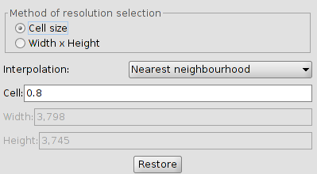
    - Cell size. Activate the text box "cell" and is where the value of the new cell size is inserted.
    - Width x Height. Active "Width" and "High". It allows to define the width or height value in the output. If we vary the width, the height will be recalculated automatically, and vice versa.
  - Interpolation. It allows to select the interpolation method: Nearest Neighbor, Bilinear, inverse distance and B-Spline.
  - Restore. It restores the initial size values of the output layer.
- “Bands selection” tab. List of source raster bands.
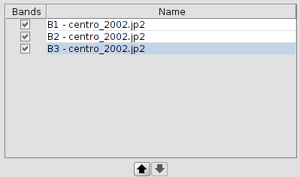
- The order can be changed with the "Up" and "Down" buttons. The currently selected row goes up or down a position in the list. Bands can also be deactivated in the resulting image with the check of the row. If the row is marked it will appear in the output, if it is not it won't be taken into account
- “Options” tab.
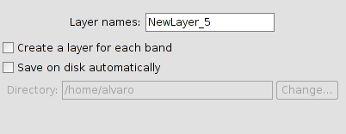
  - Layer names. Name of the resulting layers. In case of several layers, that is to say, if there is a layer for each band of the source image, it will get the same name but with numbers at the end (_xxx). For example, if the layer is called NewLayer and we have 3 result appears NewLayer_1.tif, New_Layer_2.tif and NewLayer_3.tif.
  - Create a layer for each band. Creates an output raster for each source raster band.
  - Save on disk autimatically. The layer is saved in the specified path. If we do not mark this option / s the layer / s generated will be temporary.

38.4. Change data type
Allows to change the data type of a raster.
Available from the export raster bar button and the geoprocessing toolbox.
The interface is as follows:
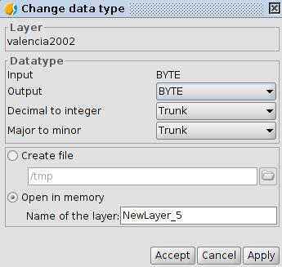
- Layer Name of the input layer.
- Datatype. Options to change the data type.
- It allows to select between create a file or open in memory.

38.5. Export View to image
Export the frame of the view to an image. Allows to select from four output formats: bmp, png, jpg and tif.
Available from the "View / Export" from the menu and from export raster button bar .

