Geoprocessing

39.1. Introduction
Geoprocessing is the execution of analytical and modelling operations of geographic data for creating new information.
To access to the geoprocessing tools, go to “Tools/Geoprocessing” menu or with the shortkey in the “Toolbox”.
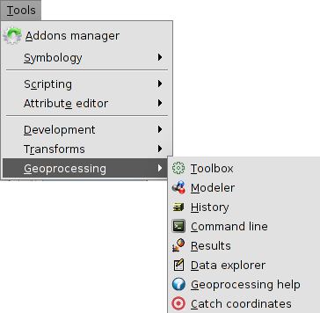
There are the following geoprocessing options:
- Toolbox. To execute a geoprocess or launch a model.
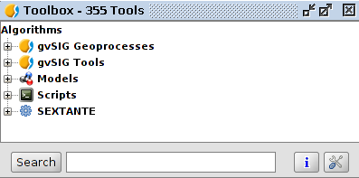
- Modeller. To create a model with the application of several geoprocesses.
- History. All geoprocessing actions are recorded. This way, the history can be consulted, run the actions from it and making easier the repetition of processes.
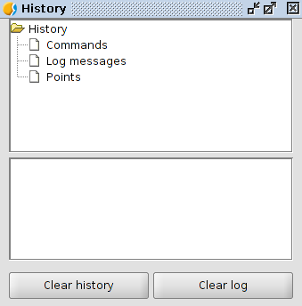
- Command line. To automatize task by creating scripts.
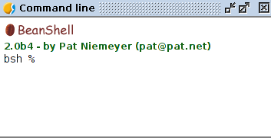
- Results. It allows to the users to get the generated results in the current session.
- Data explorer. It opens a new window with the information of the available layers and tables of the project.

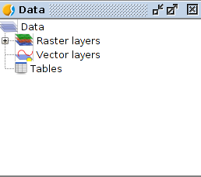
- Geoprocessing help.
- Catch coordinates. To catch the coordinates clicking on the View. These coordinates can be used in some geoprocesses.

