toolbox

40.1. Introduction
The toolbox is the main element of the graphic interface for the application of the geoprocesses and is one of the most used on daily basis. It shows all the available geoprocesses, making easier its use. From the toolbox, a geoprocess or model can be executed.
The interface is:
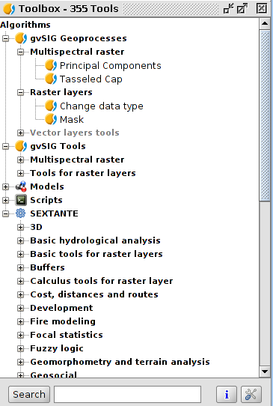
The main parts are:
- gvSIG Geoprocesses. It includes geoprocesses for vector and raster layers.
- gvSIG Tools. Raster tools which are not geoprocesses.
- Models. To execute and create new geoprocessing models.
- Scripts. To execute and create new geoprocessing scripts.
- SEXTANTE. Geoprocessing library integrated in gvSIG. It is classified in different functional groups of geoprocesses.
Depending on the available data, it will be possible or not to execute a determined algorithm. When there are enough data for executing it, the name will be in black, If not, in grey.
Apart from the geoprocesses, the main components of the interface are:
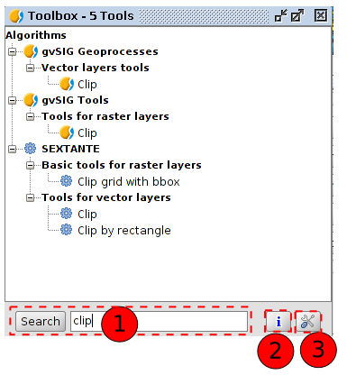
- The bottom part of the toolbox has a text box to search for a particular extension by entering a string text and pressing the "Search" button. As results, it will show only those algorithms that include the word or phrase entered. To show all the algorithms again, simply do a search with an empty string.
- Accessing to geoprocessing help.
- Allows access to the configuration of the toolbox.
To run a geoprocess must double click the name of it or click on it with the right mouse button and select "Run" from the contextual menu that appears.
When you run a geoprocess, a new dialog box (that varies according to the geoprocess is running) will open, but the interface remains with several common characteristics.
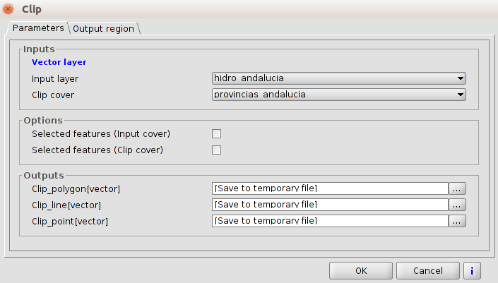
On the one hand, we find a main tab called “Parameters”, in which the input and output values must be entered for the geoprocess would be executed properly.
The number of parameters depend on the geoprocess and its requirements, but the structure is similar in all the cases.
- One raster layer to select from all the available ones in the gvSIG project. It is possible to use one layer of any of the available Views.
- One vector layer to select from all the available ones in the gvSIG project. It is possible to use one layer of any of the available Views.
- One table to select from all the available ones in the gvSIG project.
- One method or function to to select from all the available ones.
- A numeric value to enter in the text box.
- One string text.
- A field of one table.
- One band to choose from the ones of the raster layer.
- An element just of raster layers, bands of raster layer, vector layers or tables, to select from all the available ones in the gvSIG project. In this case, the parameter value in the right side has a button. When it is pressed, all the available elements to choose from, will appear.
- One file or a disk folder.
- One point of the view, with its coordinates X and Y. It is possible as well to clik on the button and select any of the captured points.
- One table for editing by the user.
If you have already executed the same algorithm (in a previous session or the actual one), you will find in the bottom part a new component. Clicking on the buttons to the right and left, you can recover automatically the assigned values to the algorithm in the previous executions, making easier to fill the needed fields. By default, the window will have the last session´s values.
The geoprocesses generate different output elements:
- A raster layer.
- A vector layer.
- A table.
- A graphic element (curve, bar diagram,...)
- An HTML text element.
The layers and tables can be saved as a permanent file in disk (with a route path entered in the textbox) or select them clicking on the button on its right and using the screen dialogue. If the route is not indicated, a temporary file will be created.
By default, the result layers will be saved in:
- .shp format for vector layers.
- .tif format for raster layers.
By default, the result layers will be saved in the defined route in the toolbox: “General”, option “Output folder”.
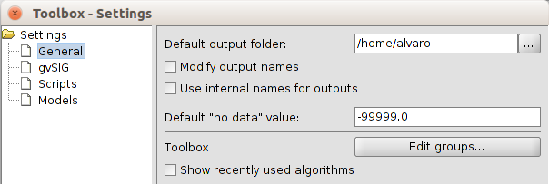
If the "Modify output names" box is checked, it will automatically replace all non-standard characters (accented vowels, brackets, parentheses,...) appearing on the names of objects when executing the algorithm.
In addition to layers and tables, geoprocesses can generate text and image results. These are stored in memory and displayed at the end the execution of the algorithm in a new window, called Results. This window stores the results of the algorithms executed in the current session and can be displayed at any time via the "Tools / Geoprocessing / Results" menu. Graphical results can be saved as an image in .png format, and texts as .html files. To do this, click on the right mouse button and select “Save Item”.

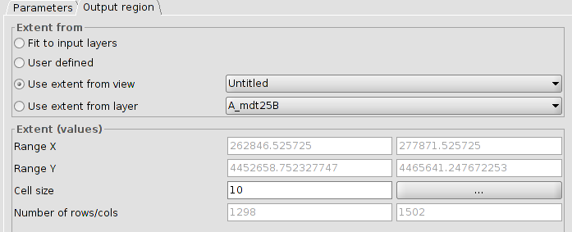
In some of the geoprocesses, the tab “Output region” allows to define the area of the output layer and, if the output is a raster, the size of the cell aimed for that output.
Also, the button help is always available in the execution window with the help for that geoprocess.
The “Output region” can have the following options:
- Fit to input layers. Automatic. It is made by the geoprocess in function on the input data. Those generating vector or raster outputs but not requiring any raster layer as input, this option is not available.
- User defined. It is possible to enter manually a group of coordinates or a cell size if it is a raster layer.
- Use extent from view. It is possible to take the extension values of the output layer from any of the Views, selecting it from a dropdown menu.
- Use extension from layer. It is possible to take the extension values of any of the available layers in the gvSIG project, even if the layer is not used as input layer in the algorithm. selecting it from a dropdown menu.
If it is not an automatic adjustment, gvSIG checks that the layer to create does not have an excessive size that can be caused by an error in entering coordinates or cell size. If the layer is very big, it will show the user a dialog to confirm the layer.
Each geoprocess has a contextual help. To view the contextual help of an extension, you must be clicked in the help button "I", located at the bottom of the execution window of the algorithm or being selected in the toolbox, click on it with the button right and select "View help" in the context menu that appears.

