gvSIG Geoprocesses. Raster layers

42.1. Change data type
To change the data type of the raster.
The interface is:
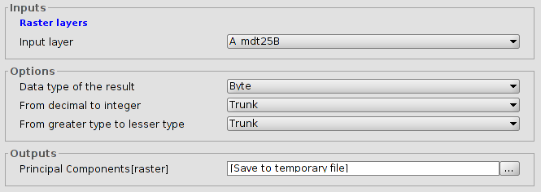
- Layer. Name of the input layer.
- Options to modify the data type.

42.2. Mask
To apply a mask enhancement.
The interface is:
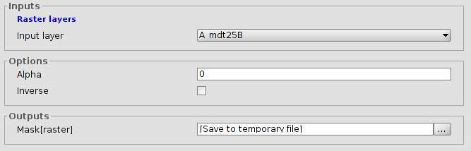
- Input layer.
- Options. Alpha values. Inverse. If this is enabled, the mask will be applied to the external areas of the output region and the internal ones will be opaque.

