Google Street view

53.1. Introduction
Allows Google Street View tool access. Google Street View provides panoramics at street level (360 degrees horizontal movement and 290 degrees vertical movement), letting users to see part of the city in the selected coordinates.
Available from the “View/Query/Google Street View” menu or from the corresponding button.
Icon | Tool | Short key | Description
 | Google Street View |  | Allows viewing Google Street View service at the indicated point.
Once activated the tool, the mouse pointer will change to reflect this fact. When you click on a view, an auxiliary window opens where the Google Street View contents of the corresponding pressed coordinates will be displayed. This window will include the functionality provided for Google Street View Navigation.
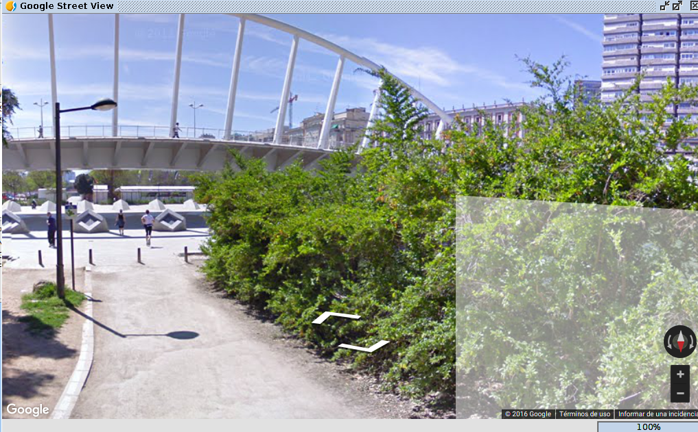

53.2. Configuration of the Google Street View tool
To correctly use the tool, it is possible that we must facilitate a valid credential for the Google Street View use.
You can find more information about the terms of use in:
https://developers.google.com/maps/terms?hl=es#1-your-relationship-with-google
You can request your credential to Google through this page: https://console.developers.google.com/
To set this credential it is available a tool configuration panel placed in “Show/Preferences/Google Street View”.
As a rule, credentials for static maps use from Google Maps are not valid for Google Street View use and vice versa.
