3D Plugin

54.1 Introduction
3D plugin offers to users several tools to create 3D views from 2D views. In “3D View” there are the main tools related to 3D plugin. They also have the corresponding button bar.

Menu | Button bar
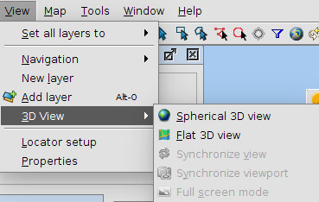
Let see every tool available:
Icon | Tool | Description
 | Spherical 3D view | Create a Spherical 3D view from active 2D view.
 | Flat 3D view | Create a Flat 3D view from active 2D view.
 | Synchronize view | Synchronize 3D view with associated 2D view.
 | Synchronize viewport | Synchronize 3D viewport with associated 2D view viewport.
 | Full screen mode | Indicate full screen mode to active 3D view.

54.2 3D View
The default 3D view is displayed like this:
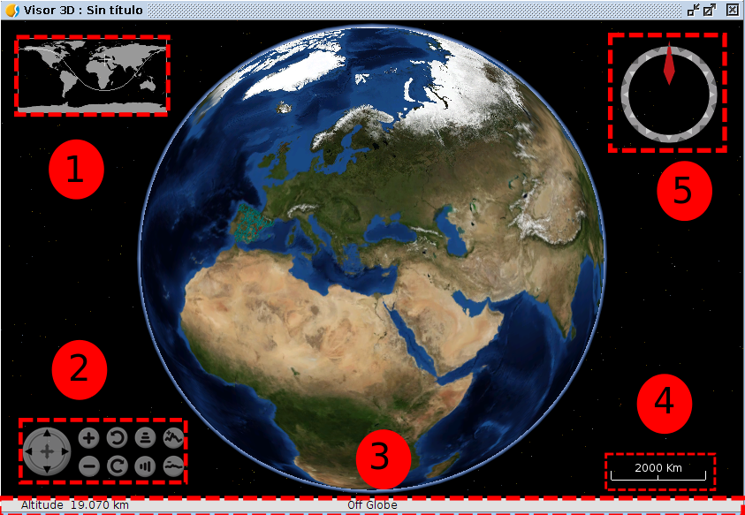
3D view is composed by five components:
- Minimap: it shows what area of the Earth is being shown and the center point of 3D view.
- View controller: It is composed by nine buttons. The first button allows user to move the viewport, the first pair of buttons allows user to increase or decrease zoom, the second pair of buttons allows user to rotate viewport, the third pair of buttons allow user to increase the grade inclination and the fourth pair of buttons allows user to increase or decrease vertical exaggeration.
- Status bar: it shows the altitude of viewport, coordinates of mouse
- Scale: it shows scale of current viewport.
- North indicator: it indicates the direction of north and viewport inclination grade.

