3D TOOLS

55.1 Spherical 3D view
This tool allows users to create a Spherical 3D view from active 2D view. To create a Spherical 3D view it is necessary to meet the following requirements:
- One 2D view active with at least one layer added.
- Active view projection must be EPSG:4326.
- There is not a Spherical 3D view created with the active view. There can only be one 3D view with the same type at the same time. Due to this, there can only be two 3D views (spherical and flat) associated with the same 2D view at the same time.
If all requirements are met, just do click on menu or bar button and a new Spherical 3D view will be created.
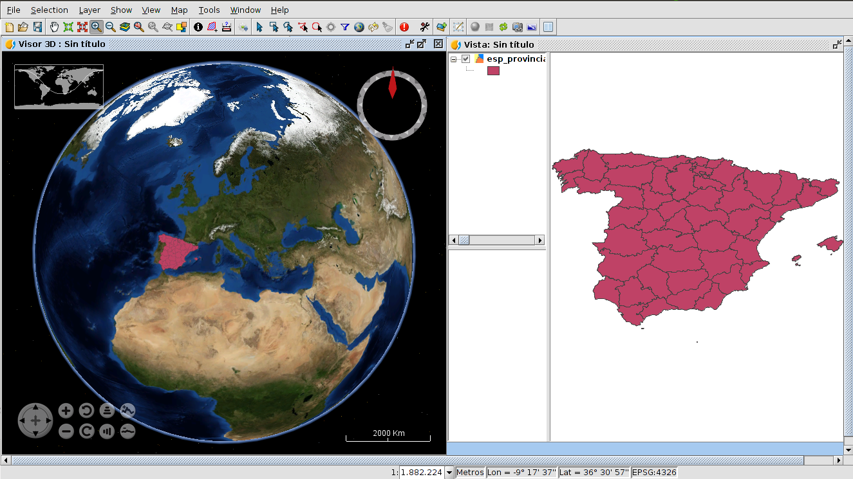
When a new 3D view is created, it takes the loaded layers in 2D to transform it into 3D layers to show it at Spherical 3D view.
The transformation of layers depends on the loading mode indicated by user. There are two loading modes available: raster and elevation. On the one hand, raster loading mode indicates that layer will be converted to raster image. All kind of supported layers by gvSIG can be converted to raster image. On the other hand, elevation loading mode indicates that layer will be converted to elevation model. Only raster layers with at least one band can be loaded as elevation. Afterwards, how to indicate loading mode with other 3D properties will be explained in this document.
An example of raster layer loaded as raster (colored layer) and as elevation (DEM) at the same time:
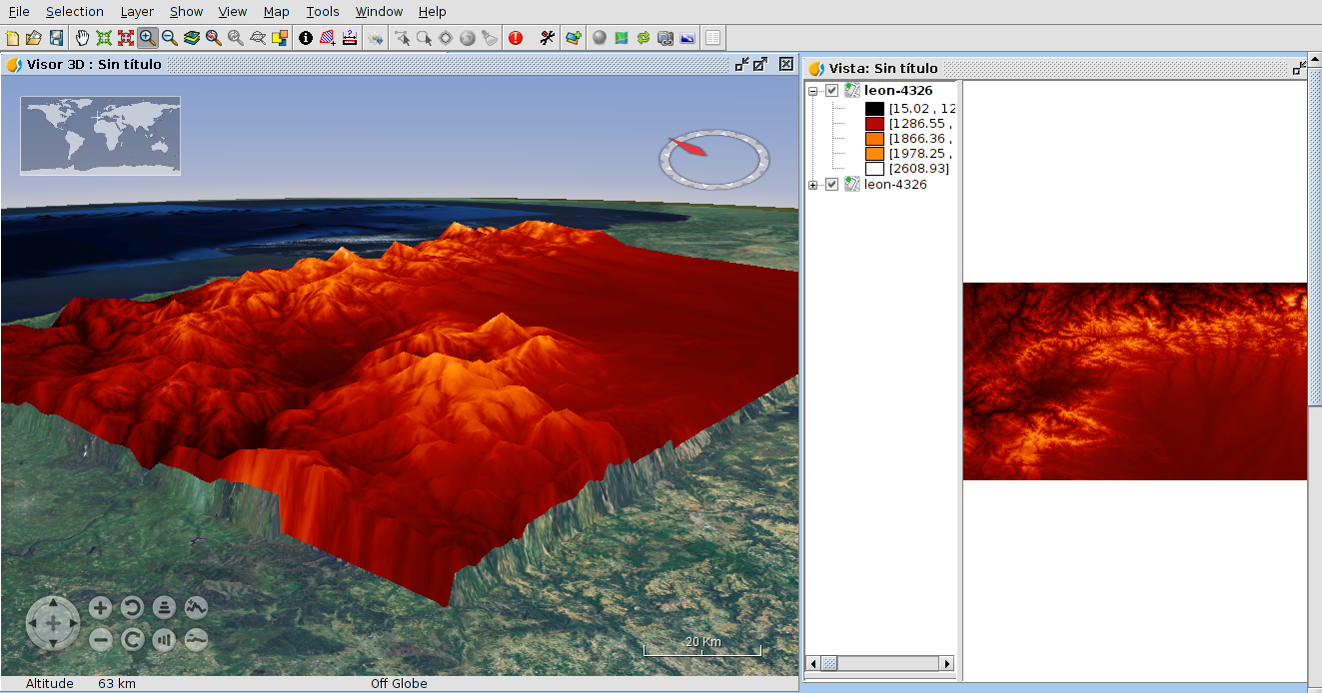

55.2 Flat 3D view
This tool allows users to create a Flat 3D view from active 2D view. To create a Flat 3D view it is necessary to meet the following requirements:
- One 2D view active with at least one layer added.
- Active view projection must be EPSG:4326.
- There is not a Flat 3D view created with the active view. There can only be one 3D view with the same type at the same time. Due to this, there can only be two 3D views (spherical and flat) associated with the same 2D view at the same time.
If all requirements are met, just do click on menu or bar button and a new Flat 3D view will be created.
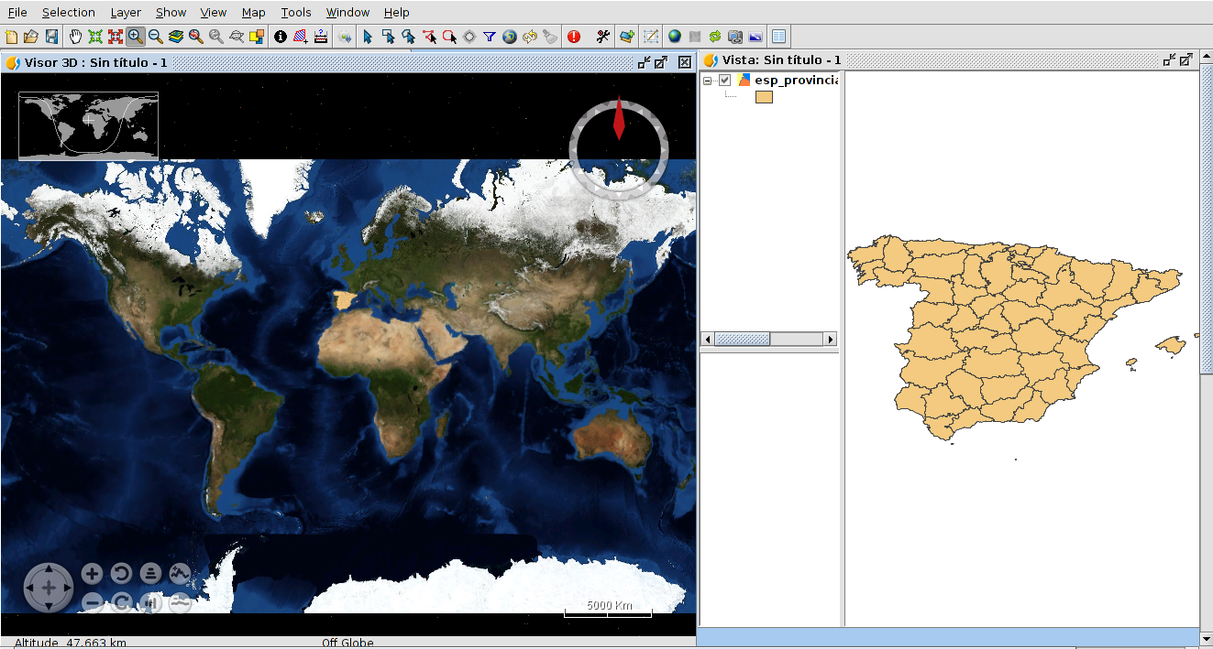
In the same way as Spherical 3D view, when a Flat 3D view is created, the layers of 2D view are converted to 3D layers to show them at 3D view.

55.3 Synchronize view
This tool allows users to synchronize a 3D view and an associated 2D view. When a 3D view is created, it is linked with the 2D view. This permits to register 2D layers changes to copy and apply them to 3D layers. For example, if we change the symbology of one 2D layer and then we click on Synchronize view button, the converted 3D layer will be affected by this change. Moreover, If we have two 3D views open at the same time, both 3D views will be synchronized.
The synchronization of views can be done in two ways: manual and automatic. The manual way is run when clicking on bar button or “Synchronize view” menu entry. The automatic way starts when the “Auto synchronize layers” option is activated in 3D View properties.

55.4 Synchronize viewport
This tool allows users to synchronize the viewport of 3D view and the viewport of associated 2D view. When a 3D view is created, it is linked with the 2D view. This permits to get the viewport of 2D view and indicates it to 3D view. Moreover, If we have two 3D views open at the same time, both 3D views will be synchronized.

55.5 Full screen mode
This tool allows users to indicate full screen mode to activate 3D view. To indicate full mode it is necessary to have one 3D view active. If one 3D view is activated, just do click on menu or bar button and full screen 3D view will be created.
To close full screen window press ESC key.

