3D Properties

56.1 General 3D preferences
3D Plugin has the next general preferences:
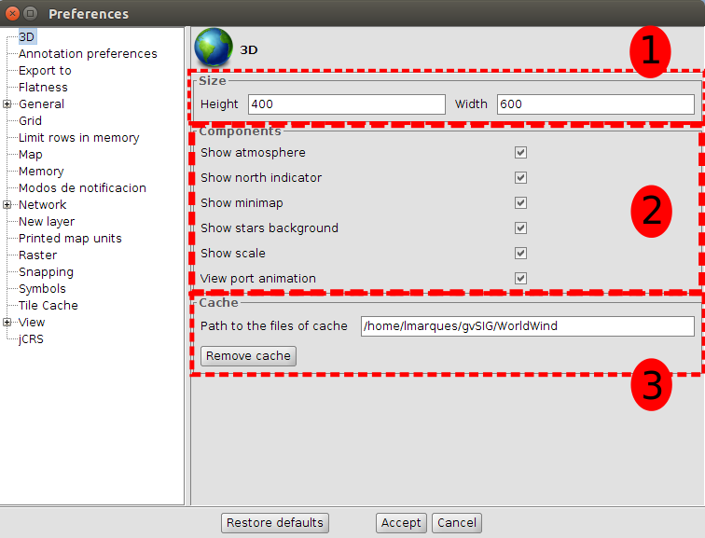
General 3D preferences are divided into three parts:
- Size: default dimensions of new 3D views.
- Components: a list of options to change the visibility of 3D view components and to enable or disable animation of viewport synchronization.
- Cache: path of current cache and a button to remove tile cache.
The general 3D preferences changes only affect new 3D views, so if we want to apply the changes, we have to close 3D views and create them again.

56.2 3D View properties
3D Plugin has the next view properties:
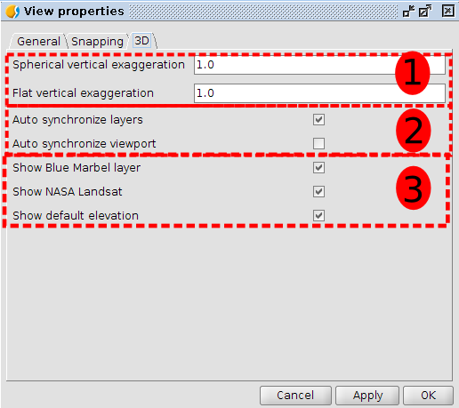
Each 2D view has its own 3D view properties. 3D View properties are divided into three groups:
- Vertical exaggeration: vertical exaggerations of 3D views. It is possible to change the vertical exaggeration from 3D view properties or from the pair of buttons at 3D view.
- Auto synchronized: two options to enable or disable the auto synchronization of layer or viewport.
- Visibility of default layers: three options to change the visibility of default loaded layers at 3D views.

56.3 3D Layer properties
3D Plugin provides 3D layer properties to indicate several options. Depending on the type of layer and loading mode selected, some properties will be enabled or disabled.

56.3.1. 3D Vector layer properties
Vector layers have three loader modes:
- Rasterized: The 2D View vector layer will be rasterized as an image that will be displayed at 3D View.
- Vector: Vectors layers elements at 2D View will be transformed in 3D vectors and loaded at 3D View.
- Extrusion: Vectors layers elements at 2D View will be transformed in 3D vectors and loaded at 3D View, applying an extrusion so as to get volume effect.
Rasterized mode converts vector layer in a raster layer at 3D View. The elevation mode converts the vector layer in a DTM (Digital Terrain Model) taking as elevation value the one indicated in the attributes table field of the layer (not available yet).
Rasterized vector layer load
The properties are the following:
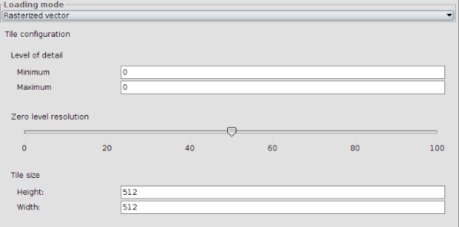
- Load mode. Enable selecting the layer load mode at 3D View.
- Detail levels. Enable defining minimum and maximum level of the layer. The minimum detail level indicates from what level a layer is visible. For example, if it is indicated 2 as minimum level, the layer will be invisible at 0 and 1 levels. The maximum detail level indicates the maximum calculated detail level. For example, if it is indicated 10 as maximum level, 10 detail levels will be calculated. If it is indicated 0 as maximum and minimum level, the 3D will calculate the best number of detail levels in relation to the layer resolution.
- Zero level resolution. Indicates the relationship between resolution and zero
level of detail. The more height is zero level resolution; the layer will be shown with more resolution.
- Tile size. Allows indicating the size tiles.
- Elevation. It indicates the elevation field, the elevation values units (meters or feet) and the NoData value (points with NoData value will be shown transparent at 3D view).
Load of vector layer as vector
Vector loading mode presents the following interface:
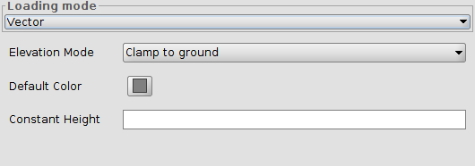
Elements altitude can be defined by two factors (or the sum of both):
- The third dimension of the geometry, in case it is a 3D layer (for example a 3D shapefile).
- A parameter or constant height
It can be applied 3 elevation modes, each of them applies height in a different way:
- clamp to ground: in this case elements overlap the elevation model or the digital elevation model which exists at 3D View. In this case a height definition is not applied.
- absolute: in this case vector elements elevation are given by the height, defined as the height over the sea level.
- relative to ground: in this case vector elements height is given by the height, defined as relative height on the ground.
An example of how is shown the clamp to ground option:
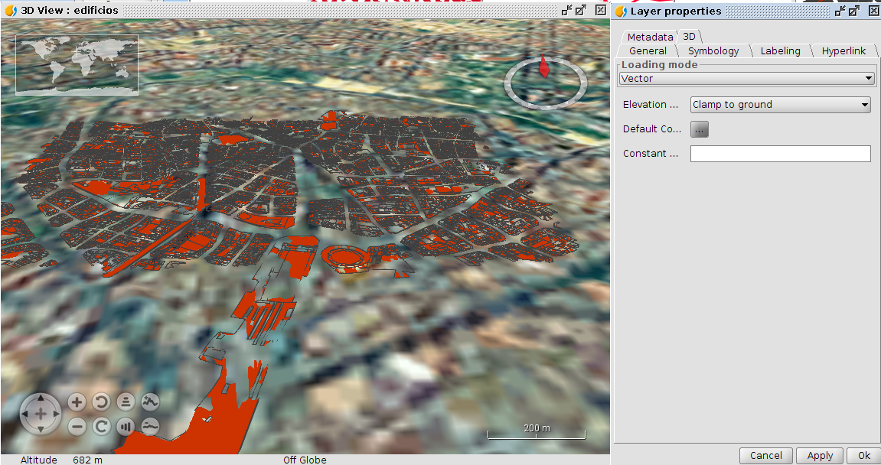
It can be seen that in several parts of the digital terrain model the ground covers the vector layer, because of the heights difference. In this case it is possible to put the relative to ground mode and apply a constant height to view data without overlaps:
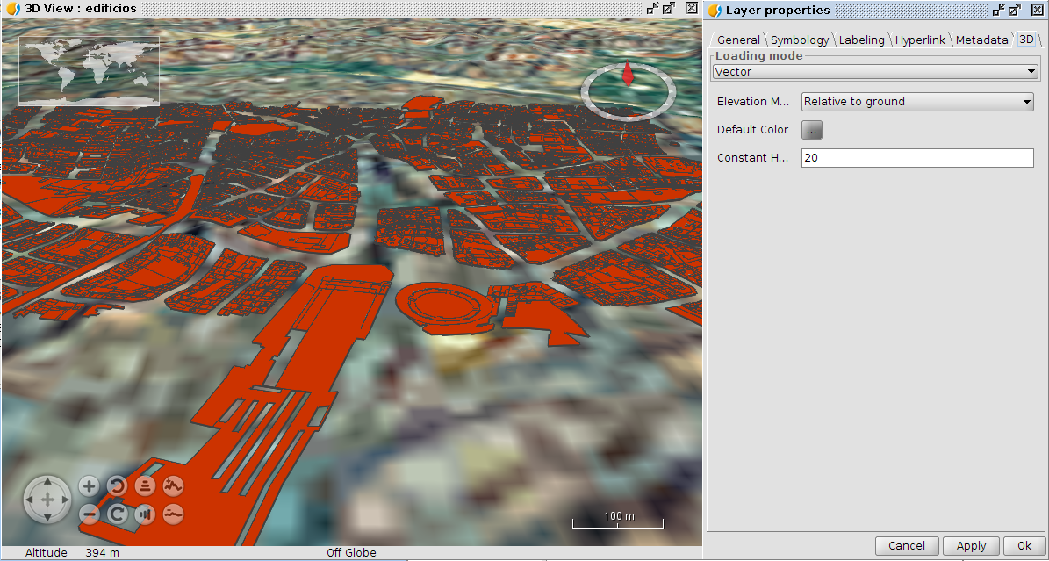
Loading vector layer as extrusion
The interface needed to be applied for extrusion to a vector layer is as shown below:
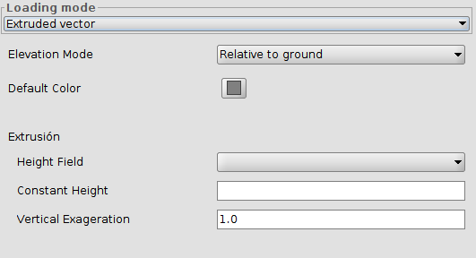
In this case the elements height can be defined by four factors:
- The third dimension or Z geometry coordinate.
- A selected height field from the attributes table.
- A parameter with constant height.
- An exaggeration vector factor, which is the multiplication of a particular factor by the height.
There are 2 available elevation modes, which consider the altitude in different ways:
- absolute: in this case vector elements elevation are given by the height, defined as the height over the sea level.
- relative to ground: in this case vector elements height is given by the height, defined as relative height on the ground.
For example, if we select the relative to ground option mode and apply a selected height field from the attribute table that contains the building heights, we should get something like this:
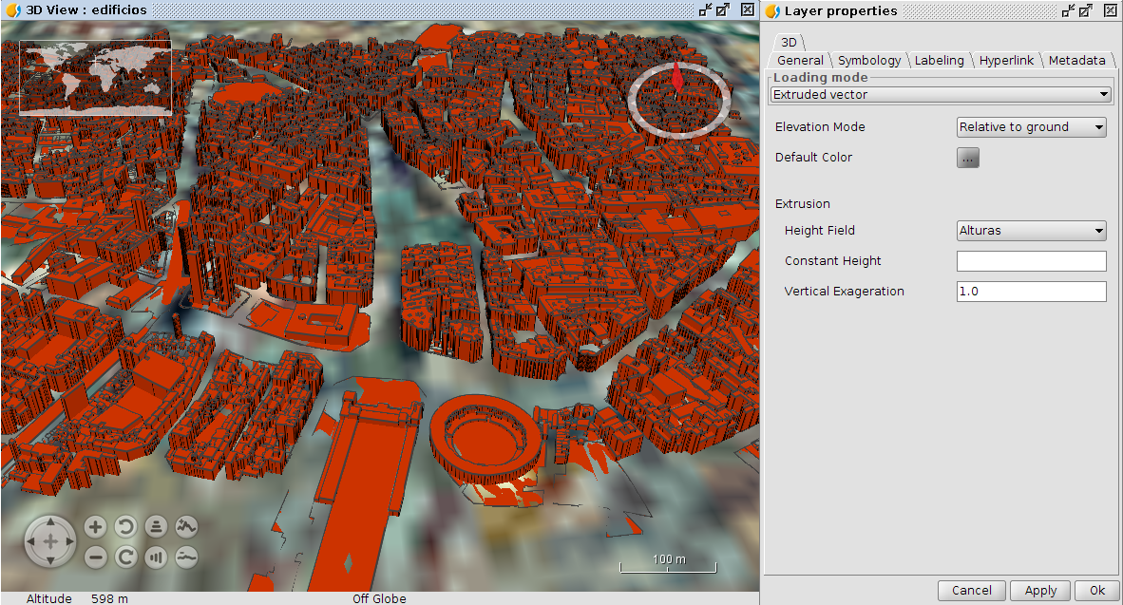
It can be applied a constant height to lift elements over the ground. It should also be used the plants number of the buildings and multiply them by a constant which would represent the plant height (for example, 3 meters).
Different modes of 3D loading vector layer. Examples
Example of contour lines layer with 3D geometries. It has been used the extrusion mode and also applied an additional 50 meters height:
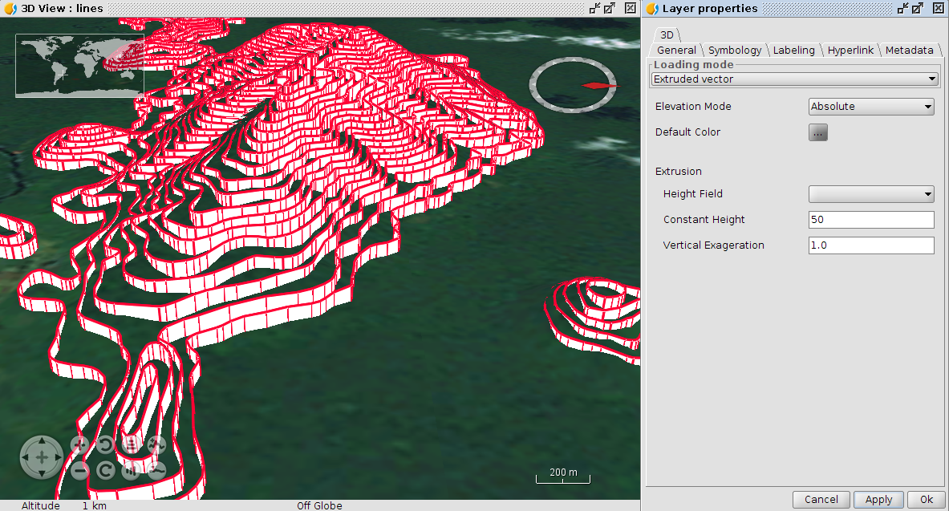
The same layer without extrusion would be shown like this:
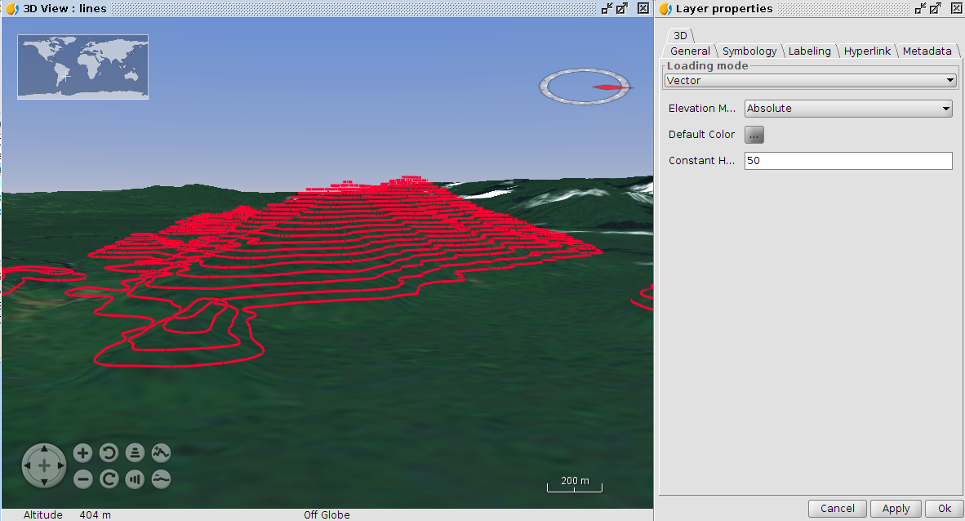
A dots layer example without Z coordinate, but applying an elevation based in an attribute of its table:
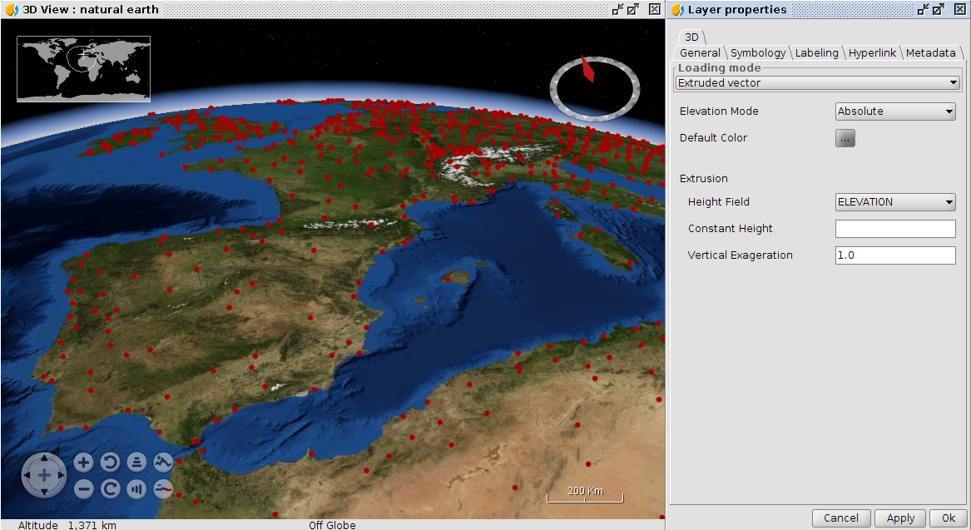
As being the elevation similar to the ground one, extrusion is not appreciated. Adding a constant height this situation is solved:
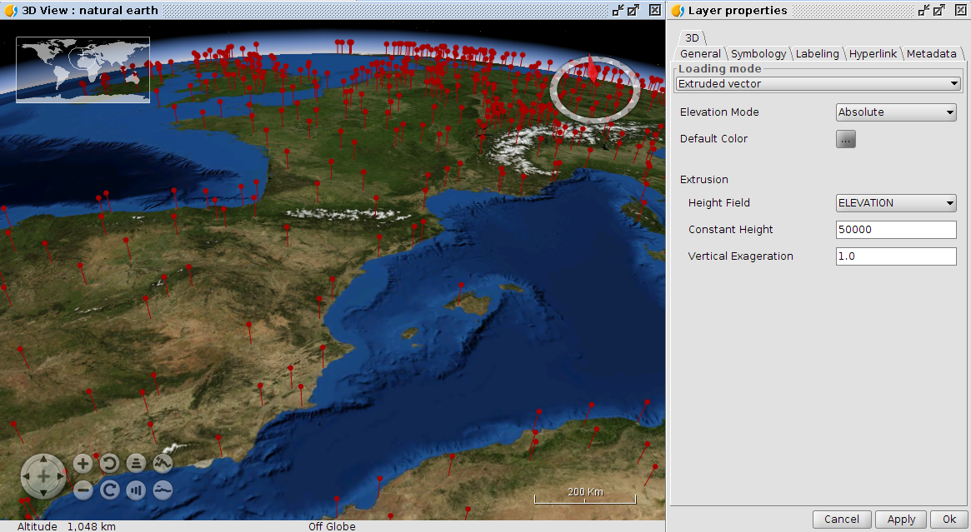

56.3.2. 3D Raster layer properties
Raster layers have two loading modes: Raster image and Elevation mode. Raster image loads raster layer at 3D view. Elevation mode converts rater layer to DEM (Digital Elevation Model) taking elevation values from first raster band.
If Raster image mode is selected, raster layer will have the following properties:
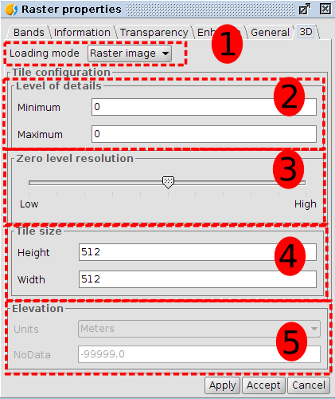
3D Raster layer properties are divided into five groups:
- Loading mode: it indicates what raster layer will be loaded at 3D view.
- Level of details: minimum and maximum detail level of layer. Minimum level of detail indicates what level the layer will be visible at. For example if we indicate two to minimum level, layer will be invisible at zero and one detail level. Maximum level of detail indicates the maximum level of detail calculated. For example, if we indicate ten to maximum level of detail, plugin only will calculate ten levels of details. If we indicate zero as maximum and minimum level, 3D Plugin will calculate the best number of detail levels in relation to resolution layer.
- Zero level resolution: it indicates the relationship between resolution and zero level of detail. If we indicate zero level resolution to high, layer will be shown with more resolution at zero detail level. If we indicate zero level resolution to low, layer will be shown with less resolution at zero detail level.
- Tile size: it indicates size of tiles.
- Elevation: elevation part only is available if elevation loading mode is selected
If Elevation mode is selected, vector layer will have the following properties:
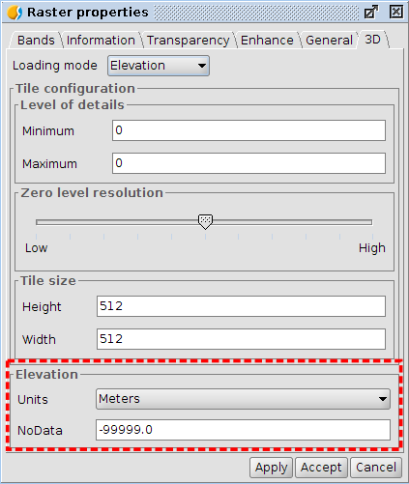
When we select elevation model, elevation group properties will be enable with other options to indicate:
- Units: it indicates units of elevation values. Two options: meters and feet.
- NoData: it indicates NoData value. All points that have indicated NoData value will be transparent at 3D view.

