3D ANIMATION

57.1. Introduction
This tool allows the creation, edition, deletion and reproduction of animations over 3D views linked to the View document.
The animation manager is available in the “View/3D Viewer” menu or in the toolbar.
Menu | ToolBar
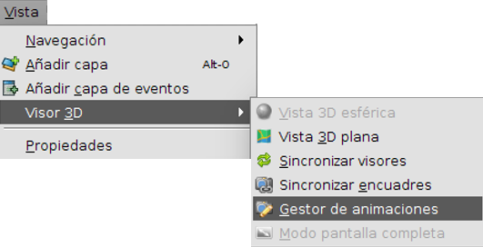
The available tools are:
Icon | Tool | Description
 | Animation Manager | Opens the 3D Animation Manager

57.2. Animation Manager
The animation manager allows the user the creation, edition, deletion and reproduction of animations over 3D views associated to a view document. Requirements for executing the tasks are the following:
- Have the view document active and open.
- It must not be another animation manager already open. The animation manager has support for managing animations of all existing view documents in the project.
The tool can be executed from the “View/3D Viewer /Animation Manager”menu or from the corresponding toolbar. When the tool is executed the following window is shown:
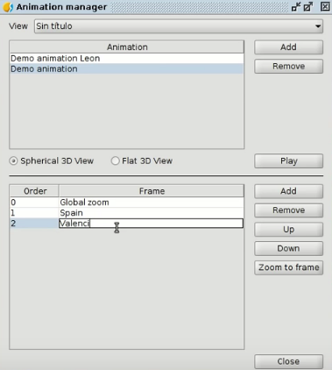
In the manager superior part, the existing view document list is viewed in the project. 3D animations are managed through the view documents. When a view document is selected from the list, animations are linked to the selected document are shown. In case the document doesn’t have any animation it should be shown an empty list.
When a document is selected from the list, it is possible to add new animations clicking over the “Add”button; for removing already existing animations select an animation from the list and click the “Delete”button (both buttons are placed in the right part of the animations list) and for modifying the name make double click with the primary button over one animation from the list.
When an animation is selected, it must be selected one of the available options: “Spherical 3D view” or “Flat 3D view”. These options determine over which 3D view associated to the document is going to be managed those frames. Each animation is composed by two frame lists: a spherical type framing list and another flat type framing one. Both lists are independent of each other and don’t keep any relationship.
When one of the available options is selected, the frames of the selected type are displayed in the framing list (placed in the bottom part). In the right side of the list can be performed the following actions:
- Add: allows adding the 3D view current frame of the selected type. For executing this tool is needed to create a 3D view of the selected type.
- Delete: delete one or many selected frames.
- Upload: allows uploading the selected frame in the established order.
- Download: allows to download the selected frame in the established order.
- Zoom to the frame: from the selected frame allows making zoom in the 3D view of the selected type.
In addition to the described actions, is also possible to modify the frame name facilitating the identification by double clicking over an element in the list.
Finally, the animation manager offers the possibility to reproduce created animations over de 3D selected view in the animations manager. To reproduce an animation is needed that a 3D view of the selected type exists and the animation at least has a defined frame.

