Document table

58.1. Table’s properties
We can Access table’s properties configuration window by:
- In a document table opened, in menu “table/properties”
- From the “Project manager” with the table selected, clicking on button “properties”
Menu (Document Table) | Button (Project Manager)
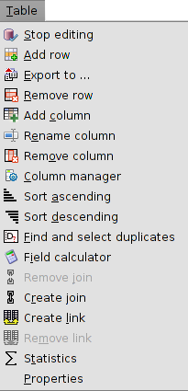 | 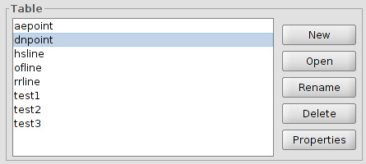
Table’s properties configuration window options are:
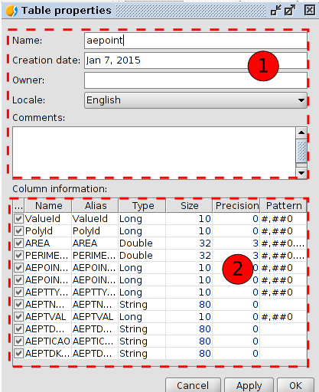
- Table’s identification fields. Allow change name, creation date, owner, language and comments.
- Columns properties.
- “...”. Checkbox that allow choose show/hide one field of the table. By default all fields are visible, except field “Geometry”. Field “Geometry” contains coordinates that integrate a geometry; set it visible can slow down the operation of the table.
- Name. Name of the field. Not modifiable.
- Alias. Allow set an alias to a field. With double click on a cell we can change it’s alias.
- Type. Indicates field’s type: boolean, date, integer, double, string. Not modifiable.
- Size. Number of characters allowed. Not modifiable.
- Precision. Number of decimals (to numerical fields). Not modifiable.
- Pattern. Format of numerical data visualization. With double click on a cell we can chnage the format.

