TABLE’S INTERFACE

59.1. Table’s interface
Tables are gvSIG’s documents that contain alphanumeric information. Tables are composed of lines or records (representing each database element) and columns or fields (that define different attributes of each element). All lines have the same columns. Each field can store a specific type of data, like number, text or a date. Intersection of a record and a field is a cell.
When a table is opened from projects manager is shown a new window divided in this components:
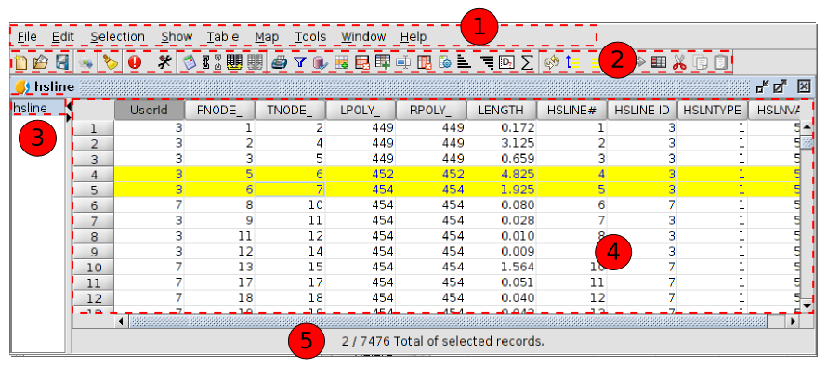
- Menus toolbar.
- Button toolbar.
- Table’s name. This header can be hidden.
- Table.
- Information of the table. Reports the total of records that the table contains and how much are selected.
Fields can be resized visually, clicking in border of header and dragging to new position.
All vector layers have an associated “Attribute table”. Each graphic element of a layer has it’s corresponding record in this “Attribute table”.
To select a record in table just click with left mouse button. Using keys “Control” and “Shift” and clicking it’s possible to select different records.
To select a field of the table you must click with mouse left button on field header.

