Table tools

61.1. Introduction
These tools are the ones for making actions in the tables.
The tools are available from the “Table” menu and its relevant button bar. The function “Join” is also located in “Tools/Transforms/Create”.
Menu | Button bars
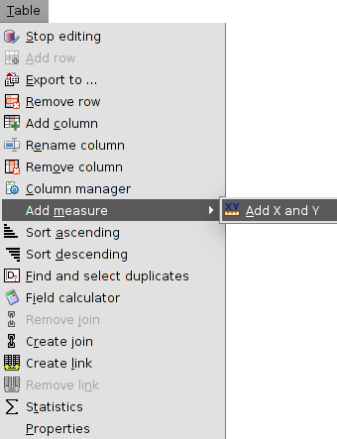
Let´s see all the available tools:
Icon | Tool | Shortkey | Description
 | Export to... |  | To export one table
 | Field calculator |  | To make calculations with the fields of the Table
 | Remove join |  | To undo the join between two Tables
 | Create join |  | To create one join between two Tables
 | Remove link |  | To remove the link between two tables
 | Link |  | To create one link between two tables
 | Add X and Y |  | It adds two new fields to the table with the X and Y coordinates (length and latitude). Only available for the attribute tables.
 | Print Table |  | To print the table
 | Start editing |  | To start editing one Table. Only available for alphanumeric tables.
 | Finish Editing |  | To finish editing one Table. Only available for alphanumeric tables.
 | Select by attributes |  | To make a selection by attributes
 | Add row |  | To add one row to the table
 | Remove row |  | To delete the selected row
 | Add column |  | To add one column to the Table
 | Rename column |  | To rename one field.
 | Remove column |  | To delete the selected field
 | Column manager |  | To access to the column manager
 | Sort ascending |  | To sort ascending alphabetically the table depending on the data of the selected field.
 | Sort descending |  | To sort descending alphabetically the table depending on the data of the selected field.
 | Find and select duplicates |  | It detects and selects the roww with duplicate values of the selected field.
 | Statistics |  | It shows statistics of the selected field.

61.2. Join
It allows to see the join between two Tables- The join allows one to one or many to one relations. To make the join, both tables must have a common field, which it will be the joining point: the field name doesn´t need to be the same, but yes the data type.
This tool is available from the “Table” menu, “Tools/Transforms/Create” or its relevant button bar.
The interface gives the steps to make the join:
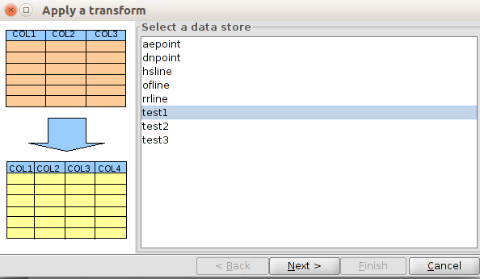
- Select a data store. The Table where the fields of the second table will be joined, must be selected. Click on “Next”.
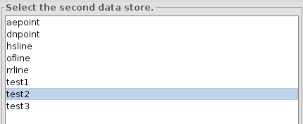
- Select the second data store. The Table, which has the new fields to be joined to the first Table, must be selected. Click on “Next”.
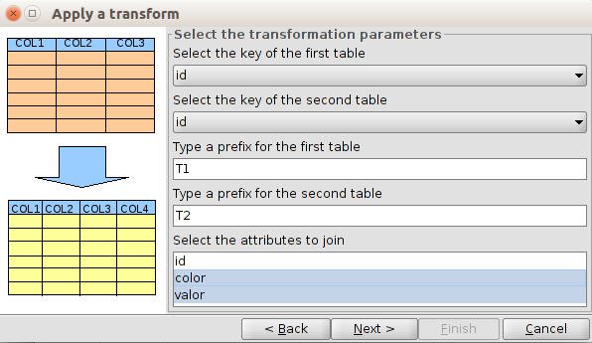
- Select the transformation parameters:
- Select the key of the first table. Joining field of the first table.
- Select the key of the second table. Joining field of the second table.
- Type a prefix for the first table. Optional. It allow to add a prefix to the fields of the first table.
- Type a prefix for the second table. Optional. It allow to add a prefix to the fields of the second table.
- Select the attributes to join.
Once all have been defined, click on “Next” to access to the last panel.
- Apply the transform. A message will appear saying that the transformation has been applied. This last panel can be different if the join is with the attribute table of one layer (which contains attributes of geometries) or if it is with alphanumeric tables.
In the case of an attribute table, it will appear the option to load the transformation output like a new layer.
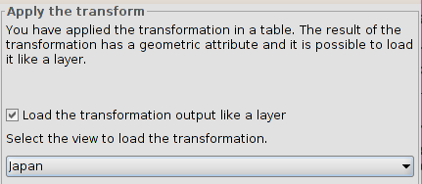
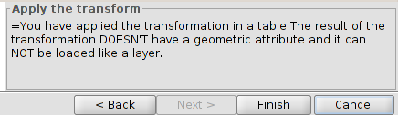
The join can be deleted with the “Remove join” tool, from the “Table” menu or its relevant button bar.

61.3. Link
It allows to create a link between two Tables. One link is a connection between tables allowing that any change in one table appears also in the other one (for instance, a selection). The related data will not be attached as in the joining case. To make the link, both tables must have a common field, which it will be the linking point: the field name doesn´t need to be the same, but yes the data type.
This tool is available from the “Table” menu or its relevant button bar.
The interface gives the steps to make the link:.
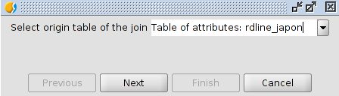
- Select origin table of the link. Dropdown menu with all the available tables to select. Click on “Next”.
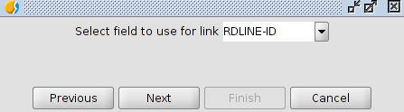
- Select field to use for the link. Dropdown menu with all the available fields to select. Click on “Next”.
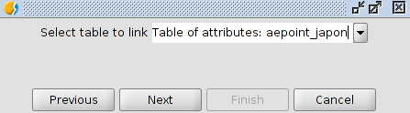
- Select table to link. Dropdown menu with all the available tables to select. Click on “Next”.
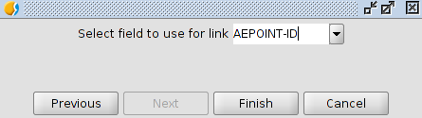
- Select field to use for link. Dropdown menu with all the available fields to select. Click on “Next”.

61.4. Find and select duplicates
To find and select duplicate values in one field of the Table.
This tool is available from the “Table” menu and its relevant button bar.
For using this tool, the field of the table must be selected. The tool will select automatically all the records with a value not unique; the value will be repeated in more than one record of the Table.
It will show a window with the number of different values with duplicates and the total number of duplicates.

61.5. Statistics
To get statistic values of one numeric field of the Table.
This tool is available from the “Table” menu and its relevant button bar.
For using this tool, the field of the table must be selected. It is possible to calculate statistics of all the records of one table, if there is not any selected, or of which are selected.
The interface is:
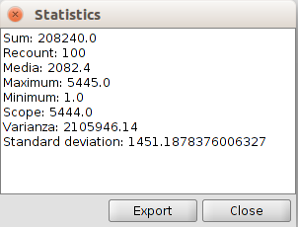
- Statistics. Show the values of the sum, recount, media, maximum, minimum, scope, varianza, and standard deviation.
- Export. To export these values as a table in.csv or.dbf format. If it is.csv, a new panel will appear where the user will choose the separator type: semicolon, comma or any other symbol defined by the user.

