Selection tools

62.1. Introduction
These tools are the ones for selecting a group of features in one table. Some of the gvSIG tools only work with selected elements.
In the case of attribute tables of one layer, the selection of vectorial elements can be made from the View or from the attribute table of the layer.
These tools are available from the “Selection” and its relevant button bar. The tool “Select by attributes” is among the Table button bar.
Menu | Button bar
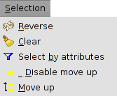
Let´s see all the available tools:
Icon | Tool | Shortkey | Description
 | Clear |  | To clear the selection
 | Select by attributes |  | To select features in function on one query by attributes.
 | Reverse |  | Ito reverse the selection
 | Disable move up |  | To disable the move up option
 | Move up |  | To move up the selected records in the table
To add records to an existent selection, the key “ctrl” must be pressed while selecting the records. To remove one or more records, press “ctrl” and click on them. With the key “Shift” (capital letters) is possible to select consecutive records.
The selected records will be highlighted in yellow.

62.2. Selection by attributes
To select records from one table using an attribute query.
This tool is available from the “Table” menu and its relevant button bar.
The interface is:
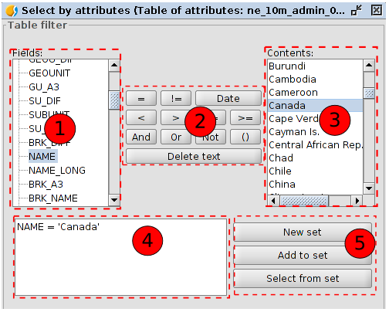
- Fields. Field listing of the layer. Double click on the field to be added to the selection query.
- Logical operators. To insert, clicking on them, one logical expression to the query.
- Known values. It shows one list with all the different values for the selected field. Double click on the value to add to the selection query.
- Query. The query to execute will be written. It is possible to type it directly.
- Selection options
- New set. To create a new selection.
- Add to the set. To create a selection taking into account the last query and the sum of the actual query.
- Select from the set. To create a selection of the selected set, subtracting from the previous query the actual query.

