Table edition

63.1. Introduction
All the tools for modifying the values or structure of one table.
In the case of attribute tables, the edition must begin from the View. In the case of alphanumeric tables begins from the Table document.
These tools are available from “Table” menu and its relevant button bar..
The available edition tools are:
Icon | Tool | Shortkey | Description
 | Field calculator |  | To make operations with the fields of the table
 | Add X and Y |  | To add two new fields to the table with X and Y coordinates (length/latitude). Only available for attribute tables.
 | Start editing |  | To start editing one Table. Only available for alphanumeric tables.
 | Finish Editing |  | To finish editing one Table. Only available for alphanumeric tables.
 | Add row |  | To add one row to the table
 | Remove row |  | To delete the selected row
 | Add column |  | To add one column to the Table
 | Rename column |  | To rename one field.
 | Remove column |  | To delete the selected field
 | Column manager |  | To access to the column manager

63.2. Add column

To add a new column to the table.
This tool is available from the “Table” menu and its relevant button bar.
It shows one window to select the characteristics of the column.
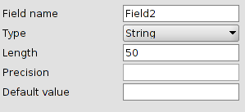
- Field name
- Type. Dropdown with the available types.
- Length. Field length. Maximum is 254.
- Precision. Number of decimals for the numeric fields (double).
- Default value. It is possible to set a default value for all the records of the table.

63.3. Column manager
To add, remove or rename fields.
This tool is available from the “Table” menu and its relevant button bar.
The interface is:
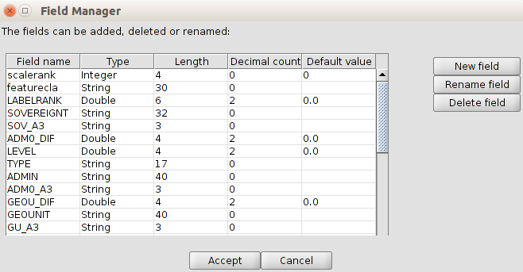
- List with all the fields of the table and with their characteristics.
- The available buttons allow to create, rename or delete one field.

63.4. Field calculator
To make calculations with the fields of the table.
This tool is available from the “Table” menu and its relevant button bar.
It is possible to execute in all the records if none is selected, or in the selected fields.
The interface is:
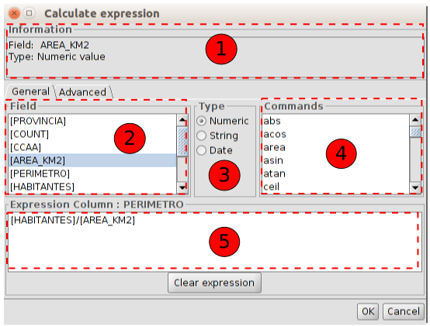
- Information about the selected “Field” or “Command”
- Filed. List of the fields. Double click on the field to add the expression.
- Type. Depending on the selected type, the available “Commands” are updated.
- Commands. List of the available commands depending on the selected “Type”. Double click on the expression to apply.
- Expression. Operation which will be applied to the selected field. It is possible to type it directly.
The “Advanced” tab is for using one expression saved in one file.
The interface is:
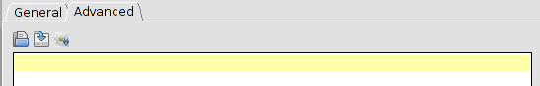
- Load script with the expression.
- Save script with the expression.
- Run script to test the expression.
Some usual commands are:
Command | Description
rec | The 0-based index of the current record
ToNumber | Returns a new number initialized to the value represented by the specified string..
ToString | Returns the string representation of the numeric field.
area | Returns the area of the polygon
perimeter | Calculates the perimeter of the polygon or the length of one line
subString | To make crops of one alphanumeric field. Examples:  - Crop 7 last characters:  subString([Field],0,length([Field])-7)  - Delete the 3 first characters:  subString([Field],3,length([Field]))  - Keep the last 5 characters and delete the rest:  subString([Field],length([Field])-5,length([Field]))
x | Calculate X coordinate of one point
y | Calculate Y coordinate of one point

