Export table

64.1. Export table
To export one table.
This tool is available from the “Table” menu.
The interface with all the steps to export the table is:
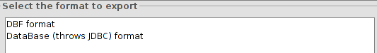
- Select the format to export from the available ones. Click on “Next”.
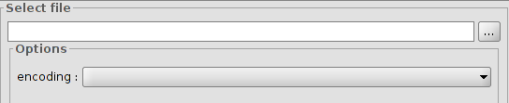
- Select file. To indicate the location for the file. There is an option of encoding the table. Click on “Next”.
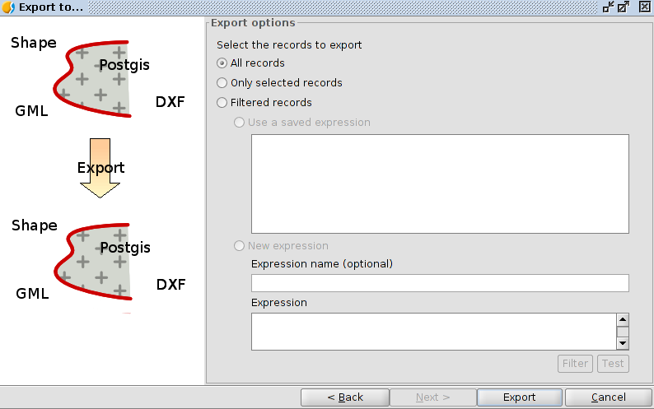
- Export options: To indicate the records to export:
- All records
- Only selected records.
- Filtered records- It is possible to set up one filtering expression.
Once the export is finished, a new window will appear with the option for adding a new table to the project.
