map

65.1. Introduction
“Map” type documents allow you to design and combine all the elements you wish to have in a printed map.
A Map document is a set of design elements of a map or plane, organized in a virtual page and its objective is a graphic output (printing or exporting to PDF). What the design shows is what is obtained when exporting or printing the map at the same page size as the defined.
You can insert two types of elements in a Map:
- Cartographic elements.
- Design elements.

65.2. Creating a Map
To create a new map in a gvSIG project, from the “Project manager”:
- Select the View icon.
- Click on “New”. A new dialog window is automatically opened which allows to define the Map we want to create.
The interface is as follows:
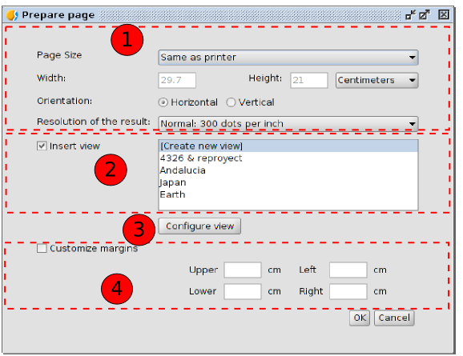
- Options to define the features of the page: size, orientation and resolution.
- It allows to define if you want to create a Map without a View initially inserted, with an empty View or from an existing View. The list with the project views is shown and there is the option “Create New View” in case you want to insert an empty View. This last option will also add a new View to the project.
- Configure View. It allows to access to the “View Properties” window.
- Margins. It allows to define the Map's margins.
By default, a new Map has the name “Untitled”. We can change the name by clicking on the “Rename” button of the “Project manager” (when the Map we want to rename is selected in the “Project manager”). A new dialog window is shown where you have to type the new name:
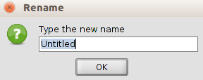
From the Map properties window you can also rename the Map.
Using the “Delete” button from the Project manager the selected Maps are removed.
Using the “Open” button from the Project manager the selected maps are opened.

65.3. Map properties
You can access to the Map properties window from:
- When we have a Map document opened, by going to the “Map” menu and then to “Properties”.
- From the “Project manager”, having the map selected, by clicking on the “Properties” button.
Menu (Map document) | Button (Project manager)
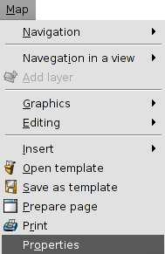 | 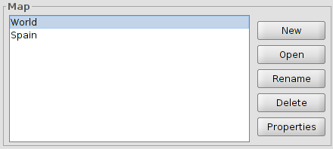
The configuration options of the Map properties window of the View are:
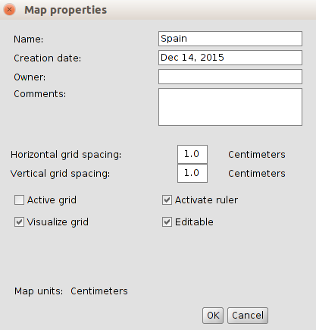
- Name. It allows to rename the Map.
- Creation date. Creation date of the map.
- Owner. To indicate the Map's creator. This is optional.
- Comments. Optional space to add comments.
- Grid. It helps to the design of the Map. Activating the grid means that any element inserted in the map will be adjusted to the grid.
- The grid is defined by the horizontal and vertical spacing. This spacing defines the distance between the different points which make up the grid.
- Active grid. When this box is checked the grid is active.
- Visualize grid. When this box is checked the grid is visible. A grid can be active but not to be visible.
- Activate ruler. By enabling this check box a ruler appears which can be used as a drawing aid.
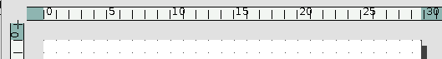
- Editable. If you do not enable this option, the objects that make up the map will be blocked, thus preventing modifications.

65.4. Preparing a page
You can use this tool to define the working area, i.e. the size and properties of the page to be used for the map layout.
You can access this tool by clicking on the “Configure page” button in the tool bar or from the menu bar by selecting the “Map” option and then “Prepare page”.
Menu | Button
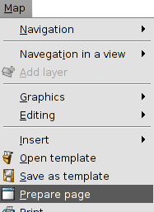
When you have selected the tool a new window will appear. The interface is as follows:
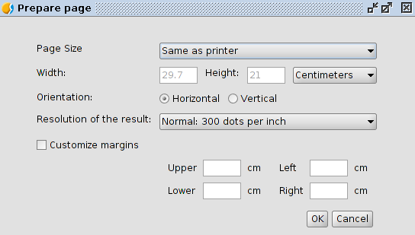
- Page size. It allows you to define the page size. You can select a standar size through a pull-down menu or define your own.
- Orientation. This defines whether the paper will be printed horizontally or vertically.
- Resolution of the result. It allows users to define the resolution of the result.
- Margins. This allows you to define the page's four margins. The ruler is adjusted to fit in with the page margins.

