Map interface

66.1. Map interface
The Maps are the gvSIG documents which allow the design of maps. You can insert different Views in a Map, having access to the TOC of each View.
When opening a Map from the Project manager, a new window appears which is divided in the following parts:
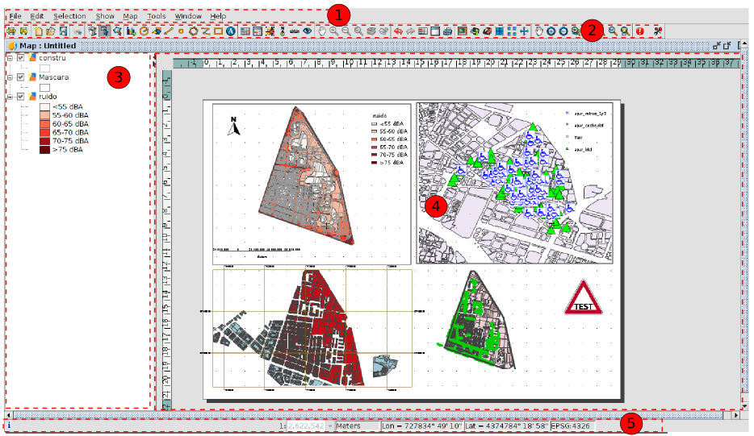
- Menu bar.
- Button bar.
- Table of Contents (TOC): It lists all the layers that the selected View in the Map contains, and the legend which represents the symbology used for each layer.
- Map area. It is where the page is represented. You can make the main actions in this area (such as navegation, selection, insertion of elements...).
- Status bar. The status bar provides information about the coordinate system of the selected view, scale of visualization, coordinates and units.
The components 3 and 4 are resizable, dragging their edge to their right and left by clicking and holding the left button of the mouse.

