cartographic elements

67.1. Tools for the insertion of cartographic elements
These tools allow to insert cartographic elements in a Map document.
Most of the cartographic elements are linked to a View document, so that when you make changes in the View, they can be reflected in the map (zoom changes, displacements, legend's changes, layer's organization, etc.)
These tools are available from the “Map/Insert” menu and in the corresponding button bar.
Menu | Button bar
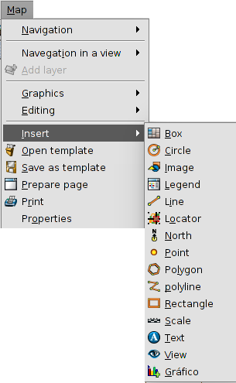
Let's see each of these available tools:
Icon | Tool | Shortcut | Description
 | Insert view |  | It allows to insert a View in the Map.
 | Insert legend |  | It allows to insert an associated legend to the View's TOC in the Map.
 | Insert scale |  | It allows to insert an scale associated to a View in the Map.
 | Insert north |  | It allows to insert a north symbol associated to a View in the Map.
 | Insert locator |  | It allows to insert a locator associated to a View in the Map.
 | Insert box |  | It allows to define a box by number of colums and rows.
The properties window of the cartographic elements is available from the contextual menu of the inserted element, which appears when we right-click on it while it is selected.

67.2. Insert a View
It allows to insert a View to the Map. When we create a new Map we can insert automatically a new View or an existent View.
This tool is available from the “Map” menu and then in “Insert/View”, and in the corresponding button bar.
After selecting this tool, place the mouse pointer on one of the vertexes of the rectangle which define the view area, left click and drag the pointer to the opposite vertex and drop.
A dialog box appears in which you can define the view-type element properties you have just inserted:
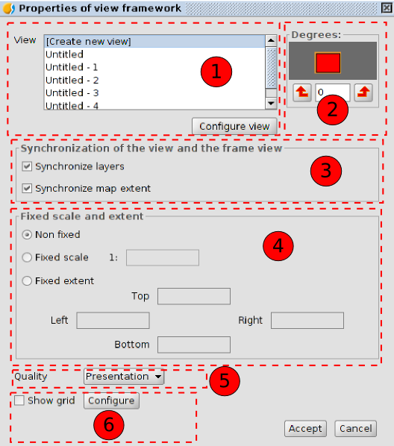
- View. It allows users to create a new View or to select one of the available Views in the list. The “Configure view” button allows to access to the “View properties” window.
- Degrees. This allows you to specify a degree of rotation when the view is inserted in the map.
- Synchronization of the View and the frame View. It allows to enable or disable the synchronization of layers and the extension of the Map. When the synchronization is active the changes you do in the View document will be reflected on the inserted View in the Map.
- Scale and extent. It allows to define the type of scale or extent of the inserted View.
- Non fixed. The scale or extent of the View changes when we use the navegation tools.
- Fixed scale. It allows to define a fixed scale.
- Fixed extent. It allows to define a fixed extent indicating the top, bottom, right and left limits.
- Quality. It allows to define the quality of the visualization.
- Grid. It allows users to configure the View's grid.
A grid is a network of horizontal and vertical lines spaced uniformly used to identify X, Y coordinates on a map. Graticules are lines showing parallels of latitude and meridians of longitude on Earth and it is used to identify geographic coordinates (degrees longitude and latitude).
By clicking on the “Configure” button you access to the grid settings.
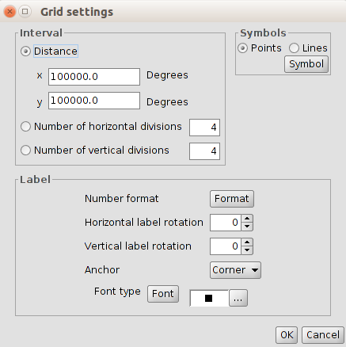
- Interval. It allows you to select the grid interval, by defining the distance between lines or points which make up the grid, or by defining the number of horizontal and vertical divisions.
- Symbols. It allows to select the grid symbology between points and lines. Using the “Symbol” button you can select a certain type of symbol from the “Symbol selector”.
- Label. It allows to define the characteristics of the labels that indicate the grid coordinates.
  - By clicking on the “Format” button you access to a new window which allows to define the decimal separator, the thousands separator and the decimal digits.
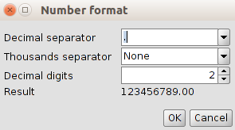
  - Horizontal and vertical rotation. It allows to apply a rotation to the horizontal and vertical intervals.
  - Anchor. It allows to select the anchor of the lable to the center or the corner.
  - Font type. It allows to select the font characteristics.

67.3. Insert a Legend
A legend shows the meaning of the symbols which are used to represent the entities of an inserted View in the Map. The legends are made up of two elements: the symbols and the layers or explanatory texts that are associated with every symbol.
The legend, which is always associated with an inserted View in the Map, allows to represent the symbology of the different layers of that View. A legend is associated with a unique View. When inserting a legend, this will be added with the same order as in the TOC.
This tool is available from the “Map” menu and then in “Insert/Legend”, and in the corresponding button bar.
After selecting this tool, place the mouse pointer wherever you want inside the Map area, left click and drag the pointer to the opposite side and drop.
A dialog box appears in which you can define the properties of the inserted legend:
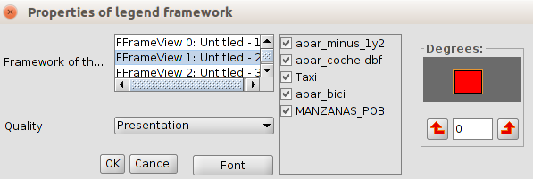
- Framework of the View. It allows to select the associated View for the legend which will be inserted. If we select a View, a list with available layers will be shown, which allows to show/hide the symbology of the layers that will make up the legend.
- Degrees. This allows you to specify a degree of rotation when the legend is inserted in the map.
- Quality. It allows to define the quality of the visualization.

67.4. Insert a scale
This tool allows you to insert a graphic scale or text scale associated with an inserted View in the Map.
The graphic scale is the representation of the scale in a visual way, where each segment shows the relation between the length in the representation and the real length. The graphic scales provide a visual indication of the size of the entities and the distances between them. A graphic scale is a line or bar divided in parts and labeled with its real lenght.
This tool is available from the “Map” menu and then in “Insert/Scale”, and in the corresponding button bar.
After selecting this tool, place the mouse pointer wherever you want inside the Map area, left click and drag the pointer to the opposite side and drop.
A dialog box appears in which you can define the graphic properties of the inserted scale:
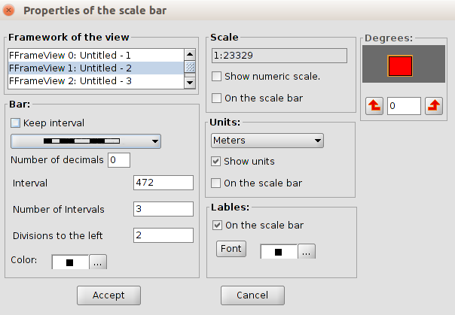
- Framework of the View. It allows to select the View which is related to the legend we want to insert.
- Bar. By clicking on the pull-down menu, you can see the type of scale you want to insert: text or graphic scale. There are options to define the number of intervals, the distance that each interval represents and the divisions to the left of zero.
- Scale. You can use this section to display a text with the numeric scale.
- Units. This defines the graphic scale units of measurements (metres, km., etc.)
- Labels. It allows to select the characteristics of the labels.
- Degrees. This allows you to specify a degree of rotation when the scale is inserted in the map.

67.5. Insert North symbol
It allows users to insert a North symbol which indicates the orientation of an inserted View in the Map.
This tool is available from the “Map” menu and then in “Insert/North”, and in the corresponding button bar.
After we select this tool, place the mouse pointer wherever you want inside the Map area, left click and drag the pointer to the opposite side and drop.
A dialog box appears in which you can define the graphic properties of the inserted north:
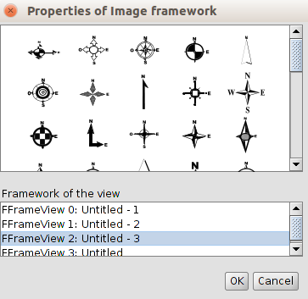
- In the top of the box we find the available north symbols. It allows to select the north symbol you want to apply.
- Framework of the View. It allows to select the View related to the north symbol we want to insert.

67.6. Insert locator
It allows to insert a locator related to the inserted View in the map.
This tool is available from the “Map” menu and then in “Insert/Locator”, and in the corresponding button bar.
After we select this tool, place the mouse pointer wherever you want inside the Map area, left click and drag the pointer to the opposite side and drop.
A dialog box appears in which you can define the graphic properties of the inserted locator:
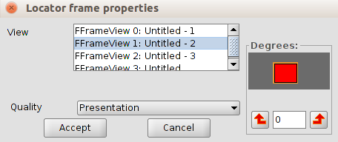
- View. It allows to select the View related to the locator you want to insert.
- Degrees. This allows you to specify a degree of rotation when the scale is inserted in the map.
- Quality. It allows to define the quality of the visualization.

67.7. Insert a box
It allows to insert a box in the Map.
This tool is available from the “Map” menu and then in “Insert/Box”, and in the corresponding button bar.
After we select this tool, place the mouse pointer wherever you want inside the Map area, left click and drag the pointer to the opposite side and drop.
A dialog box appears in which you can define the graphic properties of the inserted box:
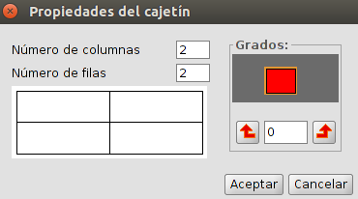
- Number of columns and rows. It allows to define the number of columns and rows which make up the box.
- Degrees. This allows you to specify a degree of rotation when the box is inserted in the map.

