Graphic elements

68.1. Tools for the insertion of graphic elements
These tools allow to insert graphic elements into a Map document.
They are available from the “Map” menu and then in “Insert”, and in the corresponding button bar.
Menu | Button bar
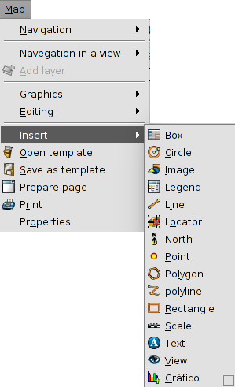
Let's see each of the available tools:
Icon | Tool | Shortcut | Description
 | Insert chart |  | It allows to insert a chart document.
 | Insert circle |  | It allows to insert a circle
 | Insert image |  | It allows to insert an image.
 | Insert line |  | It allows to insert a line
 | Insert point |  | It allows to insert a point
 | Insert polygon |  | It allows to insert a polygon.
 | Insert polyline |  | It allows to insert a polyline.
 | Insert rectangle |  | It allows to insert a rectangle
 | Insert text |  | It allows to insert a text
The properties window of the graphic elements is available in the contextual menu of the inserted element, which appears when we right-click on it while it is selected.
Whith the tool Edit vertex, that is available in the “Map/Editing” menu, you can modify the vertexes of the graphic elements.

68.2. Insert chart
It allows to insert a Chart document.
This tool is available from the “Map” menu and then in “Insert/Chart”, and in the corresponding button bar.
After we select this tool, place the mouse pointer wherever you want inside the Map area, left click and drag the pointer to the opposite side and drop.
A dialog box appears in which you can define the graphic properties of the inserted box:
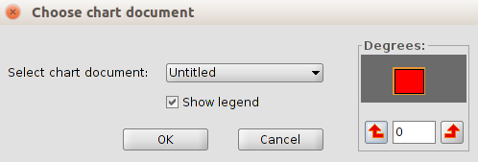
- Select chart document. It allows to select a Chart document to insert.
- Show legend. It allows to select if you wish to show the legend of the inserted graphic document.
- Degrees. This allows you to specify a degree of rotation when the box is inserted in the map.

68.3. Insert Circle
It allows users to insert a circle.
This tool is available from the “Map” menu and then in “Insert/Circle”, and in the corresponding button bar.
After we select this tool, place the mouse pointer wherever you want inside the Map area, left click and drag the pointer to the opposite side and drop.
With the circle properties you can access to the window of the symbology selector.

68.4. Insert image
It allows you to insert an image.
This tool is available from the “Map” menu and then in “Insert/Image”, and in the corresponding button bar.
After we select this tool, place the mouse pointer wherever you want inside the Map area, left click and drag the pointer to the opposite side and drop.
A dialog box appears in which you can define the graphic properties of the inserted image:
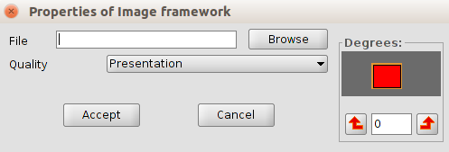
- File. It allows to select an image file, either by typing its path or by cliking the “Browse” button. Allowed formats are jpeg, jpg, gif, png, bmp and svg.
- Degrees. This allows you to specify a degree of rotation when the box is inserted in the map.
- Quality. It allows to define the quality of the visualization.

68.5. Insert Line
It allows to insert a line.
This tool is available from the "Map / Insert / Line" menu and in the relevant button bar
After selecting the tool, will be displayed the first vertex of the line by clicking on the map area in the desired location, and a second click to indicate the second point of the line is displayed.
The properties of the line open a symbology selector window.

68.6. Insert point
This allows to insert a point.
This tool is available from the "Map / Insert / Line" menu and in the relevant button bar
After selecting the tool, will be indicated the location of point by clicking on the map area in the desired location
The point properties open a symbology selector window.

68.7. Insert polygon
It allows to insert a polygon
This tool is available from the "Map / Insert / Line" menu and in the relevant button bar
After selecting the tool, will be displayed the first vertex of the polygon by clicking on the map area in the desired location, and a second click to indicate the second point of the line is displayed.
The polygon properties open a symbology selector window.

68.8. Insert polyline
It allows to insert a polyline.
This tool is available from the "Map / Insert / Line" menu and in the relevant button bar
After selecting the tool, will be displayed the first vertex of the polyline by clicking on the map area in the desired location, and a second click to indicate the second point of the line is displayed.
The polyline properties open a symbology selector window.

68.9. Insert rectangle
It allows to insert a rectangle
This tool is available from the "Map / Insert / Line" menu and in the relevant button bar
After selecting the tool, will be indicate the first end of the rectangle by clicking on the map area in the desired location, and dragging to drop indicating the opposite end .
The rectangle properties open a symbology selector window.

68.10. Insert text
It allows to insert a text
This tool is available from the "Map / Insert / Line" menu and in the relevant button bar
After selecting the tool, will be indicate the first end of the rectangle which defines the space to be occupied by text by clicking on the map area in the desired location, and dragging to drop indicating the opposite end .
A dialog box appears in which can be define the properties of the inserted text
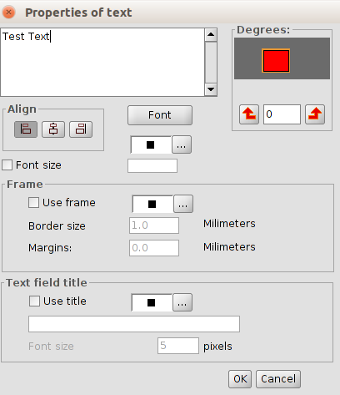
- Text area. It allows write the text wich apears insert on map
- Degrees. It allows to define the rotation of the inserted text.
- Align. Select the type of alignment (left, center or right).
- Font. It allows to define the characteristics of the font.
- Font size. With the box checked allows to fix a text size
- Frame. It allows to define the characteristics of an optional frame for text
- Text field title. It allows to establish a title associated with the frame that surrounds the text entered.

