Navigation tools

69.1. Map navigation tools
There are the tools to move around the Map page, closer or away from it
These tools are available from the "Map / Navigation" menu and at the corresponding button bar.

Menu | Button bar
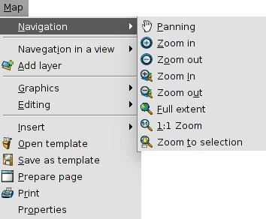
Let's see each of the available tools:
Icon | Tool | Shortcut | Description
 | Panning |  | It allows to change the frame of the Map page by dragging the field of visualization in all directions with the mouse. Must be maintained mouse button pressed and move the mouse in the desired direction.
 | Zoom in |  | It allows approaching the center of the frame data of the Map page.
 | Zoom out |  | It zooms out from the center of the frame data of the Map page.
 | Zoom in |  | it allows to do a zoom in on a particular area of the Map page.
 | Zoom out |  | It allows to do a zoom out on a particular area of the Map page.
 | Full extent |  | A frame is made to the full extent of the Map page.
 | 1:1 Zoom |  | It allows you to do zoom to 1: 1 scale map of the page.
 | Zoom to selection |  | It allows to do a frame to selected items of the Map page.

69.2. View navigation tools
These are tools that allow navigation through the inserted View and basically consist of changes in the visualization scale and displacements.
These tools are available from the "View / Navigation in a View" menu and in the corresponding button bar.
Menú | Barra de botones Button Bar
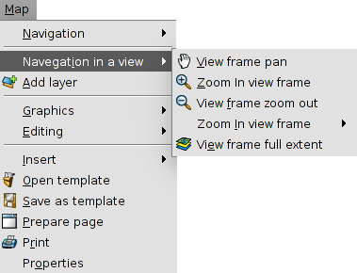
Consider each of the available tools:

Icon | Tool | Keyboard shortcut | Description
 | View frame pan |  | It allows to change the frame of the view by dragging the field of visualization in all directions with the mouse. You should keep the primary mouse button down and move the mouse to the desired direction.
 | Zoom in view frame |  | it allows to approach a specific area of the View
 | View frame zoom out |  | it allows to out a specific area of the View
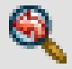 | Previous zoom |  | It allows to return to previous frame.
 | View frame full extent |  | This makes a frame to the total extension that defines all layers of the View
In the status bar it is possible to indicate the scale of the view, directly writing the scale factor in or selecting one of the available drop.
