DESIGN TOOLS

70.1. Design tools
These are those that allow us to do actions design and layout of the map.
These tools are available from the "Map / Graphics" menu and the corresponding button bar.

Menú | Barra de botones button bar.
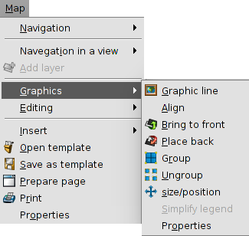
See each of the available tools:
Icon | Tool | Keyboard shortcut | Description
 | Graphic line |  | It allows to draw a frame around the selected items.
 | Align |  | It allows to change the alignment, distribution and size of the selected items.
 | Bring to front |  | It allows to modify the visualization order of the elements, bringing to front the selected items.
 | Place back |  | It allows modify the visualization order of the elements, placing behind the selected items.
 | group |  | It allows to combine multiple items in a group. A group behaves as a single element.
 | Ungroup |  | It allows to ungroup multiple items
 | Size/position |  | It allows to modify the size and the position of a selected item
 | Simplify legend |  | It allows to simplify an embedded legend. This action breaks the link with the view and the legend becomes a graphic elements.

70.2.Graphic line
It allows to draw a frame around the selected items.
This tool is available in the "Map / Graphics / Graphic line" menu and the relevant button bar.
A dialog box where you can define the properties of the line graph will be displayed:
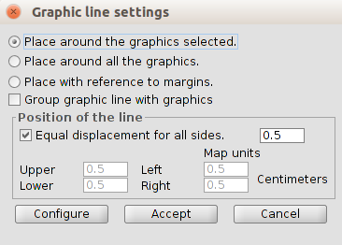
- Place options. It allows to select the place of the graphic line.
  - Around the graphics selected
  - Around all the graphics. Not required to have any selected graph
  - With reference to margins. Not required to have any selected graph
- Group graphic line with graphics. With the box checked allows you to group the graphic line and the element, so as to form a single entity and not two independent.
- Position of the line. It allows to configure the position of the graphic line
- Configure. It allows to access to the simbology selector

70.3.To Align
It allows to change the alignment, distribution and size of the selected items.
This tool is available from the "Map / Graphics / Align" menu.
A dialog box where you can set options to align items will be displayed
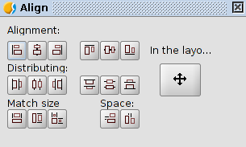
- Alignment. It allows to align the selected elements, placing them on the same axis: left, center, right, horizontal, top, center and bottom vertically.
- Distributing. It allows to place the elements at equal intervals in the area defined by the selected items.
- Match size. It allows to modify the size of a selected item with reference to another selected item. The adjustments are made based on the largest element in the selection there. The size of the elements can be matched in width, height or both directions respectively.
- Space. It allows to do a spatial distribution of the selected items.
- In the layout. The tool is applied to the entire area of the map.

70.4. Size and position
It allows to modify the size and the position of the selected element
This tool is available from the "Map / Graphics / Size / position" menu and in the relevant button bar
A dialog box where you can define the properties of size and position will be displayed:

