EDIT TOOLS

71.1. Edit tools
They are those that allows to edit the map.
These tools are available in the "Edit" menu and in the corresponding button bar.

Menú | Barra de botones Button bar
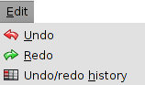
See each of the available tools:

Icon | Tool | Keyboard shortcut | Description
 | Undo/redo history |  | It allows to see the history of actions and undo until the desired action.
 | Undo |  | Undo the last action.
 | Redo |  | Redo the last undo action

