EXPORT AND PRINT TOOLS

72.1. Export and print tools
They are those that allows to print or export the map
These tools are available from the "Map" menu and in the corresponding button bar.

Menú | Barra de botones
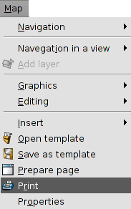
See each of the available tools:
Icon | Tool | Keyboard shortcut | Description
 | Export to PDF |  | It allows to export the Map page to PDF format.
 | Export to PS |  | It allows to export the Map page to PostScript format.
 | Print |  | It allows to print the Map page

