Map Template

73.1. Map template
A map template is a .gvst file that contains a design of a map that can be used as reference to create new maps. Map templates facilitates reusing or normalization of a design of a series of maps. Using a template saves time because you do not need to manually design again and again the common parts of the maps.
This tools are available in the Map menu
Menú
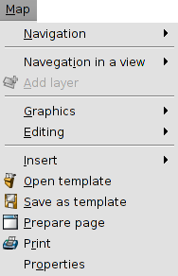
See each of the available tools:
Icon | Tool | Keyboard shortcut | Description
 | Open template |  | It allows to load a template.
 | Save as template |  | It allows to create a template from a Map page design

