Document CHARTS

74.1. Introduction
The Charts are the gvSIG documents for definying one or more plots. One Chart Document can have a determined number of plots.
It is possible to create a chart from the attribute table of one layer or from an alphanumeric Table.
Supported charts by gvSIG:
Type | Icon | Description
Pie | 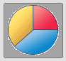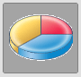 | The pie chart or circle chart is one circle divided into two or more sections. The pie charts show relations between the parts and the total, and are useful for proportions and relations.
Bars | 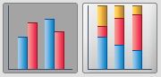  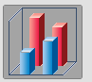 | The bars chart has two or more parallel rectangles, each of them represents an attribute value- These charts are useful to compare quantities or to show trends. Tha bars can be orientated horizontally or vertically
XY | 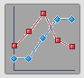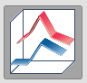 | The XY chart or linear graph has one or more lines, which connect values of succesive attributes. The linear graphs are useful for showing trends in values within a continuous scale. The lines can be orientated horizontally or vertically.
Temporary | 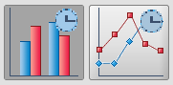 | To create plots with temporary data.
The Chart tools are available from the “Chart“ menu and their relevant button bars.
Menu | Button bars
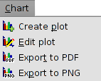
Let´s see all the available tools:
Icon | Tool | Shortkey | Description
 | Create plot |  | To create a new plot in one Chart document.
 | Edit plot |  | To edit the properties of one plot in one Chart document.
 | Export to PDF |  | To export a Chart document to PDF.
 | Export to PNG |  | To export a Chart document to PDF.

74.2. Create Charts
To create Charts in a gvSIG project, from the “Project manager”:
- Select the Charts icon.
- Click on “New”.The Chart document will open as an empty document where new plots can be added.
By default the new Chart document will be called “Untitled”. It is possible to change the name, clicking on “Rename” in the “Project manager” (having the Chart document selected). A dialog screen will open for typing the new name:
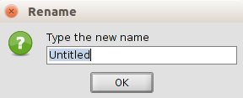
With “Delete” button oft the Project manager the selected charts will be deleted.
With ”Open” button of the Project manager the selected charts will open.

74.3. Create plot
To add a new plot in the Chart document. One Chart Document can have a determined number of plots.

This tool is available from the “Chart“ menu, in its relevant button bar and with the “Create Plot” in the window “Chart Properties”.
The interface shows the steps to follow for definiyng the chart parameters:
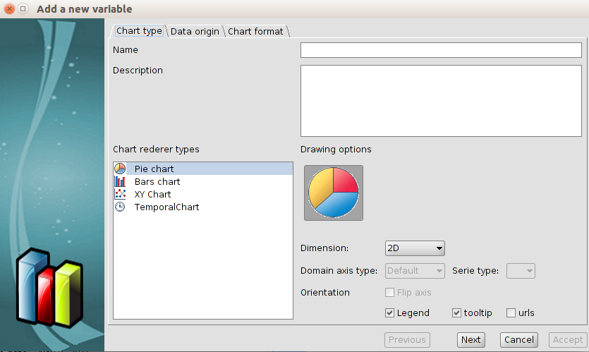
- Chart rendered types. It defines the type of chart for representing the data. In each type is possible to define the different characteristics to adapt the charts to the data.
- Name. Chart name.
- Description. It is possible to describe the chart.
- Renderer typesr. To select the type of the plot.
- Drawing options. To select the different options for reperesenting the selected chart (dimension, orientation,...)
Once all has been set up, click on “Next”.
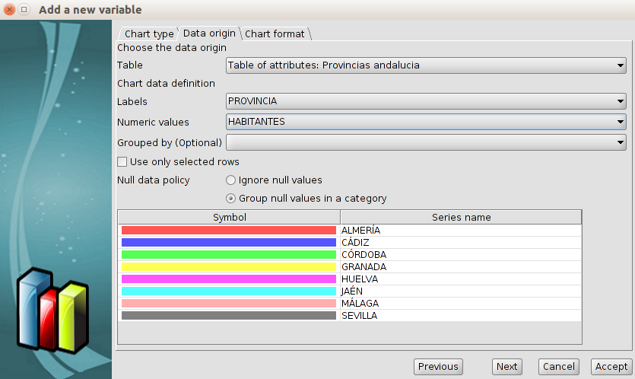
- Data origin. It sets the relation between the data and the axis of the plot.
- Table. To select the table as the data origin.
- Agrupados por (Optional). To classified the data in groups by one field.
- X. To select the X field. Clicking on “Sort axis alphanumerically” the values will be sorted alphanumerically.
- Y. To select the Y field.
- Use only selected rows. Only the selected values of the Table will be used.
- Null data policy. It is possible to ignore or group the null values in a category.
- Symbol. To define the colour of the legend.
Click on “Next”.
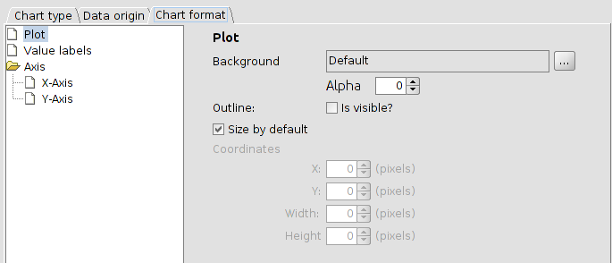
- Chart format. To define the format of the different elemnents of the Chart.
- Plot. To define the background, outline and the size.
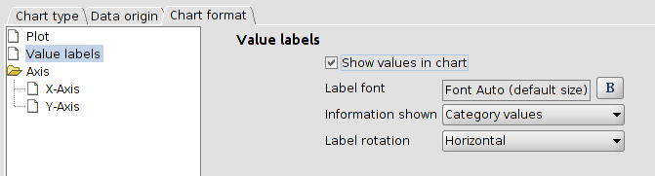
- Value labels. To define the labels of the Chart.
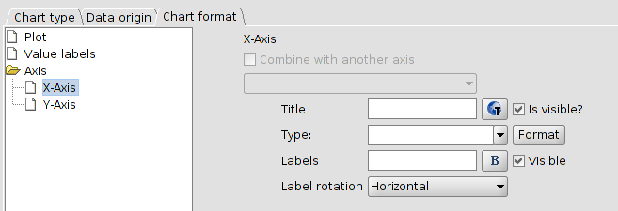
- Axis. To define the X and Y axis.
Once all has been set up, click on “Accept” and the plot will be shown in the Chart document.
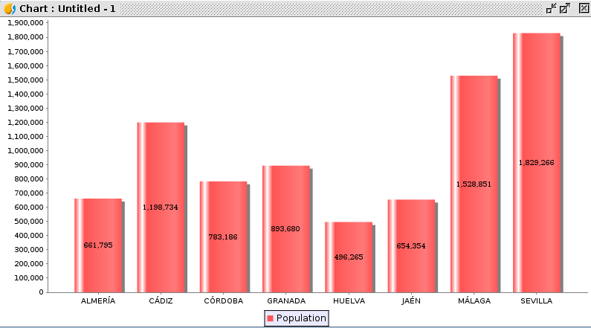
Clicking on “Create plot” again, we can make a new plot and combine it with the existent one.
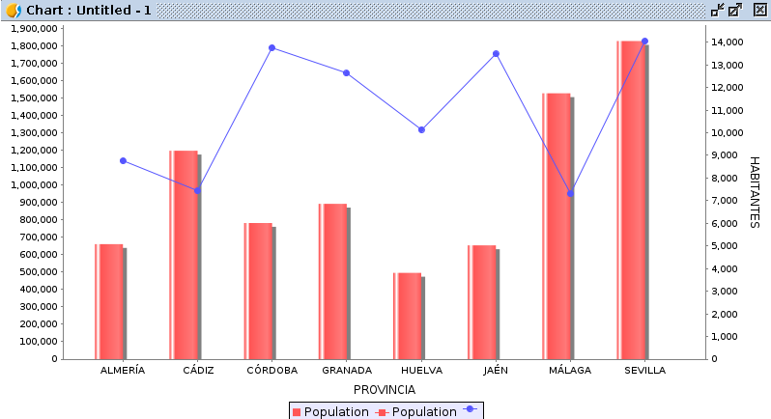

74.4. Edit plots. Properties.
To edit the properties of the Chart document.
This tool is available from the “Chart“ menu, in its relevant button bar and in the “Properties” button of the “Project Manager/Charts”.
The interface is:
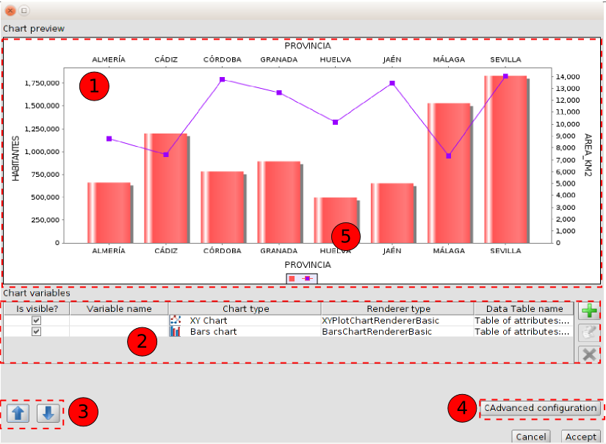
- Chart preview. It is a preview of the plot to insert in the Chart document.
- Chart variables. Table with all the created plots. It is possible to:
Icon | Tool | Description
 | Create plot | To create a new plot
 | Edit plot | To edit a plot, The “Create plot” window will be open and it is possible to change its characteristics. The plot to edit must be selected in the table.
 | Delete plot | To delete a plot. The plot to delete must be selected in the table.
- Up/Down. It allows to sort the viewing of the different plots. The variables will be painted according to this classification.
- Advanced configuration. It opens a new window for editing the general characteristics of the document:
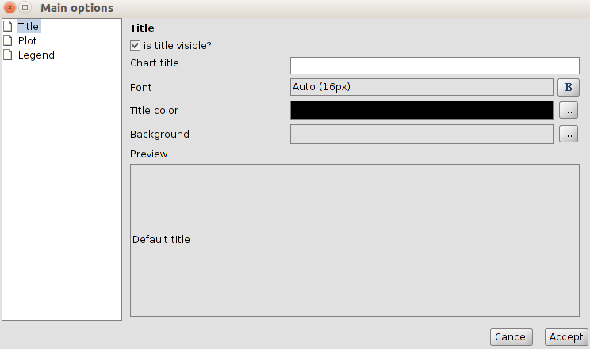
- Title. To add a title to the Chart document and configure its characteristics.
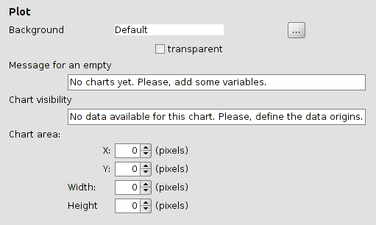
- Plot. To configure the characteristics of the Chart document (background, messages and area).
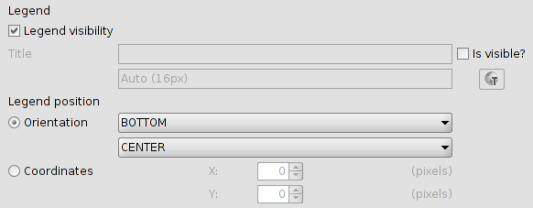
- Legend. To define the characteristics of the legend.

