Publishing

75.1. Introduction
Its aim is to enable a process automation for the maps publishing services, trying to obtain results as true as possible to the original work made in our gvSIG.
The “Publish extension” is available for downloading in the “Addons manager” and it can be found in “View/Export” and in its relevant buttonbar.
Menu | Button bar
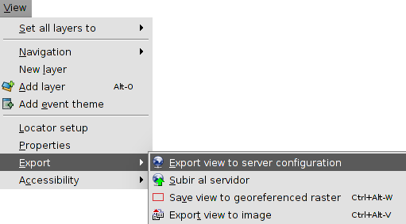
The available tools are:
Icon | Tool | Shortkey | Description
 | Export View to server configuration |  | Export View to server configuration (mapfile, MapServer).
 | Upload to the server |  | Upload the resource to the server

75.2. Export View to Mapfile
The interface is:
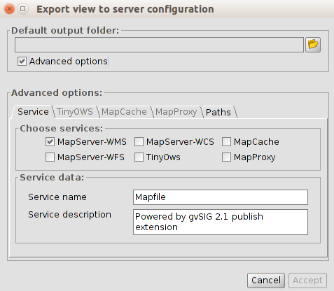
- Default output folder. Selection of the local work directory. It can be a new folder empty or one already createdv (for joining different works in one unique project).
If the output folder where the poject will be saved is not empty, the app gives the following option:
  - Overwriite: it will create all the files for the project and change the previous files if this is required..
  - Add: if new informaction want to be added to an existent project, without losing the previous information.
  - Cancel.
- Advanced options. Enable this option for seeing the advanced options, grouped in 4 tabs.
  - Service.
Choose service. Selection of services. We can check as many as we need, performing the publishing once. Each service will create a subfolder with its name in the project directory and inside of the subfolder, all the files needed for that concrete service will be stored.
Service data. to indicate the name under which the service will be displayed to customers and the description in the same form.
  - TinyOWS. Options of the TinyOWS service.
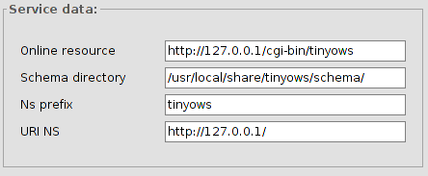
  - MapCache. Options of the MapCache service.
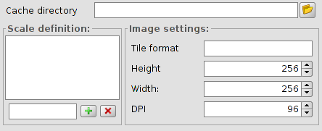
  - MapProxy. Options of the MapProxy service.
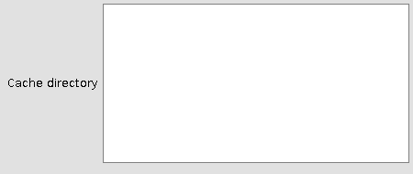

75.3. Manual edition of specific attributes
Sometimes, it can be interesting to define the parameters more precisely and adjust the specifications to the ones that Mapserver offers. For that reason, some mechanisms have been created to be able to complete these characteristics through some forms.
There are two access points:
- View “Properties”, which will define the characteristics of the Mapfile service (MapFile section). In this window, there are 4 tabs: : Mapserver, TinyOWS, MapCache, MapProxy.
MapServer | TinyOWS
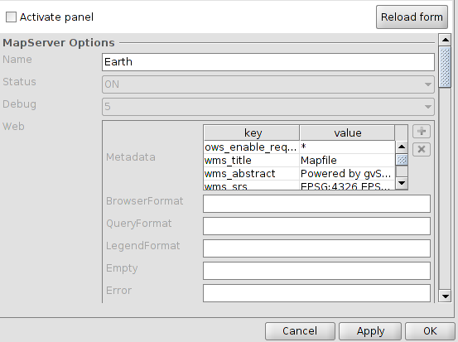 | 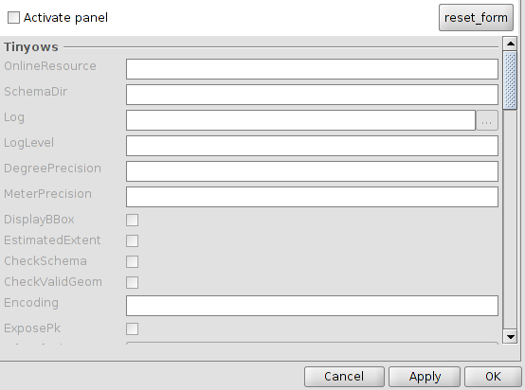
MapCache | MapProxy
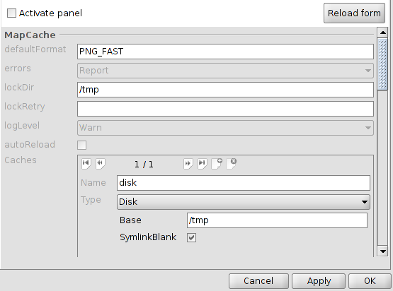 | 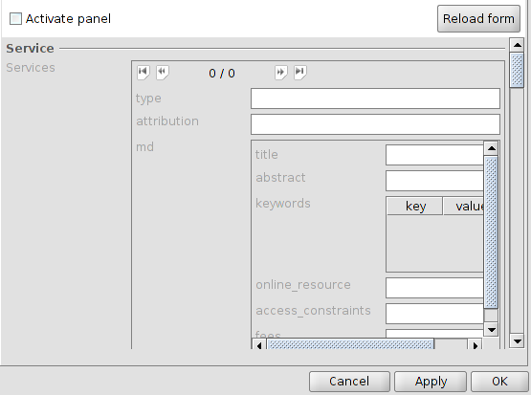
- Layer “Properties” (definition of the MapFile attributes of each Layer).
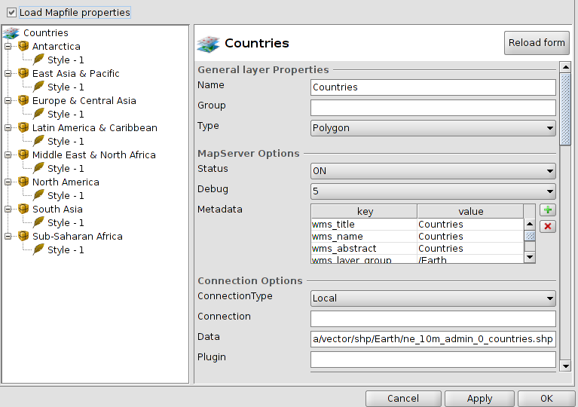
There are similar ways to define the services of TinyOWS, MapProxy and MapCache.

75.4. Upload to server
The publishing extension is able to upload to the server any project generated in local.
Visually, the menu is very similar to the publishing tool, except for the fact that all that refers to the generation of the project have disappeared, because it will not generate the definition of any other service, only it will upload an already existing one. Therefore, we only need to indicate the local project folder which we want to upload to the server and set the connection parameters.
The interface is:
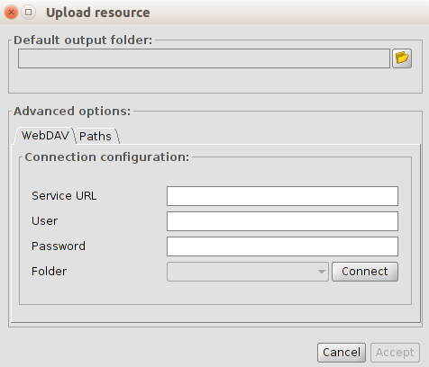
- Advanced options.
  - WebDAV. This process of publishing the project generated on the server can be done automatically at the time the project is created, or can be upload after with another tool extension.
In the first case (automatically), you need to indicate the destination address to establish the WebDAV connection. If it is a directory authentication, you must also provide the username and password.
  - Connect. It will check that connection and also it will fill the left menu with the subfolders that exist in the specified path.
  - Paths.
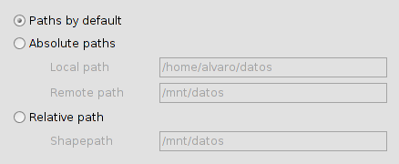
  - For a correct operation of services, it is necessary that the access to resources are properly defined. To do this, there are three possibilities to define the routes to them:
    - Default paths: This option does not alter the paths to resources, setting them such in the definition files of the different services.
    - Absolute paths: adequate if there is a correspondence between the location of the files on both machines (eg, the shapes are inside a folder called ‘data‘ and have identical directory structure inside), but the access to that folder has different routes on each machine (for instance, local directory is ‘/home/user/data‘ and the server is in ‘/mnt/data‘).
This option will replace in the configuration, the access paths to the local machine for the server ones
    - Relative paths: taking as origin the service configuration file (the mapfile if it is MapServer), you can set a route to resources from it using a ShapePath variable.
From that file and adding the indicated for the ShapePath variable, the rest of the resources accesses will be built.

