PORTABLE VIEW

78.1. Introduction
The Portable View extension lets you work with a new document that is a view with basic query options in which the rest of tools has been removed. With this you can convert a view in portable view and vice versa.
Besides, you can also package this portable view as a gvSIG complement. The generated gvSIG package contains both the generated data (files) and the portable view configuration. Using the complement manager, another user can install that portable view in his gvSIG.
Therefore, this extension has two main uses:
- Have available a query view.
- Allow portability/distribution of a gvSIG View containing all associated information (legends, labeling, map scales…)
The “Portable View: editor” y “Portable View: viewer” extensions are installed using the complement manager “Administrador de complementos”.

78.2. Create a Portable View
To create a View you must complete the following steps:
- Create a view “Vista”.
- Set up the View: CRS, layers, legends, labeling, map scales….
- Run the command “Vista Portable/Crear a partir de la vista” (Portable view/Create from view)
Menú
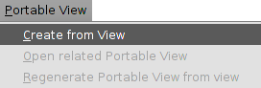
- A new window that lets you enter the View identification characteristics is open.
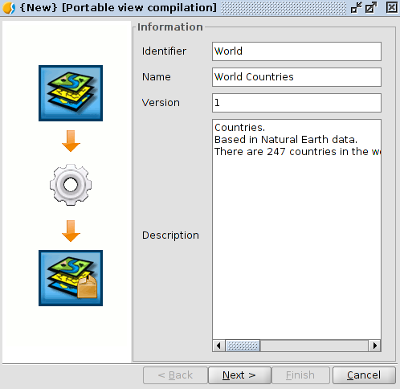
- Once you have entered the information click next “Next”.
Then a validation window is displayed, that warns you from possible errors in the portable view definition.
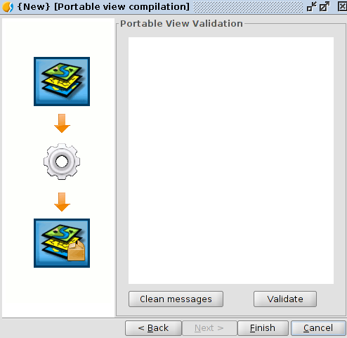
Click on the Finish button “Terminar”. And automatically is generated and opened the new document “Vista portable”.
Once a portable view is generated, it will be listed in the “Gestor de proyecto/Vista portable” (project manager/portable view).
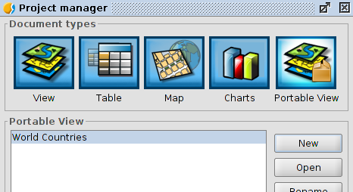

78.3. Interface
The portable view interface is a simplification of the View document, including query tools only and specific actions menu of the portable view.
The interface is as follows:
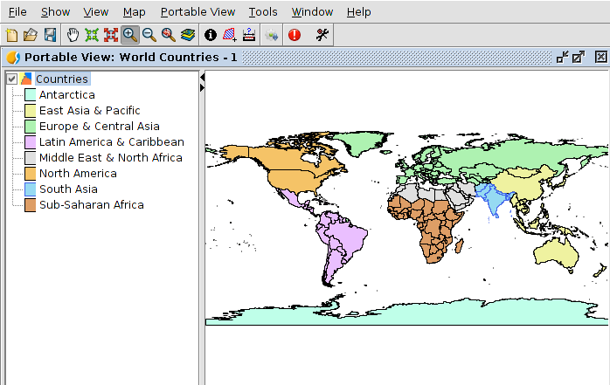
Specific tools are available from the menu “Vista portable“.
Menú
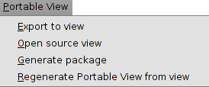
The navigation tools available are:
Icon | Tool | Shortcut | Description
 | Pan |  | Change the view framing dragging the display area in all directions with the mouse. You should keep the primary mouse button (usually the left button) pressed and move it to the desired direction.
 | Fixed zoom in |  | Allows you to zoom in on the center of your data frame.
 | Fixed zoom out |  | Allows you to zoom out on the center of your data frame.
 | Zoom in |  | Allows you to zoom in to a geographic window by clicking a point or dragging a box.
 | Zoom out |  | Allow you to zoom out from a geographic window by clicking a point or dragging a box.
 | Back |  | Allows you to go back to the previous extent.
 | Full extent |  | Allows you to zoom to the full extent of your map.
You can zoom in or zoom out using the mouse scroll wheel.
In this case the expand is made using as a focus point the center of the view. With the mouse scroll wheel pressed and moving it the command is executed.
The available query tools are:
Icon | Herramienta | Tecla rápida | Descripción
 | Identify |  | Identify the geographic feature on which you click.
 | Area |  | Measure perimeters and areas.  You can draw a polygon on the map and get its area and perimeter.
 | Distance |  | Measure distances on the map.  You can draw lines on the map and get its length.

78.4. Export a View
Lets you create a View from a portable view.
This is availble from the menu “Vista portable/Exportar a Vista“.
A new window will open requesting the folder to save the file that make up the view.
Automatically a new View containing the portable view layers and its display characteristics is generated once the files are saved

78.5. Open the Source View
Lets you open the View from which the portable view was generated.
Available from the menu “Vista portable/Abrir la Vista origen“. (portable view/Open the source view)

78.6. Generate a distributable package
You can generate a distributable package from a portable view. This package contains both the portable view configuration as the data files used. A portable view distributable package can be installed via the complement manager view “Administrador de complementos”.
Available from the menu “Vista portable/Generar paquete distribuible“.
First a window requesting the file pathname will open. After selecting a folder click on select target directory “Seleccionar directorio de destino”.
A warning message telling you that the file has been created will open. The created file is stored in the selected folder being a gvspkg file extension.

78.7. Regenerate portable view from View
You can access the “Crear Vista portable” window and modify the characteristics of the portable view.
Available from the menu “Vista portable/Regenerar Vista portable desde Vista“.

78.8. Portable view catalog
Open the portable view available list and open one of them.
Access from the “Gestor de proyecto/Vista portable”, clicking on “Nuevo” button.
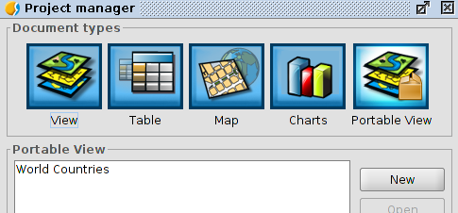
A window displaying the available portable view list is open. Selecting one of them you can see its characteristics:
Clicking on open portable view “Abrir Vista portable” and the selected portable view will be created.

