Dyschromatopsia

81.1. Introduction
Extension created for users that have problems in the perceptions of colors.
It allows to transform, from a view with a predefined number of layers and legends, these legends (or create new ones) in others that can be interpreted by users that have some difficulties related with color vision or dyschromatopsia.
The “Tool: Dyschromatopsia adaption” extension is installed using the complement manager “Administrador de complementos”.

81.2. Functionality
The interface is as follows:
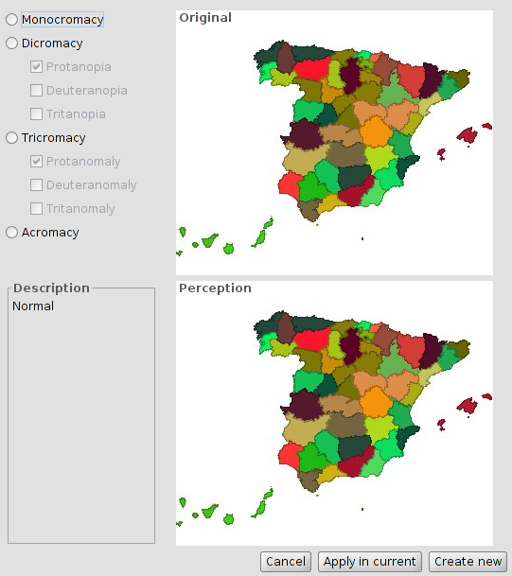
- You can select the type of anomaly:
- Monocromático (Monochrome): Lack of two of the primary colors sensitivity.
- Dicromático (Dichromacy)
  - Protanopia. Lack of red color sensitivity.
  - Deuteranopia. Lack of green color sensitivity.
  - Tritanopia: Lack of blue color sensitivity.
- Tricromático anómalo (Anomalous trichromacy)
  - Protanomaly: Anomaly in the red retinal receptors (closer to green receptor response) affecting discrimination between red and yellow.
  - Deuteranomaly: Anomaly in the green retinal receptors that affects softly the discrimination between red and green.
  - Tritanomaly: A rare hereditary vision disorder which affects discrimination between blue and yellow.
- Acromático (Achromatic): Lack of color perception.
- It displays, depending on the case, perception with respect to the original.
- Change the View layers legend.
- Aplicar en actual (Apply on current view legend): Modify the current legends.
- Crear nueva (Create new): Create a new View with the original layers and the modified legends.

