Customize

83.1. Introduction
Users may want to customize their own preferences when working with gvSIG by creating what the application calls a distribution. The plugin “Customize” allows to tailor these distributions.
Click “Tools” on the main menu and then click “Customize” to enable gvSIG customization.
Menu
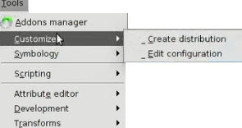
This plugin includes a wide range of capabilities such as:
- Specifying the coordinate system
- Moving between language version as needed
- Defining the OGC services frequently used
- Installing other plugins
- Adding different libraries of symbols
- Giving a name to the distribution
- Changing the splash images that appears when gvSIG is launching
The “Customize” plugin is available to the users on Linux. Using Linux, it is possible to create gvSIG distributions for all the different operating systems.

83.2. Configuring the distribution
The way to configure the new distribution preferences is to use the “Customize plugin configuration” dialog box.
Click on the main menu “Tools”, and then click “Customize> Customize plugin configuration“ to open the dialog box.
The screen capture below shows the “Customize plugin configuration” dialog box with the tabs to set the specific options.
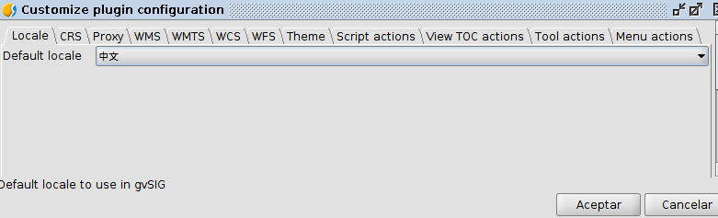
Here is a brief description for of each tab in this dialog box:
- Locale. Used to determine the default display language of the new distribution
- CRS. Allows to define the default projection
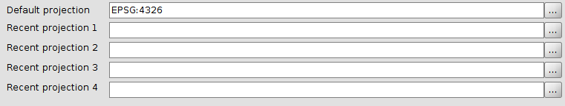
- Proxy: Allows to specify a Proxy that can be used by default.
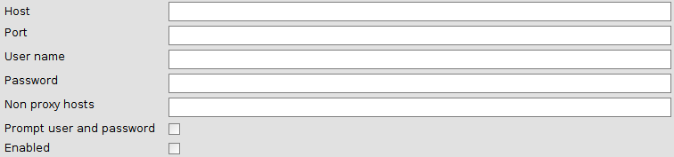
- WMS. Used to add and remove WMS layers from the list that is included under the WMS tab. Click “+” to add a new layer and then specify the URL. Check the remove checkbox and then click “X” to delete the existing layer.
- WMTS. Used to add and remove WMTS layers from the list that is included under the WMS tab. Click “+” to add a new layer and then specify the URL. Check the remove checkbox and then click “X” to delete the existing layer.
- WCS. Used to add and remove WCS layers from the list that is included under the WMS tab. Click “+” to add a new layer and then specify the URL. Check the remove checkbox and then click “X” to delete the existing layer.
- WFTS. Used to add and remove WFTS layers from the list that is included under the WMS tab. Click “+” to add a new layer and then specify the URL. Check the remove checkbox and then click “X” to delete the existing layer.
- Theme. Provides options for modifying the application name, the icon image, the splash image that appears when launching gvSIG, the application position, the font size and color, and the application background.
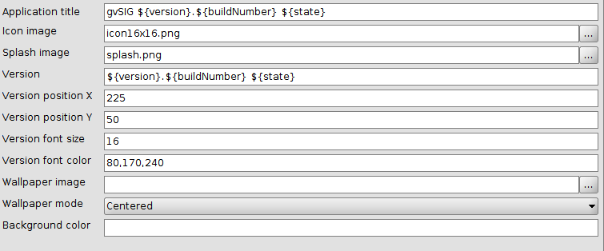
- Scripts actions. Used to create a tool that runs an action. This tool will have different parameters referred to an existing tool, button or menu. The scripting parameters can be set using the wizard window that is opened when selecting “scripts actions” tab.

83.3. Create a distribution
When we change the configuration of a new distribution we can then create it, selecting the default options. The way to generate it is to use the “Create distribution” dialog box.
Click “Tools” on the main menu, and then click “Customize>Create distribution” to open this dialog box. See the figure below that shows this dialog box
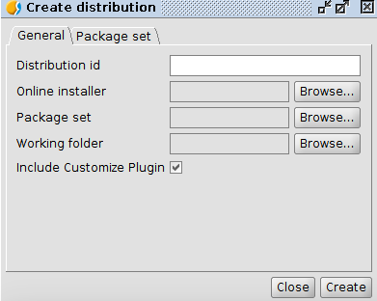
When creating a distribution, it is recommended to fill the different fields in the following order:
- Working Folder. Choose the folder to save the file.
- Distribution id. Add a name that identifies the distribution
- Online Installer. Add the online installer that will be used to create the distribution. Different installers are available for different gvSIG versions, with additional plugins for both Windows and Linux operating systems. Click on this link to download them: http://downloads.gvsig.org/download/gvsig-desktop/dists/
- Package set. Select the file that stores all the plugins. This files’ extension is .gvspks. Click the link specified above to download the available package sets for both Windows and Linux operating systems.

