Catalog of favorites

84.1. Introduction
One of the tools that users frequently employ while browsing the web is the so-called bookmarks or favorites. This tool enable users to open previously visited web pages more rapidly by reaching them from the Favorites folder.
The Catalog of favorites tool in gvSIG follows the same methodology applied to geographic information. In this way, data used frequently are easily available in the Catalog and users can add them to View very quickly.
The procedure is very easy. Users can save and classify any layer in the catalog of favorites and add it to the Views afterward.
In the present version, this tool works only for vector files.
These tools are available from the Menu: Tools/Catalogue and from the respective button bar.
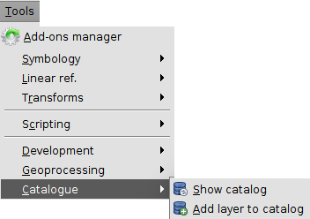

84.2. Show Catalog
It shows the window with the list of favorites.
This tool is available from the Menu: Tools/Catalog/Show Catalog
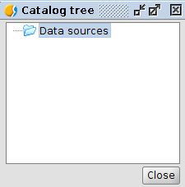
This window shows the list of layers stored in the Catalog of Favorites. (The window appears empty when it is used for the first time).
A mouse right-click over the Catalog Tree window will show a contextual menu with different options.
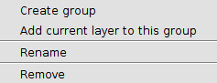
- Create group: Creates a group or folder (or sub-group or sub-folder in the case a group is previously selected)
- Add current layer to this group: Adds the active layer to the selected group. In the case there is no group selected, it adds the layer to the root or Data Sources group.
- Rename: Renames a group or layer
- Remove: Removes a layer or group. If a group is removed, it also removes sub-groups and all the layers it contains.

84.3. Add a layer to the Catalog
It shows the window with the list of Favorites.
This tool is available from the Menu: Tools/Catalog/Add layer to catalog; from the contextual Menu of the Table of Content (TOC) Add to Catalog and from the contextual menu of the window Catalog Tree.
The tool Add Layer from the contextual menu of TOC to the Catalog:
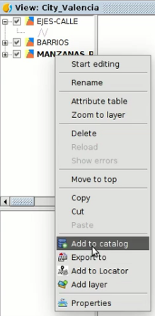
And from the contextual Menu of the window Catalog Tree:
In this case, the main difference is that it adds the active layer in the folder or sub-folder previously selected in the window Catalog Tree.

