

USER MANUAL
gvsig 2.3

Index
InstalLATION 16
1.1. Introduction 16
1.2. Installation step by step 16
Addons Manager 24
2.1. Interface and behaviour 24
2.2. Introduction 24
INTRODUCTION 26
3.1. What can we do with gvSIG Desktop? 26
finding out about gvSIG 27
4.1. Interface 27
4.2. Types of documents 27
4.3. Vocabulary used in gvSIG? 28
PROJECTs 30
5.1. Project tools 30
5.2. Save project changes 30
5.3. Change resource folder 31
PROJECT MANAGER 33
6.1. Interface 33
preferencES 35
7.1. Introduction 35
7.2. Settings 36
VIEW DOCUMENT 44
8.1. Create a view 44
8.2. View properties 44
COORDINATE SYSTEM 47
9.1. Change the View Coordinate System 47
9.2. Define a User’s CRS. 48
9.3. Reprojecting a layer 52
9.4. Reprojecting a layer with PRJ file 52
VIEW InterfaCE 53
10.1. View Interface 53
adding layers 54
11.1. Introduction 54
11.2. Adding a file 55
11.3. Adding a WMS 59
11.4. Adding a WMTS 64
11.5. Adding a WFS 68
11.6. Adding a WCS 73
11.7. Addin a OSM service 76
11.8. Adding web maps (Google Maps / Bing Maps) 77
11.9. Adding a spatial database (GeoDB) 78
11.10. Adding PostGIS Raster 80
11.11. Add event layer 82
11.12. Add OGR layer 84
Create a new layer 86
12.1. New Layer 86
12.2. Layer export 87
12.3. Export to annotations 96
supported Formats 99
13.1. File 99
13.2. Remote services 101
13.3. Database 101
13.4. OGR 102
Table of Contents (TOC). common operations with layers 103
14.1. Introduction 103
14.2. Enable / disable layers 103
14.3. Display / hide layers 103
14.4. Display / hide legends 104
14.5. Change the order of layers in the TOC 104
14.6. Layer context menu 104
14.7. Remove layers 104
14.8. Copy / Cut / Paste layers 105
14.9. Groups of layers 105
14.10. Rename a layer 105
Layer properties 107
15.1. Introduction 107
Vector layer properties 108
16.1. General 108
16.2. Hyperlink 108
16.3. Metadata 109
16.4. 3D 109
vector symbology 110
17.1. Introduction 110
17.2. Unique symbol 111
17.3. Categories. Unique values 111
17.4. Categories. Expressions 113
17.5. Quantities. Dot density 114
17.6. Quantities. Intervals 115
17.7. Quantities. Graduated symbols 117
17.8. Quantities. Proportional symbols 118
17.9. Multiple attributes. Bars 118
17.10. Multiple attributes. Pies 120
17.11. Multiple attributes. Quantity by category 121
17.12. Multiple attributes. Join Table 123
17.13. Multiple attributes. Complex symbol 123
labelling 125
18.1. Introduction 125
18.2. Basic labelling. Label attributes defined by table. 125
18.3. Advanced labelling. Label features in the same way. 126
18.4. Advanced labels. Label only when feature is selected. 127
18.5. Advanced labelling. Define classes of features and label each differently. 127
18.6. Advanced labelling. Define classes of features and label each differently. Labelling by scale. 128
18.7. Advanced labelling . Opciones comunes. 128
Raster layer properties 137
19.1. Information 137
19.2. General 137
19.3. Bands 138
19.4. Transparency 139
19.5. Enhance 140
19.6. 3D 141
Edition and symbol management 143
20.1. Symbol browser 143
20.2. Editor. Simple marker symbol 145
20.3. Editor. Simple marker symbol 146
20.4. Editor. Simple line symbol 147
20.5. Editor. Picture line symbol 149
20.6. Editor. Simple fill symbol 150
20.7. Editor. Picture fill symbol 150
20.8. Editor. Marker fill symbol 151
symbol libraries 153
21.1. AIGA 153
21.2. Collective Mapping 153
21.3. Colours 154
21.4. Commerce 154
21.5. Crime Mapping Symbology (CMS) 155
21.6. Emergency 156
21.7. Forestry 156
21.8. G-Maps 157
21.9. Geology 157
21.10. gvSIG Basic 158
21.11. Japanese 158
21.12. Military-APP6 159
21.13. Navigational 159
21.14. Numbers 160
21.15. OCHA-Humanitarian 160
21.16. OSM 161
21.17. POI Cities 161
21.18. Weather 162
Create symbol libraries 163
22.1. Import picture marker symbols 163
22.2. Create package symbols 164
Navigation tools 167
23.1. Introduction 167
168
23.2. Zoom Manager 168
23.3. Center View to point 169
23.4. Locate by attribute 169
23.5. Locator map 170
23.6. Finding by Gazetteer 172
Consulting tools 175
24.1. Introduction 175
24.2. Information 175
24.3. Query area 176
24.4. Query distance 176
24.5. Hyperlink 177
Selection Tools 178
25.1. Introduction 178
25.2. Select by buffer 179
25.3. Select by layer 180
25.4. Select by attributes 181
Graphic editing tools 183
26.1. Introduction 183
26.2. Start / Finish editing 184
26.3. Command console 184
26.4. Flatness 185
Tools for modifying features 186
27.1. Introduction 186
27.2. Symmetry 187
27.3. Internal polygon 188
27.4. Explode geometry 188
27.5. Move geometry 188
27.6 Rotate geometry 189
27.7. Duplicate geometry 189
27.8. Split geometry 190
27.9. Split line in one point 190
27.10. Scale geometry 190
27.11. Simplify geometry 191
27.12. Join geometries 192
27.13. Insert autopolygon 192
27.14. Stretch geometry 192
27.15. Extend line to object 192
27.16. Split line with an object 193
27.17. Smooth line 193
27.18. Edit vertex 194
27.19. Converting to polyline 194
27.20. Reverse direction 194
27.21. Paralell Geometry 195
27.22. Copy features 195
27.23. Paste features 195
27.24. Delete features 195
TOOLS for inserting FEATURES 196
28.1. Introduction 196
28.2. Insert point 197
28.3. Insertar multipoint 197
28.4. Insert line 197
28.5. Insert arch 198
28.6. Insert circle (centre and radius) 198
28.7. Insert circumference (centre and radius) 198
28.8. Insert circle (three points) 199
28.9. Insert circumference (three points) 199
28.10. Insert ellipse 199
28.11. Insert filled ellipse 200
28.12. Insert polygon 200
28.13. Insert polyline 201
28.14. Insert filled regular polygon 201
28.15. Insert regular polygon 201
28.16. Insert filled rectangle 202
28.17. Insert rectangle 202
28.18. Insert filled spline curve 202
28.19. Insert spline curve 203
28.20. Insert rectangular matrix 203
28.21. Insert polar matrix 203
drawing supporting tools 205
29.1. Snapping 205
29.2. Grid 206
29.1. Snapping 206
29.2. Grid 208
Editing tools 209
30.1. Introduction 209
30.2. Undo/Redo history 209
attributes editor 212
31.1. Introduction 212
DERIVED GEOMETRIES 213
32.1. Introduction 213
RASTER TOOLS 216
33.1. Introduction 216
raster layer 221
34.1. Select raster layer 221
34.2. Histogram 221
34.3. Colour table 225
34.4. Information by point 228
34.5. Area of interest 229
34.6. Generate overviews 230
34.7. Analysis view 230
MULTISPECTRAL RASTER 232
35.1. Principal components 232
35.2. Tasseled cap 234
Enhancement 235
36.1. RGB Filters 235
36.2. Radiometric enhancements 242
36.3. Mask by region of interest 244
Geographic Transformations 246
37.1. Reproject layer 246
37.2.Geolocalization 247
37.3. Asign projection 248
37.4. Georeferencing 248
Export to raster 256
38.1.Save View to georeferenced raster 256
38.2. Save as 257
38.3. Clipping 258
38.4. Change data type 260
38.5. Export View to image 261
Export to raster 262
38.1.Save View to georeferenced raster 262
38.2. Save as 263
38.3. Clipping 264
38.4. Change data type 266
38.5. Export View to image 267
Geoprocessing 268
39.1. Introduction 268
toolbox 271
40.1. Introduction 271
gvSIG Geoprocesses. Vector layers 277
41.1. Group by a field 277
41.2. Buffer 278
41.3. Lateral buffer 279
41.4. Convex Hull 280
41.5. Clip 280
41.6. Split lines 281
41.7. X and Y shift 282
41.8. Difference 283
41.9. Dissolve 284
41.10. Fuse spatially 284
41.11. Intersection 285
41.12. Merge 286
41.13. Reproject 287
41.14. Spatial Join 288
41.15. Union 289
gvSIG Geoprocesses. Raster layers 291
42.1. Change data type 291
42.2. Mask 291
gvSIG Geoprocesses. Multispectral raster 292
43.1. Principal components 292
43.2. Tasseled cap 292
gvSIG tools. Raster layers 294
44.1. Set projection 294
44.2. Change data type 294
44.3. Export 294
44.4. Filters 294
44.5. Mask by region of interest 294
44.6. Radiometric enhancement 294
44.7. Clip 294
44.8. Reproject 294
gvSIG herramientas. Ráster multiespectral 295
45.1. Principal components 295
45.2. Tasseled cap 295
sextante 296
46.1. Introduction 296
modeler 298
47.1. Introduction 298
47.2. Definition of inputs 299
47.3. Definition of the workflow 300
47.4. Editing the model in the canvas 302
47.5. Saving and loading models 302
Batch processing 304
48.1. Introduction 304
48.2. Parameters table 304
48.3. Características de las salidas ráster 304
48.4. Ejecutar el proceso por lotes 304
48.5. Procesos por lotes con capas ya cargadas 304
command line 306
49.1. Introduction 306
49.2. Getting information about data 306
49.3. Getting information about algorithms 307
49.4. Running an algorithm 308
49.5. Running a model 310
49.6. Managing layers from the command-line interface 310
49.7. Adjusting output raster characteristics 310
HISTOry 312
50.1. Introduction 312
CATALOG 313
WEB MAP CONTEXT (WMC) 314
Google Street view 315
53.1. Introduction 315
53.2. Configuration of the Google Street View tool 315
3D Plugin 317
54.1 Introduction 317
54.2 3D View 318
3D TOOLS 319
55.1 Spherical 3D view 319
55.2 Flat 3D view 320
55.3 Synchronize view 321
55.4 Synchronize viewport 321
55.5 Full screen mode 321
3D Properties 322
56.1 General 3D preferences 322
56.2 3D View properties 322
56.3 3D Layer properties 323
56.3.2. 3D Raster layer properties 329
3D ANIMATION 332
57.1. Introduction 332
57.2. Animation Manager 332
Document table 335
58.1. Table’s properties 335
TABLE’S INTERFACE 337
59.1. Table’s interface 337
ADD A TABLE 338
60.1. Introduction 338
60.2. Add a file 338
60.3. Add a database 339
60.4. Add a CSV file 340
Table tools 343
61.1. Introduction 343
61.2. Join 344
61.3. Link 347
61.4. Find and select duplicates 348
61.5. Statistics 348
Selection tools 350
62.1. Introduction 350
62.2. Selection by attributes 351
Table edition 352
63.1. Introduction 352
63.2. Add column 352
To add a new column to the table. 352
63.3. Column manager 353
63.4. Field calculator 353
Export table 356
64.1. Export table 356
map 358
65.1. Introduction 358
65.2. Creating a Map 358
65.3. Map properties 359
65.4. Preparing a page 361
Map interface 363
66.1. Map interface 363
cartographic elements 364
67.1. Tools for the insertion of cartographic elements 364
67.2. Insert a View 365
67.3. Insert a Legend 368
67.4. Insert a scale 369
67.5. Insert North symbol 370
67.6. Insert locator 370
67.7. Insert a box 371
Graphic elements 372
68.1. Tools for the insertion of graphic elements 372
68.2. Insert chart 373
68.3. Insert Circle 374
68.4. Insert image 374
68.5. Insert Line 374
68.6. Insert point 375
68.7. Insert polygon 375
68.8. Insert polyline 375
68.9. Insert rectangle 375
68.10. Insert text 375
Navigation tools 377
69.1. Map navigation tools 377
69.2. View navigation tools 378
DESIGN TOOLS 380
70.1. Design tools 380
70.2.Graphic line 381
70.3.To Align 382
70.4. Size and position 382
EDIT TOOLS 384
71.1. Edit tools 384
EXPORT AND PRINT TOOLS 385
72.1. Export and print tools 385
Map Template 386
73.1. Map template 386
Document CHARTS 387
74.1. Introduction 387
74.2. Create Charts 388
74.3. Create plot 388
74.4. Edit plots. Properties. 392
Publishing 396
75.1. Introduction 396
75.2. Export View to Mapfile 396
75.3. Manual edition of specific attributes 398
75.4. Upload to server 400
ORACLE SPATIAL/LOCATOR 403
76.1. Introduction 403
76.2. Metadata 403
76.3. Data type 403
76.4. Coodinate systems 403
76.5. Reading geometries 403
76.6. Dumping gvSIG layer to Oracle 404
Sísmica 405
PORTABLE VIEW 406
78.1. Introduction 406
78.2. Create a Portable View 406
78.3. Interface 408
78.4. Export a View 410
78.5. Open the Source View 410
78.6. Generate a distributable package 410
78.7. Regenerate portable view from View 411
78.8. Portable view catalog 411
Map sheets. Installation 412
Map sheets document 413
Dyschromatopsia 414
81.1. Introduction 414
81.2. Functionality 414
Linear reference system (LRS) 416
Customize 417
83.2. Configuring the distribution 417
83.3. Create a distribution 419
Catalog of favorites 421

InstalLATION

1.1. Introduction
gvSIG Desktop (gvSIG henceforth) set up it is very simple. There are available (installable) binary to gvSIG for:
- Linux 32 bits
- Linux 64 bits
- Windows 32 bits
- Windows 64 bits
- Max OS X (only portable version)
There are portable versions of gvSIG for each of these options. The portable versions don't require setting up, just download and unzip them to run gvSIG and begin to use it.
You can find binary and portable version in this link:
http://www.gvSIG.com/en/products/gvSIG-desktop/downloads

1.2. Installation step by step
The installation process is similar in Windows as well as in Linux.
The only additional precaution in Linux is that the downloaded file has executing permissions. In Ubuntu, we would have to select it, then click on the secondary button of the mouse and open its “Properties”. We would mark the option to permit to run the file as an application.
Step 1: Selecting installation language
When running installation file, a window appears, where we can select installation language. We select our language and we press “OK”.
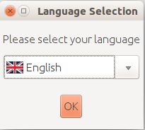
Step 2: License agreement
When the installation starts, a welcome message appears. We press “Next”.
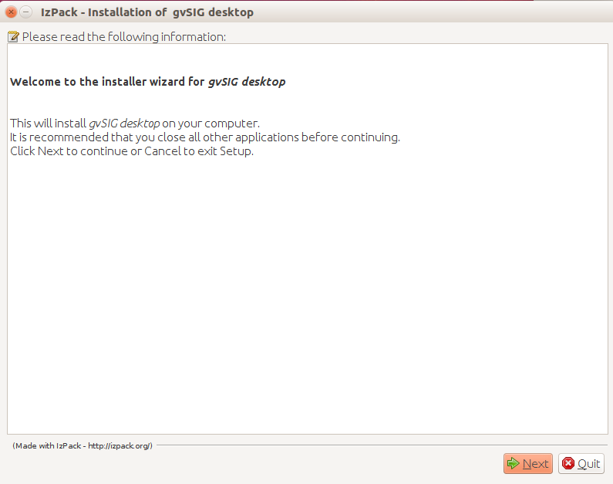
The gvSIG license is shown (GNU/GPL v.3). We mark “I accept the therms of this license agreement” option.
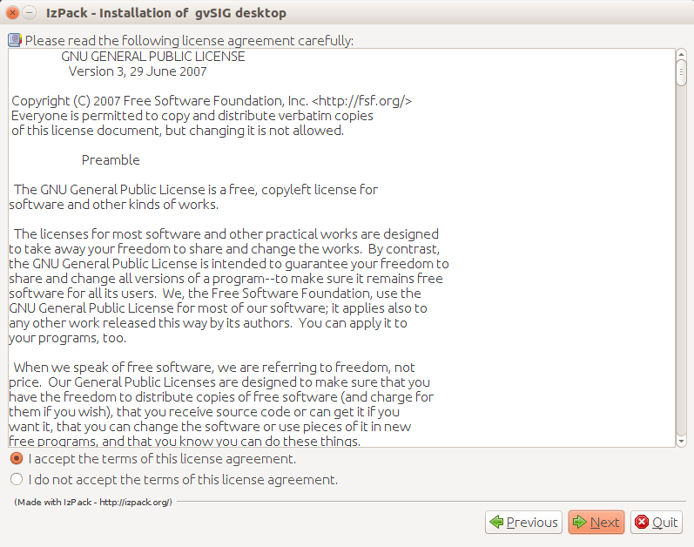
Step 3: Select location
Now we have to select the folder where gvSIG will be installed. By default it's created in the user folder. Pressing “Browse...” we can change the location.
Once it's confirmed, we press “Next”.
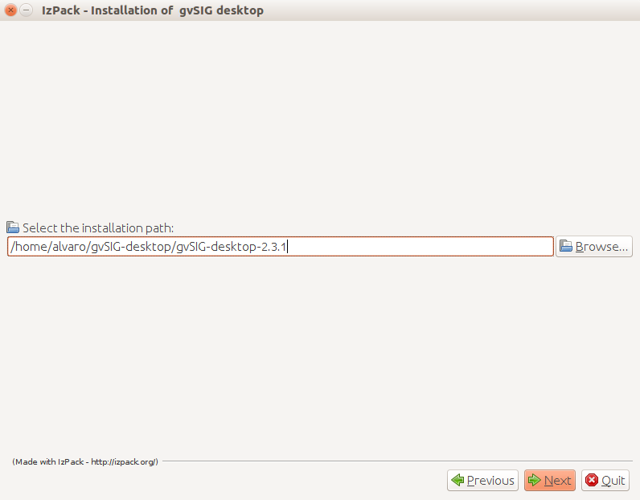
A message to confirm the creation of the folder will appear. We press “Accept” button.
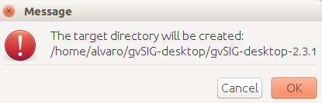
Step 4: Starting installation
A window with a progress bar will indicate that gvSIG is being installed.
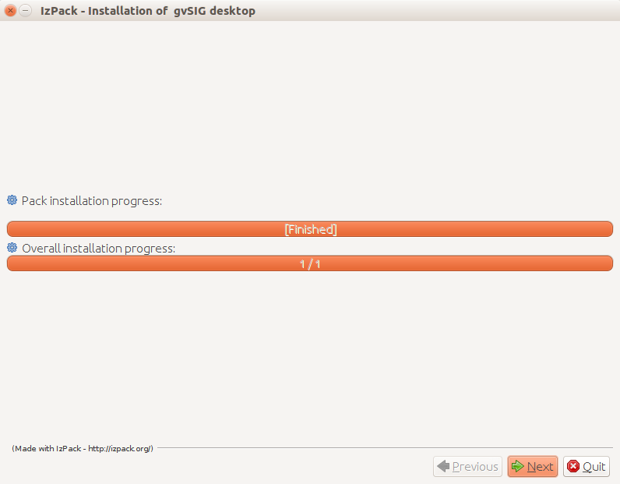
Once it finishes we press “Next”.
A new window informs us that the basic gvSIG has been installed. At the next steps we will be able to customize the gvSIG installation, installing the typical add-ons or adding other ones.
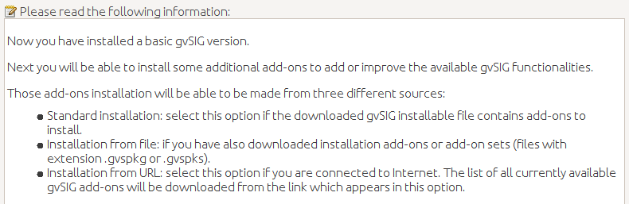

Step 5: Customizing the installation
A first window indicates that the packages (plugins) that are available in that gvSIG Desktop version are being extracted
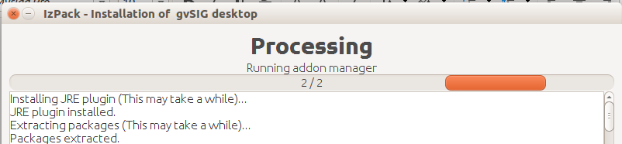
A new window will indicate that we can install additional add-ons in gvSIG. We select the add-ons installation source and then we press “Next”.
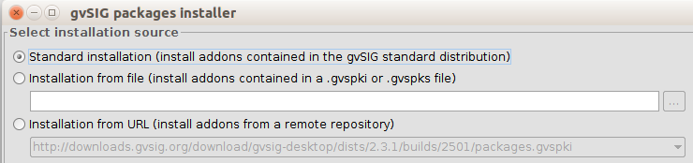
The add-ons can have three different sources:
- The installation binary. The installation file that we have downloaded contains a lot of plugins that aren't installed by default, but they are available to be installed. It allows to customize gvSIG without internet connection.
- Installation from file. We can have a file with a set of plugins to install in gvSIG.
- From URL. Through an Internet connection we can access to every plugin that is available at the gvSIG server and install whatever we need. The only difference between this option an the first one is that additional plugins or updates of the existing ones can be released after a final gvSIG version.
It's not necessary to install any complement in that moment. The Add-ons manager is always available in gvSIG and we can access to it from the “Tools” menu.
The next window shows two options:
- Typical installation. It installs the add-ons by default. It doesn't allow to add any additional plugin during installation process.
- Advanced installation. It allows to access to the “Add-ons manager” and select the plugins that we want to add to the typical installation (for further information you can see “Add-ons manager” section)
Note: during the installation all functional plugins can be installed but not the symbol libraries because installation has to be finished for it. They can be installed later running the “Add-ons manager” from gvSIG.
Once the add-ons are selected or the “Typical installation” option has been chosen, we will press “Next” button.
Step 7: Finishing installation
A new window informs us about the installing process, indicating the number of add-ons (packages) that are being installed. Once the packages installation finishes we press “Finish”.
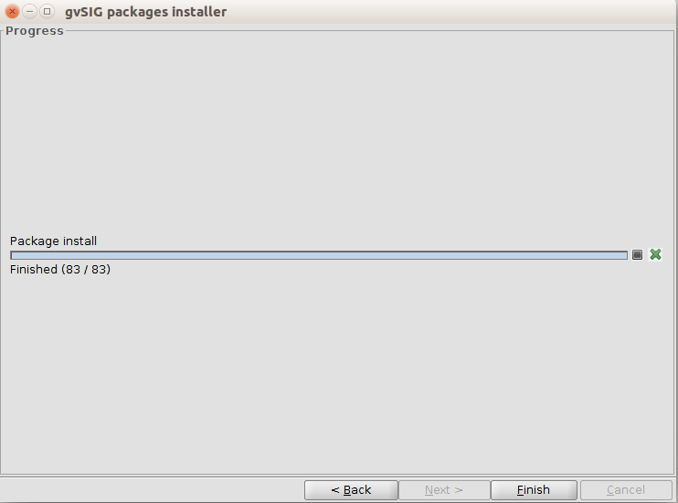
The information window of the installation process will show the list of installed plugins. We press “Nest” button.
The last window will show installation process finishing, showing (check boxes) with options to create direct accesses.
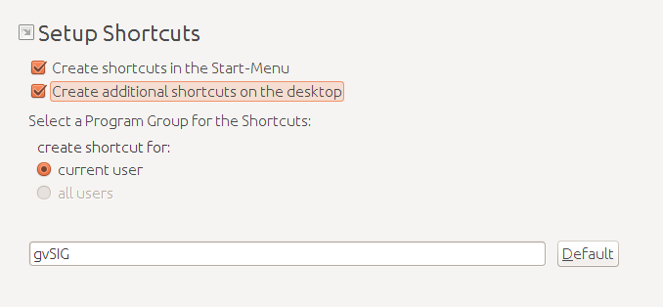
We press “Next” and a message about the successful end of the installation will be shown. We will finish the wizard finally.
We can start to work with gvSIG Desktop now.

Addons Manager

2.1. Interface and behaviour
The Addons Manager is a function which allowsus to personalize gvSIG installing new addons, functional or otherwise (symbols libraries)
We can execute it from “Tools>Addons Manager”. It is accesible during the installation progress.
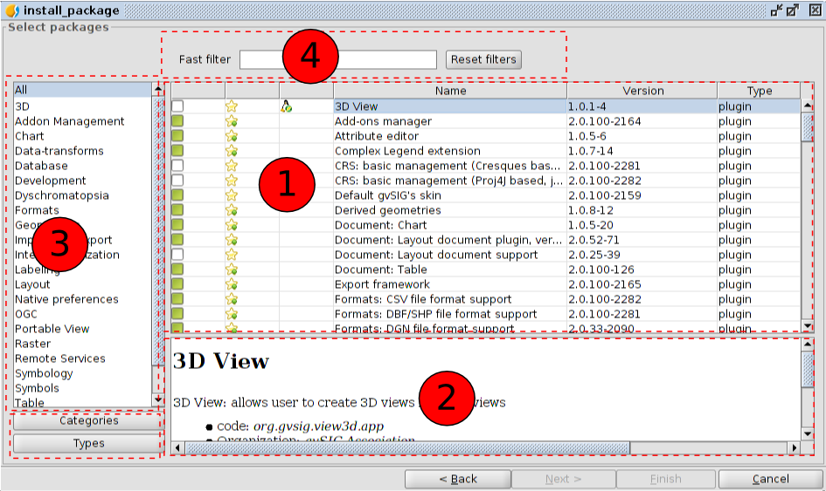
The “Add-on Manager” interface is divided into four parts:
- List of available add-ons. The plug-in name, version, and type are indicated. The verifcation check boxes allow to distiguish between available (white) or already installed add-ons (green).
- Information area concerning the selected plug-in (1)
- Area that shows the “Categories” and “Types” in which the plug-in is classified.
When we choose a category or type from the list, a filter that runs on “1” shows only the plug-ins related to this category or type.
- Fast filter. Enables a filter from a text string entered by the user.

2.2. Introduction
In the add-ons list we can see several icons that we should know.

The plug-in is only valid for Linux 32 bits.

The plug-in is only valid for Linux 64 bits.
The plug-in is official
The plug -in is official and recommended for the proper functioning of gvSIG (included in the typical installation )

INTRODUCTION
gvSIG Desktop (gvSIG from this point forward) is a Geographical Information System in free software, that is, a computer application aimed to represent, edit, analyze and manage information from the point of view of spatial relations.
The gvSIG licence is GNU/GPL v.3 which gives the user the rights of free use, study, improvement and distribution.
The gvSIG firts version was born in 2004 within a project that consisted in a full migration of the information technology systems of the Generalitat Valenciana in Spain (Valencian Regional Government). Since 2010, the project is managed by gvSIG Association.
Developed under the values of collaboration and sharing knowledge, gvSIG has evolved very quickly and in a few years it has become one of the most used applications to manage the geographical information.
Welcome to gvSIG!

3.1. What can we do with gvSIG Desktop?
gvSIG is a sophisticated Geographical Information System and, as such, it is used to do every kind of work related to the territory management.
If you are curious about the different gvSIG uses, don't hesitate to visit the website for cases of use.
http://outreach.gvSIG.org/case-studies
The most common tasks to do with gvSIG are:
- To represent data spatially. gvSIG allows you to open all format types (vector and raster; archives, databases and remote services) and represent them spatially in the different coordinate systems. You can apply all kind of legends and labels to represent your data.
- To design maps to print, gvSIG has tools to easily design maps, allowing you to add all type of cartographic elements and offering different options to print and export your new map.
- Edition. It offers a huge range of tools to edit either cartographic data or alphanumeric.
- Analysis. gvSIG has tools to facilitate the analysis of the existent data, either cartographic or alphanumeric data. More than 300 geoporcessing tools ara avaliable in gvSIG.
- To customize gvSIG. Apart from having the option to extend the funcionality of gvSIG through Java, it has a scripting module using Python

finding out about gvSIG
- gvSIG allows to work with different types of documents. These documents allow to work with data from different points of view: data as a map, as a alphanumeric table, as graphics... Each document has a serie of menus and buttons.
- When we save a session or project in gvSIG, this is saved in a file with a “.gvsproj” extension.

4.1. Interface
- Let's see the main components of the gvSIG interface.
- 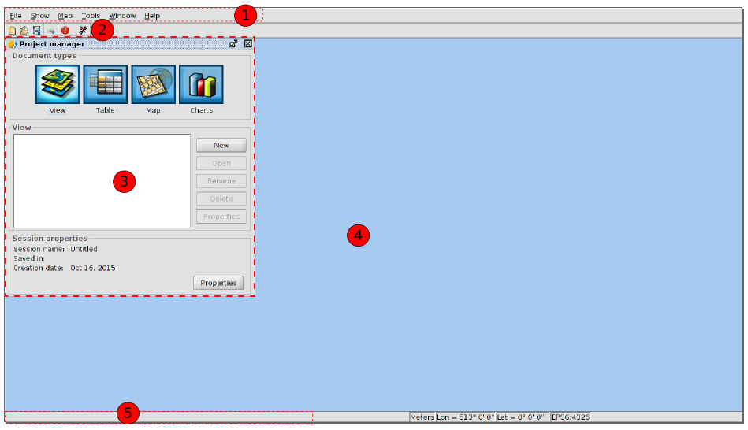
- Menu bar.
- Buttons bar
- Project manager. It allows to manage all the documents which make a project.
- Work area. In this space we will be able to have the different project documents opened and work with them.
- Status bar. The status bar provides information about coordinates, distances, etc. to the user.

4.2. Types of documents
- In gvSIG there are the following documents:
- Views: It allows to work with geographical data. The geographical information is represented as a set of layers.
- Tables: It allows to work with alphanumeric data
- Maps: It allows to design maps with the different cartographic elements which make a map (View, legend, escale...) to print it or export it as a PDF. ca.
- Note: Some of the complements add new documents to gvSIG. An example is the new complement of “Portable view”.

4.3. Vocabulary used in gvSIG?
- It is advisable that the gvSIG user gets familiar with the following terms:
- Project (.gvsproj) | - gvSIG projects allows to save your work sessions in a file with a .gvsproj. extension. A gvSIG project has the origins of the information (file paths, geodatabases, web links) and the work done on this data (legends, labeled, designed maps, graphics...)
- Layer | - The information with a geographical component is shown as layers . Each layer represents a given dataset. Layers can represent the information through collections of points, lines or polygons, continuous surfaces such as Digital Terrain Model or raster images (aerial photos or satellite images).
- Table of contents (TOC) | - It is the area where you can find a list of the layers which are available for a viewing. It allows to change the position of our layers (the order of appearance of the layers in the “View” ties in with the display order), to activate or deactivate the viewing and to show how each layer represents the information using a legend.
- WMS | - Web Mapping Service, is a OGC (Open Geospatial Consortium) standard service for visualization. It represents geographical information in an image format such as PNG, GIF o JPEG.
- WMTS | - Web Map Tiled Service, is a OGC standard service for visualization. It uses tessellation to improve the response speed relative to WMS. It represents the geographical information in an image format. servicio de visualización estándar del OGC.
- WFS | - Web Feature Service, another OGC standard service to access to vector information.
- WCS | - Web Coverage Service, OGC standard service to access to raster data.
- OSM | - Access to OpenStreetMap tile services.
- CRS | - Coordinate Reference System. Also known as Spatial Reference System. Sistema de referencias coordenado o, como se denomina más habitualmente, sistema de referencia.

PROJECTs

5.1. Project tools
gvSIG projects have .gvsproj extension. In "File" menu are the main tools related to the project. We also have the corresponding button bar.
Menu | Button bar
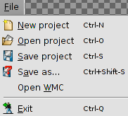
Let see every tools available:
Icon | Tool | Shortcut key | Description
 | New project | Ctrl+N | Create a new project
 | Open project | Ctrl+O | Open an existing project
 | Save project | Ctrl+S | Save the session work.  If you are working with a new project, we will request the name by which the project is saved (with .gvsproj extension).  If you are working with an existing project, update changes the working session.
 | Save as.. | Ctrl+Shift+S | Save the work session on a new file, requesting the name.

5.2. Save project changes
When a work session in gvSIG closes, a window asking if you want to save changes to the project appears.
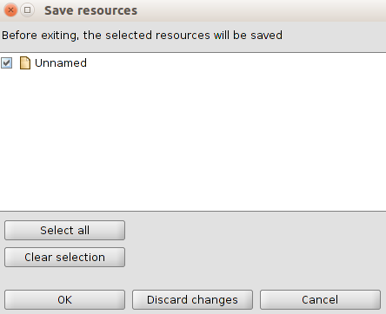
By default gvSIG have all fields activated about changes that have occurred in the project and then can be saved. These changes also make reference to the project, show the layers and tables that were in edit mode before trying to close the project.
The "Select all" and "Clear selection" buttons allow to enable and disable the check boxes.
The available options are:
- Ok: saves the changes of the elements that are activated.
- Discard changes: no changes are saved, regardless of whether or not the elements activated.
- Cancel: closes the window and return to the workshop.

5.3. Change resource folder
gvSIG stores the paths of the various data sources used in the project. It may be happen that some of the routes to a particular data source has been modified since last session. For example, you may have changed the name of a folder where one of the layers used was located.
In this case gvSIG warns that this problem exists.
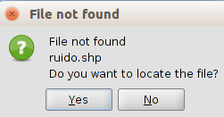
If select "Yes" it will be displayed in a new window that allow you to locate the current location of the file. If "No" is selected, the project is opened, whether to display information on the layer not found.
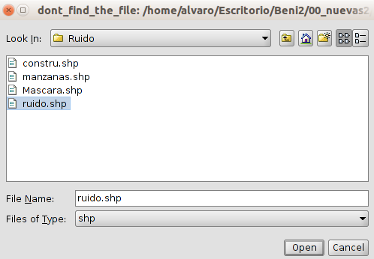
Once selected, the project will open, accessing the layer information from its new location.

PROJECT MANAGER

6.1. Interface
Project manager is the window where all documents that are part of a gvSIG project are organized.
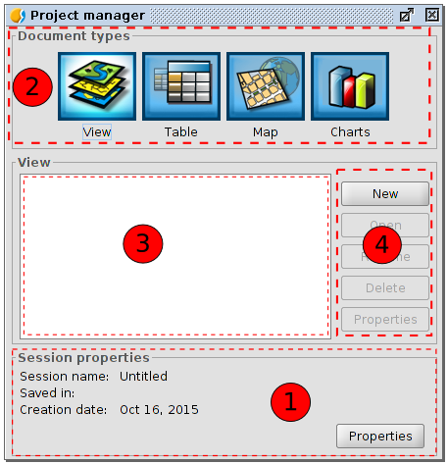
Project manager window consists of four main areas:
- Session properties. It is reported the main session data (name, location and .gvsproj file creation date).
Button "Properties" gives access to a new window where you configure the properties of the session.
In session window "Properties" we can change the color selection. By default gvSIG uses yellow color to indicate that an item is selected.

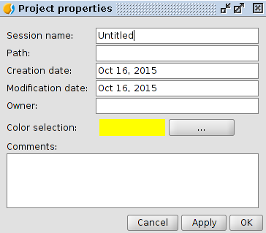
- Type documents. Shows the documents available in gvSIG. The typical installation of gvSIG shows four types of documents (View, Chart, Map and Graphic); some compplements can add new types of documents.
Clicking on the icon of one of these documents, change its lighting, indicating that it is the active document, activating the 3rd and 4th areas for this type of document. By default, when you create a new project, the View document is active.
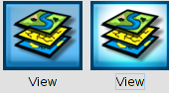
- Document list. Displays the list of existing documents on the selected document type. If, for example, the View document is selected, all views created in the project appears. If no element is created the box stay blank.
- Toolbar. It contains tools to create, open, rename, delete and access the properties of each type of document.

Quick access to project manager: using the "Show/Project manager" menu or the Shortcut "Alt + P" gvSIG shows the project manager in the foreground.

Copy / Paste documents: in the area of the list of documents, taking one of the listed documents selected, with the right button we will show a context menu that lets you cut, copy and paste documents

preferencES

7.1. Introduction
In “Preferences” window you can set certain preferences in gvSIG configuration. These preferences apply to all sessions of gvSIG.
To open the "Preferences" dialog you can use the "Display/Settings" menu or the corresponding button.
Menu | Button
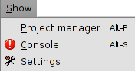
This dialog box includes several sections organized in a tree. Each section corresponds to specific settings.
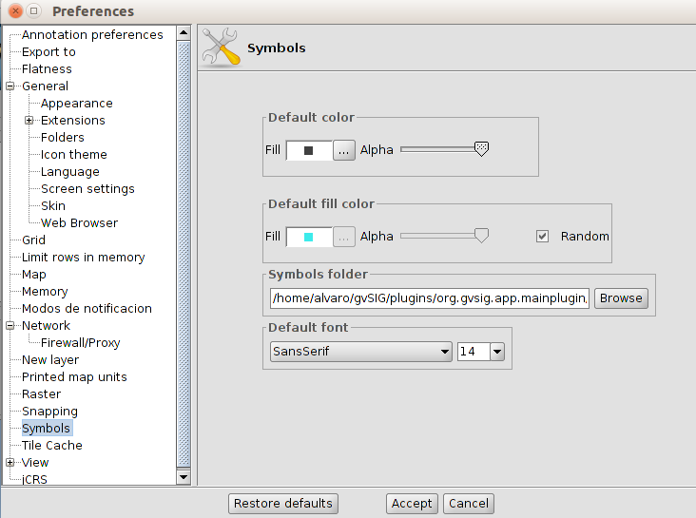

Installation of some supplements can add new setting options.

Restore defaults: eliminate changes that have been configured and restore the default settings of the Preferences window.

7.2. Settings
Here are the different preferences that can be configured in gvSIG
Anotations | It shows an options list that allow you to configure the format of the annotation layers.  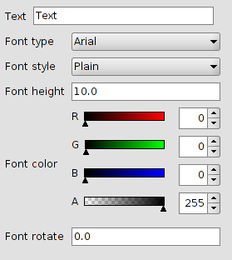
Export to | Sets the formats that appear when launching the "Export to .." from "Layer" menu tool  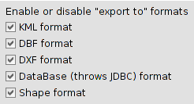
Appearence | It lets you modify the appearence of gvSIG. It requires a restart for changes take effect.  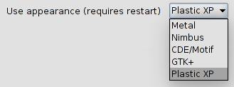
Folders | Sets default folders used to access gvSIG projects, data, map templates and symbol libraries.  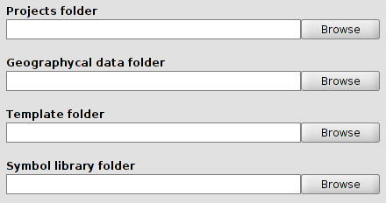
Display settings | Configure display settings resolution.  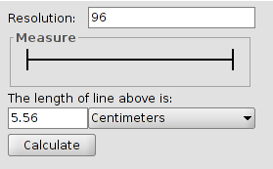  Lets calculate the resolution automatically following steps:  - Measure with a ruler on the line drawn in the "Test Measurement" dialog screen.  - Write in the text box and the measurement obtained and their units.  - Pressing the "Calculate resolution" button, will automatically provide the default resolution in dots per inch.
Add-ons | It provides access to the add-ons list, activate/deactivate and set its priority. It is not recommended to change these settings if you are not an expert on the implications of these changes.
Language | Set the interface language of gvSIG. Restart required for proper application.  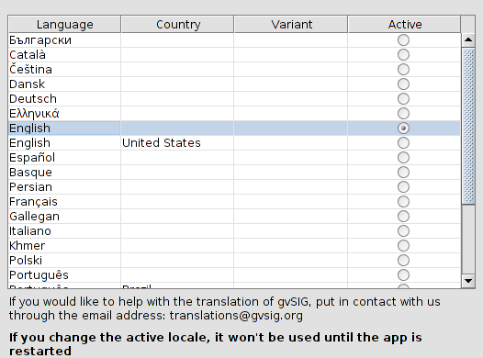
Icon Packs | Although by default only has a set of icons installed, gvSIG is prepared to apply different sets of icons to your interface.
Web Browser | Selects the default web browser will use gvSIG to those tools that require it.  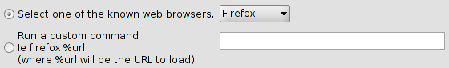
Skin | Although there is only one default skin available, gvSIG is prepared to apply different "skins" that change the look of the application.
Map | It allows you to customize preferences Map work with documents.  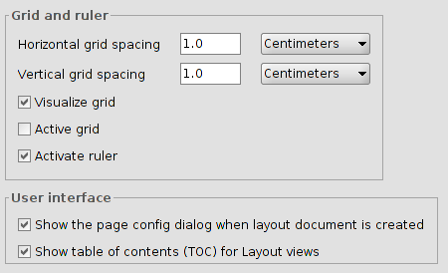
Notification Modes | Set the mode of notification of findings, with a message on the status bar or opening a window with information about the incident.  To restart gvSIG to apply the changes.
New layer | It allows you to dial the formats available for layering. gvSIG default given the option to Shapefile (.shp).
Raster | It lets you modify the default settings for working with raster data.  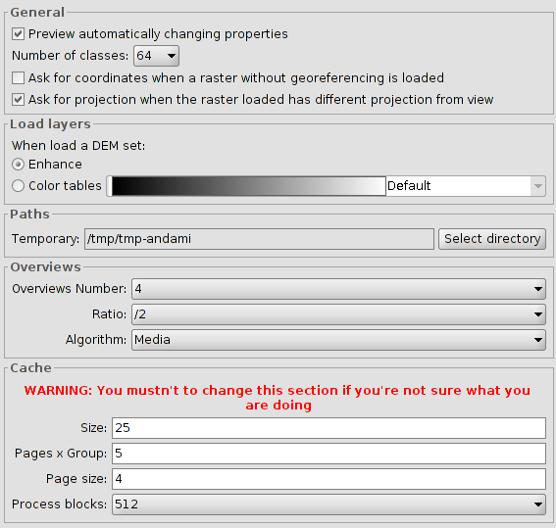
Network | It lets check the status of the Internet connection.  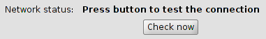
Firewall/Proxy | If you connect to the Internet through a proxy, this section allows you to set the connection parameters used gvSIG.  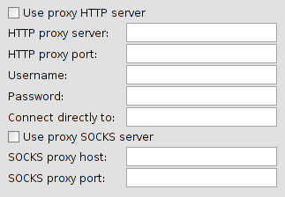
Symbols | Set the symbology that is applied by default when you add a vector layer.  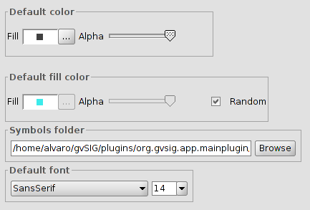
Tile Cache | Sets the cached properties that use gvSIG.  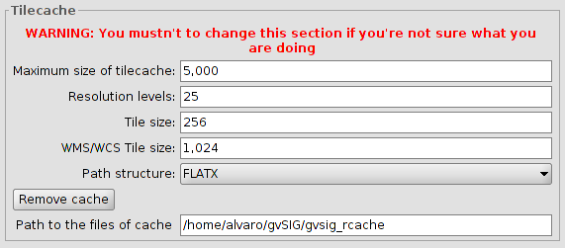
Printed map units | It sets the default measurement units.  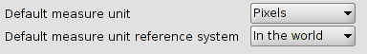
View | Sets the options for working with View documents.  Set the projection system will default to the view, zoom factors, and background color selection and units.  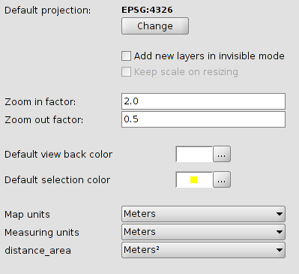
Behavior | It sets the screen refresh.  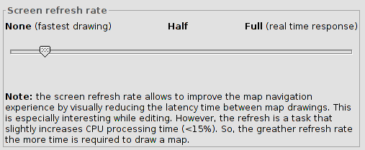
Layer order in TOC | It sets the position where a new layer in the TOC will be placed (and thus the display order).  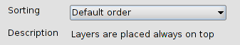
Grid | You set up the options grid.  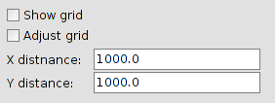
jCRS | Through the "Plugin Manager" you can install different versions of the EPSG data base.  In this section we can select, if you have more than one EPSG database installed base, which we want to work with.  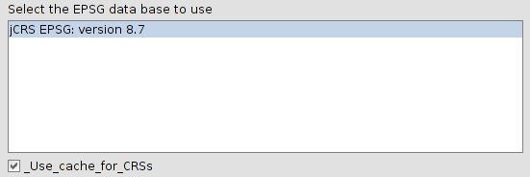

VIEW DOCUMENT

8.1. Create a view
To create a new View in a gvSIG project from the “Project manager”:
- Select the View icon.
- Choose the button “New”, then automatically the View is open.
A new view with the name “Untitled” appears by default. You can change it by clicking the button “Rename” from the project manager (The View that we want to rename should be selected). Then a dialog box appears where we can type the new name:
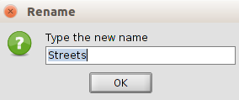

From the View Properties window you can also rename the View.
With the “Delete” button from the project manager you can delete the selected Views.
With the “Open” button from the project manager you can open the selected Views.

8.2. View properties
You can open the View properties configuration window trough:
- An open View document , in the “View/Properties” menu.
- From the “Project Manager” and having the View selected, click the “Properties” button.
Menu (View document) | Button (Project manager)
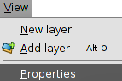 | 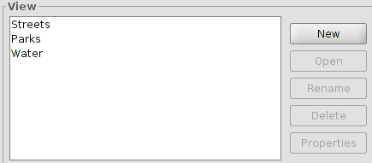
The configuration options from the View properties window are:
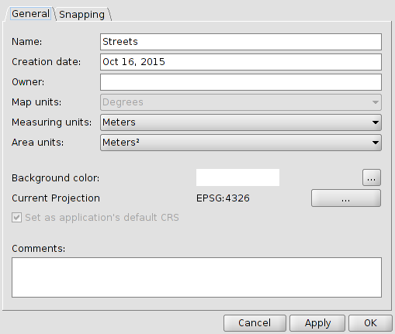
- Name: The View’s name. You can rename the View.
- Creation date: Date created of the View.
- Creator: this is optional, to specify the creator of the View.
- Map units, measures and areas: dropdown box where you can choose the measure units for your work (meters, miles, yards,...).
- Background color. White is the color by default. But you can change the View background color. A new window with tabs for the different options of color selection will be displayed.
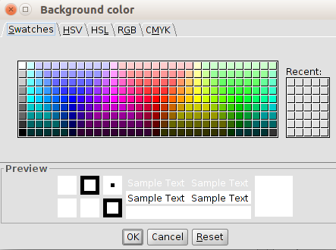
- Current projection: The default projection is EPSG:4326. You can select another projection. It will display a new window (see “coordinate system” topic).
- Comments: You can add comments about the View.
All options in this window only apply to the current document view. In the dialog box gvSIG “Preferences” we can change the background color and the default projection.

Certain supplements (plugins) can add additional tabs to the View properties dialog box.

COORDINATE SYSTEM

9.1. Change the View Coordinate System
Each View uses a coordinate system to visualize the data properly. It determines the map projection of the View.
The View coordinate system doesn’t need to be the same to the data used in the view, since gvSIG has reprojection options available.
The gvSIG Views uses the “EPSG:4326” projection by default. From the View “Properties” we can change the coordinate system of a View and make geographic transformations.
When you open the projection dialog box named “New CRS” from Coordinate Reference System, it will display a list of coordinate systems used recently.
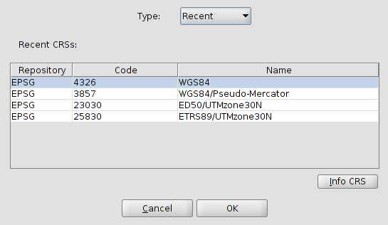
Using the dropdown “Type” you can access the rest of options that gvSIG provides to select a coordinate system: EPSG, CRS, ESRI, IAU2000 and CRS user. EPSG contains the official coordinate systems more used.
European Petroleum Survey Group or EPSG was a scientific organization linked to the european oil industry. EPSG compiled and spread a set of EPSG geodetic parameters, a widely used database containing ellipsoids, datums, coordinate systems, map projections, etc. The roles performed by the EPSG previously were taken up by the International Association of Oil and Gas Producers Surveying and Positioning Committee (OGP) in 2005.
This Spatial Reference Identifier system (SRID, English acronym) is still know as EPSG (Source: Wikipedia)

Select the type “EPSG” from the dropdown box and it will display the following options to find a coordinate system.
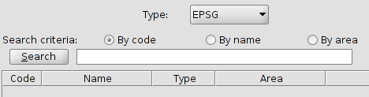
- Indicate the Search criteria (code, name or area).
- Write the text string you want to search, either a code, name or geographical area.
- Click the “Search” button. The list of coordinate system containing the text string will be displayed.
- From the list select the CRS that you want to apply to the View and click OK.
The “InfoCRS” button that is in the “New CRS” dialog box allows access to the report of the coordinate system properties.
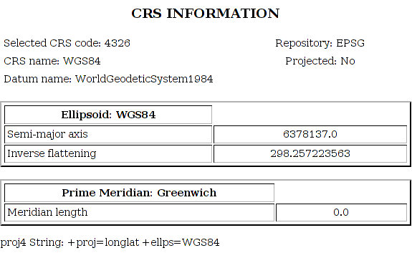

9.2. Define a User’s CRS.
It allows the definition of user’s CRS. When you select “User CRS” type, in the “New CRS” window, the following options are displayed:
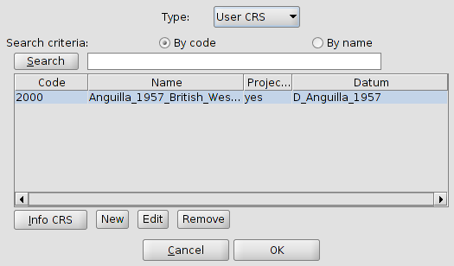
- Choose a previously created CRS, you just need to select it from the list with the different user’s CRS available y click OK.
- Choose the “Edit” button to modify an existing user’s CRS.
- Choose the “Remove” button to delete an existing user’s CRS.
- Choose the “New” button to create a new CRS. This option will open a new dialog box with three tabs.
  - User CRS
  - Datum
  - Coordinate System.
Let’s see each of them:
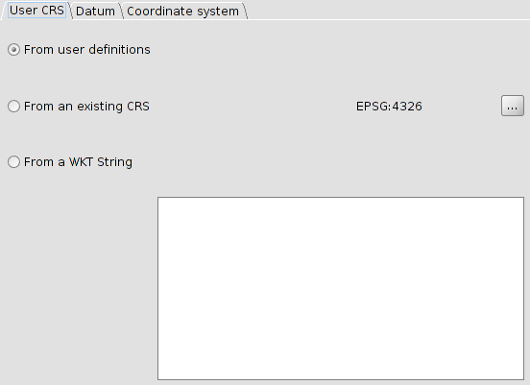
The user CRS tab lets you Select from three options to create the CRS.
- From user definitions. You can put manually all information. By selecting this option the “Datum” and “Coordinate system” panel tabs are shown empty.
- From an existing CRS. You can choose a CRS from EPSG pressing the “...” button and upload you “Datum” and “Coordinate system” data, being able to create the new CRS from these data.
- From a wkt string. Similar to the previous option, upload “Datum” and “Coordinate system” data from CRS defined by the wkt string entered.
You can paste a wkt string using the “Ctrl+V” shortcut.
The data contained in the “Datum” and “Coordinate system” panel are shown in the following images:
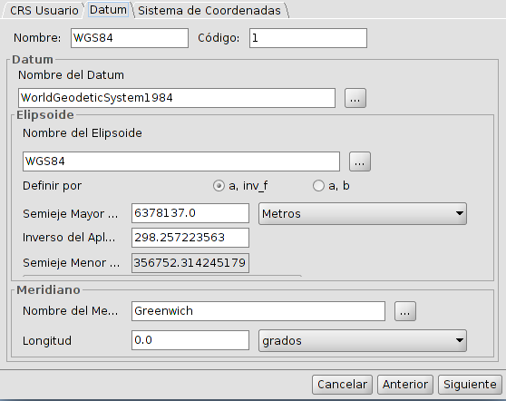
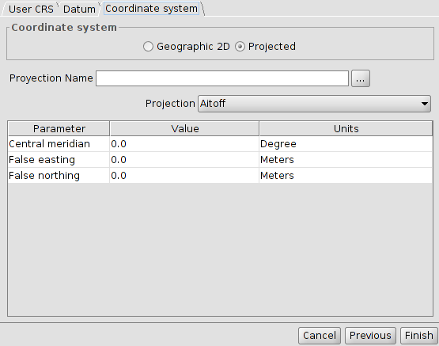
After defining the several parameters, click the “Finish” button, on the “Coordinate system” panel and the new user’s CRS will be created.

9.3. Reprojecting a layer
When adding layers to a View with different CRS, we have the option of reprojecting them. To do this simply indicates the projection of the layer and if necessary a geographic transformation.
The window for reprojecting a layer is similar to the “New CRS” window, adding the function of applying a geographic transformation.
For more information see the “Add layer” topic.

9.4. Reprojecting a layer with PRJ file
A PRJ is a file which goes associated with an information layer (shapefile, raster…) and contains information about the coordinates reference system of that layer.
In gvSIG there is support for PRJ files, so that application will interpret these types of files and will identify the layer projection automatically. Similarly, when creating or exporting the layer Hill automatically generate its PRJ file.

VIEW InterfaCE

10.1. View Interface
The Views are the gvSIG document that constitute the main working area of the geographical information. In a view you can display different layers of information (hydrography, road networks, administrative boundaries, contours, etc.).
When you open a View from the project manager, a new window composed of the following sections appears:
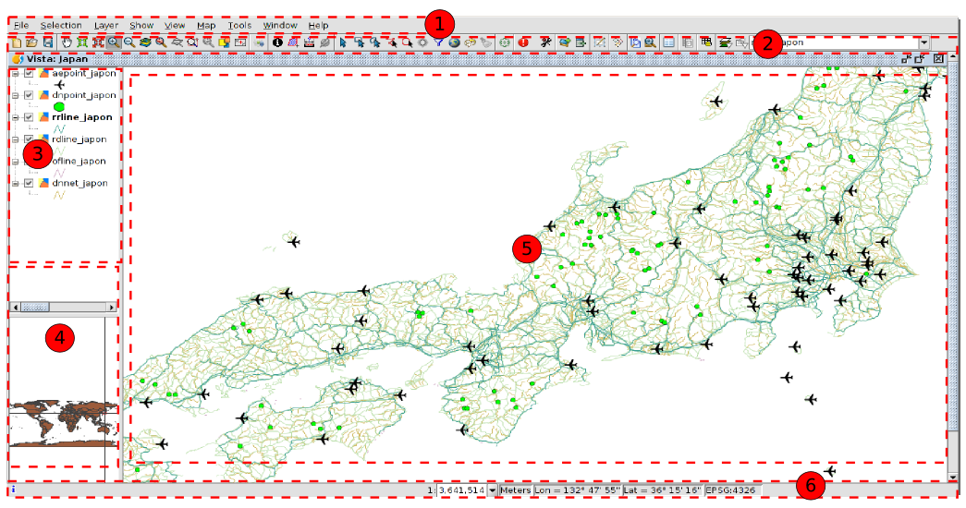
- Menu toolbar.
- Buttons bar.
- Table of contents (ToC): All the layers containing in the View and the Legend representing the simbology of each layer are listed.
- Locator. Displays the current frame in the total work area.
- Visualization area. Workspace where the geographical information is displayed and the main work is taken place (navigation, selection, edition, etc.).
- Status Bar. Displays information of the View coordinate system, scale, coordinates and units. The information resulting from the use of certain tools is shown in the status bar.
The 3, 4 and 5 components are resizables, dragging its edge to the right/left and for the Locator and the TOC from up/down.

adding layers

11.1. Introduction
A layer is a dataset with geographical information which might be stored in different formats: vectorial or raster files, remote services, databases... (See “Supported formats”).
There are different options to add a layer to a gvSIG View:
- With “Add layer”, clicking on the “Add layer” button or in the menu “View/Add layer”.
Menu | Button
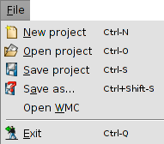
- Copy/Cut a layer from another View. With a right-click on the layer you can access to the contextual menu with options to “Copy” or “Cut” a layer. With a right-click on the View's TOC where we want to paste it, we access to the option “Paste”.
- Drag and drop a layer from a file browser to the gvSIG View.
When using the order “Add layer” in one session, gvSIG will automatically return to the same location from where data for the View was selected.
When the layer is added a window with different tabs is opened.
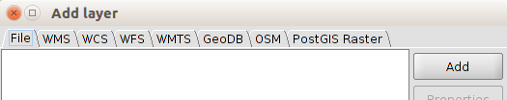
Each tab belongs to a different datum:
- File: data stored in files (shp., dxf., tiff., asc...)
- Acces services to remote data according to OGC, WMS, WCS, WFS, WMTS standards.
- GeoDB: Vectorial data in spatial databases.
- OSM: Access services to OpenStreetMap images (tiles).
- PostGIS Raster: Raster data stored in a PostGIS database.

11.2. Adding a file
In the “File” tab, if we click on “Add” a new window appears. In here we can search the file we want to add.
Once the file is added it appears a list where the file name is indicated and its CRS. By default gvSIG interprets that the CRS is the same as the View, To modify the CRS the layer must be selected in the list and we click on “Properties”.
A new window is opened where there are two tabs “Basic” y “Advanced”. Between all the properties available the most used is “CRS”.
Once we defined the CRS, clicking on “OK” the layers will be added to the View.
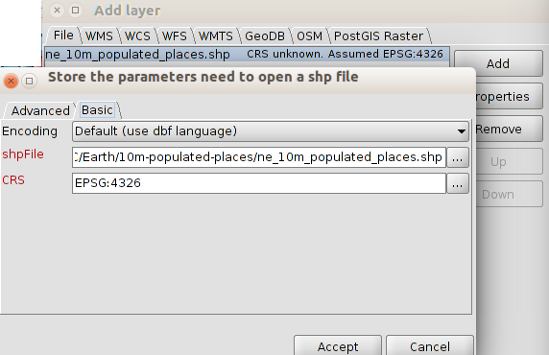
Clicking the “...” button of CRS we will be able to access to a window where we can select the reference system. This window is similar to the one for selecting the reference system in a View (See “Coordinate system” to get more information), except the option to select a transformation.
When selecting a CRS for a layer different to the CRS for the View, gvSIG automatically makes a reprojection of the layer.
Reprojection is on-the-fly (OTF). This means that the layer keeps its original projection without any change. If we want to create a new layer with a different projection we will use the “Reprojection” geoprocess (See “Geoprocessing”).
Transformation and conversions
According to the 19111 ISO, there are two types of operations to relate two different CRSs: conversion operations and transformation operation.
A coordinates conversion operation is applied when the CRS datum of the layer is the same as the CRS datum of the View, that is, both CRS belong to the same geodesic reference system but they are in different coordinates systems. In this case, when choosing the layer CRS we must select the option “No Transformation”.
A coordinate transformation operation is applied when the CRS datum of the layer is not the same as the CRS datum of the View. In this case there are two types of coordinates operations:
- That the operation just involve a transformation, when the CRS coordinate system of the layer is the same as the CRS coordinate system of the View; in both CRSs the position is expressed in the same coordinates system but in a different datum.
- That a transformation and a conversion are made because neither the datum, neither the coordinates system of the CRS of the layer and of the View are the same.
If a transformation operation is needed, we must choose the type of transformation in the CRS selection panel of the layer, and click the “Next” button, accessing to a panel where we choose the corresponding transformation.
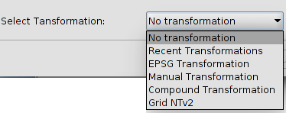
The transformation dialog depends on the type of transformation we want to apply.
EPSG Transformation | Official transformation operations with 7 parameters defined in the repository EPSG. In the dialog of this type of transformation there is a table which includes all the applicable transformations of the EPSG taking as source CRS the one which was chosen for the layer and the CRS of the View as destination CRS.  You must take into account that the transformation operations of this type are always between the base CRS, that is, non-projected CRS, and therefore if the CRS of the view or the CRS of the layer is projected, the corresponding base CRS will appear in the fields Source CRS and Destination CRS. Keep also in mind that for this type of transformation, the CRS for the View and the CRS for the layer must come from the same EPSG repository. If they come from different repositories, the table will appear empty.
EPSG Transformation | 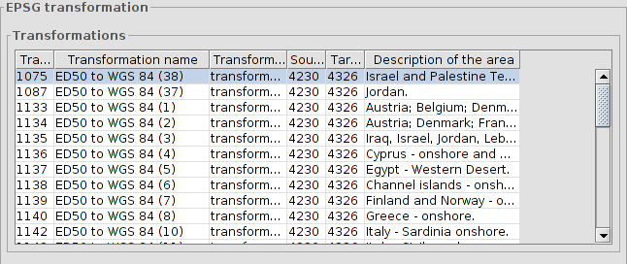
Manual Transformation | It allows users to define a Helmert transformation through the introduction of its 7 parameters.
Manual Transformation | 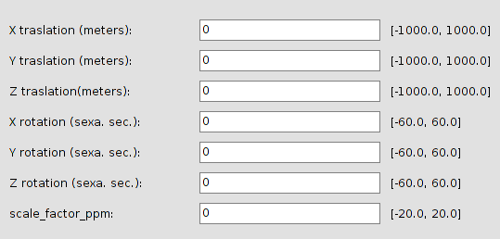
Grid NTv2 | Transformation based on an NTv2 grid file. For this, you must choose the NTv2 file from a list of available files or import it from a location to be specified. Since in the NTv2 file the translations have been calculated in a given base CRS, you must indicate here whether the NTv2 was calculated in the base CRS of the View, or the base CRS of the layer.  The grid file has a specific scope, which can be deduced from the file information that is displayed in the processing panel. Transformation is not applied beyond this scope, so the re-projection accuracy will be considerably lower, since only the corresponding coordinate system conversion would be applied.
Grid NTv2 | 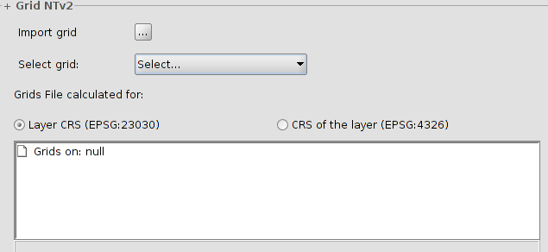
Recent Transformations | With this application you can select a transformation that has been used previously.  If a recent transformation is selected, two actions can be taken: to accept the transformation or to click on the “Next” button to review the selected transformation. In the next panels you access to the information of the chosen transformation, where you can modify it or select a different one.
Recent Transformations | 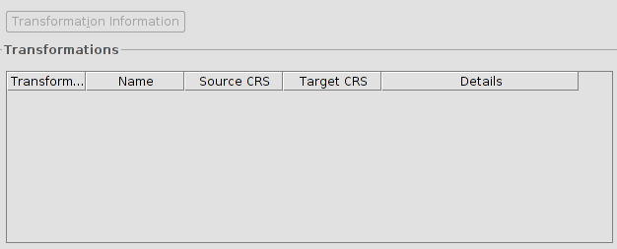
Composite transformations | It provides gvSIG users with the possibility to represent two CRS with different datums without the transformation between those two CRS, but with a transformation of those two CRS into a third CRS.  In this case, the composite transformation can play an important role when you need to define two transformations, one that refers to the CRS of the layer and the other to the CRS that has been defined for the view.  With this mechanism, you can set the CRS for the layer and the CRS of the View through an intermediate CRS that connects the two CRS.  To do this, after selecting the CRS of the layer and setting the type of transformation to Compound transformation, you need to:  - Define the transformation to be applied to the CRS of the layer  - Define the transformation to be applied to the CRS of the view
Composite transformations | 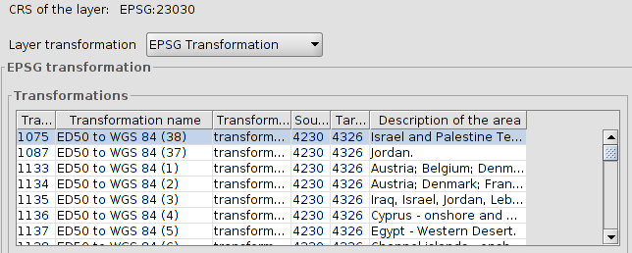

11.3. Adding a WMS
The steps to add a WMS through the “Add layer” window are:
- Connecting to the service
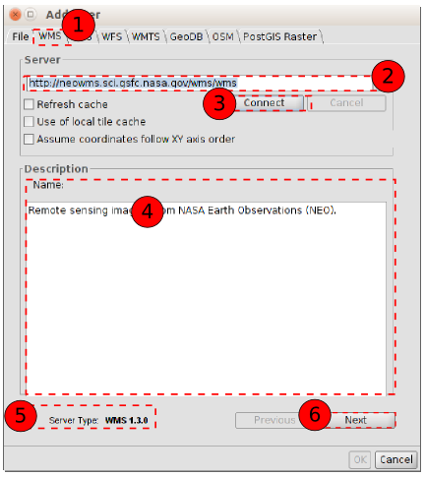
  - Select the “WMS” tab.
  - Introduce the server URL, which will be stored and it will be shown in the pull-down menu for the future.
  - Click on “Connect”.
  - When the connection is made, a welcome message from the server appears (not always).
  - The WMS version number that the connection has been made to is shown at the bottom of the box.
  - When the connection is made the “Next” button is enabled. We click on it to begin with the configuration of the layer.
You can select the “Refresh cache” option which will search for the server information in the local host. This will only work if the same server was used on a previous occasion.
- Information. It shows information from the server.

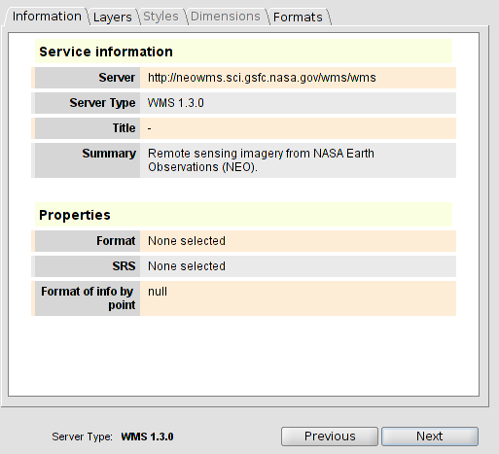
  - Click on “Next”.
- Layers. It allows users to access to the available layers in the WMS server and select the one you wish to load.
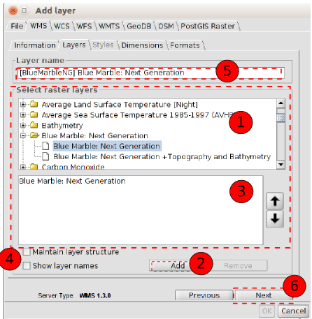
  - The available layers are shown. We select the ones we want for our WMS layer. We can double click on a layer and it will be automatically add...
  - ... or to click on the “Add” button.
  - List of layers that we are adding. We can change the order in which they appear using the up/down arrows.
  - You can select to keep the structure of the layers and to display their name.
  - Name that the layer will have in the TOC.
  - Click on “Next”
You can select several layers at once by holding down the “Control” key whilst left clicking on the mouse.
You will obtein a layer description if you move the cursor over a layer and wait for a few seconds. The information the server has about these layers is shown.
If we add a folder, the WMS will have all the layers in that folder.

- Styles. It allows you to choose between the different types of styles (Symbology) that are available. It can happen that there is only one defined style or that the tab is disabled.
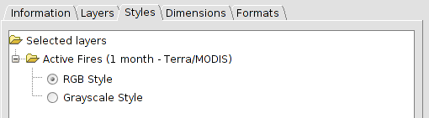
  - Click on Next.
- Dimensions. It helps to configure the value for the WMS layer dimensions. However, the dimensions property (like the styles property) is optional and may be disabled.
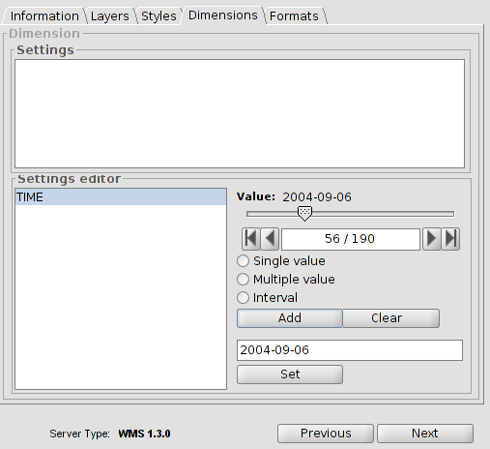
  - Initially, no dimension is configured. It allows users to select one from the “Settings editor” area in the list of dimensions. The controls in the bottom right-hand corner of the tab are enabled.
  - Use the slider control to move through the list of values the server has defined for the selected dimension. You can move back to the beginning, one step back, one step forward or move to the end of the list using the navigation buttons which are located below the slider control.
  - If you know the position of the value you require, you can simply write it in the text field and it will move automatically to this value.
  - Click on “Add” so that you can write the selected value in the text field and request it to the server.
gvSIG allows you to choose between:
  - Single value: Only one value is selected
  - Multiple: The values will be added to the list in the order they are selected in.
  - Interval: An initial value and then an end value are selected.
  - When the expression for your dimension is complete, click on “Set” and the expression will appear in the information panel.
Although each layer can define its own dimensions, only one choice of value is permitted (single, multiple or interval) for each variable.
The server may come into conflict with the layer combination and the variable value you have chosen. Some of the layers you have chosen may not support your selected value. If this occurs, a server error message will appear.
You can personalise the expression in the text field. The dialogue box controls are only designed to make it easier to edit dimension expressions. If you wish you can edit the text field at any time.
- Formats. Selecting the format, coordinate system and text format.
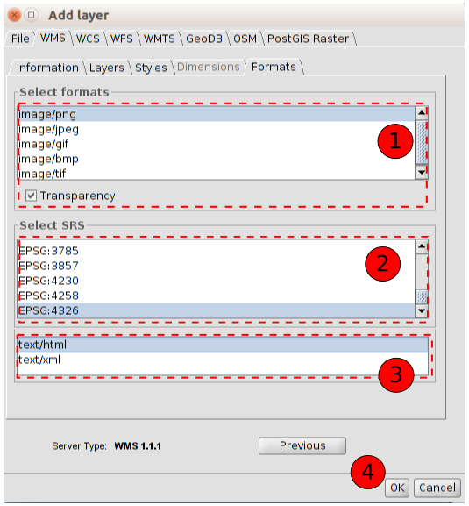
  - It allows you to choose the image format. The main difference between formats is the capacity they have to support transparencies (for instance, PNG supports transparency, JEPG shows transparency areas in an opaque white.
  - It allows you to choose the CRS for the layer. It should be similar to the one from the View.
  - It allows you to choose the text format for information queries.
  - Click on the “OK” button and the layer will be added to our View.
WMS can have as a feature an associated legend. In this case the legend will be shown in the TOC.

11.4. Adding a WMTS
The steps to add a WMTS through the “Add layer” window are:
- Connecting to the service.
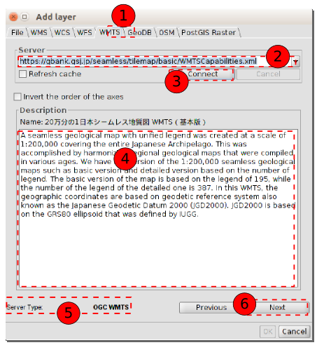
  - Select the “WMTS” tab.
  - Introduce the URL server. The URL will be stored and it will be shown in the drop-down box for other occasions.
  - Click on the “Connect” button.
  - When the connection is made, a welcome message from the server appears (not always).
  - The information about the type of server with which the connection has been made to is shown at the bottom of the box.
  - When the connection is made the “Next” button is enabled. Click on it to start with the configuration of the WMTS layer.
You can select the “Refresh cache” option which will search for information from the server in the local host. This will only work if the same server was used on a previous occasion.
- Information. It shows the service information.
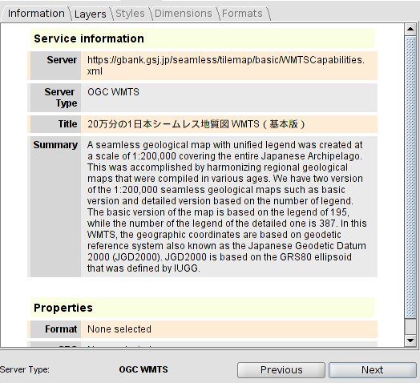
  - We click on the “Next” button.
- Layers. It allows you to access to the set of available layers in the WMTS server and to choose the one you want to add to the View.
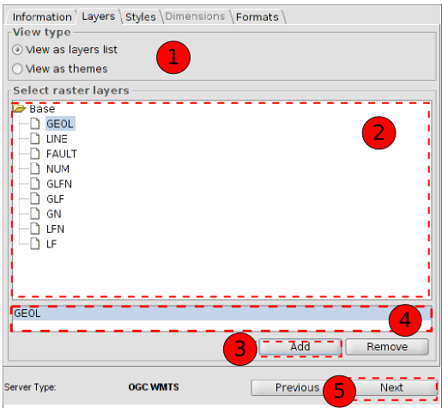
  - We select the type of View: view as a layer list or view as a theme.
  - The list of the available layers is shown. Double-click on a layer and it will automatically be added.
  - ... or click on “Add”.
  - Name of the added layer.
  - Click on “Next”.
- Styles. It allows you to choose between the different types of styles (Symbology) that are available. It can happen that there is only one defined style or that the tab is disabled.
  - We choose the style.
  - We click on “Next”.
- Formats. Choosing the format, coordinate system and text format.
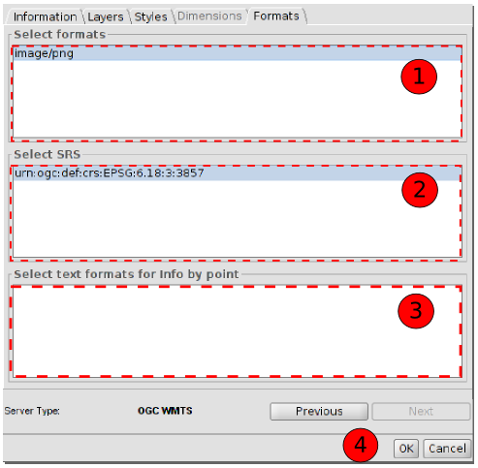
  - It allows you to select the image format.
  - It allows you to select the CRS of the layer. It should be similar to the one from the View.
  - It allows you to select the text format for information queries.
  - Click on “OK” and the layer will be added to the View.

11.5. Adding a WFS
The steps to add a WMTS through the “Add layer” window are:
- Connecting to the service.
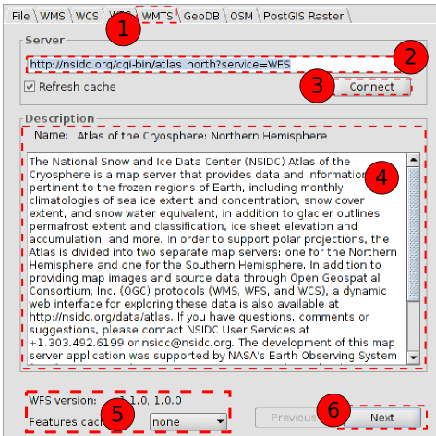
  - Select the “WFS” tab.
  - Introduce the URL server. The URL will be stored and it will be shown in the drop-down box for other occasions.
  - Click on “Connect”.
  - When the connection is made, a welcome message from the server appears (not always).
  - The information about the type of server with which the connection has been made to is shown at the bottom of the box.
  - When the connection is made the “Next” button is enabled. Click on it to start with the configuration of the WFS layer.
You can select the “Refresh cache” option which will search for information from the server in the local host. This will only work if the same server was used on a previous occasion.
- Information. It shows the server information.
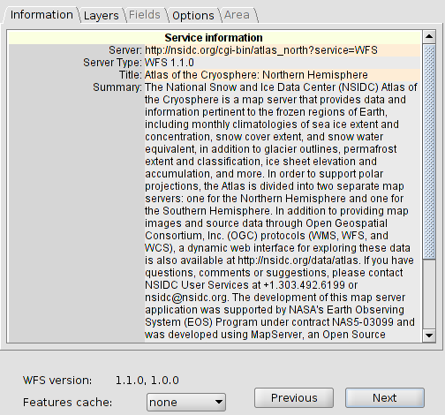
  - Click on “Next”.
- Layers. It allows you to access to the set of available layers in the WFS server and to choose the one you want to add to the View.
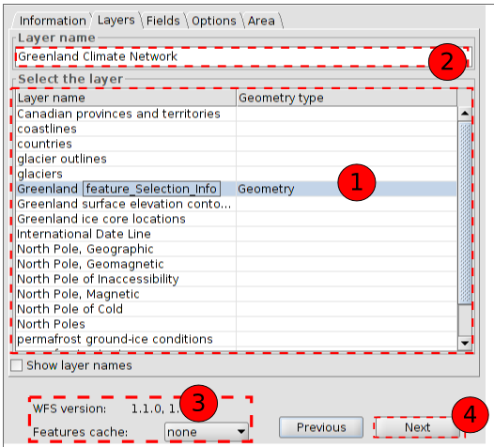
  - Double-click on the layer you want to add to the View.
  - Name with which the layer will be displayed in the TOC.
  - Information about the WFS version.
  - Click on “Next”.
- Fields.
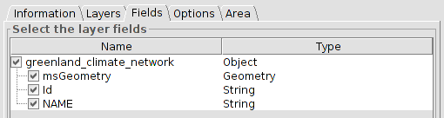
  - It allows you to select the fields which will make the attributes table associated to the selected layer.
  - Click on “Next”.
- Options.
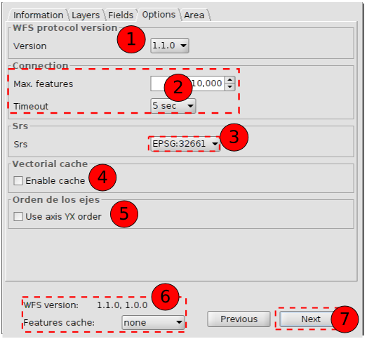
  - WFS version
  - Max. Features: It allows users to set a maximum number of entities that can be downloaded. Timeout is the length of time beyond which the connection is rejected as it is considered to be incorrect. If these parameters are very low, a correct request may not obtain a response.
  - SRS: CRS of the layer. gvSIG reprojects the loaded layer to the spatial system in the view.
  - Enable cache.
  - Invert the order of X/Y axis.
  - Inform about the WFS version.
  - Once the parameters are selected, Click on “Next”.
- Area
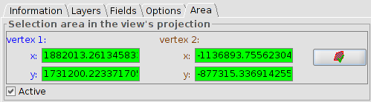
  - It allows you to delimit the area of the View in which the vectorial elements will be downloaded. The validation button allows you to confirm that the coordinates are correct (when you click on it, if the X Ycoordinates tabs have right values they become green)
  - After this we click on “OK” and the WFS will be added to the View.

11.6. Adding a WCS
The steps to add a WCS through the window “Add layer” are:
- Connecting to the service
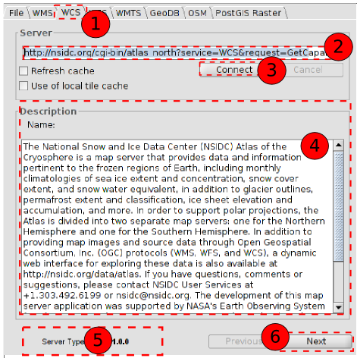
  - Select the “WCS” tab.
  - Introduce the URL server. The URL will be stored and it will be shown in the drop-down box for other occasions.
  - Click on “Connect”.
  - When the connection is made, a welcome message from the server appears (not always).
  - The information about the type of server with which the connection have been made to is shown at the bottom of the box.
  - When the connection is made the “Next” button is enabled. Click on it to start with the configuration of the WCS layer.
- Information.
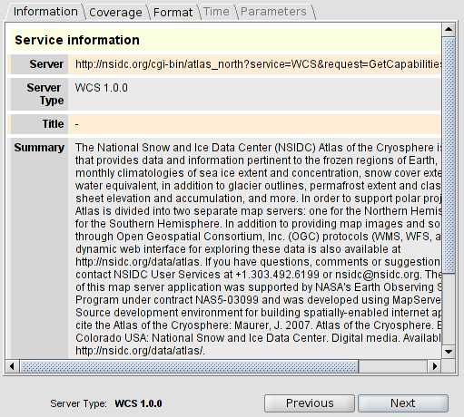
  - Click on “Next”.
- It allows users to access to the set of available layers in the WCS server and to choose the one you want to add to the View.
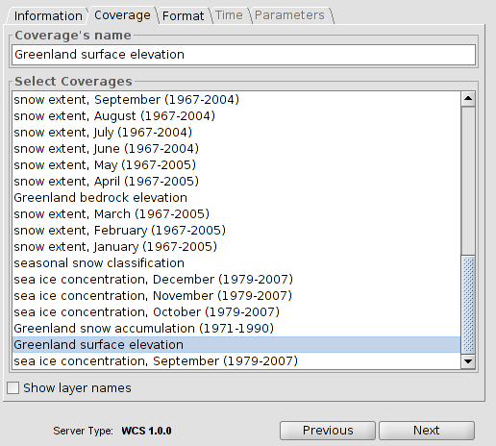
  - Double-click on the coverage you want to add to the View.
  - Click on “Next”.
- Formats. It allows users to choose the image format with which the request will be made and the reference system.
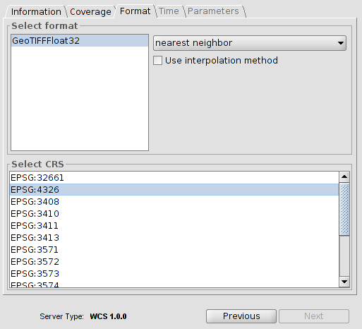
  - Select the format.
  - Select the CRS. It must coincide with the CRS of the View.
  - Click on “Next”.
- There are tabs such as “Time” and “Parameters” that can be disabled or enabled depending on the service.
- Click on “OK” and the WCS will be added to the View.

11.7. Addin a OSM service
The steps to add an OSM service by means of the window "Add layer" are:
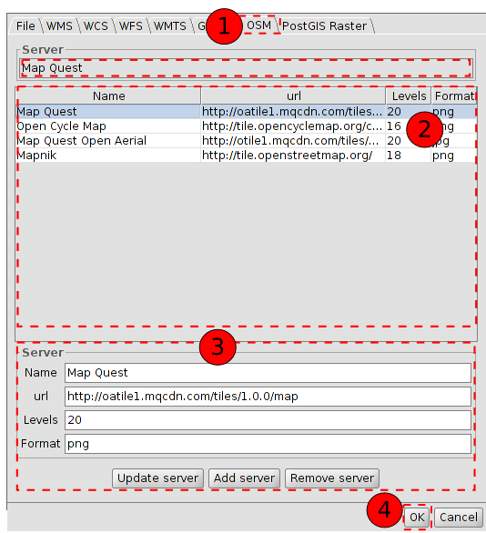
- Select “OSM” tab.
- Select one of the tile services available in OSM (Mapnik, Stamen Watercolor, Open Cycle Map, Stamen Toner, Stamen Terrain)
- When we select a service from the list its characteristics are automatically filled in. In this section we can also add a new server’s features or update an existing server.
- Click on “Ok” and OSM layer is added to View

11.8. Adding web maps (Google Maps / Bing Maps)
This tool adds a map service like Google Maps or Bing Maps to View. It uses the projection system EPSG: 3857; therefore, in order to obtain a correct visualization of the data, it is recommended that View must be in the same projection.
The steps to add a map service from the window Add Layer are the following:
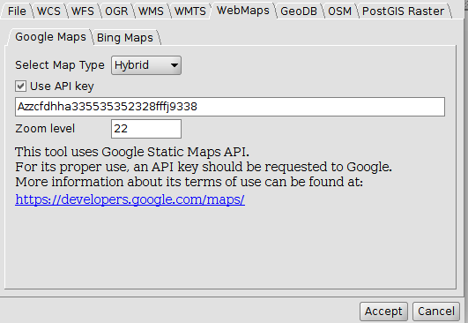
- Select the Tab “WebMaps”
- Select the Tab of the map service of preference (Google Maps o Bing Maps)
- Select the type of map from the drop down menu
- Indicate (optional) the API key
  - Google Maps: This tool uses the library of static maps of Google Maps; hence, it must follow these terms of use: (https://developers.google.com/maps/terms?hl=es#1-your-relationship-with-google). For this, it is necessary to use a credential that identifies the service used. This credential is obtained from Google and must be set up before using it with static maps. The credential must be obtained from: https://console.developers.google.com/
  - Bing Maps: This tool uses the library of static maps of Bing Maps; hence, it must follow these terms of use: (https://msdn.microsoft.com/es-es/cc300389). For this, it is necessary to use a credential that identifies the service used. This credential is obtained from Bing and must be set up before using it with static maps. The credential must be obtained from: https://www.microsoft.com/maps/create-a-bing-maps-key.aspx
  - Set (optional) the zoom level. This field indicates the number of zoom the layer allows. Although it is predetermined at 22 in Google Maps, this is a default value and may change depending on the zone and the type of map used, so other values might be necessary. In Bing Maps, it is not necessary to use zoom level because it is provided by Bing Maps according to the type of layer
  - Click OK and the new layer is added to View

11.9. Adding a spatial database (GeoDB)
It allows the user to access spatial databases in a simple and unified way to different suppliers.
gvSIG stores the different sessions’ connections. This way is not necessary to enter the parameters of each server to which we connect every time. Similarly, if you open a project file that has some connection to databases we only will be asked for the password.
The steps to add a GeoDB layer to the View are:
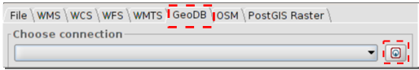
- Connect:
  - Select “GeoDB” tab.
  - Click on the button to create a new connection. If there already created connections we simply select it from the drop-down. When we create a new connection the following window opens:
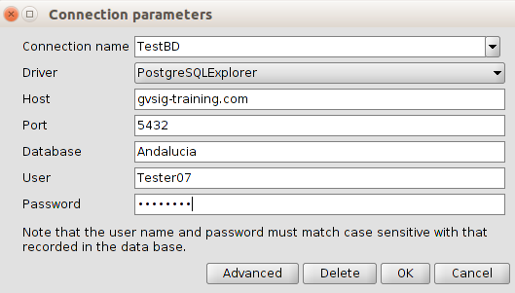
  - We indicate the connection parameters:
  - Connection name: user’s choice
  - Connector. Select the type of database which we want to connect to from the drop down menu (MySQL, PostgreSQL/PostGIS, JDBC).
  - Server: Server URL
  - Port.
  - Database: database name
  - User
  - Password
  - Click on “OK" and the connection will be established. When connected, the window "Add Layer / GeoDB" shows the tables (layers) available.
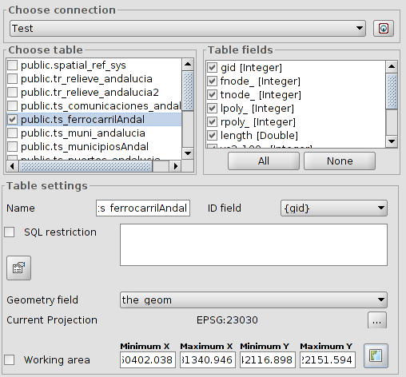
- Selection of information
  - Select the table / to load. When we select a table, the "Table Columns" section will be updated showing all selected fields available in our table; we can unselect those we don't want to load.
  - Table settings. In this section we can change the name of the layer displayed in the TOC which is filled by default with the name of the table. It allows indicating a restriction by means of a SQL expression, design and work area.
- Once all the parameters are set click on "OK" and the information will be added to our Vista.

11.10. Adding PostGIS Raster
It allow to add raster information stored in PostGIS database. Its behaviour is similar to GeoDB
- Connect.
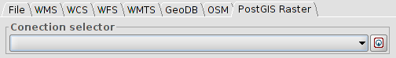
  - Select “PostGIS Raster” tab.
  - Click on the button to create a new connection. If there are connections already created we must select from the drop-down. When the connection is established the following window opens:
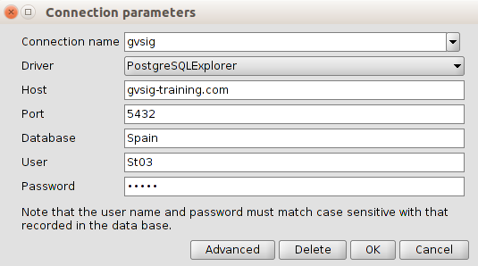
  - We indicate the connection parameters:
  - Connection name: user's choice
  - Connector. Select the “PostgreSQLExplorer” option from the dropdown:
  - Server: Server URL
  - Port.
  - Database: database name
  - User
  - Password
  - Click on “OK” and set connection. When we connect, the window "Add Layer / PostGIS Raster" displays the avaiable tables.
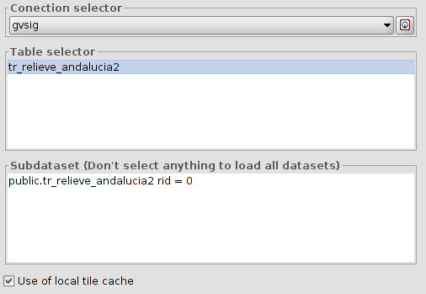
    - Select a table from the list and the “Subdataset” paragraph will update.
    - Click on “OK” and our View information will be added.

11.11. Add event layer
It allows to create a point layer from a table which has the points X and Y coordinates as fields. We must have a table in the project to run this tool.
It is available in the "View / Add event theme" menu, in the "Tools / Transforms / Create" menu and from the corresponding button.
Icono | Herramienta | Tecla rápida | Descripción
 | Add event theme |  | It allows to create a point layer from a table which has the points X and Y coordinates as fields
The interface will guide us through the steps to add a event theme
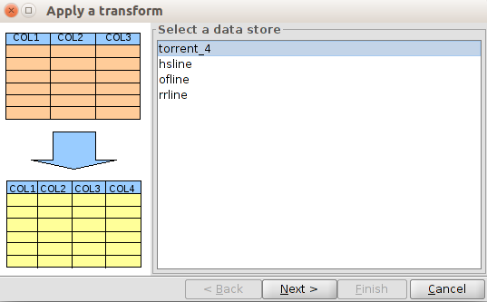
- Select data store. It allows the selection of the table we want to add as a layer of events from the available table lists of our project. Once selected we must click on the "Next" button.
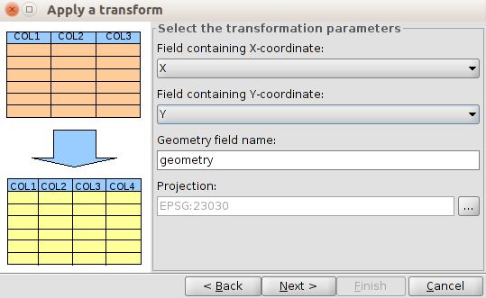
- Select the transformation parameters. It allows us to indicate the table fields wich contains the points X and Y coordinates. The default projection is the View, although it can be modified. Once the options are set we must click on the “Next” button.
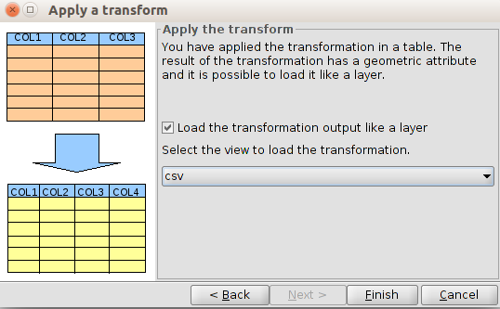
- It allows us to indicate if we want to load the generated layer in one of the Views of the project. Once we click on the "Finish" button the new layer is created and, if appropriate, added to the selected View.

11.12. Add OGR layer
This tool adds OGR vector format files. The complete list of OGR files is available at http://www.gdal.org/ogr_formats.html
The steps to add an OGR file from the window Add Layer are the following:
- Go the tab “OGR”
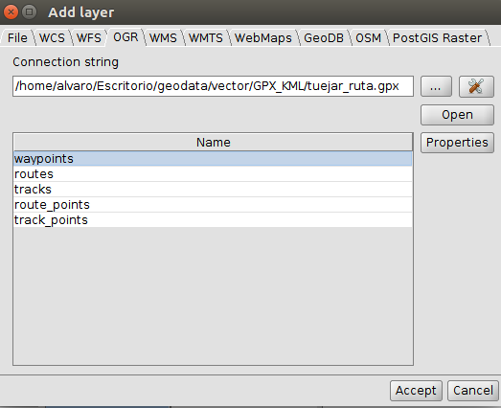
- Select the button “...” to load a file
- Click the Button OPEN. It will add one or several rows (depending on the file format) to the list of available layers
- Select the layer to load
- Click ACCEPT and the layer will open on View

Create a new layer

12.1. New Layer
It allows us to create a new Shapefile layer.
It is available from the View/New Layer menu.
The interface guides us through the steps to create a new layer:
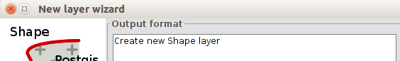
We must select “Creat new Shape layer” and click on “Next” button.
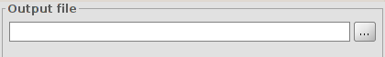
Output file. It allows us to indicate the name and file path where the new layer will be saved.
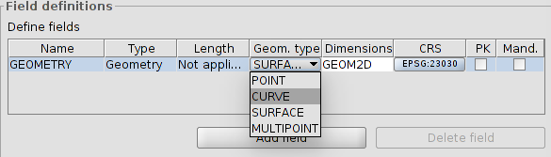
Field definitions. It allows us to define the type of layer.
Point: Point.
Curve: Line.
Surface: Polygon.
Multipoint: Multipoint.
With the “Add field” button we can add attribute fields to the new layer. Once the geometry type and possible additional fields are set, click on the “Next” button.
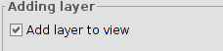
At last, we can add the new layer to the View. Click on “Finish” button to finish.

12.2. Layer export
It allows to export a vector layer. All the elements of a layer or only a selection of them can be exported. Supported formats for export are kml, dxf, shp and PostGIS.
It is available from “Layer/Export to...”
A new window allowing us to select the export format opens.
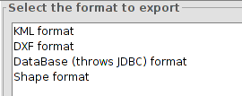
Once the format is selected, click on the "Next" button. We are then guided through the export process. Export options depend on the selected format.

12.2.1. Export layer to a shp format
It allows us export a vector layer to a shapefile.
The interface will guide us through the export process:
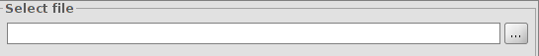
First of all, we must select the name and file location of the new layer. Once those fields are set click on the “Next” button.
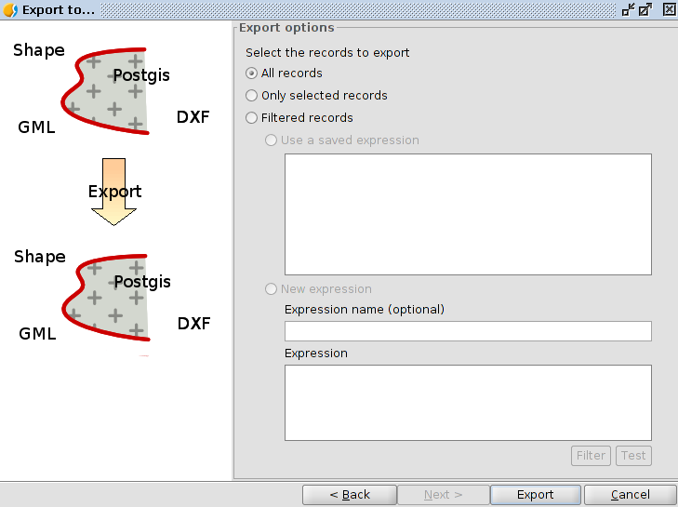
Export options. It allows us to indicate if we want to export all the elemnts of the original layer, those that are selected or those that meet certain selected criteria. In the latter case we can enter filter expressions. To finish the export we must click on the “Export” button.

12.2.2. Export layer to a dxf format
It allows us to export a vector layer to a dxf format
The interface will guide us through the export process:
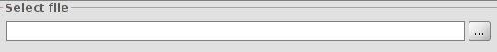
First of all, we must select the name and file location of the new layer. Once those fields are set click on the “Next” button.
Export options. It allows us to indicate if we want to export all the elements of the original layer, those that are selected or those that meet certain selected criteria. In the latter case we can enter filter expressions. Click on the “Export” button to finish the export.

12.2.3. Export layer to a kml format
It allows us to export a vectorial layer to a kml format.
The interface will guide us through the export process:
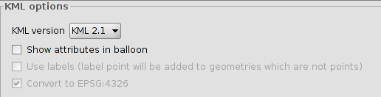
At first we must define the kml options: version, whether we want to show atributtes in balloons and to use labels. Once those fields are set click on the “Next” button.
We must select the name and file location of the new layer. Once those fields are set click on the “Next” button.
Export options. It allows us to indicate if we want to export all the elements of the original layer, those that are selected or those that meet certain selected criteria. In the latter case it lets us enter filter expressions. Click on the “Export” button to finish the export.

12.2.4. Export layer to a PostGIS format
It allows us to export a vectorial layer to a PostGIS format.
The interface will guide through the export process:
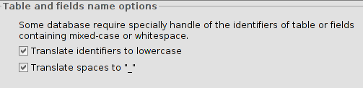
Tables and fields name options. It allows us to select if we want to move identifiers to lowercase and spaces "_". Once this is set, press the "Next" button.
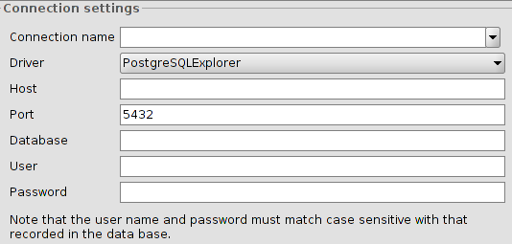
Connection settings. It allows us to define the connection parameters of the PostGIS database to which data are exported. Once this is set, click on the "Next" button.
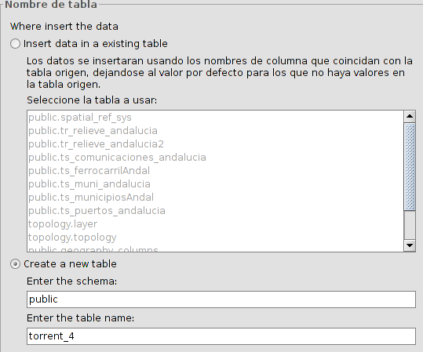
Table name. It allows us to select if you want to insert the data into an existing table or in a new one. Once this is set, click on the "Next" button.
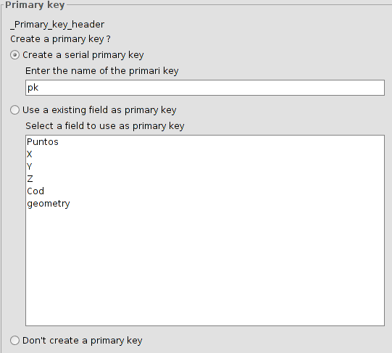
Primary Key. It allows us to select between the different options to define the primary key. Once this is set, click on the "Next" button.
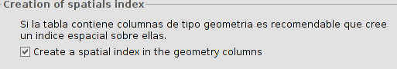
Creation of spatial index. It creates a spatial index for geometry type fields. Once this is set, click on the "Next" button.
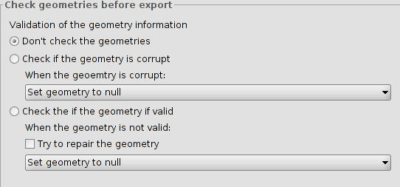
Check the geometry before exporting. It allows the selection among different options to perform a validation of geometric information. Once this is set, click on the "Next" button.
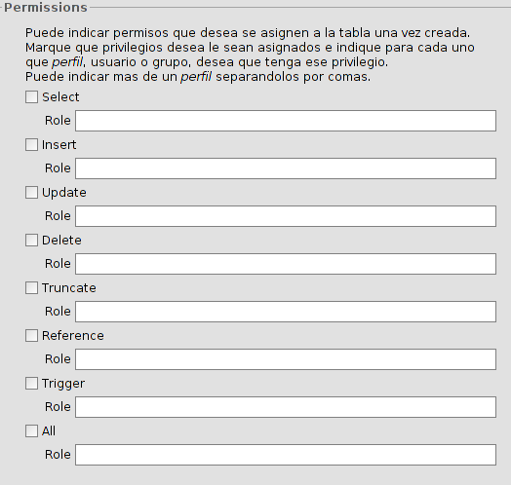
Permissions. It allows to assign permissions to the table. Once this is set, click on the "Next" button.
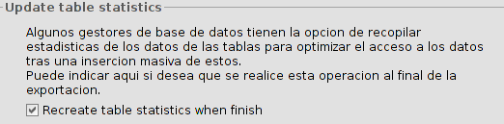
Update table statistics. It allows to recalculate the table statistics at the end of the export. Once this is set, click on the "Next" button.
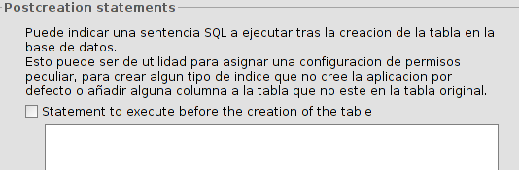
SQL post-creation. It allows to designate an SQL statement to be executed after completion of the export. Once this is set, click on the "Next" button.
Export options. They allow to indicate if we want to export all elements of the original layer, those that are selected or those that meet certain selected criteria. In the latter case it allows us to enter filter expressions. Click on the "Export" button to inish the export.

12.2.5. Export layer to .las (LIDAR)
This command exports a vector layer to .las format (LiDAR).
The interface guides in the steps to carry out the export:
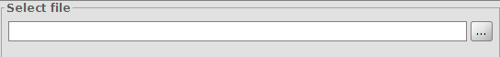
First, select the name and location of the new layer. Once defined, click on the “Next” button.
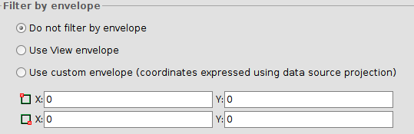
The following steps allow one to select a sub-group of data to export them as a new file. By filtering the data, it will be exported the points within the selected geometric area. The possible options are:
Do not filter by geometric extension
Filter data by using the visible extension in the active view
Filter data by using a user custom geometric extension
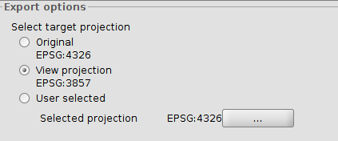
The following step defines the projection system of the exported layer. It selects the layer’s original projection, the View’s projection (in case it is different from the original) or any other projection
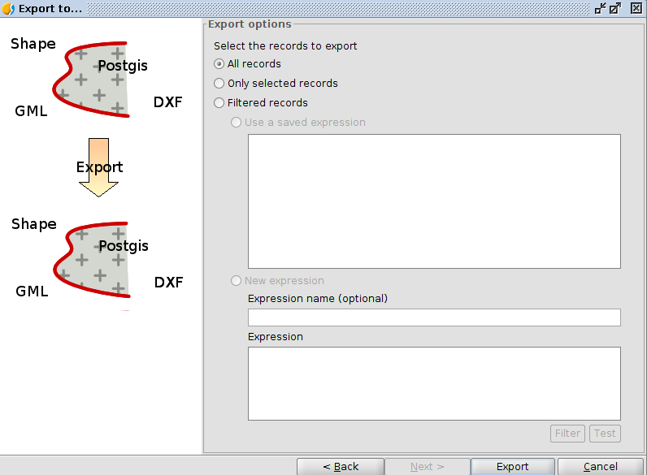
Export options. It exports all the elements of the original layer, only those elements selected, or those elements that follow specific criteria. In this latter case, provide an expression. To finish, click on the “Export” button.
It is important to highlight that if we have loaded the layer in View with the “clarified” (simplification) of data, the export tool will respect those options; hence, it will export a simplified version of data.

12.3. Export to annotations
It allows us to export a vector layer to an annotation layer.
It is Available from the menu “Layer/Export to annotations”
The interface will guide us through the export process:
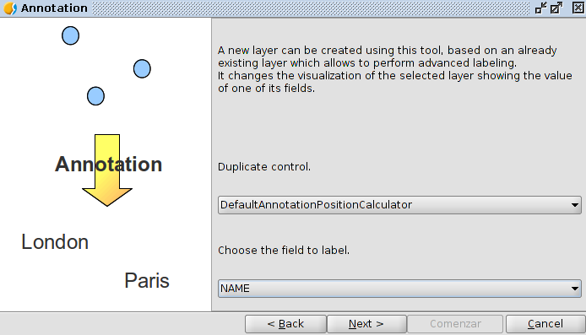
Choose the field to label. First, we have to select the field from which the annotations will be created. Once this is set, click on the "Next" button.
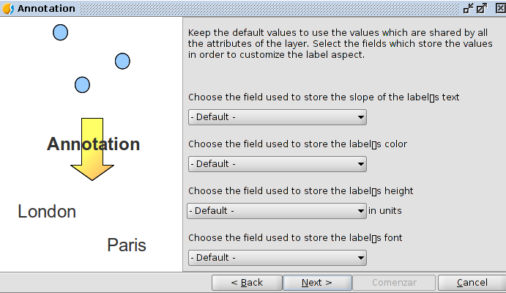
It allows us to select fields where the different annotations properties will be stored. Once this is set click on the "Next" button.
Select file. First, we must select the name and file location of the new layer. Once this is set click on the “Comenzar” button.
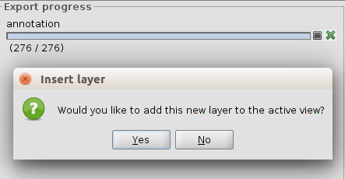
The export process is performed and a new window allows us to select if we want to add the annotation layer in the View.

supported Formats

13.1. File
Informative table of the file formats supported by gvSIG:
Format | Extension | Read | Write | Notes
DBF | .dbf | Yes | Yes
CSV | .csv | Yes | Yes
MsEXCEL | .xls | Yes | No
Shapefile | .shp | Yes | Yes
GML | .gml | Yes | No
KML | .kml | Yes | No
DXF (Drawing Exchange Format) | .dxf | Yes | Yes
DWG (Drawing) | .dwg | Yes | No | Supported versions: 12, 13, 14, 15, 2004
DGN (Design) | .dgn | Yes | No | Supported versions: 8
NetCDF (Network Common Data Form) | .nc  .cdf | Yes | No | Vectorial and raster
ECW (Enhanced Compression Wavelet) | .ecw | Yes | No
MrSID (Multiresolution seamless image database) | .sid | Yes | No
IMG | .img | Yes | Yes | GDAL raster file
GIF (Graphics Interchange Format) | .gif | Yes | No | GDAL raster file
TIFF (Tagged Image File Format) | .tiff  .tif | Yes | Yes | GDAL raster file
JPEG (Joint Photographic Experts Group) | .jpg  .jpeg | Yes | Yes | GDAL raster file
JPEG2000 | .jp2  .j2k | Yes | Yes | GDAL raster file
PNG (Portable Network Graphics) | .png | Yes | Yes | GDAL raster file
ASCII | .asc | Yes | No | GDAL raster file
RAW |  | Yes | No | GDAL raster file
Netpbm format PPM (Portable pixmap format) | .ppm | Yes | Yes | GDAL raster file
Netpbm format PGM (Portable Graphic format) | .pgm | Yes | No | GDAL raster file
Windows Bitmap BMP | .bmp | Yes | Yes | GDAL raster file
DAT (ENVI) | .dat | Yes | No | GDAL raster file
LAN (ERDAS) | .lan | Yes | No | GDAL raster file
GIS (ERDAS) | .gis | Yes | No | GDAL raster file
PIX (PCI Geomatics) | .pix | Yes | No | GDAL raster file
AUX (PCI Geomatics) | .aux | Yes | No | GDAL raster file
ADF (ESRI Grids) | .adf | Yes | No | GDAL raster file
BSB Nautical Chart KAP | .kap | Yes | No | GDAL raster file
Idrisi Raster ERS | .rst | Yes | No | GDAL raster file
TXT | .txt | Yes | No | GDAL raster file
RMF (raster matrix format) | .rsw  .mtw | Yes | No | GDAL raster file
Ilwis Raster Map MPL | .mpl | Yes | Yes | GDAL raster file

13.2. Remote services
Informative table of the remote services supported by gvSIG:
Formato | Notas
WMS (Web Map Service) | v.1.1.0, 1.1.1, 1.3.0
WFS (Web Feature Service) | v.1.0.0, 1.1.0
WMTS (Web Map Tile Service)
WCS (Web Coverage Service) | v.1.0.0, 1.1.0
WMC (Web Map Context) | It allows to save the parameters of a WMS layer conection
CS-W (Web Catalog Service) | v.0.9.0, 2.0.0, 2.0.1, 2.0.2  Profiles ebRIM and ISO 19115/19139
Z39.50 (Catalog)
SRW (Catalog) | Z39.50 in web
GAZ/WFS-G (Gazetteer) | v.0.9.0, 0.9,1
ADL (Gazetteer)
Geonames (Gazetteer)
OSM (Open Street Map)

13.3. Database
Informative table of the databases supported by gvSIG:
Formato | Lectura | Escritura | Notas
PostGIS vectorial | Yes | Yes
PostGIS raster | Yes | Yes
MySQL | Yes | Yes
Oracle Spatial / Locator connector | Yes | Yes | Requires manual installation of the Oracle proprietary libraries in gvSIG to work.
Database connectors (Generic) | Yes | Yes

13.4. OGR
The complete list of vector formats supported by OGR can be consulted here:
http://www.gdal.org/ogr_formats.html

Table of Contents (TOC). common operations with layers

14.1. Introduction
Table of Contents or TOC is the View area where the layers and its legends are listed. In the TOC we can perform some of the most common operations with layers. The TOC helps manage the display order of the layers and the assignment of symbols.
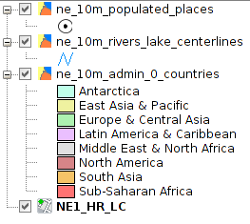
A layer is accompanied by an icon that indicates its type (file, remote service group, etc.), a legend that can display / hide and a display activation box.

14.2. Enable / disable layers
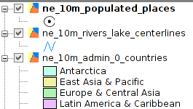 | When a layer is active we can take action on it  A layer is activated when its name appears in bold.  A layer is activated clicking with the left mouse button on it.
From the menu "View /Set all layers to" we have access to "Active" and "Inactive" orders. We can activate or deactivate all layers of the TOC.

14.3. Display / hide layers

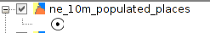 | When a layer is visible it is viewed in the map area.  A layer is visible when you have marked the checkbox.

A layer can be visible and inactive, or active and hidden.

14.4. Display / hide legends
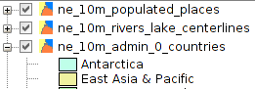 | We can show or hide the legend of a layer in the TOC.  A legend is hidden when the mark of dropdown appears with a "+". When a "-" is shown the legend is unfolded and on display..

14.5. Change the order of layers in the TOC
The order in which the layers appears in the TOC is important because it corresponds to the display order. The layers of the upper TOC are drawn on top of which are below.
It is desirable that layers formed by text elements, points and lines are at the top, leaving the lower positions of TOC for polygonal layers and images that form the background of the view.
To move and change the order of the layers in the TOC, place the cursor over them, click the left mouse button and holding it, drag the layer to the desired location.
You can also select multiple layers in the TOC pressing Control or Shift key while selecting with the left mouse button.

14.6. Layer context menu
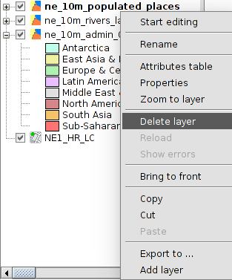 | Clicking the right mouse button on an active layer shows the contextual menu layer.  This menu contains some of the most common features that perform on a layer.

14.7. Remove layers
- Activate the layers we want to to delete.
- We click on one of the active with the right mouse button in the context menu and select "Delete Layer".

14.8. Copy / Cut / Paste layers
- Activate the layers that we want to cut or paste.
- We click on one of the active with the right mouse button and select the context menu "Cut" or "Copy" layers.
- We click the right mouse button on the view TOC-in a space where there are no layers- the context menu and select "Paste"
We can copy and cut layers in the same view or between views.

14.9. Groups of layers
gvSIG allows to group different layers in a cluster. This is useful because it enables that we can have in the TOC many layers without taking up much space therein, enabling group those that are related.
This option allows operations simultaneously on all the layers that form the group.
To make a grouping:
- Activate the layers that we want to group.
- We click on the right mouse button on one of them and from the context menu select "Grouping layers".
- A new window where the name of the Association shall indicate opens.
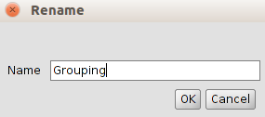
- Press "OK" and the layers will appear grouped in the TOC.
To undo a grouping, select the "Ungroup layers" option from the context menu.

14.10. Rename a layer
- Activate the layer that we want to to rename.
- We click on it with the right mouse button in the context menu and select "Rename".
- A new window showing the new layer name is displayed.
- Press "OK" and the layer will be displayed with its new name in the TOC.
The name change is at a visual level in TOC. The file name does not change in any case.

Layer properties

15.1. Introduction
The layer properties are those characteristics that define the layer. Most layer properties can be modified by the user.
The vector and raster layers have different properties. In both cases to access the Properties window, click with the right mouse button on the layer in the TOC and select the command "Properties"(for vector layers) and “Raster Properties” (for raster layers).
Access to a vector layer Properties | 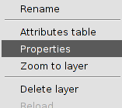
Access to a raster layer Properties | 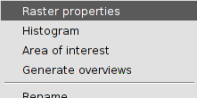
Vector layer properties | 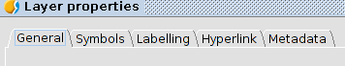
Raster layer properties | 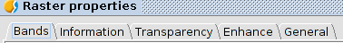
Also, it has to be taken into account that, first, the remote services have the connection properties and, second, the properties depending on being vector or raster data. In the WFS case, the connection properties are in the “Properties” window; in the rest of service cases, the two options (connection properties and properties depending on data) are separated in the context menu.
The connection properties of a remote service allow us to access to the window “Add layer” of the remote service and modify the connection parameters for that layer.
Some add-ons can add new layer properties.

Vector layer properties

16.1. General
The layer properties show the description of the layer and allow to specify the drawing properties linked to the scale.
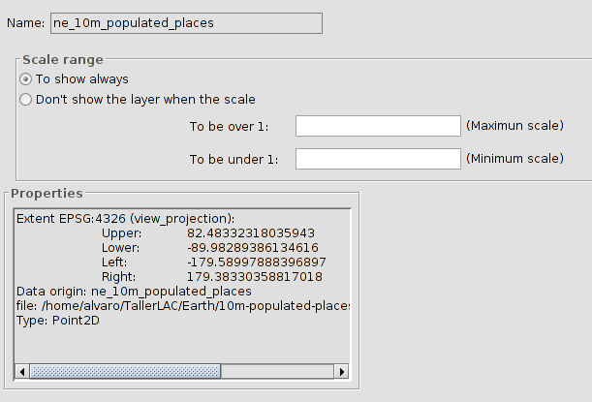
It´s possible to set the automatic visualization of the layers within a determined scale range. To set the viewing scale range:
- In “Scale range” click on “Don´t show the layer when the scale”.
- Indicate maximum and minimum values for the scale. With the denominator is enough. The greatest numbers are referred to smaller map scales.
“To be over 1:” is the greatest scale aimed which are the smallest numbers of the map scale, (maximum scale).
“To be under 1:” is the smallest scale aimed in the active layer in the view (minimum scale).
Once the scale range is defined, the layer will not be drawn if the View scale is out of the visible scale range of the layer

16.2. Hyperlink
It allows to enable/disable and set the hyperlink of one layer. A hyperlink is a link with other resource (image, website,...) and it´s associated with one element of the layer.
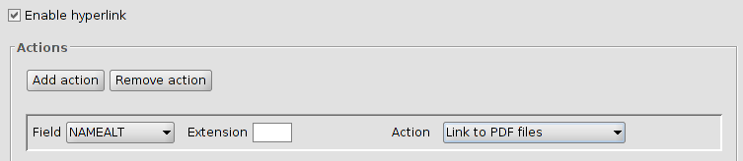
One layer can have different hyperlink´s actions. To add or delete one action, the buttons “Add action” or “Remove action” are used.
The configuration settings of each hyperlink action are:
- Field: Select the field in the attribute table of the layer containing the hyperlink (path to the resource). A drop-down menu appears with all the available fields.
- Extension: to define the resource extension. For instance, if the hyperlink is a JPG image, here “JPG” can be indicated. If the extension is indicated in the attribute table, the space should be empty; the extension only has to be used when the resource path has been indicated without the extension.
- Action: Drop-down menu with all the available hyperlinks supported by gvSIG. When the hyperlink tool is used, gvSIG will open a new window with the selected link type. Those supported links are:
  - Image files (jpg, png, bmp,...).
  - PDF files.
  - SVG files.
  - Text files and HTML.

16.3. Metadata
It allows to consult the metadata of one layer. At the moment, only the name and the CRS of the layer.
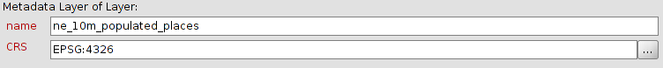

16.4. 3D
See section “3D”

vector symbology

17.1. Introduction
The symbology is one of the most important properties of one layer. In gvSIG, a great variety of options are available for representing layers with symbols, graphs and colours. The symbols are assigned to each element depending on its attribute values and the selected symbology type.
By default, when a layer is added into the View, will be in one random colour; all the elements of the layer with the same symbol. To modify the symbology, access to the “Properties” window and select “Symbols”.
On the left part, you can see all the available legends for representing data in gvSIG. The symbology panel shows different options depending on the selected legend type.
The different legend types will depend on the layer type and the attribute type. There are some legends that they can only applied with numeric attributes.
The interface contains the following elements:
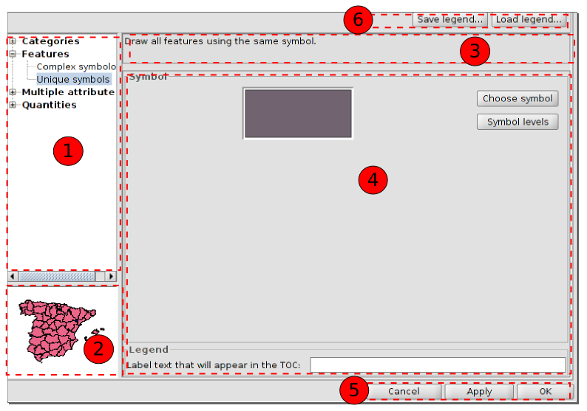
- Symbology types.
- Visual representation. It changes depending on the selected symbology.
- Description. It changes depending on the selected symbology.
- Options. To define the characteristics of the symbology. It changes depending on the selected symbology.
- Buttons to apply for the defined symbology..
- Buttons to save or load one legend.

17.2. Unique symbol
All the entities of the layer will be represented with one unique symbol. Click on “Choose symbol” to access to the “Symbol selector”.
There is an option to introduce a label text that will appear in the TOC. TOC.
To apply for the legend, click “Apply” and “Accept”.
To change the symbol or the layer colour in a fastest way, double click in the symbol that appears in the TOC and the “Symbol selector” window will open.

17.3. Categories. Unique values
Each record can be represented with a symbol according to the unique value adopted in a certain field in the attributes table. Each element will be drawn depending on the attribute value indicated by the category. For instance, in a field of a uses map, each use will have a specific colour.
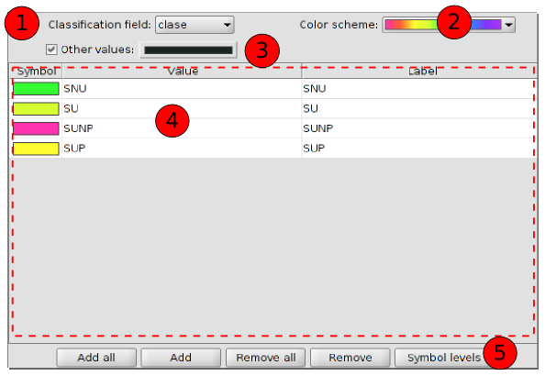
The interface contains:
- Classification field: A drop-down menu where you can select the field of the attributes layer which contains the data to carry out the classification.
- Color scheme: Drop-down menu where you can select a colour scheme for generating automatically the symbols.
- Other values: If this is enabled, all the values without a symbol for its value will be represented with a specific symbol. If it´s not active, those elements will not be shown.
- To define the symbol, the value and the label.
To modify the symbol, double click on it. A new window will open to access the screen dialogue “Symbol selector”.
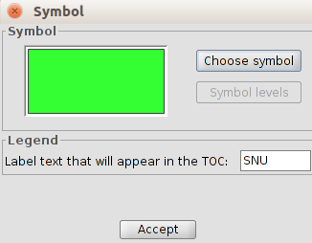
Double click on a concrete value to modify it. The value is the one found in the attributes table.
Double click on the label to modify its text. The label is the text that will appear e¡in the TOC legend. By default, the label will be the same than the value on that field.
- Buttons area
Add all/Add: Once the “Classification field” and the “Colour scheme” are selected, clicking on the “Add all” buttons, all the different values are shown by assigning a symbol (colour) different to each one. Clicking on “Add” you can add new values to the list.
Delete all/Delete: Allows to delete all (delete all) or some (delete) of the elements that make up the legend.
Symbolology level: To define a specific order of visualizing the elements. This is important when some geometries of the same layer intersect, because defining that order can make to some symbols appear over others.
It´s activated clicking on the verification space. The value “0” will be the symbol under the rest. The value “1” will be over that and so on.
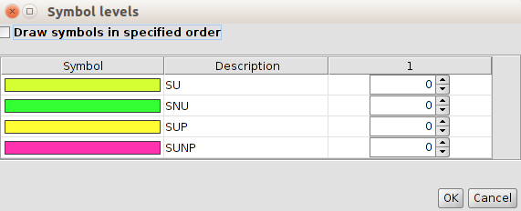

17.4. Categories. Expressions
It shows layer elements according to a certain filtered expression.
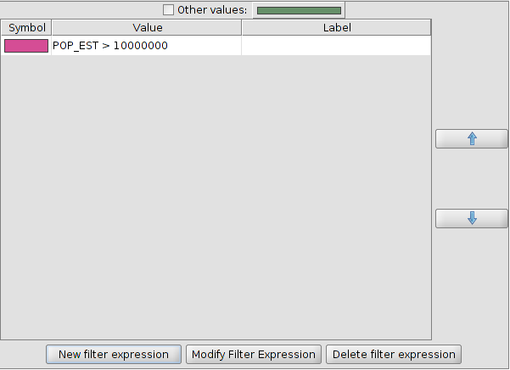
The interface contains:
- New filtered expression: The “Expression creator” window opens where you can configure expressions (filters) for applying onespecific symbol. Each of those filters will be shown as a row in the main window of this legend type. The syntax used by these filters is SLD.
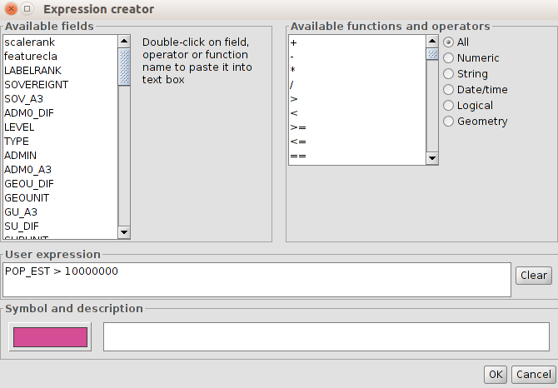
- Modify filter expression: To modify an expression by selecting it.
- Delete filter expression: To delete an expression by selecting it.
- Up/Down: To move the created expressions up or down as we wanted to have them in the TOC.
- Other values: If this is enabled, all the values without a symbol for its value, will be represented with a specific symbol. If it´s not active, those elements will not be shown. If this is enabled, all the values

17.5. Quantities. Dot density
To show the quantity of one attribute in one area as a dot density map. Each dot will be a specific number of element; for instance, in a layer of the world countries, one dot can be a population of 1,000,000.
The dots will be distributed randomly in each area and will not be real ubications.
This legend is only for polygon layers.
The interface is:
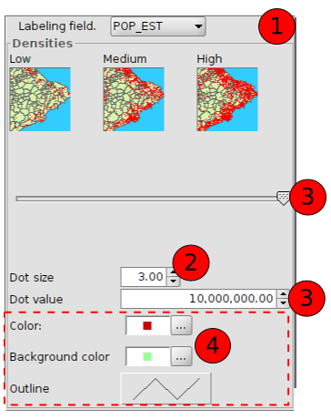
- Labelling field: Drop-down menu to choose the numeric field to make up the legend.
- Dot size: To define the size of the point.
- Dot value: this is the numeric value which will be given to each point. It can be set up with numbers or with the buttons.
- Options to define the symbology:
Colour: Dot colour.
Background colour: For the polygons in the background.
Outline: For defining the outline in the background polygons.

17.6. Quantities. Intervals
This legend represents the elements of one layer using a range of colours. Within that value range all the elements will have the same colour. The intervals or graduated symbols are used for representing quantitative data with a progression; population, temperature,....
The interface is:
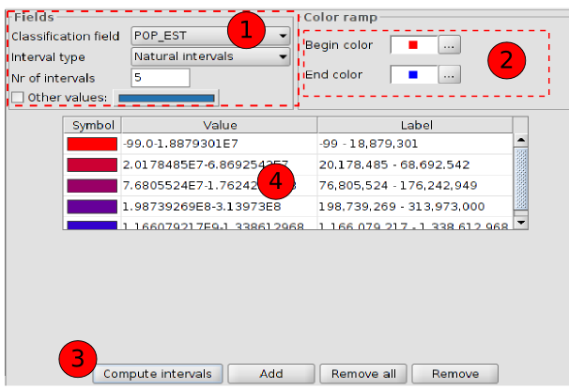
- Fields. Options to define the intervals.
Classification field: Drop-down menu to chose the numeric field to make the classification.
Interval type: There are three different intervals:
- Equal intervals: Calculate equal intervals from the values found in the selected field to make the classification.
- Natural intervals: The number of intervals are specified and the sample of this number is divided into this number according to the Jenk optimisation method, regarding to the natural localization of intervals.
- Quantile intervals: The number of intervals are specified and the sample is divided into this number but putting them into groups according to their order.
Number of intervals: To indicate the number of intervals of the legend.
- Begin color and End color: To select the colours that will be used to make the graduation. The initial colour will be for the lower values and the final one for the higher ones.
- Compute intervals: Once all the previous options have been defined, this button will calculate the intervals defined by the legend.
Add: To add new ranks.
Remove all/Remove: To delete all (remove all) or some (remove) of the elemens that make up the legend.
- To modify the symbols, labels and intervals.

17.7. Quantities. Graduated symbols
To represent quantities using the symbol size to show relative values. Within a value range, all the elements will have the same symbol.
The interface contains:
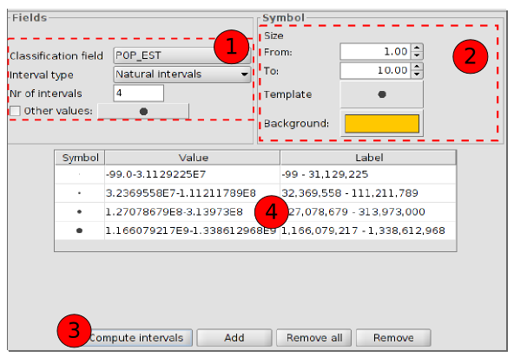
- Fields. Options for defining the intervals.
Classification field: To choose the numeric field from which the intervals will be calculated.
Interval types: There are three interval types.
- Equal intervals: Calculate equal intervals from the values found in the selected field to make the classification.
- Natural intervals: The number of intervals are specified and the sample of this number is divided into tyhis number according to the Jenk optimisation method, regarding to the natural localization of intervals.
- Quantile intervals: The number of intervals are specified and the sample is divided into this number but putting them into groups according to their order.
Number of intervals: To indicate the number of the intervals for the legend.
- Symbol: To define the symbol for the graduation. The size is defined with a minimum value (From) to a maximum value (Until). You can also modify all the features of a specific symbol by clicking on the “Template” button or in its “Background”.
- Computentervals: Once the above options have been defined, this button will calculate the intervals defining the legend.
Add: New ranks to the calculation can be added.
Remove all/Remove: to delete all (remove all) or some (remove) of the elements which make up the legend.
- To modify symbols, labels and intervals automatically.

17.8. Quantities. Proportional symbols
To represent quantities using symbol size to show exact values.
The interface contains:
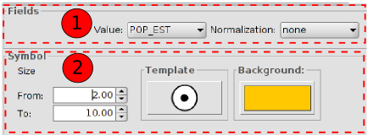
- Fields
Value: To choose the numeric field for which the classification will be made.
Normalization: It´s possible to choose a numeric field which will normalize the results, being the quantities proportional.
- Symbol: To define the symbol for the graduation. The size is defined with a minimum value (From) to a maximum value (Until). You can also modify all the features of a specific symbopl by clicking on the “Template” button or in its “Background”.

17.9. Multiple attributes. Bars
To represent numeric values of one element using bar charts. It´s useful when there are few categories.
The interface contains:
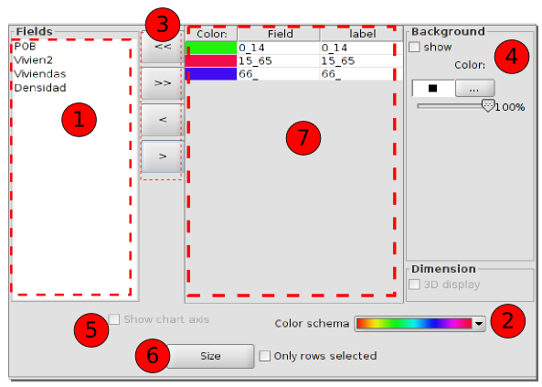
- Fields. List of all the available numeric field to be part of the chart.
- Colour scheme. Drop down menu to choose the colour scheme which will be used in the chart by default.
- Buttons to add/remove all the fields or the selected ones. The selected fields in 1 will be added in 7. The selected fields in 7 can be removed and will appear again in 1.
- Background symbol: If “show” is not active, the background will be transparent.
- Show chart axis
- Size. It opens a new window to set up the chart size. These are the options:
  - Fixed height: All charts will have the same size.
  - Sum of field values: The size of the bars will be indicated by the sum of all the records for the fields making up the chart and it will be represented in a proportional way.
  - Field size depending on one field: The chart will be proportional to a specific field.
  - Draw symbols within specific boundaries: Only the symbols within this range will be drawn, avoiding the rest.
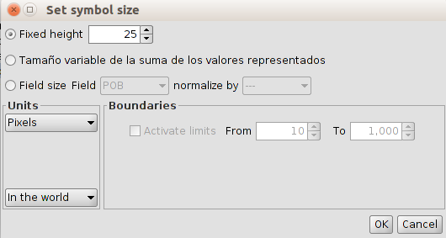

17.10. Multiple attributes. Pies
To represent numeric values of one element using pie charts. These charts show how the individual parts pèrform within a full group. They are usefule when there are not many categories.
The interface contains:
1. Fields. List of all the available numeric field to be part of the chart.
2. Colour scheme. Drop down menu to choose the colour scheme which will be used in the chart by default.
3. Buttons to add/remove all the fields or the selected ones. The selected fields in 1 will be added in 7. The selected fields in 7 can be removed and will appear again in 1.
4. Background symbol: If “show” is not active, the background will be transparent.
5. Show chart axis
6. Size. It opens a new window to set up the chart size. These are the options:
  - Fixed height: All charts wwill have the same size.
  - Sum of field values: sThe size of the bars will be indicated by the sum of all the records for the fields making up the chart and it will be represented in a proportional way.
  - Field size depending on one field: The chart will be proportional to a specific field.
  - Draw symbols within specific boundaries: Only the symbols within this range will be drawn, avoiding the rest.

17.11. Multiple attributes. Quantity by category
To represent one field of the layer with a colour intervals and other field with graduated symbols. Both fields must be numerical.
The interface contains:
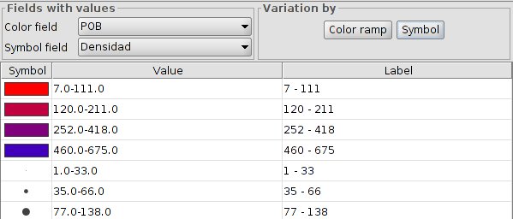
- Fields with values.
Colour field: Drop down to select the field for the intervals legend.
Graduated symbol field: Drop down to select the field for the graduated symbols legend.
- Colour ramp: Options for defining the intervals legend. “Colour ramp” will open a new window:
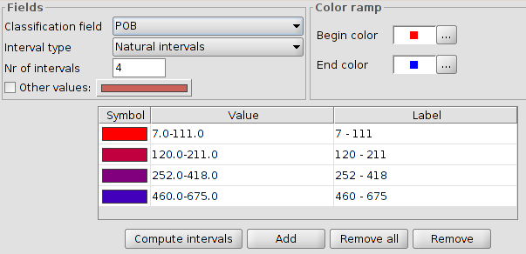
- Symbol. Options for definig the graduated symbols legend. “Symbol” will open a new window:
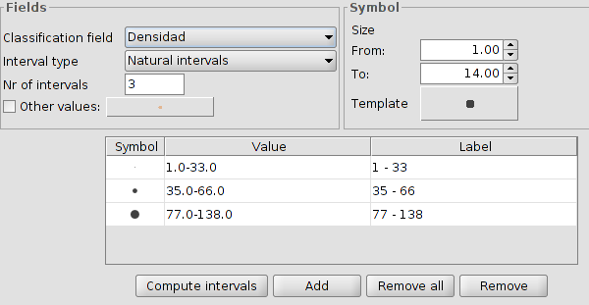
- To modify symbols, labels and intervals automatically.Permite modificar los símbolos, etiquetas e intervalos calculados de forma automática.

17.12. Multiple attributes. Join Table
TO DO

17.13. Multiple attributes. Complex symbol
To define different symbologies by scale ranges for one layer. gvSIG will apply the legend depending on the scale visualization.
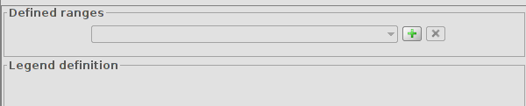
The process to create the legend by scale is:
- Ranges defined. Click on “+” to open a new window where the scale ranges can be defined.
- Define the scale ranges and legend type to apply. The legend type will be selected from a dropdown menu with all the different types supported by gvSIG.
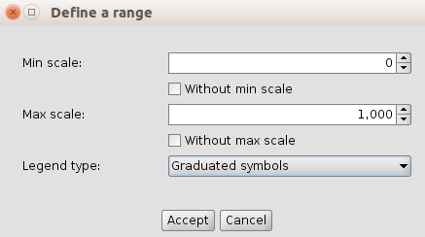
- Click on “Accept”.
- The options for defining the selected legend will be created automatically in the panel area called “Legend definition”
- Legend settings.
- Now, it´s possible to add a new legend by scale range, clicking on “+” again in the panel area called “Ranges defined”.
- Once the different legends have been defined by scale ranges, click on “Apply” or “Accept” in the “Layer properties” window.

labelling

18.1. Introduction
A label is the text which describes one or more attributes. The labels are located over or close to the elements of one layer, according to the labelling characteristics defined by the user, as well to the changes of the View. The labels can not be modified by the user directly.
Labelling can be defined, activate or deactivate from the “Labelling” tab in the “Properties” window of the layer.
To activate/deactivate the labelling, we have to enable/disable the “Enable labelling” space.
Once the labelling had been defined, even when is disabled, the memory will keep the characteristics, so the user will not need to define them, each time the user wants to show the labels.
There are two different main types of labelling in gvSIG:
- Label attributes defined by table. It´s a basic labelling and quick to set up.
- User defined label. It is subdivided into different types of labelling, with multiple options for defining the different characteristics of labeling to apply.

18.2. Basic labelling. Label attributes defined by table.
The labelling can be defined quickly and based on the data of the attibute table.
The interface contains:
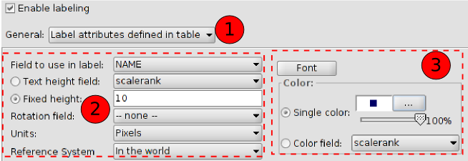
- Dropdown with the two labelling types. Select “Label attributes defined by table”
- Labelling parameters:
- Field to use in label. Dropdown that allows to choose the field in the attribute table of the layer which contains the values to be displayed as labels.
- Text height field. Dropdown to select one field of the table that contains the height of each label.
- Fixed height. To enter a fixed value for the label size.
- Rotation field. Dropdown to select one field and its values will indicate the rotation angle for the labels. The field must be “integer”.The angles values must be within the interval[0-360] and will be applied clockwise.
- Units. Dropdown to select the units for measuring the values of the text height. If “Pixels” are selected, the labels will not be scaled if the View zoom changes, having the same size always.
- Reference system. To select the units will be referred to the worl or to the paper.
- Font properties:
- Font. To select the font type.
- Single colour. To choose a colour for the labels. It´s possible to apply for transparency.
- Colour field. Dropdown that allow to choose one of the attribute fields, so their values are taken as the colour of the labels. gvSIG uses decimal codes corresponding to 24 bits to represent colours from a table field.
When this is enabled, many labels as possible will be created, without overlapping, within the space available in the View.

18.3. Advanced labelling. Label features in the same way.
It applies the defined labelling to all the features of the layer.
The interface contains:
- Select from the dropdown the option “User defined labels”.
- Select from the dropdown “Label features in the same way”. It will show the different options for this labelling.
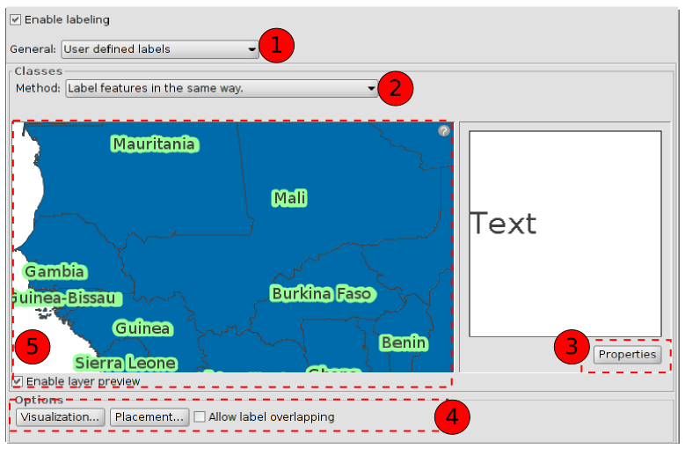
- Properties. New window to set up the characteristics of the labelling.
- Options. New dialogue screen to set up the characteristics of the visualization and placement of the labelling.
- Preview. “Enable layer preview” shows a preview of the final result for the labelling.
For more information see “Advanced labelling. Common options”

18.4. Advanced labels. Label only when feature is selected.
It applies the defined labelling only when the features are selected in he View.
This labelling is more dinamic, if the features selection changes, the labels for that new selection will be drawn automatically.
The interface is the same than the previous one.

18.5. Advanced labelling. Define classes of features and label each differently.
With this option is possile to create different labelling types with the “Add button”, give them priority of visualization (“Move up/Move down”) and label them separately.
To set up the properties, double click on the labelling row to define. “Label class properties” window will open.
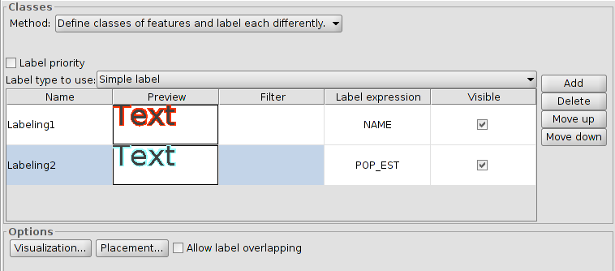
For more information see “Advanced labelling. Common options”

18.6. Advanced labelling. Define classes of features and label each differently. Labelling by scale.
For more information see “Advanced labelling. Common options”.

18.7. Advanced labelling . Opciones comunes.
Properties.
To set up the labelling properties. This dialogue screen is available in all the manual labelling methods.
The interface contains:
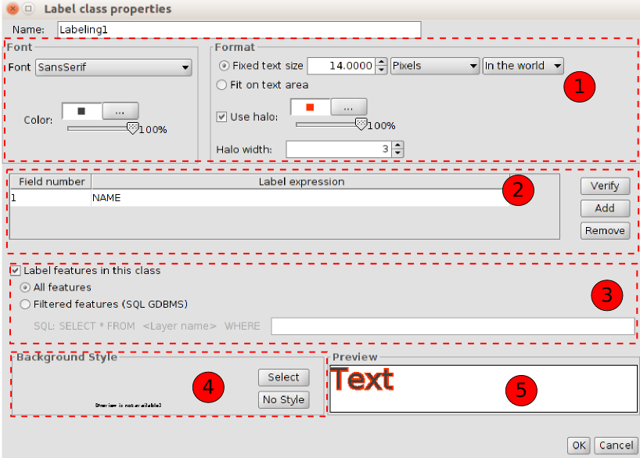
- Options to set up the format and the font of the labelling.
- Font. To select the font.
- Color. To select the colour and transparecny.
- Fixed text size. To define the label size.
- Fit on text area. To give the text size depending on the area of the feature labelled.
- Use halo. To use a colour halo around the labels. It´s useful to improve the visualization of the labels.
- Halo width. To define the halo width.
- To define the labelling expression. Clicking on “...” a new window will open to set up the labelling expression.
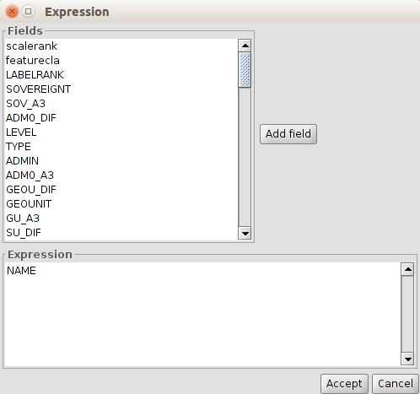
- To create SQL sequencies to apply filters to the features for the different labelling types.
- To select a background style (image) for the labelling. “Symbol selector” window will open. In “gvSIG Basic” library there are some to be used or the user can create its labels.
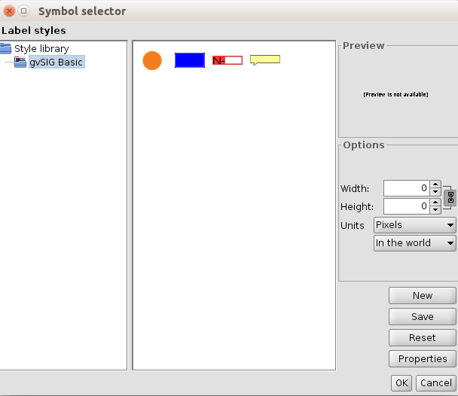
Selecting one image and clicking “Properties”, a new window will open to indicate the label ubication referred to the image.
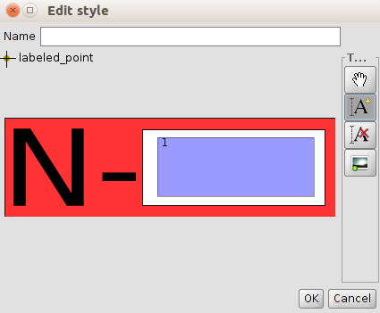
Clicking on “A+” the area rectangle to be used for the label or labels will be set up.
- Preview area of the defined label.
It is not possible to put as a background style a line layer if the option choosen is “represents the sign following the line”
Placement
To set up the properties of the labelling placement: location, orientation, duplication,...
The options of “Placement properties” will change depending on the layer geometry (points, lines or polygons). In the case of multigeometric layers (dwg, dxf, gml,...) the interface contains a tab for each type of geometry: points, lines, polygons.
For the dot layers the interface is:
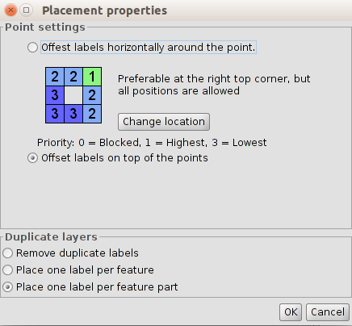
- Point settings. To choose between the label on the item or moved around.
In the second case, the priority of the placement of the label around the dot is configurable. To do this, click on “Change location” and “Symbol selector” window will open. Click on “Properties” to show a new dialog screen where the priority of placing labels around a point can be set up.
Using the buttons on the right and selecting positions of the chart, we will prioritize what location will take the text in relation to the point:
- 1 = High priority
- 2 = Medium priority
- 3 = Low priority
- 0 = Forbidden
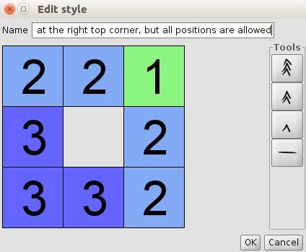
- Repeated labels. To choose between “Place one label per feature” or “Place one label per feature part “(multigeometries) or “Remove duplicate labels” which will place a label by entity and if this is repeated, it will only show one.
The interface for a line layer is:
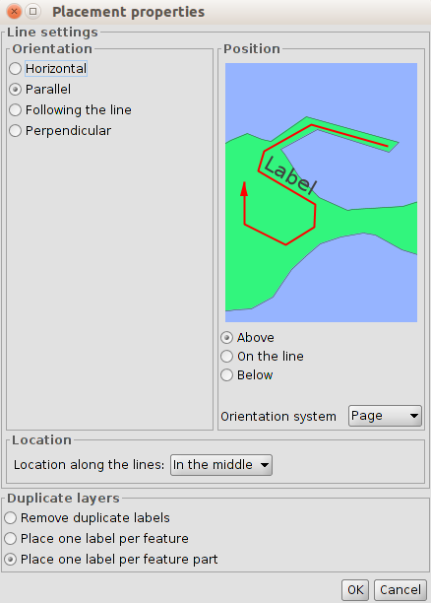
- Orientation. To choose from horizontal, parallel, following the line or perpendicular to this..
- Position. To show label above, below or on the line.
- Location. Dropdown for selecting the location at the beginning, middle or the end of the line (depending on the scanning direction)..
- Repeated labels. To choose between “Place one label per feature” or “Place one label per feature part” (multigeometries) or “Remove duplicate labels” which will place a label by entity and if this is repeated, it will only show one.
For polygon layer the interface is:
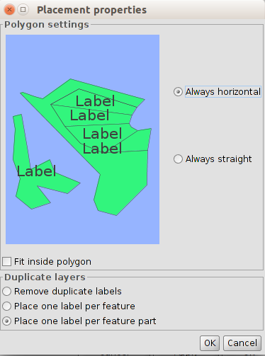
- Polygon settings. It allows horizontal labelling and under the orientation of the polygon, also the option to put the text inside or not. This last option is indicated for polygons with islands or U shaped polygons, in which the label will be placed within the geometry and not in the middle gap.
- Repeated labels. To choose between “Place one label per feature” or “Place one label per feature part” (multigeometries) or “Remove duplicate labels” which will place a label by entity and if this is repeated, it will only show one.
Visualization
To set up the display scale range of the labels.
It is possible to use the same scale range specified for the labels (“General” tab in layer properties or specify a range only to be applied for the labels).
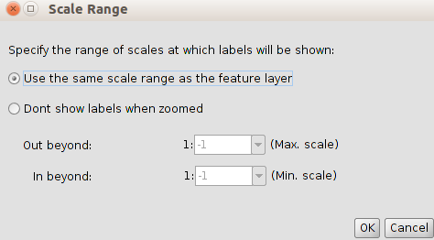
Label overlapping
If this is enabled, all the labels will be drawn, even if they overlap. If this is not checked, the labels will be drawn without ovelap, and can not showw all existing ones.

Raster layer properties

19.1. Information
Provides general information about the raster layer, such as the file path, number of bands, pixel size, and geographic coordinates of the corners.
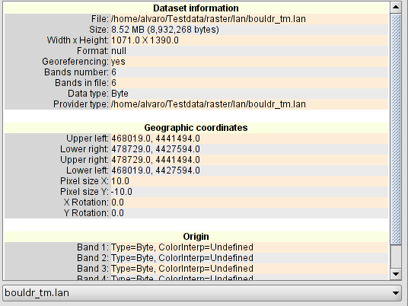

19.2. General
To change the general raster properties. It sets a scale range for the image visualization, set the NoData values, check and recalculate the statistics of the image.
The interface is:
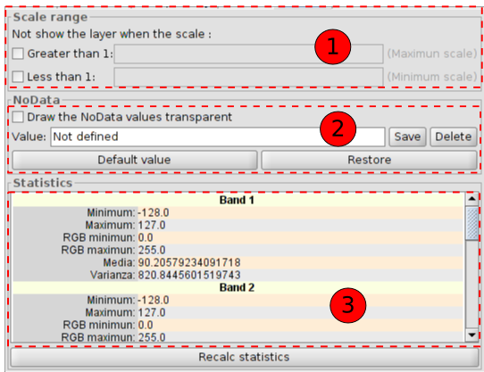
- Scale range. To hide the layer when the display scale is above or below the defined ranges.
- Set and use the NoData values as transparent if it is checked.
- Layer statistics, sorted by band. It may be the case that statistics are badly generated or not calculated, in which case is possible to recalculate them, clicking on “Recalc statistics”. In each band we will see:
- Minimum: Minimum value of the band.
- Maximum: Maximum value of the band.
- RGB minimum:RGB minimum value of the band.
- RGB maximum: RGB maximum value of the band.
- Media: Shows the average of all values of the band.
- Varianza: Shows the varianza of the band.

19.3. Bands
To change the way in which each band of the image is displayed. It allows to make compositions using the different bands of the raster.It is also possible add more bands from other files. This is useful when working with Landsat type images, where each band is from a different file.
The interface is:
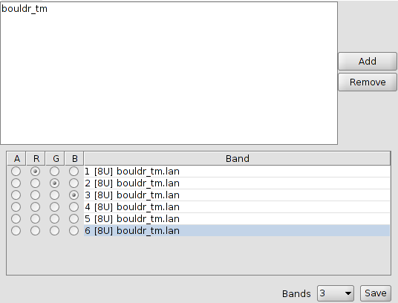
At the top there is a list with all the files of the layer. Here, you can add more files considering that must be a relation between them, they have to be from the same geographic area. This is useful for loading in the same layer, various files frome the same sensor, where each file represents a band.
At the bottom, you can select the display order. By default, the display order is assigned by the colour interpretation of the bands if this information is available. From the display selector , we can change this display order, marking the band we want to be displayed in red (R), green (G), blue (B) or alpha(A). If we click on “Save” the interpretation of colour we have at the moment in the picture will be saved. This means that the next time we open it with gvSIG, the bands will be displayed in that order.

19.4. Transparency
It provides tools to change the transparency levels that can be applied to a raster coverage.
The interface is:
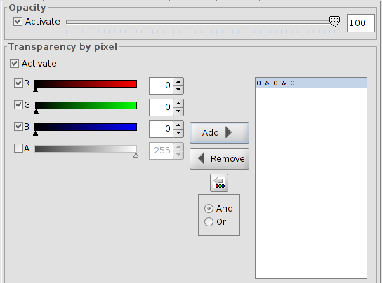
On one hand, there is the “Opacity” option which indicates a opacity percentage. A smaller percentage of opacity, a greater transparency percentage. If is enabled, it is possible to indicate the degree of opacity by numbers or by the slider.
On the other hand, there is the ”Transparency by pixel” option which allows to the (RGB) colour groups to be completely transparent. This is useful, for example, to remove the “wedges” in the ortophotos or satellite scenes, or for deleting the edges between the images of one mosaic.
We must add the RGB transparents in the layer by clicking on “Add”. Three different values will be added, separated with "&" or "|". These values mean the RGB value of the pixel which will be trabsparent. The added values are those that appear on the text boxes, the alpha value is optional. The information in these text boxes can be changed by three methods: typing the value, varying the color sliders or by clicling on the View a colour value. This last option will be activated clicking on "Select RGB clicking on the View". This activates a gvSIG tool in the View to change the RGB values in the transparency box.
If we add the line "255 & 0 & 0", all the pixels with the red colour set as the maximum (255) and green and blue set as the minimum (0), all of them will be transparent. All the full red pixels will be transparent. The symbol "&" can be changed with "And" y "Or". If "Or" is activated, any new entry in the table will appear with the symbol"|". If we add the line "255 | 0 | 0", all the pixels with a red value of 255, or with a green value 0 or with a blue value 0, will be transparent.

19.5. Enhance
It provides a tool for making enhancements over the raster coverage. It allows to modify brightness, contrast and enhance. This last option is essential for correct viewing of images of 16 bits.
The interface is:
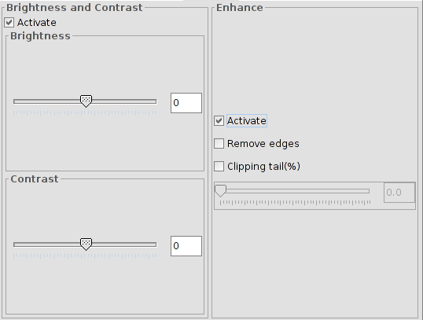

Any changes in this panel will be applied to the display and will never be aimed at generating a new layer. If we want that, the enhancement must apply from the bar raster tools "Enhance".
On the left side of the dialog appear the controls to adjust the brightness and contrast. By defaul, they must appear disabled and if we begin to manipulate, we have to select the check box "Enable".
The right side applies to the linear enhancement. This is a simplification of linear radiometric enhancement to monitor the display of images with different data byte types. By default this enhancement controls are deactivated, unless the image would be of a different data byte type; in that case, it is automatically assigned when the raster is loaded. It is reccomended only to use this interface to automatically vary the values ​​assigned. If you want to assign an enhancement and have more flexibility in the implementation, it is more appropriate to use the functionality "Enhancements Radiation".
This enhancement assigns data input range to a range between 0 and 255 for display.
"Delete ends" option does not take into account the most extreme data values ​​(maximum and minimum) of those in the raster. The "Cut queue (%)" sorts the image data from low to high values. Then, apply the percentage indicated on the right and the left. Those who remain on the outside of the percentage values ​​are removed and only values ​​matching those left inside will be applied. The effect created is to have displaced the maximum and minimum.

19.6. 3D
See section “3D”.

Edition and symbol management

20.1. Symbol browser
From “Tools/Symbols/Browse Symbols” menu:
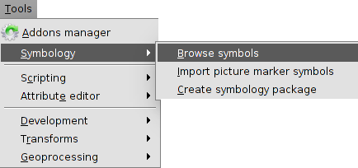
It allows to explore the different symbols in the program and they are classified in three tabs:
- Marker: Point symbols for layers containing point geometries.
- Line: Linear symbols for layers containing linear geometries.
- Fill: Fill symbols for layers containing polygonal geometries.
The interface is similar to the “Symbology selector” window which appears when we want to change any symbol of the legend. In this last case, it will not appear the three tabs, only the relevant for the layer type.
The “Symbol browser” allows to explore the available symbols and through the “Symbol property Editor” to create new symbols or modify the existent ones.
The interface is:
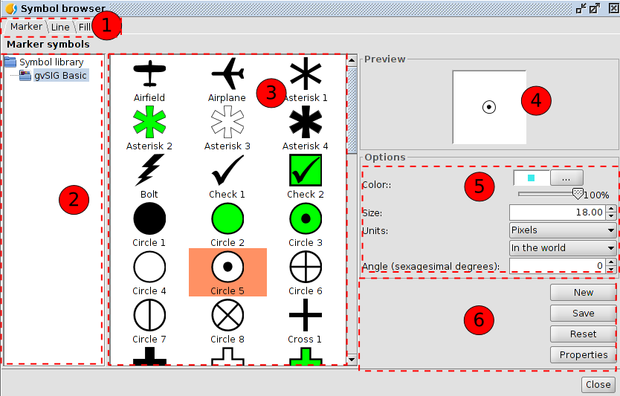
- Tabs with the different types of symbols depending on the geometry of the features.
- Symbol library. The library contains a group of symbols organized in folders and subfolders. The same library can have marker, line or fill symbols. Select the folder or subfolder to see the symbols.
- Symbol viewer of the symbols in one folder or subfolder. Select the symbol to apply or modify.
- Preview of the selected symbol according to the selected properties (size, rotation angle, colour and transparency).
- Options. To define colour, transparency percentage, size and rotation angle of the symbol.
With the units drop-down is possible to choose the unit type to apply. By default is pixel, but is possible to choose between, kilometres, meters, centimetre, millimetres, miles, yards, feet, inches, degrees and pixels. Also, is possible to specify if they are units “in the word” (the size will depend on the zoom) or "in the paper" (it will have a fixed size in screen and printing).
If it is an image file (svg, jpg,...) the colour and transparency will not be applied.
- Buttons to create a new symbol (button “New”) or modify the properties of one already existent (button “Properties”). In both cases the “Symbol Property Editor” will open.
The button “Reset” to start again with the edition of the symbol, deleting all the changes.
The button “Save” to save the new symbol. It will be saved with the extension.gvssym. By default, it will be saved in the “Symbols” folder, which is the root of the symbol library list. The user will have to save the symbol in the folder or subfolder chosen by the user.
The gvSIG basic installation has one single symbol library called “gvSIG Basic”. It is possible to install more symbol libraries from the “Addons manager”.

20.2. Editor. Simple marker symbol
Selecting the “Symbol marker symbol” the interface is:
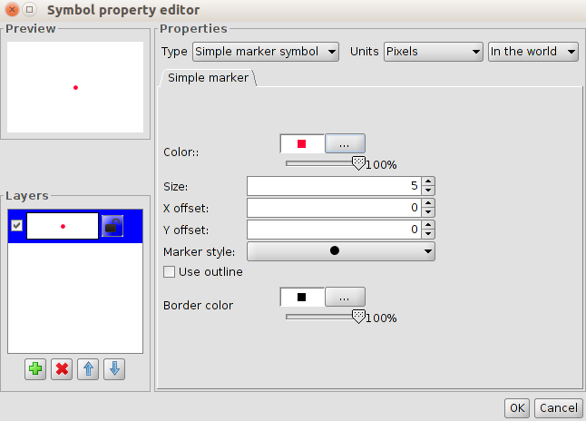
In the left side, there is the symbol preview and the list of the layers. The selected layer is the one with the values showed in the right side (color, size,...)
Simple marker symbol options:
- Colour. Marker colour. It is possible to apply transparency.
- Size. Marker size.
- Offset in X and Y. To move the symbol in relation to the X axis and Y axis.
- Marker style. To select between the available markers (circle, square, cross,...)
- Use outline and border colour. Enabling the space, the marker will have the chosen colour. It is possible to apply transparency.
With the options in “Layers” is possible to create a symbol composed by different layers, with the button “Add layer (green +)”.The layers can be deleted or ordered, with the buttons “Delete layer” and “Order layer”
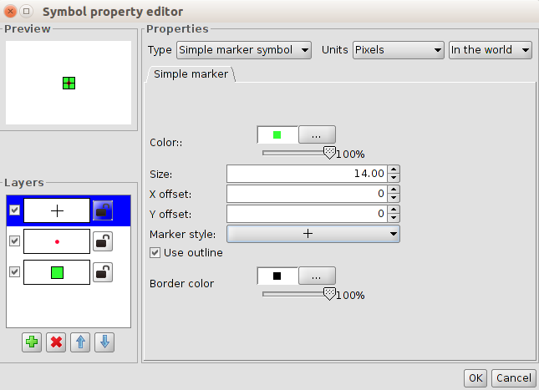

20.3. Editor. Simple marker symbol
Selecting the “Simple marker symbol” the interface is:
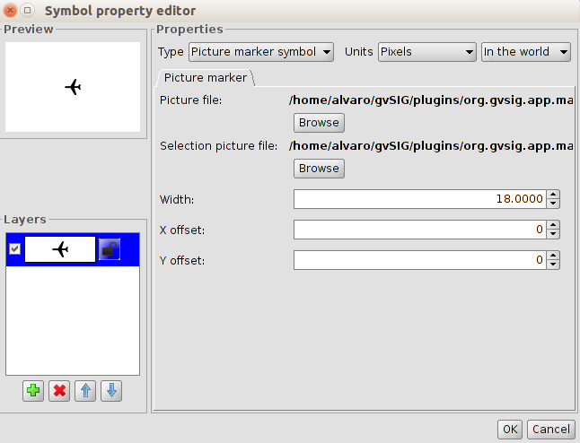
It is possible to select the image for representing one symbol. This image can be (jpg, png,bmp, svg,..) To add it, select the path to the image, clicking on “Browse” and “Picture file”.
Also, it is possible to put as a reference any image “URL” if the format is supported by gvSIG.
There is the option to select other image to represent the geometries when they are selected in the View with the path “Image of selection”.
It allows displacement in X e Y depending on the X axis and Y axis of the image.

20.4. Editor. Simple line symbol
Selecting the “Simple line” the interface with three tabs is:
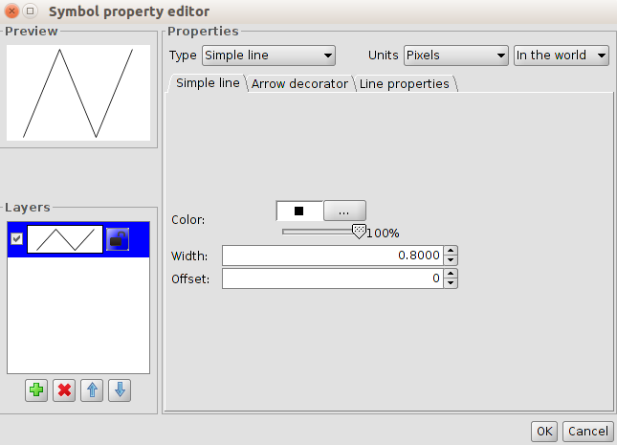
In “Simple line symbol” are the options to select the colour of the line, the transparency, its width and the offset.
As the point layers, it is possible to create a line composed by different lines or line symbols.
“Line properties” is to modify the join and end style, along the fill pattern.
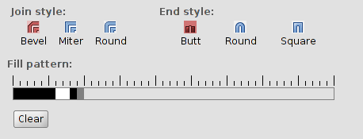
- Join style. There are three types: bevel, miter and round.
- End style. There are three types: butt, round and square.
- Fill pattern. By default gvSIG shows continuous lines. Modifying the fill pattern is possible to create dashed lines.
How it works: Click on the grey section over the ruler and move it to the right. Then click over the ruler section wanted and a black section will appear, which can be deleted if clicks again in a new section. This way new sections to define the line can be added. The black sections are the filled sections and the white ones will be transparent. To delete the created line, press “Clear”.
“Arrow decorator” allows to use the decorate the arrows of the lines enabling “Use decorator”.
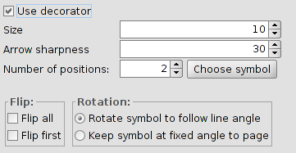
The options are:
- Arrow size
- Arrow sharpness
- Number of positions. Number of times that the arrow is repeated in one line.
- Choose symbol. It opens the “Symbol selector” window for markers. It allows to select the arrow shape and set it up as a dot symbol.
- Flip. To flip just one arrow or all the arrows.
- Rotation. Rotate symbol to follow line angle or keep symbol at fixed angle to page.

20.5. Editor. Picture line symbol
Selecting “Picture line symbol” the interface is:
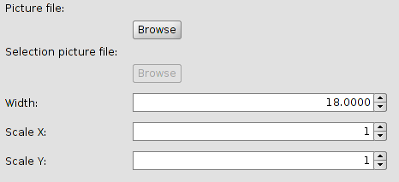
It is possible to select the image that we want to be part of the line. This image has to be (jpg, png,bmp, svg...). To add it, select the route path to the image clicking on “Browse”.
There is the option to set up the width and scale the image in “X” and “Y”.

20.6. Editor. Simple fill symbol
Selecting “Simple fill symbol” the interface is:
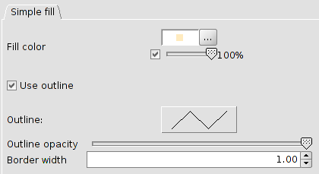
It is possible to select the fill colour of the polygon and its outline opacity.
Clicking on the button showing the border, the “Symbol selector” for lines is open to set up the outline.
There is the option to set up the width and the outline opacity.

20.7. Editor. Picture fill symbol
Selecting “Picture fill symbol” the interface with two tabs is:
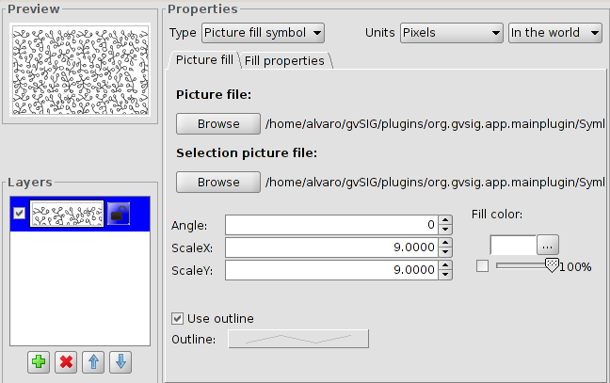
To fill the polygon with one image. It is possible to modify the angle and scale it in “X” and “Y”.
It allows to choose the fill colour and transparency.
These images can be outlined with different lines.
The tab “Fill properties” is to set up the fill depending on the offset (in X and Y) and the separation (in X e Y) of the image.
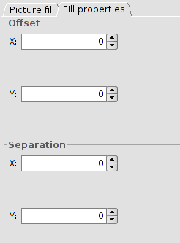

20.8. Editor. Marker fill symbol
Selecting “Marker fill symbol” the interface with two tabs is:
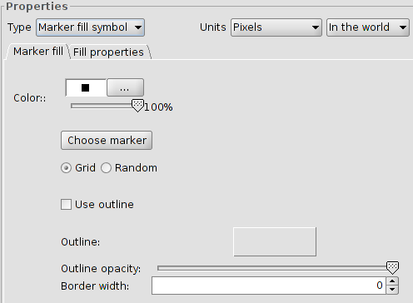
It is possible to give a fill with different marker types: dot, images....with their properties. The fill can be placed as grid as randomly..
The tab “Fill properties” is to set up the fill depending on the offset (in X and Y) and the separation (in X e Y) of the image.
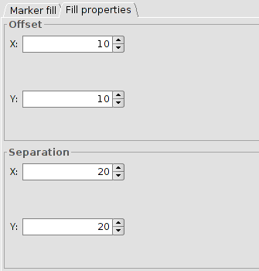

symbol libraries

21.1. AIGA
AIGA is the American Institute of Graphic Arts acronym. AIGA is known by its activities in graphic design, specially in the pictograms for the American Department of Transport in 1979. The library is based on this pictogram group.
The symbols for lines and fills are inspired on the colour palette of the document “Thinking inside the box. AIGA identity and branding guidelines“.
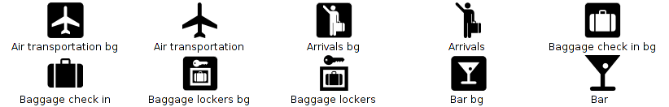
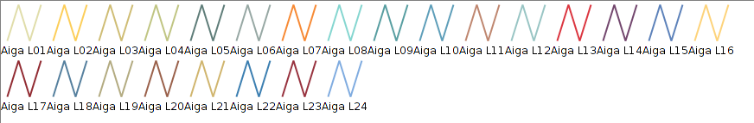
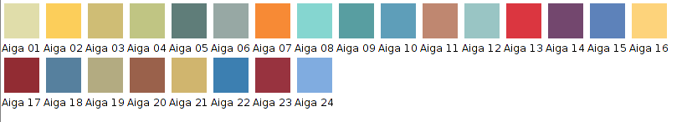

21.2. Collective Mapping
It is a symbology orientated to the collective mapping workshops. It is far from the usual symbology for geographic elements. Its iconography is orientated to ideological representation.
This library is based on the “Collective mapping tutorial. Critical mapping resources for shared mapping ” in Spanish, by Iconoclasistas.
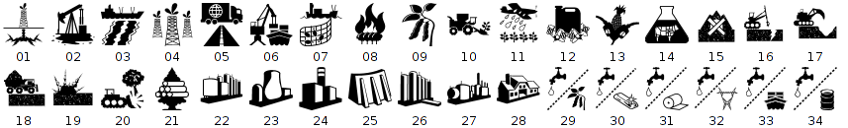
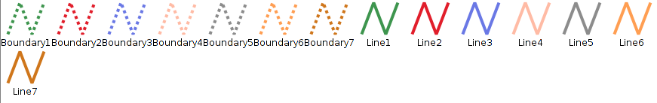
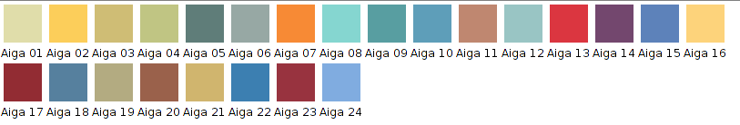

21.3. Colours
Symbology with colour palettes for quantitative data..
The symbol library is based on the colour palettes of “Colour Brewer: Colour Advice for Maps”.
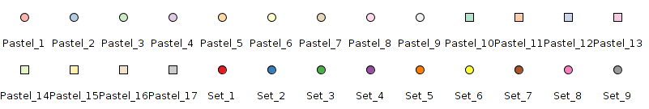
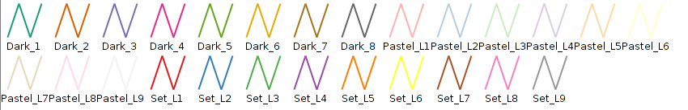
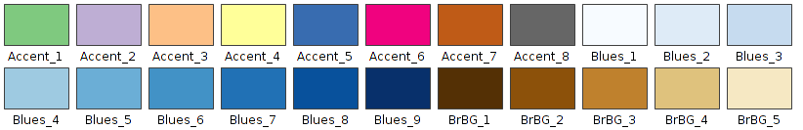

21.4. Commerce
Symbology for commercial activities.
The symbol library is based on the symbols of E-commerce Business Icons of Design Contest, GIS/GPS/MAP Icons of Icons-Land, Bag And Boxes Icons of Babasse and Vista Artistic Icons of Lokas Software.
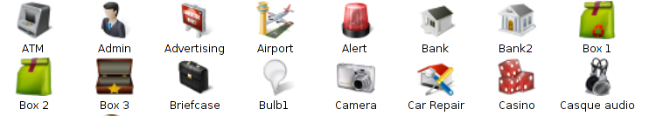
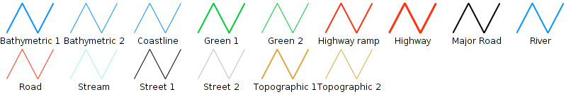
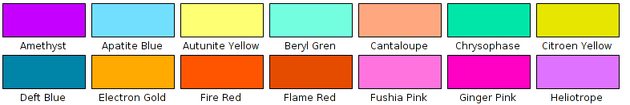

21.5. Crime Mapping Symbology (CMS)
This symbol library is based on the “CMS. The Crime Mapping Symbology”, designed by the US Department of Justice for covering the symbology needs of the Police Department. CMS includes two core systems, Computer Aided Dispatch (CAD) and the Records Management System (RMS).
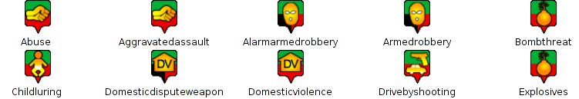
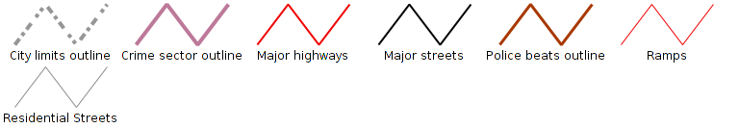
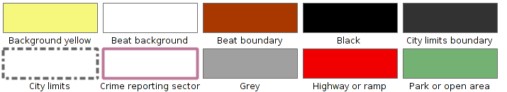

21.6. Emergency
Symbology related to the emergency management.
The symbol library is based on the “EMS. The Emergency Mapping Symbology”, made by the Department of Natural Resources.
The linear and fill symbols are inspired by the document “Biosecurity Emergency Management – Mapping Symbology”.
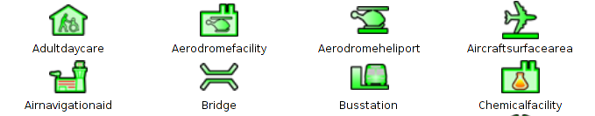
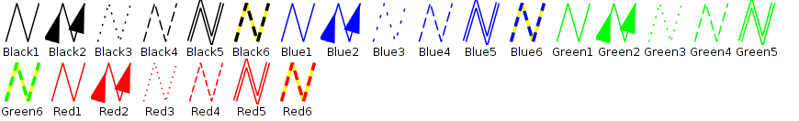
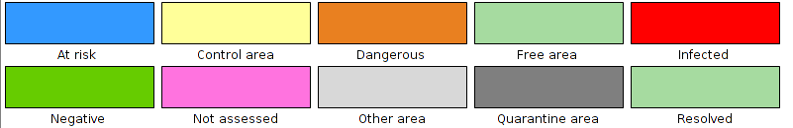

21.7. Forestry
This symbol library is based on the NPS (U.S. National Park Service) symbology and also based on “Trees & Shrubs” made by Jim Mossman.
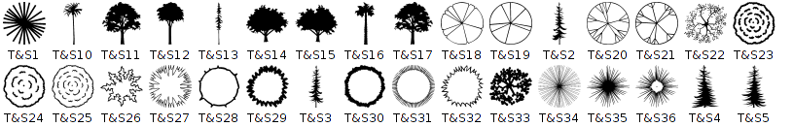
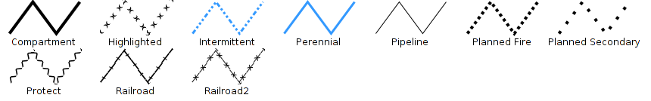
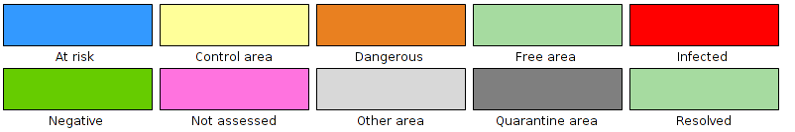

21.8. G-Maps
This symbol library is based on the symbols of Nicolas Mollet, called “Map Icons Collection” and is for Google Maps.
When using point symbols you have to remember that, by default, no “y” offset is applied thus, if you want that the symbol will be over the geometrical point, symbol properties have to be edited adding a “y” offset with a value equal to the half of symbol size (in our case, since the symbol has a default size of 32, an offset of 16 will be used).
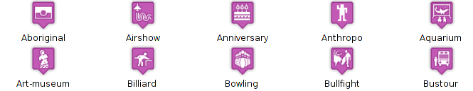
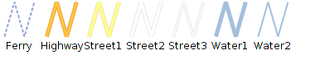
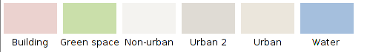

21.9. Geology
This symbol library is based on the “Digital Cartographic Standard for Geologic Map Symbolization “ guide of the FGDC (Federal Geographic Data Committee). The symbols are classified in folders and subfolders (bedding, cleavage, eolian, pluvial/alluvial, foliation, geohydrology…).
The set of filled designed from the RGB colour codes defined by the CGMW (Commission for the Geological Map of the World) represent the different stratigraphic units.
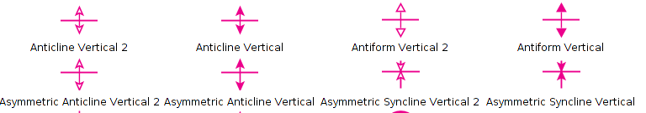
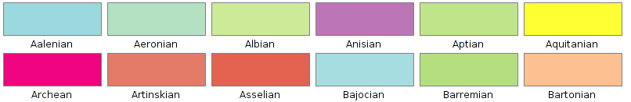

21.10. gvSIG Basic
Basic gvSIG symbol library
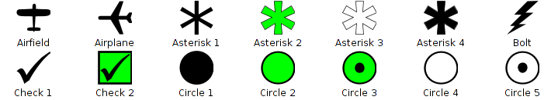
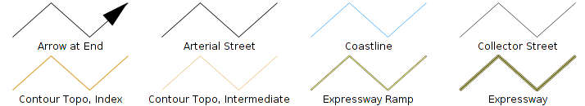
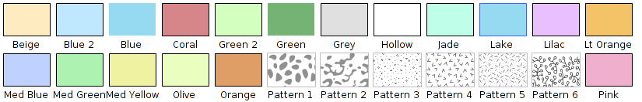

21.11. Japanese
The symbology used in Japan for the representation of maps. It is based on the “Japanese Map Symbols” of the Geographical Survey Institute.
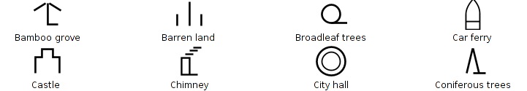
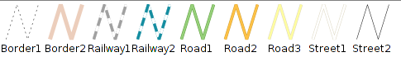
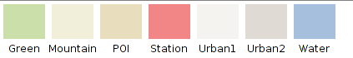

21.12. Military-APP6
This library has all the symbols which are part of the APP6 standard used by the Defence sector. This library is based on the document “Commented APP-6A – Military symbols for land based systems. Defence Research and Development Canada – Valcartier. Technical Notel DRDC Valcartier TN 2005-222. “.
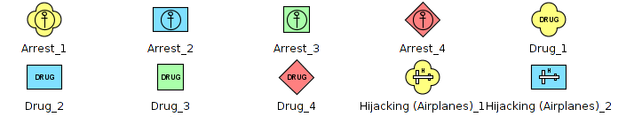
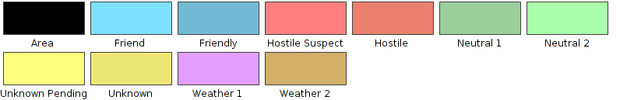

21.13. Navigational
Symbology used for maritime shipping and nautical charts.
This symbol library is based on the symbology used by the IHO (International Hydrographic Organization) and the ECDIS (Electronic Chart Display and Information System).
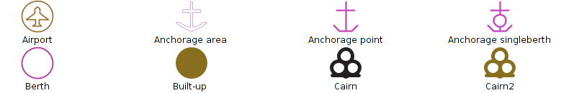
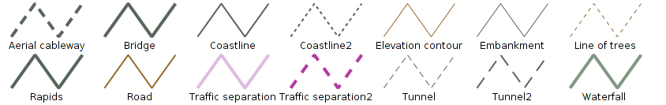
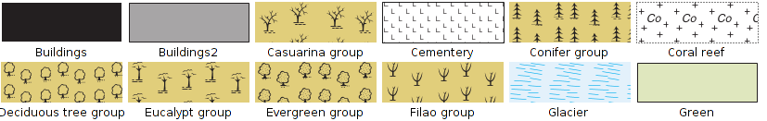

21.14. Numbers
Library with numeric symbols.
This library is based on the symbols of “Letters & Numbers” published by Little Web Things that contains beyond symbols from number 0 to 99, letters symbols in upper-case of Latin alphabet, text fonts from Data Deja View (DDV) called “Circle, Diamond, Hexagon, Pentagon, Shield and Square”, that and the numbers icons belonging to the set called Red Orb Alphabet Icons of Icon Archive.
When using point symbols of set “IwtMapIcons” consider that by default it don’t have applied an offset in “y”, if wanted the vignette appears over geometric point we have to edit the symbol properties and add an offset in “y” of a half the size (in our case, as we set these symbols in size 32, we’ll use an offset of 16).
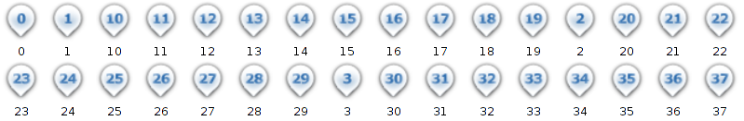
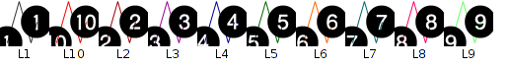
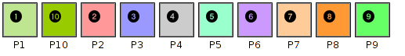

21.15. OCHA-Humanitarian
It is the set of symbols created by the Office for the Coordination of Humanitarian Affairs (OCHA) with humanitarian goals aiming help workers and volunteers show and interpret information about emergencies and crisis quickly and easily. This is the standard or the emergencies symbology.
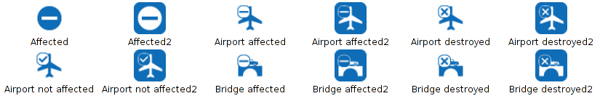
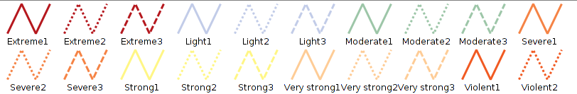
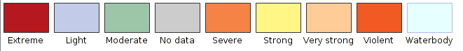

21.16. OSM
This symbol library is based on the symbology made by “SJJB Management” and called “SJJB SVG Map Icons”. Some of these icons have their oringin in the “US National Park Service Cartography”.
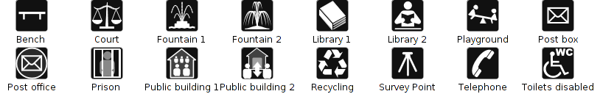
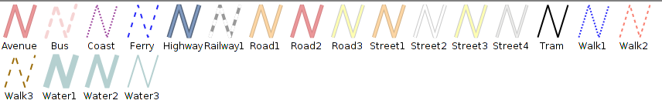
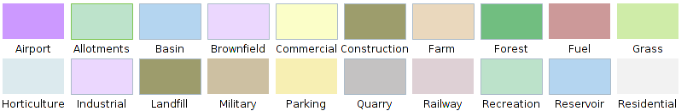

21.17. POI Cities
This library includes a set of symbols that represent the main attractions of a city: parks, airports, subway stations, different types of shops, museums, monuments, ...
It is based on the symbology that MapBox project uses and, specifically, in the library called Maki.

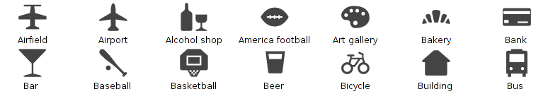
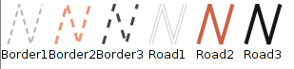
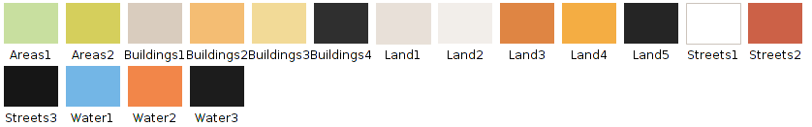

21.18. Weather
Symbology for climate mapping according to the standard World Meteorological Organization in the document “WMO No. 485 – Manual on the Global Data Processing and Forecasting System Manual” the work done by the group MetOceanDWG of OGC related to the symbology to represent the Climatology.
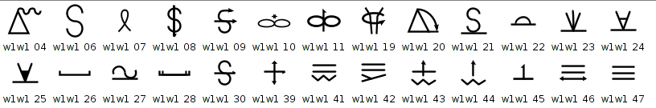
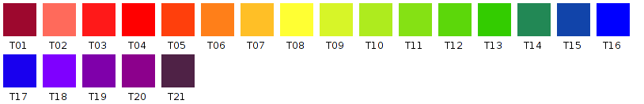

Create symbol libraries

22.1. Import picture marker symbols
With the “Import picture marker symbols” tool, the user can create new symbol libraries from image files (.png,.svg,...) or add these marker symbols to libraries already installed. This tool is located in “Tools/Symbols/Import picture marker symbols”
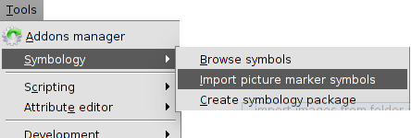
The interface is:
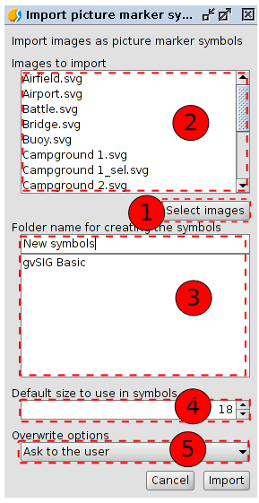
- Clicking on “Select images” a new window appears where we can search and select the images to import.
- Listing of all the selected images to be imported to the symbol library.
- In “Folder name for creating the symbols” we will indicate the name of the new library. It is possible to create subfolders. If we want the symbols saved in one subfolder, we use “/” as the separator between the folder name and the subfolder (folder name/subfolder name).
Listing of installed libraries. If the folder where we want to save the symbols is already in the list, we just need to select it.
- Size by default of the symbols.
- Drop down menu for overwriting options.
- Clicking on “Import”, all the selected symbols will be saved in the defined folder (or subfolder) with the wanted size. A window will appear indicating that the import have been finished.
If we want to have a different symbol when we make a selection, we can do it automatically during the import. We only have to take into account the name of the images that will represent every symbol during the selection; we have to add “_sel” to the symbol name.

22.2. Create package symbols
gvSIG allows to create packages for sharing symbol libraries with other users.
This tool is located in “Tools/Symbols/Create package”.
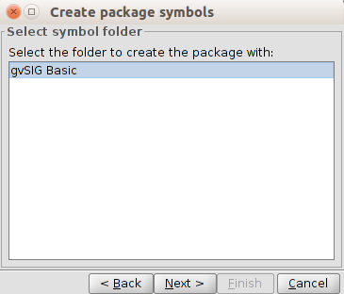
In this window we can see all the symbol libraries available in our gvSIG, in this case “gvSIG Basic”, which is the default library plus the ones created by the user. We can select the library from we want to create the package and click on “Next”.

A form appears to fill the metadata of the package.

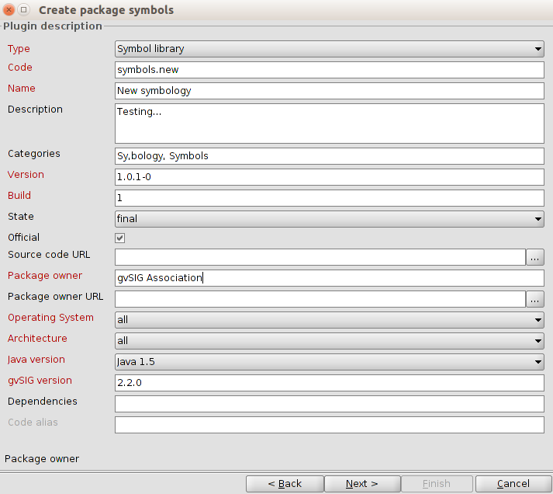
The option “Categories” must have the categories “Symbology, Symbols” to make easier the localization in “Add ons manager”.
Clicking on “Next” one last window will appear where all the output options must be indicated.
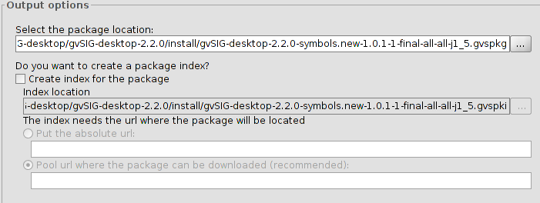
- Package file. It is the folder where the generated package will be saved in. By default, packages are saved in the gvSIG install folder, inside a folder called “install” (usually with a default name and with.gvspkg extension.
- In the case of we want to share the package from an URL, we need to take into account:
– Creating the package index. We will only check this option if we want to share the package. The package index is a GVSPKI file which is useful to install it on-line from gvSIG. No need to check it in any other case.
– Download URL. The server address where the package is available has to be indicated (server/package name)

Navigation tools

23.1. Introduction
The navigation tools are those that allow navigation within the View data and basically make changes to the display scale (zoom) and movements (pan).
These tools are available from the "View / Navigation" menu and in its own button bar.
Menu | Toolbar
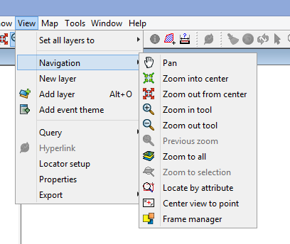
Let´s see all the available tools:
Icon | Tool | Shortcut key | Description
 | Pan |  | This allows you to change the View frame by dragging the viewing field all over the View with the mouse. Click and hold down de primary button of the mouse and move it in the required direction.
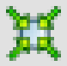 | Zoom in to center |  | Zoom in to the center of the View data.
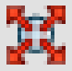 | Zoom out from center |  | Zoom out from the center of the View data.
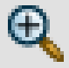 | Zoom in tool |  | Enlarges a particular area of the View.
 | Zoom out tool |  | Reduces a particular area of the View.
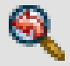 | Previous zoom |  | To go back to the previous used zoom.
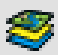 | Zoom to all |  | Full extent zoom of the total area defined by all the layers of the View.
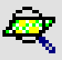 | Zoom to selection |  | Full zoom of the area with all the selected elements.
 | Locate by attribute |  | Zoom in the area of the layer defined by one specific attribute.
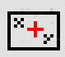 | Center view to point |  | Locate any point in the View by its coordinates and centre the View on this point..
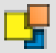 | Frame manager |  | Save and go back to many zooms as you want.
 | Zoom to layer |  | Zoom to the total extension of the layer..  Right click on the selected layer in TOC and click “Zoom to layer” in the contextual menu.
 | Zoom to raster resolution |  | Zoom to a screen pixel with the same pixel size of the raster layer.  Right click on the selected layer in TOC and click “Zoom to raster resolution” in the contextual menu. Clickingf on the visible area and it will center the View on this point.
Scrolling the mouse is possible to zoom in and zoom out. In this case, the enlargement will use as focus, the View center. With the mouse wheel pressed and moving it, the frame order will be executed.
In the status bar is possible to indicate the View scale, writing the scale factor or selecting any of the available in the drop-down menu.

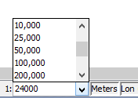

23.2. Zoom Manager
It is possible to save a zoom and go back to it at any time.
This tool is available in the “View/Navigation/Frame Manager” and in the specific tool bar.
The interface is:

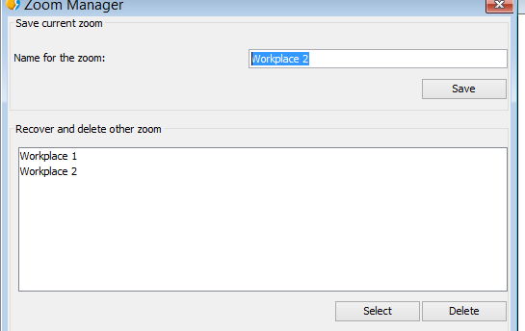
- Name for the zoom. It allows to give a name to the actual zoom of the View.
- “Save” button. The zoom currently in the View will be added to the Zoom Manager text box with the given name and with the rest of available zooms.
- Recover and delete other zooms. Available zooms list.
- “Select” button. Selecting one zoom from the list, the View will recover that selected zoom.
- “Delete” button. Delete the selected zoom from the list.

23.3. Center View to point
Center the View to one point with its specific coordinates.
This tool is available in the “View/Navigation/Center View to point” and in the specific tool bar.
The interface is:
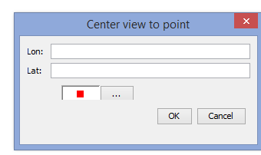
Input any required coordinates and select the colour of the point. Clicking “Accept”, the zoom will be focused on that point and it will show an information screen of that point.

23.4. Locate by attribute
This tool allows to zoom in the entities of one layer with a particular attribute.
It is available in the “View/Navigation/Locate by attribute” and in the specific toolbar.
The interface is:
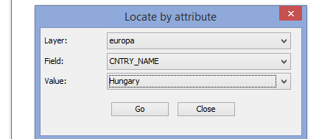
- Layer. Drop-down menu for selecting any available layer of the View.
- Field. Drop-down menu for selecting one field of the selected layer of the View.
- Value. Drop-down menu for selecting one value from the selected field.
- “Go” button. It will show a zoom of the View which contains all the entities of the layer with the indicated attribute.

23.5. Locator map
The locator is a general map which is displayed in the bottom left corner of the View´s window and it will locate the working area (main window zoom).
Available in “View/Locator Map” menu.
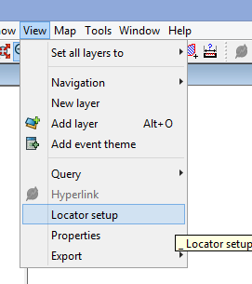
It shows the following window:
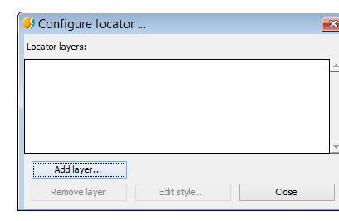
We can add layers which will be part of the locator map. From this window, we can delete layers or edit the legends.
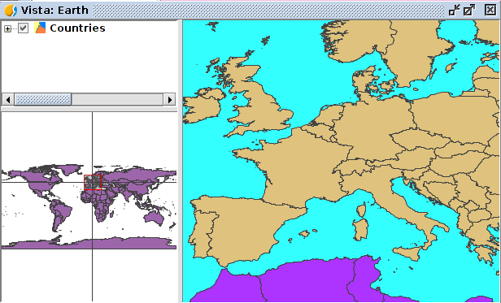
Locator elements:
- Red box. It is the View zoom..
- Horizontal/vertical axis indicates the central point in the View zoom.
Some of the properties are:
- Clicking on the locator with the primary button mouse and dragging, the frame (zoom and displacement) of the View.
- Clicking on the locator with the secondary button mouse and dragging, the View frame will be displaced, maintaining the scale.

23.6. Finding by Gazetteer
A Gazetter or geographical dictionary is one group of data in where all the toponyms are related to its geographic coordinates. It is a geographic index for identifying the geographical place of one toponym.
Available in the specific toolbar:
Let´s see all the available tools:
Icon | Tool | Shortcut key | Description
 | Finding by Gazetter |  | Search by Gazetteer.
 | Delete previous searches |  | Delete the searches made by Gazetteer. This button will appear with the first search.
It shows the following window:
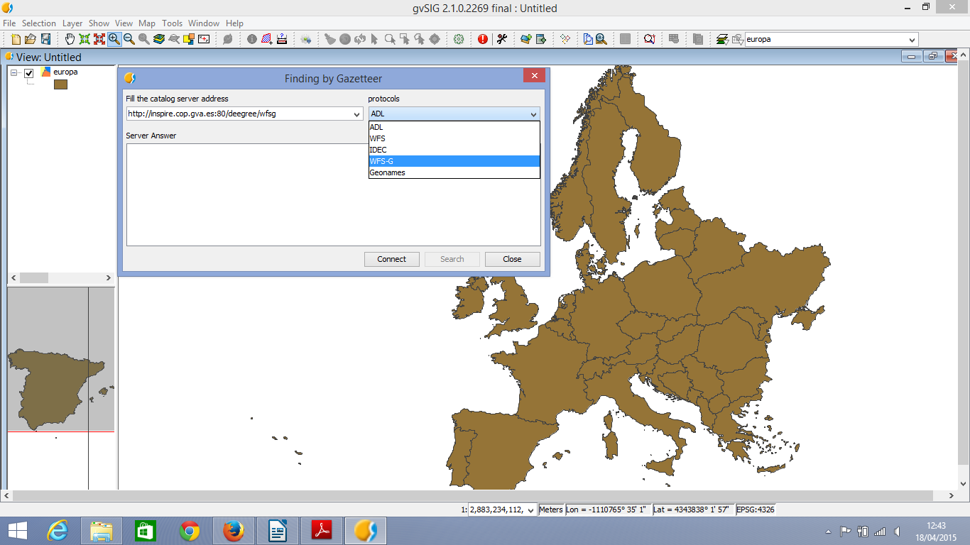
- Fill in the catalog server address: Blank space to introduce the URL. With “Ctrl+V” is possible to paste a text from the clipboard.
- Protocols: To select the server- The available ones are:
  - ADL. Protocol specified by Alexandria Digital Library.
  - WFS. Protocol for the searching for any place name, always in the case of having a text attribute in any of the tables. At the same time, it allows to make searches using any other field, not only with text attributtes.
  - IDEC. Protocol for using the Gazetteer service of the “Instituto Cartográfico de Cataluña” (ICC).
  - WFS-G. Protocol defined by OGC.
  - Geonames. Protocol for using the Geonames web service with a world database.
  - “Connect”. To connect to the server. A new window will appear for the search.
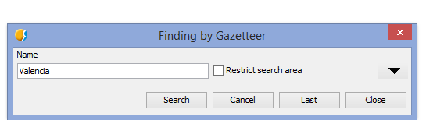
- This window allows to make a criteria search defined by the user. It is possible to view the form in a summarised way or make an advanced search clicking the triangle at the top right corner.
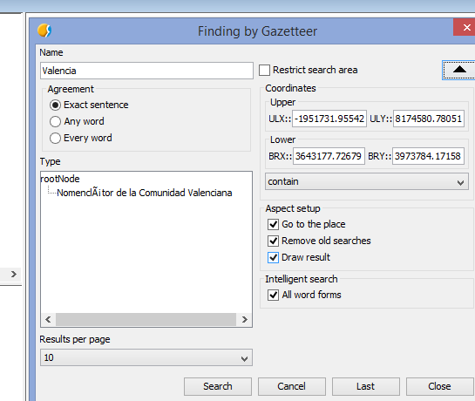
- Name. Write down the name for the search.
- Agreement. Define the search criteria of the input text:
  - Exact sentence.
  - Any word.
  - Every word.
- Coordinates. To define the coordinates of the searching area. By default, the coordinates will be the ones referred to the View frame.
- Restrict search area. Clicking it, the searching area will be restricted.
- Aspect setup:
  - Go to the place. The searched place name will be the center of the View.
  - Remove old searches. Delete all the old searching texts from the View.
  - Draw result. Draw one point and one label text in the place of the searching.
- Results per page. To indicate the number of results for each page.
- “Search” button. To launch the searching process. A new window will be opened:
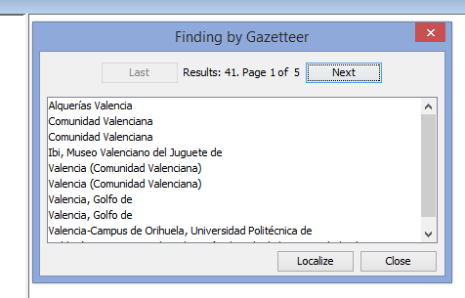
- Use the buttons “Last” and “Next” to move for the results pages.
- Selecting the place name from the result list and clicking “Localize”, the View will be focused on the place name.

Consulting tools

24.1. Introduction
These tools are for getting information from the layers and are available from the “Layer/Query” menu or in its specific buttons in the toolbar.

Menu | Toolbar
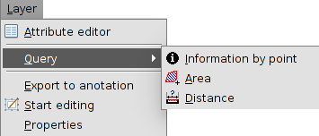
Let´s see all the available tools:
Icon | Tool | Shortcut key | Description
 | Information by point |  | To see the attribute values for one entity.
 | Query area |  | To measure areas and perimeters. It is possible to draw a polygon over the View area and obtain the area and peimeter.
 | Query distance |  | To measure distances. It is possible to draw lines and obtain the lenght.
 | Hyperlink |  | To see the hyperlinks of any entity.

24.2. Information
With this tool is possible to see the attribute values for one entity.
This tool is available from the “Layer/Query” menu or in its specific buttons in the toolbar.
The steps to follow are:
- Activate in TOC the layer or layers which contains the elements to be identified.
- Click on “Information”.
- Click on in any point of the area of the View frame to identify the entities of the ubication.
- A new window will be showed; “Identify results”.
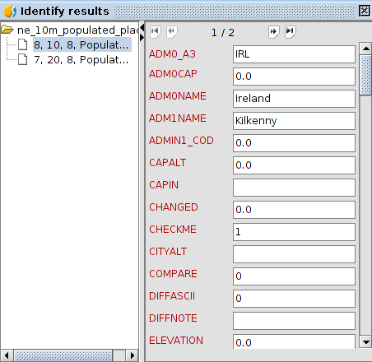
On the left side, the elements from which the information has been asked and its layer will be visible.
On the rigth side, the attribute values of the seleced element on the left part.

24.3. Query area
To measure areas and perimeters over the area of the View frame.
This tool is available in its specific toolbar.
The steps to follow are:
- Click on “Query area”.
- Click on the point which represents the first vertex of the area to be measured and drag the mouse and make click on each new vertex., ending with a double click.
- On the right bottom part of the View window, the area (A) and perimeter (P) can be found.

24.4. Query distance
To measure distances over the area of the View frame.
This tool is available in its specific toolbar.
The steps to follow are:
- Click on “Query distance”.
- Click on the point which represents the first vertex of line to be measured and drag the mouse and make click on each new vertex., ending with a double click.
- On the right bottom side, the distance of the last line (Dist) and the sumatory of all the measured lines (Total).can be found.

24.5. Hyperlink
To consult the hyperlinks of one entity. The hyperlink is one link to other resource(image, website,...) and it is associated to the elements of one layer.
This tool is available in its specific toolbar.
The steps to follow are:
- In the layer properties, the hyperlink option must be activated.
- Activate in TOC the layer with the elements whose hyperlinks are going to be consulted.
- Click on “Hyperlink”.
- Clicko on the element.
- The hyperlink results will appear. These results will depend on the hyperlink properties: image, PDF,....

Selection Tools

25.1. Introduction
These tools are the ones that allow you to select a group of features in a layer. ome tools in gvSIG can work only on selected features.
The selection of vector features can be performed both from the view like from the attributes table associated with a layer.
These tools are available from the "Layer / Selection" menu on the corresponding button bar.

Menu | Button bar
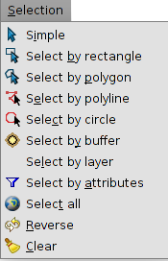
Let's see one by one all the available tools:
Icon | Tool | Shortcut | Description
 | Clear selection |  | Clean the previously done selection
 | Select all |  | Select all the elements of a layer
 | Select By Attributes |  | Selects entities based on a query by attribute
 | Reverse |  | Reverse selection
 | Simple |  | Selecting feature by feature
 | Select by circle |  | Select features that intersect the circular area defined by the user
 | Select by Layer |  | Spatial selection of features in a layer respect to another
 | Select by rectangle |  | Select features intersecting the rectangular area defined by the user
 | Select by polygon |  | Select features intersecting the polygonal area defined by the user
 | Select by buffer |  | Selection by area of influence
To select the elements of a layer, it is required that the layer is active.
To apply most of the graphic selection tools, you should click the left mouse button on the selection starting point, then drag and drop to finalize the selection. In the case of the simple selection, just click on the item you want to select. In the case of selection by polygon, click on each vertex of the polygon and double-click to finalize the selection.
To add features to an already existing selection, you must hold down the "Control" key while selecting features. To unselect one or more selected features of a multiple selection, you must hold down the "Control" key and click over them.
The selected features are displayed in yellow
In the "Preferences" of the View, it is possible to change the default color of the selection

25.2. Select by buffer
Permite realizar una selección por área de influencia a partir de uno o más elementos seleccionados. Crea áreas de influencia utilizando la distancia de área de influencia en torno a las entidades fuente (elementos seleccionados de partida) y devuelve todas las entidades que intersectan las áreas de influencia.
Allows to perform a buffer selection from one or more selected features. It creates buffer areas using the distance of an influence area around the source elements (starting selected features) and produce as output all the features intersecting the areas of influence.
This tool is available from the "Selection" menu on the corresponding button bar.
There must be at least one element selected from a layer. The resulting selection is applied to the active layers.
This is the user interface:
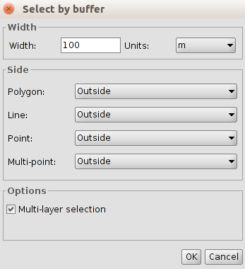
- Width: width of the area of the buffer.
- Unit. measurement unit selectable via a drop down list.
- Side. Depending on the type of layer, selects the direction to be applied to the buffer: Outside (external), Inside (internal).
- Options. Multi-layer selection. Activating the check box selection, the buffer is applied to all layers that are multi-layer.

25.3. Select by layer
You can select features based on their poistion in relation to other layer(s) feature(s) by using several selection methods.
This tool is available from the "Selection" menu through this interface:
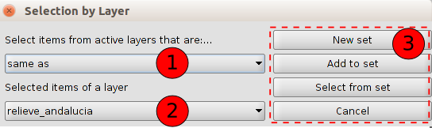
- Select the active layers and by the dropdown list define the selection method.

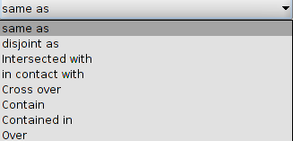
The location selection methods include:
- Same as. Select the features that are the same in another layer. Two elements are considered equal if their geometries are exactly the same. Layers type must be the same.
- They are disjoint as. Select features in a layer that are different from other layers. Two features are considered different if their geometries are not exactly the same.
- Intersected with. Select the entities that are completely or partially overlapped with the source features.
- In contact with. A target feature is selected if the intersection of geometry to the source entity is not empty, but the intersection of their interiors is empty.
- Cross over. Selects features crossing the limits of the source features. The boundaries of the source and destination features must share at least one side, vertex or node.
- Contain. The geometry of the source entity should be within the geometry of the target layer, including its boundaries.
- Contained in. Select the entities that are within the geometry of the source entities.
- Over. Select the features that overlap with the geometries of the source entities.
- Selected features of the layer. Selects by a drop down list, the selected layer selected of the source features.
- Selection Options.
- New set. Create a new selection
- Add to set. Create a selection considering the already existing query and summing the result of the current query to it.
- Select from set. Create a selection only from the already selected features
If we want to use all elements of a layer as the source entities, we must previously select all the elements of that layers.

25.4. Select by attributes
It makes user able to select features by using an attributes query
This is its user interface.
- Fields. List of attribute fields in the layer. Double-click on the field to add it in the query.
- Logical operators. Inserts, by clicking on them, a logic operator to the query expression.
- Known values. Lists the values present in the layer attribute table for the selected field. Double click on the value to add it to the selection query.
- Expression. Text box reporting the query that is going to be run. It allows direct typing.
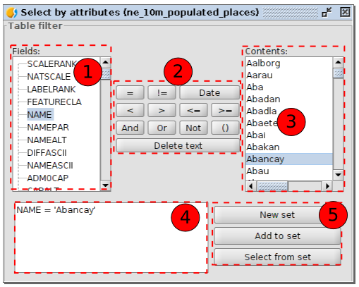
- Selection Options.
- New set. Create a new selection
- Add to set. Apply the query considering the already existing query and sum the result.
- Select from set. Apply the query only to the already selected features

Graphic editing tools

26.1. Introduction
To create and edit various types of vector data with some feature formats. Other formats are read-only and don´t allow editing.
To add or modify elements of one layer, it requires that the layer is active and in editing mode. Depending on the layer type the options will be different.
These tools are available from “Layer” menu and “Remove”, “Insert” and “Modify” submenus, from the “Edit” menu and from the specific button bar.
Button bar
Menu
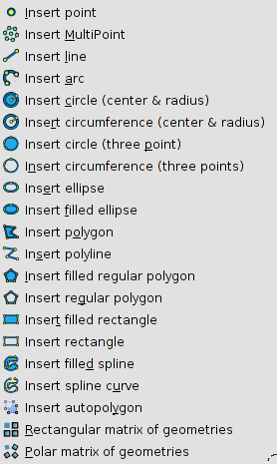  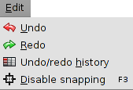 | 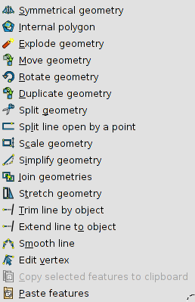

gvSIG allows to have more than one layer active at the same time.
With “Esc” key any edition operation will finished.

26.2. Start / Finish editing
To start or finish the editing session (the layer must be active).
The tool changes itself depending on the status of the edition. When the layer is not in editing mode, it will be “Start editing” and when the editing session has been initiated, it will be “Finish editing”.
It is available from “Layer” menu, in the context menu of the layer and in the specific button bar.
Menus
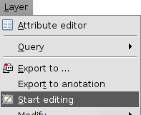 | 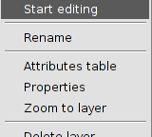

Icon | Tool | Shortkey | Description
 | Start / Finish editing |  | To start of finish the edition.

26.3. Command console
To introduce orders and editing options using the command console.
It is located at the bottom part of the View frame when the layer is in editing mode.
The console can be resized and hidden.
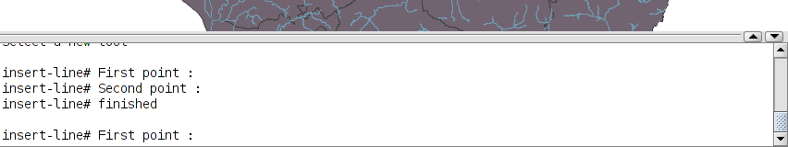
To write down the commands use the keyboard. Once the selected option is indicated, press “Enter” for being registered.

26.4. Flatness
In gvSIG any curved geometry is made up of one determined number of sections. Flatness is the parameter to define the density of the straight lines which define the curved geometries. A high Flatness number can make that the curved elements will be visualized as polylines.
In “Preferences/Flatness”, its value can be modified.

Tools for modifying features

27.1. Introduction
To modify elements of one layer in editing mode.
These tools require a selection of features (geometries) where to apply the tool.
Once the tool is executed, press the right button to access to a context menu which allows to select between the different tool options, indicate points with its exact coordinates,.....
Let´s see all the available tools:
Icon | Tool | Shortkey | Description
 | Geometric Symmetry |  | To create symmetries of existing elements.
 | Internal polygon |  | To delete internal parts of one polygon, creating an island polygon.
 | Explode/Break down geometry |  | Break downs a multigeometry in geometries.
 | Move geometry |  | Move the geometries between two specific points.
 | Rotate geometry |  | Rotate the selected geometries a specific angle.
 | Copy geometry |  | To copy and move existing geometries.
 | Split geometry |  | To split one geometry using a cut option.
 | Split line in one point |  | To split one line in one specified point
 | Scale geometry |  | To modify the size of one geometry using a scale value.
 | Simplify geometry |  | To simplify the geometry preserving the essential size of the geometry.
 | Join geometries |  | To join geometries.
 | Insert autopolygon |  | To insert a polygon next to the existing ones.
 | Stretch geometries |  | To stretch a geometry moving the selected vertex.
 | Extend line to object |  | To extend one line to one object.
 | Cut line with one object |  | To cut one line with a cutting edge defined by other objects.
 | Smooth line |  | To smooth the angles of one line.
 | Edit vertex |  | To edit the vertex of one geometry (move, remove or add).
 | Copy features |  | To copy selected elements to the clipboard.
 | Paste features |  | To paste copied features from the clipboard.
 | Delete |  | To delete the selected features.

27.2. Symmetry
To create symmetries of the existing features. The resulting geometries will have the same attributes.
This tool is available from the "Layer / Modify" menu and from the relevant button bar.
The steps are:

1. Select the feature or features on which to apply the tool. If there are selected features previously to the use of the tool, the tool will be applied on these. To end the selection, press "Enter".
2. First point on the axis of the symmetry. You can enter it graphically by clicking with the mouse, specifying the coordinates of the point using the console command or with the context menu by selecting "First point..." that opens a window for entering the coordinates.
3. Second point on the axis of symmetry. You can enter it graphically by clicking with the mouse, specifying the coordinates of the point using the console command or with the context menu by selecting “Second point..." that opens a window for entering the coordinates.
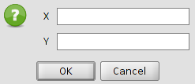

4. Select between delete or keep the original geometries. The aimed option can be indicated in the command console or with the context menu.
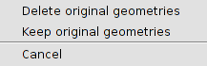

27.3. Internal polygon
To delete internal parts of one polygon. It generates an “island” polygon.
This tool is available from the "Layer / Modify" menu and from the relevant button bar.
The steps are:
1.Select the feature or features on which to apply the tool. If there are selected features previously to the use of the tool, the tool will be applied on these. To end the selection, press "Enter".
2.Select one tool from the ones used to insert features to draw the internal polygon or cutting area.

27.4. Explode geometry
To break down one multigeometry into geometries. The resultant geometries will have the same attributes.
This tool is available from the "Layer / Modify" menu and from the relevant button bar.
The steps are:
1.Select the feature or features on which to apply the tool. If there are selected features previously to the use of the tool, the tool will be applied on these. To end the selection, press "Enter".

27.5. Move geometry
To move the selected geometries between two specified points.
This tool is available from the "Layer / Modify" menu and from the relevant button bar.
The steps are:

1. Select the feature or features on which to apply the tool. If there are selected features previously to the use of the tool, the tool will be applied on these. To end the selection, press "Enter".
2. First point. You can enter it graphically by clicking with the mouse, specifying the coordinates of the point using the console command or with the context menu by selecting "First point..." that opens a window for entering the coordinates.
3. Second point. You can enter it graphically by clicking with the mouse, specifying the coordinates of the point using the console command or with the context menu by selecting “Second point..." that opens a window for entering the coordinates.

27.6 Rotate geometry
To rotate the selected geometries one specified angle.
This tool is available from the "Layer / Modify" menu and from the relevant button bar.
The steps are:
1. Select the feature or features on which to apply the tool. If there are selected features previously to the use of the tool, the tool will be applied on these. To end the selection, press "Enter".
2. Rotation centre. You can enter it graphically by clicking with the mouse, specifying the coordinates of the point using the console command or with the context menu by selecting "Rotation centre..." that opens a window for entering the coordinates.
3. Rotation angle. You can enter it graphically by clicking with the mouse, specifying the grades of the rotation angle using the console command or with the context menu that opens a window for entering the rotation angle.
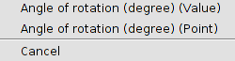
In the case of using the angle graphically, a visual aid will be available indicating the value of the rotation angle.
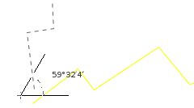

27.7. Duplicate geometry
To copy and move existing geometries. The duplicated geometries will keep the same attributes.
This tool is available from the "Layer / Modify" menu and from the relevant button bar.
The steps are:

1. Select the feature or features on which to apply the tool. If there are selected features previously to the use of the tool, the tool will be applied on these. To end the selection, press "Enter".
2. First point. You can enter it graphically by clicking with the mouse, specifying the coordinates of the point using the console command or with the context menu by selecting "First point..." that opens a window for entering the coordinates.
3. Second point. You can enter it graphically by clicking with the mouse, specifying the coordinates of the point using the console command or with the context menu by selecting “Second point..." that opens a window for entering the coordinates.

27.8. Split geometry
To divide a geometry in various geometries using a cutting element. The resultant geometries will have the same attributes.
This tool is available from the "Layer / Modify" menu and from the relevant button bar.
The steps are:

1. Select the feature or features on which to apply the tool. If there are selected features previously to the use of the tool, the tool will be applied on these. To end the selection, press "Enter".

2. Select one inserting tool to draw the cutting element.

27.9. Split line in one point
Split one line from a specified point.
This tool is available from the "Layer / Modify" menu and from the relevant button bar.
The steps are:

1. Select the feature or features on which to apply the tool. If there are selected features previously to the use of the tool, the tool will be applied on these. To end the selection, press "Enter".

2. Cutting point. You can enter it graphically by clicking with the mouse, specifying the coordinates of the point using the console command or with the context menu by selecting "Point" that opens a window for entering the coordinates.

27.10. Scale geometry
To resize the geometry using a scale value.
This tool is available from the "Layer / Modify" menu and from the relevant button bar.
The steps are:

1. Select the feature or features on which to apply the tool. If there are selected features previously to the use of the tool, the tool will be applied on these. To end the selection, press "Enter".

2. Origin. You can enter it graphically by clicking with the mouse, specifying the coordinates of the point using the console command or with the context menu that opens a window with two options for entering the scale origin.

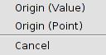
3. Scale factor or reference point. You can enter it graphically by clicking with the mouse, specifying the coordinates of the point using the console command or with the context menu that opens a window with two options for entering the scale origin.
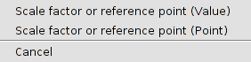
4. Second reference point. You can enter it graphically by clicking with the mouse, specifying the coordinates of the point using the console command or with the context menu by selecting “Second reference point” that opens a window with two options for entering the coordinates.
In the case of using the angle graphically, a visual aid will be available indicating the value of the scale factor and the possible result.
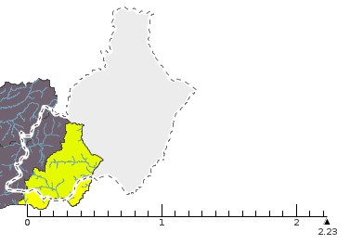

27.11. Simplify geometry
To simplify a geometry keeping the essential form of the geometry.
This tool is available from the "Layer / Modify" menu and from the relevant button bar.
The steps are:

1. Select the feature or features on which to apply the tool. If there are selected features previously to the use of the tool, the tool will be applied on these. To end the selection, press "Enter".

2. Tolerance. It is the maximum distance between two lines which define the geometry of the three sequential nodes and the line of the simplified geometry from joining the first and the last of those nodes. You can enter the value by using the console command or with the context menu that opens a window for entering the value.
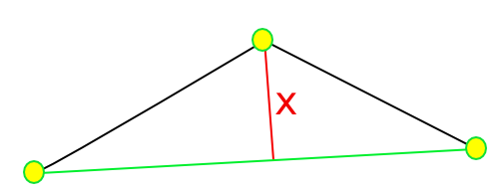

27.12. Join geometries
To join various geometries in one unique geometry.
This tool is available from the "Layer / Modify" menu and from the relevant button bar.
The steps are:

1. Select the feature or features on which to apply the tool. If there are selected features previously to the use of the tool, the tool will be applied on these. To end the selection, press "Enter".

27.13. Insert autopolygon
To insert one polygon next to other existing elements, without drawing the common borders.
This tool is available from the "Layer / Modify" menu and from the relevant button bar.
The steps are:

1. Select one tool for inserting polygons and draw the autopolygon.

27.14. Stretch geometry
To stretch one geometry moving the selected vertex.
This tool is available from the "Layer / Modify" menu and from the relevant button bar.
The steps are:

1. Select the feature or features on which to apply the tool. If there are selected features previously to the use of the tool, the tool will be applied on these. To end the selection, press "Enter".

2. Select one tool for inserting polygons and draw the polygon, which allows to select the vertex to stretch. The selected vertex will be shown.

27.15. Extend line to object
To extend one line to object.
This tool is available from the "Layer / Modify" menu and from the relevant button bar.
The steps are:

1. Select the feature or features on which to apply the tool. If there are selected features previously to the use of the tool, the tool will be applied on these. To end the selection, press "Enter".

2. Select each line to extend. When the mouse is over the line, a result preview is shown; at the time the lines are being selected, they will be extended until the indicated objects in the previous step.

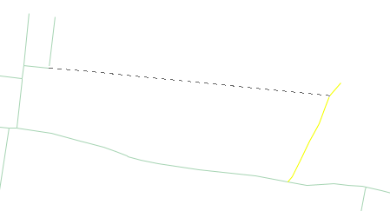
3. Once all the lines have been extended, press “Esc” to close the function.

27.16. Split line with an object
To split a line in a cutting edge defined by other objects.
This tool is available from the "Layer / Modify" menu and from the relevant button bar.
The steps are:

1. Select the feature or features on which to apply the tool. If there are selected features previously to the use of the tool, the tool will be applied on these. To end the selection, press "Enter".

2. Select each line to split. When the mouse is over the line, a result preview is shown; at the time the lines are being selected, they will be extended until the selected objects in the previous step.
3. Once all the lines have been extended, press “Esc” to close the function.

27.17. Smooth line
To smooth angles in one line.
This tool is available from the "Layer / Modify" menu and from the relevant button bar.
The steps are:

1. Select the feature or features on which to apply the tool. If there are selected features previously to the use of the tool, the tool will be applied on these. To end the selection, press "Enter".

2. Intermediate steps [1,9].

3. Smooth method. There are three methods available: natural cubic splines, Bézier curves, B-splines

27.18. Edit vertex
To edit the vertex of one geometry(move, delete and add).
This tool is available from the "Layer / Modify" menu and from the relevant button bar.
The steps are:

1. Select the feature or features on which to apply the tool. If there are selected features previously to the use of the tool, the tool will be applied on these. To end the selection, press "Enter".The vertex of the geometry will be shown.

2. Select one vertex. You can enter it graphically by clicking with the mouse, specifying the coordinates of the point using the console command or with the context menu by selecting “Select one vertex..." that opens a window for entering the coordinates.

3. Move, insert or delete vertex. Once the vertex has been selected, there these options available:
  - Move. Moving the mouse and clicking in the new position to move the selected vertex.
  - Insert vertex. Pressing on “+”.
  - Delete vertex. Pressing on “-”.

27.19. Converting to polyline
Allow converting curve lines to polylines.
The steps are:
- Select the element to which will be applied the tool. If a selected element exists prior to the tool use, it will be applied the tool on it. To complete the selection press “Enter”. The selected curved lines will become polylines

27.20. Reverse direction
Allows you to reverse the digitization sense of a geometry.
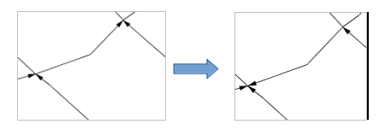
The steps are:
- Select the element on which we want to apply the tool. If a selected element exists prior to the tool use, it will be applied the tool on it. To complete the selection press “Enter”. The selected elements will automatically reverse their digitization sense.

27.21. Paralell Geometry
Allows selecting lines series and create a parallel with them.
The steps are:
- Select the element on which we want to apply the tool. If a selected element exists prior to the tool use, it will be applied the tool on it. To complete the selection press “Enter”.
- Distance. It can be input in a graphic way with the mouse clic, specifying the point coordinates through the commands console or with the shorcut menu, selecting “Distance (value)” to open a window to enter the distance value or “Distance (point)” which opens a window for entering the coordinates.
- Keep or delete original geometries. It will allow the selection between keeping or removing the original geometries. The option can be indicated either through the commands console or the shortcut menu which let us choose between both options.

27.22. Copy features
To copy selected features to the clipboard. It allows to copy features between laers.
This tool is available from the "Layer / Modify" menu and from the relevant button bar.
The steps are:
- Select the feature or features to copy.
- Run “Copy features”.
- It will be given the option to copy as well the alphanumeric attributes along the graphic elements.
The features are copied in the clipboard and can be pasted in another layer which allows the same type of geometry than the original layer.

27.23. Paste features
Paste the features from the clipboard.
This tool is available from the "Layer / Modify" menu and from the relevant button bar.
The steps are:
- Put the layer where we want to paste the features in editing mode to paste the available features in the clipboard.
- Run “Paste features” and the copied features will be pasted.

27.24. Delete features
To delete the selected features.
This tool is available from the relevant button bar.

TOOLS for inserting FEATURES

28.1. Introduction
To insert features in one layer in editing mode.
Once the tool is executed, press the right button to access to a contextual menu which allows to select between the different tool options, indicate points with its exact coordinates,.....
Let´s see all the available tools:
Icon | Tool | Shortkey | Description
 | Insert point |  | To draw points
 | Insert multipoint |  | To draw multipoints
 | Insert line |  | To draw lines
 | Insert arch |  | To draw archs
 | Insert circle (centre and radius) |  | To draw circles indicating the centre and radius
 | Insert circumference (centre and radius) |  | To draw circumferences indicating the centre and radius
 | Insert circle (three points) |  | To draw circles indicating three points
 | Insert circumference (three points) |  | To draw circumferences indicating three points.
 | Insert ellipse |  | To draw ellipses
 | Insert filled ellipse |  | To draw filled ellipses
 | Insert polygon |  | To draw irregular polygons
 | Insert polyline |  | To draw polylines
 | Insert filled regular polygon |  | To draw filled regular polygons (polygon feature)
 | Insert regular polygon |  | To draw regular polygons (polyline feature)
 | Insert filled rectangle |  | To draw filled rectangles (polygon feature)
 | Insert rectangle |  | To draw rectangles (polyline feature)
 | Insert filled spline curve |  | To draw filled spline curves (polygon feature)
 | Insert spline curve |  | To draw spline curves (polyline feature)
 | Rectangular matrix of geometries |  | To draw rectangular matrix
 | Polar matrix of geometries |  | To draw polar matrix

28.2. Insert point
To draw points.
This tool is available from the "Layer / Insert" menu and from the relevant button bar.
The steps are:
- Insert point. You can enter it graphically by clicking with the mouse, specifying the coordinates of the point using the console command or with the context menu by selecting "Insert point..." that opens a window for entering the coordinates.

28.3. Insertar multipoint
To draw multipoints. A multipoint is a serial of points working as a single features.
This tool is available from the "Layer / Insert" menu and from the relevant button bar.
The steps are:
1. Insert points of one feature. You can enter it graphically by clicking with the mouse, specifying the coordinates of the point using the console command or with the context menu by selecting "Indicate a new point..." that opens a window for entering the coordinates. All the points inserted will belong to the same feature.
2. Finish. To finish the point insertion. It can be made pressing “Enter” or in the context menu selecting “Finish”.

28.4. Insert line
To draw lines, indicating the initial and final points which define the line.
This tool is available from the "Layer / Insert" menu and from the relevant button bar.
The steps are:
1. First point. You can enter it graphically by clicking with the mouse, specifying the coordinates of the point using the console command or with the context menu by selecting "First point..." that opens a window for entering the coordinates.
2. Second point. You can enter it graphically by clicking with the mouse, specifying the coordinates of the point using the console command or with the context menu by selecting "Second point..." that opens a window for entering the coordinates.

28.5. Insert arch
To draw archs, indicating the initial and final points which define the arch.
This tool is available from the "Layer / Insert" menu and from the relevant button bar.
The steps are:
1. Initial point. You can enter it graphically by clicking with the mouse, specifying the coordinates of the point using the console command or with the context menu by selecting "Initial point..." that opens a window for entering the coordinates.
2. Second point. You can enter it graphically by clicking with the mouse, specifying the coordinates of the point using the console command or with the context menu by selecting "Final point..." that opens a window for entering the coordinates.
3. Middle point. You can enter it graphically by clicking with the mouse, specifying the coordinates of the point using the console command or with the context menu by selecting "Middle point..." that opens a window for entering the coordinates.

28.6. Insert circle (centre and radius)
To draw circles, indicating the centre and radius which define the circle. The circle is a linear feature.
This tool is available from the "Layer / Insert" menu and from the relevant button bar.
The steps are:
1. Centre. You can enter it graphically by clicking with the mouse, specifying the coordinates of the point using the console command or with the context menu by selecting "Centre..." that opens a window for entering the coordinates.
2. Radius. You can enter it graphically by clicking with the mouse, specifying the coordinates of the point using the console command or with the context menu by selecting " Radius (point)..." that opens a window for entering the coordinates, or “Radious (value)...” that opens a window for entering the value.

28.7. Insert circumference (centre and radius)
To draw circumferences, indicating the centre and radius which define the circumference. The circumference is a polygonal feature.
This tool is available from the "Layer / Insert" menu and from the relevant button bar.
The steps are:
1. Centre. You can enter it graphically by clicking with the mouse, specifying the coordinates of the point using the console command or with the context menu by selecting "Centre" that opens a window for entering the coordinates.
2. Radius. You can enter it graphically by clicking with the mouse, specifying the coordinates of the point using the console command or with the context menu by selecting " Radius (point)..." that opens a window for entering the coordinates, or “Radius (value)...” that opens a window for entering the value.

28.8. Insert circle (three points)
To draw circles, indicating three points which define the circle. The circle is a linear feature.
This tool is available from the "Layer / Insert" menu and from the relevant button bar.
The steps are:
1. First point. You can enter it graphically by clicking with the mouse, specifying the coordinates of the point using the console command or with the context menu by selecting "First point" that opens a window for entering the coordinates.
2. Second point. You can enter it graphically by clicking with the mouse, specifying the coordinates of the point using the console command or with the context menu by selecting "Second point" that opens a window for entering the coordinates.
3. Third point. You can enter it graphically by clicking with the mouse, specifying the coordinates of the point using the console command or with the context menu by selecting "Third point" that opens a window for entering the coordinates.

28.9. Insert circumference (three points)
To draw circumferences, indicating three points which define the circle. The circumference is a polygonal feature.
This tool is available from the "Layer / Insert" menu and from the relevant button bar.
The steps are:
1. First point. You can enter it graphically by clicking with the mouse, specifying the coordinates of the point using the console command or with the context menu by selecting "First point" that opens a window for entering the coordinates.
2. Second point. You can enter it graphically by clicking with the mouse, specifying the coordinates of the point using the console command or with the context menu by selecting "Second point" that opens a window for entering the coordinates.
3. Third point. You can enter it graphically by clicking with the mouse, specifying the coordinates of the point using the console command or with the context menu by selecting "Third point" that opens a window for entering the coordinates.

28.10. Insert ellipse
To draw ellipses. The ellipse is a linear feature.
This tool is available from the "Layer / Insert" menu and from the relevant button bar.
The steps are:
1. First point of A axis. You can enter it graphically by clicking with the mouse, specifying the coordinates of the point using the console command or with the context menu by selecting "First point of A axis" that opens a window for entering the coordinates.
2. Second point of A axis. You can enter it graphically by clicking with the mouse, specifying the coordinates of the point using the console command or with the context menu by selecting "Second point of A axis" that opens a window for entering the coordinates.
3. Length of B axis. You can enter it graphically by clicking with the mouse, specifying the coordinates of the point using the console command or with the context menu by selecting "Length of B axis (point)" that opens a window for entering the coordinates, or "Length of B axis (value)” that opens a window for entering the value of the length of the second axis.

28.11. Insert filled ellipse
To draw full ellipses. The full ellipse is a polygonal feature.
This tool is available from the "Layer / Insert" menu and from the relevant button bar.
The steps are:
1. First point of A axis. You can enter it graphically by clicking with the mouse, specifying the coordinates of the point using the console command or with the context menu by selecting "First point of A axis" that opens a window for entering the coordinates.
2. Second point of A axis. You can enter it graphically by clicking with the mouse, specifying the coordinates of the point using the console command or with the context menu by selecting "Second point of A axis" that opens a window for entering the coordinates.
3. Length of B axis. You can enter it graphically by clicking with the mouse, specifying the coordinates of the point using the console command or with the context menu by selecting "Length of B axis (point)" that opens a window for entering the coordinates, or "Length of B axis (value)” that opens a window for entering the value of the length of the second axis.

28.12. Insert polygon
To draw irregular polygons indicating the different points (vertex): straight lines and archs.
This tool is available from the "Layer / Insert" menu and from the relevant button bar.

The steps are:
1. Insert point. You can enter it graphically by clicking with the mouse, specifying the coordinates of the point using the console command or with the context menu by selecting "Insert point..."that opens a window for entering the coordinates.
2. Between one point and the other one, it´s possible to indicate if the join will be with a line or an arch, from the console command or with the context menu selecting “Arch mode” or “Line mode”
3. Finish. To close the polygon from the console command or from the context menu selecting “Finish”.

28.13. Insert polyline
To draw polylines indicating the different points (vertex): straight lines and archs.
This tool is available from the "Layer / Insert" menu and from the relevant button bar.
The steps are:
1. Insert point. You can enter it graphically by clicking with the mouse, specifying the coordinates of the point using the console command or with the context menu by selecting "Insert point..." that opens a window for entering the coordinates.
2. Between one point and the other one, it´s possible to indicate if the join will be with a line or an arch, from the console command or with the context menu selecting “Arch mode” or “Line mode”
3. Finish polyline. There are two options:
- Finish: To finish the polyline from the console command or from the context menu selecting “Finish”.
- Close polyline: To close the polyline by joining the last vertex and the first one, from the console command or from the context menu selecting “Close polyline”.

28.14. Insert filled regular polygon
To draw filled polygons indicating the number of sides, if it is inscribed or circumscribed, and the center of the polygon. The full regular polygon is a polygonal feature.
This tool is available from the "Layer / Insert" menu and from the relevant button bar.
The steps are:
1. Sides. Number of sides for defining the polygon. You can enter them using the console command or with the context menu by selecting "Sides".
2. Inscribed or circumscribed. It allows to indicate if the polygon is inscribed or circumscribed to the circumference which defines it, from the console command or with the context menu selecting “Inscribed” or “Circumscribed”.
3. Centre. You can enter it graphically by clicking with the mouse, specifying the coordinates of the point using the console command or with the context menu by selecting "Centre" that opens a window for entering the coordinates.

28.15. Insert regular polygon
To draw regular polygons indicating the number of sides, if it is inscribed or circumscribed, and the centre of the polygon. The regular polygon is a linear feature.
This tool is available from the "Layer / Insert" menu and from the relevant button bar.
The steps are:
1. Sides. Number of sides for defining the polygon. You can enter them using the console command or with the context menu by selecting "Sides".
2. Inscribed or circumscribed. It allows to indicate if the polygon is inscribed or circumscribed to the circumference which defines it, from the console command or with the context menu selecting “Inscribed” or “Circumscribed”.
3. Centre. You can enter it graphically by clicking with the mouse, specifying the coordinates of the point using the console command or with the context menu by selecting "Centre" that opens a window for entering the coordinates.

28.16. Insert filled rectangle
To draw rectangles defined by two points of the opposite corners. The filled rectangle is a poligonar feature.
This tool is available from the "Layer / Insert" menu and from the relevant button bar.
The steps are:
1. First point. You can enter it graphically by clicking with the mouse, specifying the coordinates of the point using the console command or with the context menu by selecting "First point" that opens a window for entering the coordinates.
2. Second point. You can enter it graphically by clicking with the mouse, specifying the coordinates of the point using the console command or with the context menu by selecting "Second point" that opens a window for entering the coordinates.

28.17. Insert rectangle
To draw rectangles defined by two points of the opposite corners. The rectangle is a linear feature.
This tool is available from the "Layer / Insert" menu and from the relevant button bar.
The steps are:
1. First point. You can enter it graphically by clicking with the mouse, specifying the coordinates of the point using the console command or with the context menu by selecting "First point" that opens a window for entering the coordinates.
2. Second point. You can enter it graphically by clicking with the mouse, specifying the coordinates of the point using the console command or with the context menu by selecting "Second point" that opens a window for entering the coordinates.

28.18. Insert filled spline curve
To draw filled spline curves. The filled spline curve is a polygonal feature.
This tool is available from the "Layer / Insert" menu and from the relevant button bar.
The steps are:
1. Insert point. You can enter it graphically by clicking with the mouse, specifying the coordinates of the point using the console command or with the context menu by selecting "Insert point" that opens a window for entering the coordinates.
2. Finish. To finish the spline curve joining the last vertex with the first one, from the console command or with the context menu by selecting "Finish".

28.19. Insert spline curve
To draw spline curves. The spline curve is a linear feature.
This tool is available from the "Layer / Insert" menu and from the relevant button bar.
The steps are:
1. Insert point. You can enter it graphically by clicking with the mouse, specifying the coordinates of the point using the console command or with the context menu by selecting "Insert point" that opens a window for entering the coordinates.
2. Finish spline. There are two options:
  - Finish. To finish the spline from the console command or from the context menu selecting “Finish”.
  - Close spline. To close the spline by joining the last vertex and the first one, from the console command or from the context menu selecting “Close spline curve”.

28.20. Insert rectangular matrix
To copy a feature a determined number of times with a rectangular matrix shape.
This tool is available from the "Layer / Insert" menu and from the relevant button bar.
The steps are:
1. Select the feature or features on which to apply the tool. If there are selected features previously to the use of the tool, the tool will be applied on these. To end the selection, press "Enter".
2. Column number. To indicate the number of columns of the matrix, from the console command or from the context menu selecting “Column number”.
3. Row number. To indicate the number of columns of the matrix, from the console command or from the context menu selecting “Row number”.
4. New point. This point will be used as the movement centre for defining the matrix. You can enter it graphically by clicking with the mouse, specifying the coordinates of the point using the console command or with the context menu by selecting "Indicate new point" that opens a window for entering the coordinates.
5. Distance between columns. It allows to indicate the distance between the columns of the matrix, from the console command or with the context menu by selecting any of the two options (insert point or distance value).
6. Distance between rows. It allows to indicate the distance between the rows of the matrix, from the console command or with the context menu by selecting any of the two options (insert point or distance value).

28.21. Insert polar matrix
To copy a feature a determined number of times in a polar matrix.
This tool is available from the "Layer / Insert" menu and from the relevant button bar.
The steps are:
1. Select the feature or features on which to apply the tool. If there are selected features previously to the use of the tool, the tool will be applied on these. To end the selection, press "Enter".
2. Total feature number. To indicate the number of features of the matrix, from the console command or from the context menu selecting “Total feature number”.
3. Rotate features. To indicate if the features will be rotated or not, from the console command or from the context menu selecting “Yes” or “No”.
4. Centre. This point will be used as the centre of the matrix. You can enter it graphically by clicking with the mouse, specifying the coordinates of the point using the console command or with the context menu by selecting "Centre" that opens a window for entering the coordinates.
5. Angle between features. It allows to indicate the angle between the features of the matrix, from the console command or with the context menu by selecting any of the two options (insert point or distance value).

drawing supporting tools

29.1. Snapping
The Snapping lets you to create entities that are connected to each other more accurately. By activating the snapping, the pointer is set to other geometric features when it is close to them and within a specific tolerance. This allows to locate a feature concerning other locations.
This tool is available from the "Edit / Enable snapping" menu or by the key "F3". Each time you run this tool, it will change its state;it is activated or deactivated depending on the previous state of snapping.

Menú
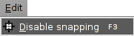
In the window "View Properties / Snapping" you can select the layers to be used for snapping.
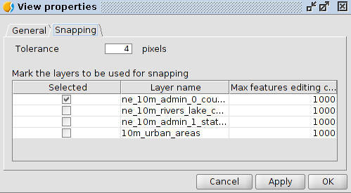
If the snapping tolerance is 4 pixels, the two features which are at a distance equal to or less than 4 pixels will be joined into a common coordinate.
The values of the column "Maximum number of features in memory" can be changed to accelerate snappings in edition. It is the maximum number of geometries with which you want to work in memory.
The types of snapping can be defined in the window "Preferences" in the "Snapping" section.
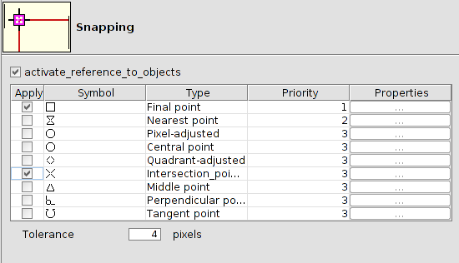

29.2. Grid
The grid is a pattern of dots that extends along the drawing area. It allows to align the objects and magnify the distance between them.
To access to the grid tools, it should be a layer in editing mode.
This tool is available from the tab “Show / Grid /Show-Hide" menu or with the key "F7". Each time you run this tool, it will change its state; it is activated or deactivated depending on the previous state of the grid.

Menú
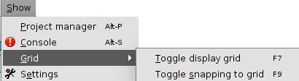
Using the "Show / Grid / Turn- turn off snapping to the grid" or by the key "F9" tool, it is possible to enable or disable snapping to the grid points. Each time you run this tool, it will change its state; it is activated or deactivated depending on the previous state of the snapping. drawing supporting tools

29.1. Snapping
The Snapping lets you to create entities that are connected to each other more accurately. By activating the snapping, the pointer is set to other geometric features when it is close to them and within a specific tolerance. This allows to locate a feature concerning other locations.
This tool is available from the "Edit / Enable snapping" menu or by the key "F3". Each time you run this tool, it will change its state;it is activated or deactivated depending on the previous state of snapping.

Menú
In the window "View Properties / Snapping" you can select the layers to be used for snapping.
If the snapping tolerance is 4 pixels, the two features which are at a distance equal to or less than 4 pixels will be joined into a common coordinate.
The values of the column "Maximum number of features in memory" can be changed to accelerate snappings in edition. It is the maximum number of geometries with which you want to work in memory.
The types of snapping can be defined in the window "Preferences" in the "Snapping" section.

29.2. Grid
The grid is a pattern of dots that extends along the drawing area. It allows to align the objects and magnify the distance between them.
To access to the grid tools, it should be a layer in editing mode.
This tool is available from the tab “Show / Grid /Show-Hide" menu or with the key "F7". Each time you run this tool, it will change its state; it is activated or deactivated depending on the previous state of the grid.

Menú
Using the "Show / Grid / Turn- turn off snapping to the grid" or by the key "F9" tool, it is possible to enable or disable snapping to the grid points. Each time you run this tool, it will change its state; it is activated or deactivated depending on the previous state of the snapping.

Editing tools

30.1. Introduction
To redo or undo the editing commands.
These tools are available from the “Edit” menu and from the relevant command bar.
Menu | Button bars
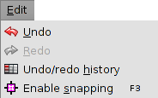
Let´s see all the options:
Icon | Tool | Shortkey | Description
 | Undo |  | To undo the last action in edition
 | Redo |  | To redo the last undone action in edition
 | Undo/Redo History |  | Edition commands history. It allows to undo or redo various edition orders in the same action

30.2. Undo/Redo history
Edition commands history. It allows to undo or redo various edition orders in the same action. It gives information about the made orders with the name and time.
This tool is available from the “Edit” menu and from the relevant command bar.
The interface is:
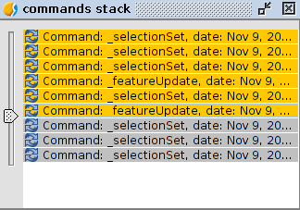
- With the slide bar the orders to undo can be selected. The bar can be moved up and down.

attributes editor

31.1. Introduction
It allows you to edit the alphanumeric attributes of the layer elements from the View. When you click on any element of the current layer, a form will be shown with all the attributes of that element, allowing users to modify them.
It is available in the “Layer/Derivative Geometries” menu or in the right button bar.
Menu | Button bars
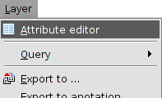
The tool interface has the following elements:
- First. It allows users to go to the first register of the attributes table.
- Previous. It allows users to go to the previous register.
- Next: it allows users to go to the next register
- Last. It allows users to go to the last register on the attribute table.
- Save. It allows users to save changes.
- Close. It closes the attributes editor window.

DERIVED GEOMETRIES

32.1. Introduction
It allows to create polygonal or linear elements from a point layer. From this layer the user can indicate elements which form a polygon or line, and it can automatically create the new elements.
It is available in the menu “Layer/Derivative geometries” or in the right button bar
Menu | Button bar
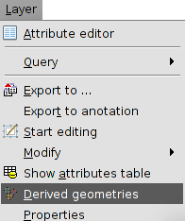
The tool interface is the following one:
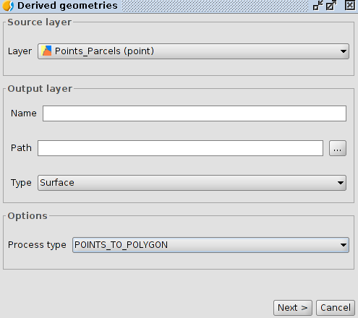
- Source layer. It allows users to select the point layer they want to use. This layer must be loaded in the View.
- Output layer: It allows users to indicate the name of the new layer we want to create and the path where it will be saved. The type of the output layer is automatically selected based on the type of process we indicate.
- Options. Type of process. It allows users to choose between to convert from points to polygons or from points to lines.
Once we define the different options, we must click “Next” button to start the operation to create the elements.
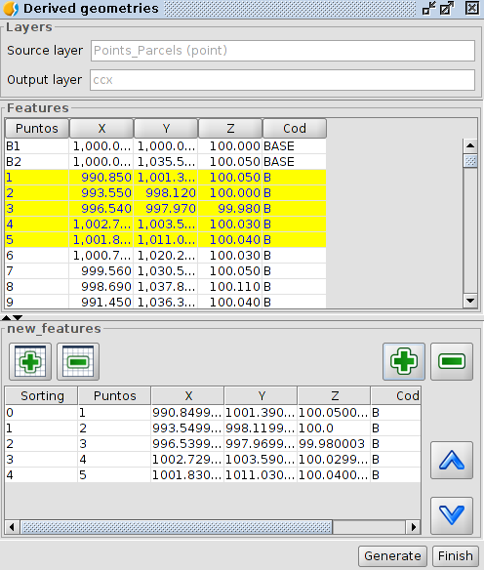
- Objects: It shows the attribute table of the source layer. It allows you to select elements in it. The elements selection will be used to indicate which points form a geometry.
- “+” and “-” buttons on the left add all elements from the attribute table from the top pannel to the bottom panel.
- “+” and “-” buttons on the right add the selected elements in the attribute table from the top pannel to the bottom panel.
- The “move up” and “Move down” buttons (^) allow users to move the element in the bottom panel. In order to do so the element must be selected in that panel.
- Create: It starts the process of creating a new polygonal or linear element from the punctual elements in the bottom panel and in the order they appear in it.

RASTER TOOLS

33.1. Introduction
Raster tools allow users to analyze, to create and to process raster data.
These tools are available from the dropdown buttons bar of raster tools. Some of these tools are available in the “Tool Box” of geoprocessing. Some raster tools are also available in the contextual menu of raster layer which appears by right-clicking on the layer on the TOC and in the menu “Layer”. The tool “Information by point” is also available as a button.
Main buttons bar | Secondary buttons bar
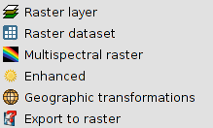 | Raster layer  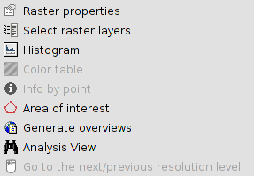
 | Raster dataset
Multispectral raster
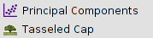
Enhancement
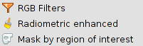
Geographic transformations
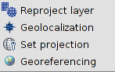
Export to raster
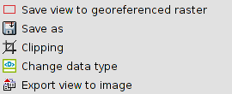
Tool Box | Contextual menu of layer
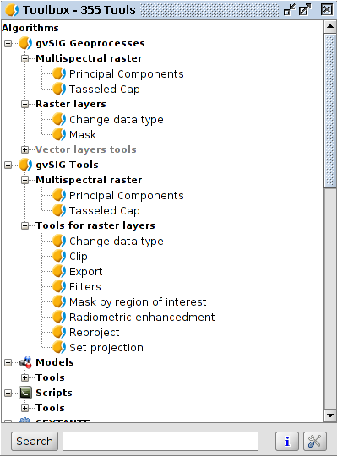 | 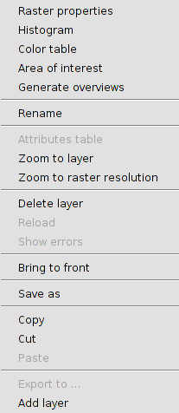
Menu
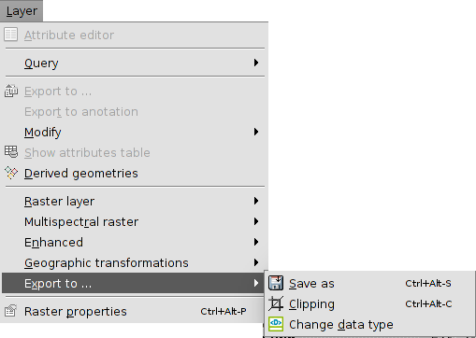
Let's have a look at every available tool:
Icon | Tool | Shortcut | Description
 | Raster properties | Ctrl+Alt+P | It allows to access to the raster properties.
 | Select raster layer |  | It allows users to enable a raster layer by clicking on it in the working area.
 | Histogram | Ctrl+Alt+H | It allows to consult and modify the raster histogram.
 | Color tables | Ctrl+Alt+T | It allows to assign color tables to a raster in a single band image.
 | Information by point. |  | It gives associated information to a pixel.
 | Area of interest | Ctrl+Alt+A | It allows to define regions of interest (ROIs) over a raster layer.
 | Generate overviews | Ctrl+Alt+O | It allows to generate pyramids. The pyramids are lower resolution versions of the original image which allow a quick load of very big images.
 | Analysis view |  | It is a tool used for a quick inspection. It has two efects. It loads the same image in the locator map and opens a new window where there is a higher zoom level and where users can see the image values in real time.
 | Go to the next/previous resolution level |  | It allows to navigate between the levels of resolution of the raster.
 | Create layer multifile |  | It creates a multifile layer.
 | Principal components |  | It allows to apply a transformation to the raster using the method of the principal components.
 | Tasseled cap |  | It allows to apply a transformation to the raster using the method of the Tasseled cap.
 | RGB Filters | Ctrl+Alt+F | It allows users the application of digital filters.
 | Radiometric enhancement | Ctrl+Alt+E | It allows the alteration of the digital levels of the image through functions to adjust them to certain process. It allows the definition of linear, piecewise linear and non-linear functions.
 | Mask by region of interest |  | It allows to generate Masks from ROIs.
 | Reproject layer | Ctrl+Alt+R | It allows the change to the projection of the raster layer.
 | Geolocalization | Ctrl+Alt+G | It allows to apply a related transformation to an image (translation, rotation and inclination) manually, no need of control points. There won't be any information about the precision.
 | Set projection |  | It sets the projection of the view to the raster.
 | Georeferencing |  | It allows to endow coordinates to an image (pixel coordinates).
 | Save view to georeferenced raster |  | It allows to export a clip view as a georeferenced raster.
 | Save as | Ctrl+Alt+S | It allows to save the raster as a new file.
 | Clipping | Ctrl+Alt+C | It allows users to make an extraction of the image.
 | Change data type |  | It allows to change the data type of the image.
 | Export view to image |  | It allows to export the View as a non georreferenced image.
The buttons bar of the raster tools has three components:
- Main button bar. Drop-down button which allows to select the secondary button bar to work with it.
- Secondary button bar: It varies depending on the selection in the main button. It shows a group of raster tools.
- Current raster layer. Drop-down button which allows to select the raster layer you want to work with. You can search/filter between the available layers.
The interface of the tools varies if you access from the geoprocessing toolbox.

raster layer

34.1. Select raster layer
It allows users to enable a raster layer by clicking on it in the working area. It is necessary that the raster layer is visible.
It is available from the buttons bar of the raster layer.
As a result the layer will be automatically enabled in the TOC and its name will appear in the drop-down list of the toolbar.

34.2. Histogram
It allows to consult and modify the raster histogram.
It is available from the “Layer” menu, the contextual menu of the layer in the TOC and the buttons bar of the raster layer.
The interface is the following one:
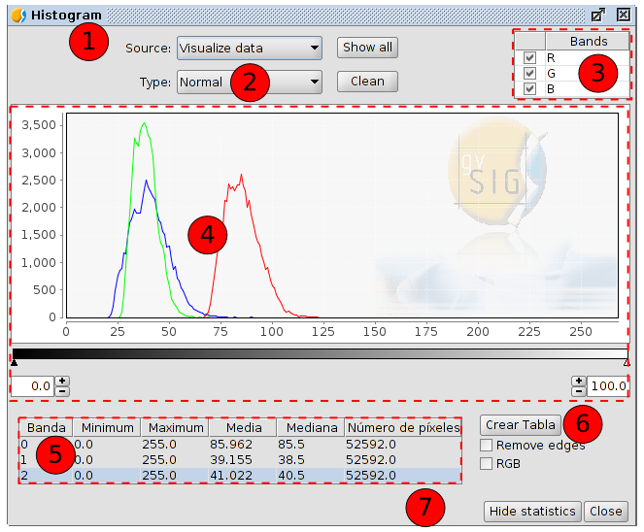

- With this option you can select the data source with which the histogram is generated:
- Visualize data. Displayable data from the raster is used. The bands selector has just the R, G and B values. Every band will appear in the graphic with its corresponding colour (red for R, green for G and blue for B). This is the default option when the histogram dialog is opened.
- Complete. With this option, the histogram for the whole raster is calculated. The image bands will appear in the band selector.
Because of the amount of time that it would take to calculate the histogram for large images, the histogram is only calculated once, which allows that the access be much faster next times a histogram or other functions which need acces to the histogram data are requested. The result of this calculation is in a new associated file with .rmf extension (it is generated in the folder in which the origin data of the image are; if we remove the .rmf file attached to the image, this calculation will be lost).
- Type: You can select one of the following types:
- Normal: This is the histogram in which for every pixel value on the X axis the number of pixels is shown on the Y axis.
- Accumulated: Histogram which shows the accumulated number of pixels for every pixel value. The graph is therefore ascending.
- Logarithmic: It assigns the logarithm's value of the histogram in every position. This allows to visualize a much more balanced histogram without excessive peaks which hide the rest.
- Bands. It allows to enable the bands that will be displayed in the graph.
It allows users to select bands by clicking on them (with the “Control” key pressed we will be able to select several bands). When a band is selected, by hovering the mouse over a point in the graph the name and the value of the point will appear.
- Graph. Viewing area of the histogram.
We can zoom in and out of the graph using the mouse directly over the graph. To zoom in one part of the graph draw a rectangle over it by pressing and dragging the mouse to the right. To return to the original graph click on the left mouse button on any point in the graph and drag to the left, then release the mouse button.
The controls that appear under the graph allow the user to restrict the range of values (X axis of the histogram) on which the histogram is based. The default setting is the complete range so that, for example in a Byte data type image, the statistics are calculated for all the pixel valued from 0 to 255. You can enter the values directly in the text boxes or use the “+” and “-” controls next to the text boxes. You can also slide the triangles over the sliding bar to select the range of values.
Right-clicking in any part of the graph, the context menu is shown.
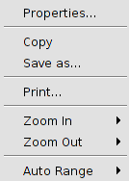
- Properties. This will open the properties dialog of the graph, where you can configure its characteristics. There are three tabs in this window:
  - Title. Options to define the title of the histogram.
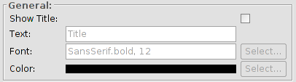
  - Plot. It has three tabs. Two of them, “Domain axis” and “Range axis”, allow to define the caracteristics of the histogram's axes.
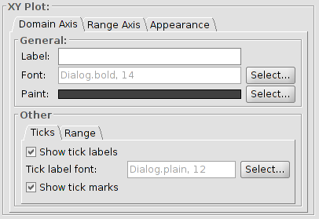
The “Apparence” tab allows to define the border, the background and the orientation of the histogram.
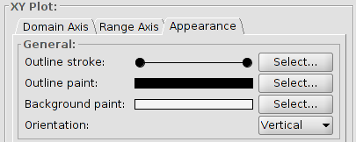
  - Other. It allows users to define the rest of the visual caracteristics of the histogram.
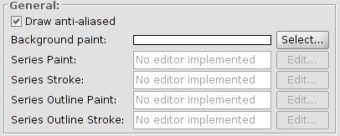
- Save as. To save the graph as an image with .png format.
- Print. It allows to print the graph.
- Zoom in. To zoom in on one or both of the axes.
- Zoom out. To zoom out on one or both of the axes.
- Auto Range. It adjusts the zoom automatically to the window size, for one axis or for both.
- Table. It shows the statistics that correspond to the selected range of pixel values. Each row of the table corresponds to one raster band as displayed in the histogram. The columns that are shown are:
- Minimum. Minimum pixel value for the selected interval.
- Maximum. Maximum pixel value for the selected interval.
- Mean. The mean (average) of all the pixel values for the selected interval in the histogram.
- Median. Median pixel value for this interval.
- Number of pixels. The number of pixels included in the selected interval.
- Create table. It allows users to create a data table in .dbf format with the histogram values. The table is atomatically added to gvSIG.
- Hide statistics. It reduces the window's size hidding the options related with the statistics.
The Raster section of the “Preferences” in gvSIG, contains the option “Number of Classes” where you can set the number of intervals in which the histogram is divided when the data type of the image is not Byte. For Byte images, this value is 256. In the preferences dialog, the default value of this option is 64. The intervals are the parts in which the range of values is divided. For example, if we have a DTM with values between 0 and 1 and there are 64 intervals, each interval will have a range of 1/64.
The number of classes does not only refer to histograms but also to other functionalities that require a division in intervals of value ranges.

34.3. Colour table
It allows users to assign specific RGB values to a range of pixel values in a single band image. We can apply existing color tables or create new ones.
It is available from the “Layer” menu, from the contextual menu of layer in the TOC and from the buttons bar of raster layer.
To use this function, it is important to know the minimum and maximum values in the image. If these values are unknown, they will have to be calculated. Depending on the size of the image, this calculation process may take some time.
The interface is the following one:
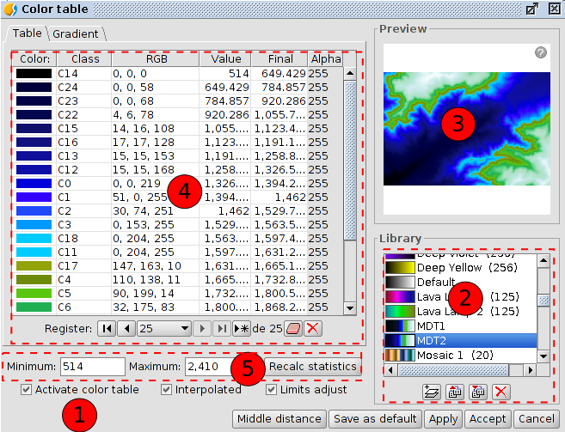
- Activate color table. When this tool is launched for an image without any associated color table, all the components are shown as not active. To start working we should tick the check box.
- Library. List of color tables that are included in gvSIG. You can choose a colour table to apply to the image.
Right-clicking on this area, a contextual menu appears, which can change the way to visualize the libraries.
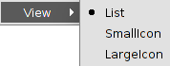

List | Small Icon | Large Icon
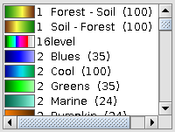 | 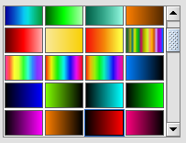 | 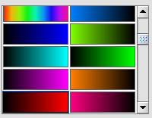
Below the colour table library there are buttons to add, export, import and delete colour tables. The supported formats are .rmf, .ggr and .gpl.
When clicking on the button with the tooltip “New library”, a dialog opens which prompts for basic information of the colour table:
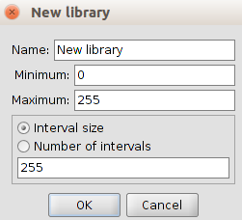
- Name. Name of the new library.
- Minimum. The default minimum value is 0.
- Maximum. The default maximum value is 255.
- The size and number of intervals. The intervals can be specified by two different methods. The first method is by assigning the interval size where we introduce the distance of an interval after which the number of intervals is calculated for the whole range of values. The second method is to specify the number of intervals, after which the distance of the intervals is calculated automatically.
- Preview. It allows to visualize the results, in real time, of the changes which are being applied.
The Preview has the following options:
  - To move on the image using the left button of the mouse.
  - To center the layer in relation to the preview using the “C” key.
  - To adjust the zoom level to see all the layer using the “Space” key.
  - Predefined zoom levels using the “1” and “5” keys. The “1” key is used for a zoom level 1/1.
  - To zoom in or out using the mouse wheel or with the “+” and”-” keys.
  - To show or hide a grid as a background to better appreciate the images with transparency using the “B” key.
  - To show the informative help using the “H” key or clicking on the question mark of the preview.
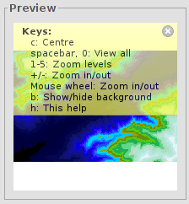
- Central part. It allows to visualize the information of the color table associated with the image in tabular form (“Table” tab) or gradient form (“Gradient” tab).
- Tabular view. Every row in the table corresponds to a range of pixel values and its associated RGB colour. This association is established by range of values. The column Value shows the first value of the range and the column Final shows the last value of the range. These values can be edited directly by double-clicking on the cell and typing a new value. The RGB column contains the RGB value to be assigned to the range of pixel values. The cells in this column are not editable, but if you want to change the colour you can go to the corresponding cell in the Colour column and click on it. The Class column contains associated labels that will not have any effect on the calculation and are just meant to add descriptive names to the range of values; this name will appear in the map legend. Finally, the column labelled Alpha shows a transparency selection dialog.
To manage the rows on the table you can use the general table controls located below the table.
- Gradient view. It contains the same information as the tabular view but presented in a different way, and with the possibility to obtain results that are difficult to achieve with the tabular view. The colour bar represents the range of values from minimum on the left to maximum on the right. At the start, the end and on intermediate points on the colour bar are a number of break points with a fixed colour value. These break points indicate the colour that will be assigned to the value that falls on that point.
A click on a break point will activate the text boxes below the colour bar. These text boxes show the following information about the selected point:
  - Colour. Colour selector which can be modified.
  - Class. Label associated with the point.
  - Value. Pixel value at this break point.
To add a break point, just click below the colour bar. After adding a break point you can modify its information. To remove a break point you can click on it and drag it away.
- Controls of minimum and maximum values, and the “Recalc statistics” button.
- In the lower part of the dialog are the controls of the tabular and gradient view:
- Interpolated. When ticking this check box the transition between the colours of two ranges of pixel values will be smoother. If you disable this check box, the transition will be abrupt. The point where a colour ends and the next one begins is defined with a rhombus symbol.
- Limits adjust. It allows users to adjust the ranges to the maximum and minimum values of the image. If this is turned off, the colour table will be applied to the whole range of values which is 0 to 255 by default.
- Middle distance. It will result in break points that all hold the same distance between them. At the same time, the first and last values of the range of pixel values will be modified accordingly in the tabular view.
- Save as default. The current colour table will be set as the default colour table for this image. The colour table information will be saved as a metadata file (.rmf) with the image, and the next time that the image is loaded in a gvSIG view it will have this colour table associated with it by default.

34.4. Information by point
It shows a window with the pixel information when clicking on it on the raster layer.
It is available in the raster toolbar and in the generic toolbar.
The interface is the following one:
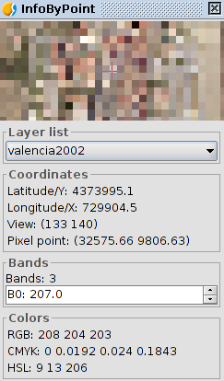
In some cases, such as WMS layers, this window can have aditional information about the type of layer.

34.5. Area of interest
This tool allows to define regions of interest (ROIs) on a raster layer. This regions can be used to extract statistics, in classifications processes, to mask, etc.
It is available from the “Layer” manu, from the layer contextual menu in the TOC and from the raster toolbar.
The interface is the following one:
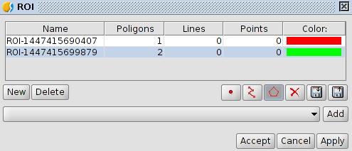
- ROIs table: This table shows the defined regions of interest for the layer. For every ROI the table shows a name, the number of geometries (displayed by types) and the colour associated with the ROI. The name and the colour can be changed by the user.
- New. It creates a new ROI.
- When the ROI has been created we can add the geometries. We can add polygons, points or lines (depending on the selected tool) on the raster in the View. Each click adds a vertex to the geometry of the ROI; to finish drawing a line or polygon just double-click. To add geometries to a ROI, select the corresponding entry in the table and draw the new geometries on the view as we just described.
- Delete. It removes the selected ROI in the table.
- Apply or Accept. The defined list of ROIs gets associated with the raster layer.
- Save ROIs to shp. file. It allows users to save the ROIs as a shape file.
- Load ROIs from shp. File. It allows to use a shape file as ROIs.

34.6. Generate overviews
It allows to create pyrimids. The pyrimids are versions of the image with lower resolution, which allow the rapid load of very big images (in a general zoom the lower resolution image is displayed, while when you zoom in, the more resolution image is loaded).
It is available from the “Layer” menu, from the layer contextual menu and from the raster toolbar.
The Raster section of the “Preferences” in gvSIG, contains the options that allow to generate “overviews”: overviews number, ratio and algorithm.

34.7. Analysis view
It is a tool for a quick inspection. It has two effects. It loads the same image in the TOC and it opens a new window where a detail zoom appears and where we can see the image's values in real time.
It is available from the raster toolbar.
With this functionality you can zoom in on the current layer with three different zoom levels:
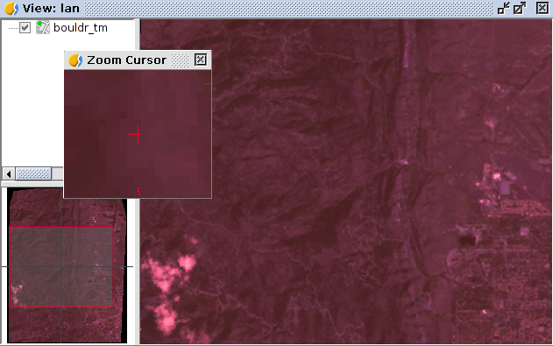
- Level 1. General view of the layer. The layer is added to the locator map.
- Level 2. Visualization area of the View.
- Level 3. Floating window with the highest zoom level. The zoom level is fixed and always centered on the mouse point. By moving the mouse over the gvSIG view, you will see contents change.
Also it shows a text at the bottom right of the window, showing the RGB values of the pixel on which the cursor is currently located.
When right-clicking on the floating window a contextual menu appears. It allows to change the relation between the zoom level of the floating window and the gvSIG view. Also it allows to change the text colour of the RGB values as well as the colour (red, green) of the central cross.
When the cursor is outside the view, the content of the floating window appears black.
There can only be one analysis view open at any time in gvSIG.
The button “Analysis view” is re-labelled as “Close Analysis view” when the analysis view is already open.

MULTISPECTRAL RASTER

35.1. Principal components
The analysis of principal components is a multispectral transformation that wants to avoid the use of redundant information in the image's bands. This technique allows to transform a series of bands into new variables called uncorrelated components, which absorb part of the variability of the data in a subset of the initial bands. The advantage of the use of this mechanism is that most of the information falls on the three first created bands, which allows to keep most of the information with a drastic reduction of space.
It is available from the raster toolbar (in Multispectral raster) and in the geoprocessing toolbox.
This tool has two dialogue boxes. The interface of the first dialogue box is the following one:
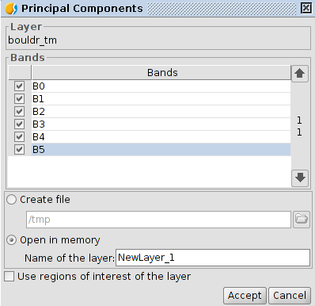
- Bands. It allows users to select bands which will become part of the transformation.
- Output options. The result of the operation can be loaded in the temporary layer (“Open in memory”) or in the file you specify (“Create file”).
- Name of the layer. Name of the resulting raster.
- Use regions of interest of the layer. It allows to use ROIs.
- Accept. Launches the calculation of principal components. When the process is finished the second dialog box appears.
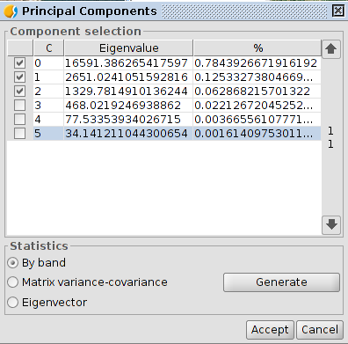
- Component selection. It shows the resulting components of the calculation with the percentage of information that each of them provides to the original raster. It allows to select which of these components will become part of the output raster.
- Statistics. Clicking on “Generate” launches the calculation of the necessary statistics to extract the principal components. It allows to select three kind of statistics: by band, matrix variance-covariance and eigenvector. If there are no selected bands, it is reported and nothing is done. The result of the statistic calculation is shown in a new window.
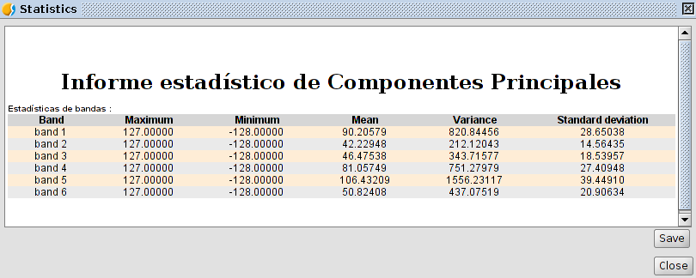
The result of the transformation generates a double type image with the same number of bands as the components choosen in the second dialog box.

35.2. Tasseled cap
The tasseled cap transformation is a more general transformation than the one of the principal components providing indexes with certain physical significance, so that it is possible to determine the brightness value, the greenness and the soil moisture. The tasseled cap transformation focuses on highlighting the relevant spectral features of the plant surfaces during their development, in order to discriminate specific crops, and crops with other plant surfaces using the spectral ranges of the multitemporal Landsat images.
It is available from the raster toolbar (in Multispectral raster) and in the geoprocessing toolbox.
The interface is the following one:
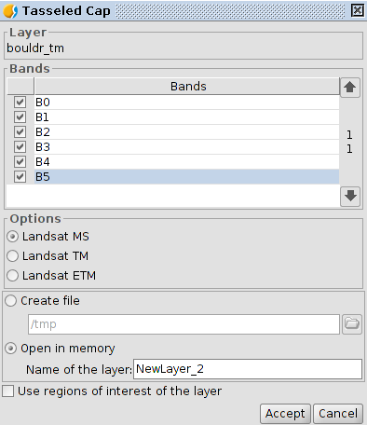
- Bands. List of the raster bands.
- Options. It allows to select the type of image. LandSat MSS, LandSat TM and LandSat ETM. In the case of MSS it is just allowed images with 4 bands. In the case of LandSat TM and ETM it is just allowed images with 6 or 7 bands.
- Output options. The result of the operation can be loaded in a temporary layer (“Open in memory”) or in the file you specify (“Create file”).
The result of the transformation generates a double type image with four bands for the MSS sensor, three bands for the TM sensor and six bands for the ETM sensor.

Enhancement

36.1. RGB Filters
It allows users to apply digital filters like border detection or softened, to apply masks and basic enhancements.
It is available from the “Layer” menu, from the raster toolbar (in Enhancement) and in the geoprocessing toolbox.
The interface is the following one:
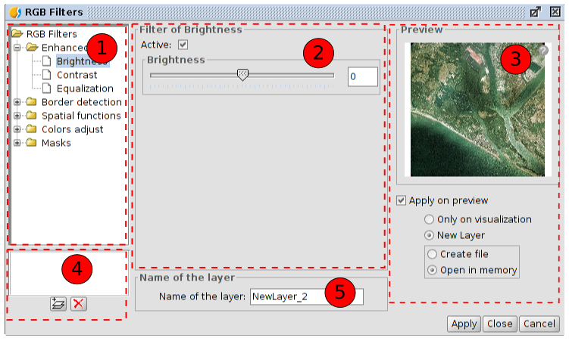
- RGB Filters. List of the available filters classyfied by type. When selecting a filter its configuration panel is shown in number 2. Double-clicking one of the filters or clicking on the “Add filter” button (available in 4) while a filter is selected, we add this filter to the list of filters to apply.
- Filter configuration. Configurable options of the selected filter in 1. All the filters have a check box to enable or disable the filter when it is in the list of added. It is usually at the top of the control panel of each filter with the text “Active”.
- Preview. It allows users to visualize in real time the result of the changes that are being applied. The options in the lower part allow to select the result only on visualization or in a new layer.
- List of filters underway. If a filter is in this list means that it is being executed in the preview. The filters will be executed in the order in which they appear. To delete a filter from being executed double-click on it in the list or click on the “Delete filter” button.
- Name of the layer. It allows to indicate the name of the layer that will be created when clicking on “Apply” creating a new layer.
The number of filters that have been added affects the performance. If it is applied only on visualization, each render that is made of the view will be penalized by the execution of the filters. If a new layer is generated it will just be penalized the execution of the creation of the layer, later the layer will be drawn as quick as if no filters had been applied. In this kind of cases it is adviced to create new layers whenever you can. Other times it can be not so advisable to create a new layer. For instance, if we have a big orthophoto and we need to modify the brightness, to create a new layer will take long time. However, if it is applied only on visualization, the filter will be applied every time but over a smaller dataset so that it will be quicker. The user will decide in which cases to create a new layer and in which cases to apply only on visulization.
The available filters are:
Enhancement
Brightness | 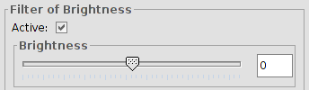
Brightness | It modifies the brihtness value of the layer. It can be varied by moving the position of the slider or by introducing directly the value in the text box and pressing the “Enter” key.
Contrast | 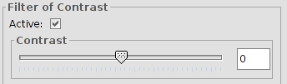
Contrast | It modifies the value of the contrast of the layer. It can be varied by moving the position of the slider or by introducing directly the value in the text box and pressing the “Enter” key. Values from -255 to 255.
Equalization | 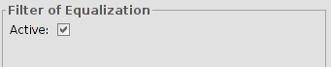
Equalization | It applies an equalization filter.
Border detection
Sobel | 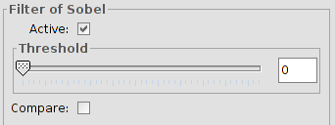
Sobel | It detects the horizontal and vertical borders separately on a greyscale image. The colour images become in RGB with grey levels. The result is a transparent image with black lines and some colour residues.  Threshold values from 0 to 255. “Compare” option.
Roberts | 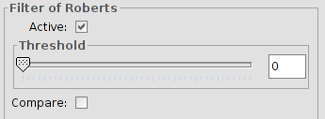
Roberts | It obtains a good response to diagonal border. It has good performance in terms of location. The main disadvantage is that it is extremely sensitive to noise so that it has poor qualities in detection.  Threshold values from 0 to 255. “Compare” option.
Prewitt | 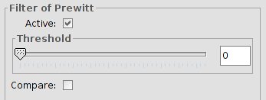
Prewitt | It is really good at defining the borders because its matrix attacks these borders from 8 different sides; this filter has 8 matrixes which are applied to every pixel in the image.  Threshold values from 0 to 255. “Compare” option.
Freichen | 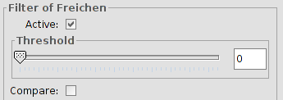
Freichen | It weighs the neigboring pixels depending on the distance from the pixel that is being evaluated. Because of this, there are not privileged directions when detecting the borders.  Threshold values from 0 to 255. “Compare” option.
Funciones espaciales Spatial functions
Median | 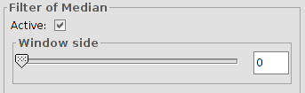
Median | It applies a kernel matrix in which you can select the dimension of its side using the scroll bar or the text box in Window side.  The obtained result is a smoothing of images and the elimination of noise, it analizes the pixel matrix of N x N and the central pixel is replaced by the value of the median of all of them. Its advantage is that the final pixel value is a real value and not an average.
Mean | 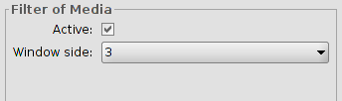
Mean | It applies a kernel matrix in which you can select the dimension of its side using the pull-down button in Window side.  It assigns the mean of all the pixels included in the window to the central pixel. The matrix of filtering is compound by ones and the divider is the total number of elements in the matrix.
Low pass | 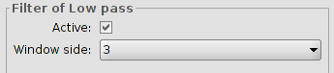
Low pass | It applies a kernel matrix in which you can select the dimension of its side using the pull-down button in Window side.  When the filter is applied the low frequencies are emphasized.
Sharpen | 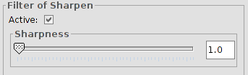
Sharpen | It allows to modify the sharpness and select the contrast (values from 1 to 100). When increasing the contrast, you can also increase the image imperfection and the noise in the gradual areas of colour.
Gauss | 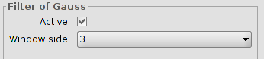
Gauss | It applies a kernel matrix in which you can select the dimension of its side using the pull-down button in Window side.  There is a maximum value in the central pixel and it decreases to the extremes.
Custom | 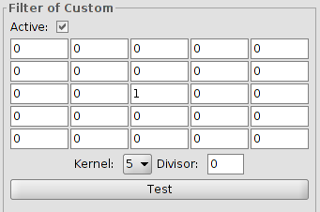
Custom | It is a kernel matrix of 5x5 or of 3x3, introducing directly the value of the boxes.  Divisor. The result of the previous calculation will be divided by this divisor.
Mode | 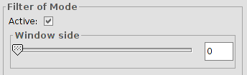
Mode | It applies a kernel matrix in which you can select the dimension of its side using the scroll bar in Window side.  This filter takes the most frecuent value, that is the value that appears more in the neighborhood.
Colour adjust
RGB->HSL | 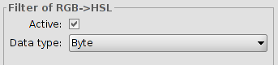
RGB->HSL | Conversion from RGB to HSL. It allows to select the data type (byte or double).
HSL->RGB | 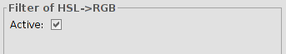
HSL->RGB | Conversion from HSL to RGB.
CMY Balance | 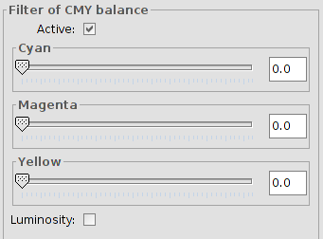
CMY Balance | It allows to modify the balance between Cyan, Magenta and Yellow into an image that needs this type of equalization. To do so, we move the slide bar to increase or decrease the values or we introduce the data directly in the text box which is next to the slide bar. The option of “Luminosity” is used to keep the level of luminosity in every pixel before the variation of CMY.
RGB Balance | 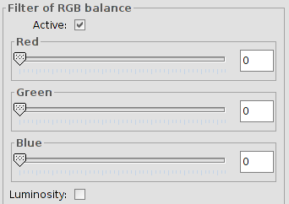
RGB Balance | It allows to modify the balance between Red, Green and Blue into an image that needs this type of equalization. To do so, we move the slide bar to increase or decrease the values or we introduce the data directly in the text box which is next to the slide bar. The option of “Luminosity” is used to keep the level of luminosity in every pixel before the variation of RGB.
HSL Balance | 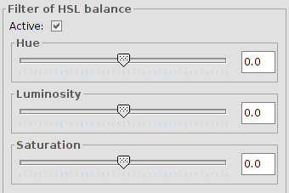
HSL Balance | It allows to modify the balance between Hue, Luminosity and Saturation into an image that needs this type of equalization. To do so, we move the slide bar to increase or decrease the values or we introduce the data directly in the text box which is next to the slide bar.
Grayscale | 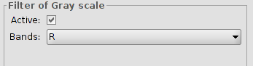
Grayscale | It allows to select bands to which apply grayscale.
Mask
Transparent area | 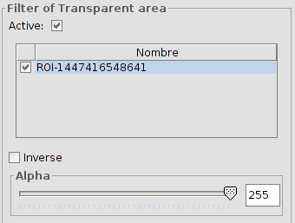
Transparent area | It allows users to introduce a certain level of transparency to a preselected interest area.  When the layer does not have a region of interest a warning message will appear “ It's necesary some ROI to apply this filter. Please, go to the dialog <<Interest regions>> and select the last one”.  Ticking the check box labeled as “Inverse” will result in the opposite effect; all of the image except for the ROI will be set to the specified transparency level.

36.2. Radiometric enhancements
They allow the alteration of digital levels of the image using functions to adjust them to certain processes such as the case of improved visualization. They allow definition of linear, step and nonlinear functions.
Available from the "Layer" menu, the enhancement button bar and the geoprocessing toolbox.
The interface is as follows:
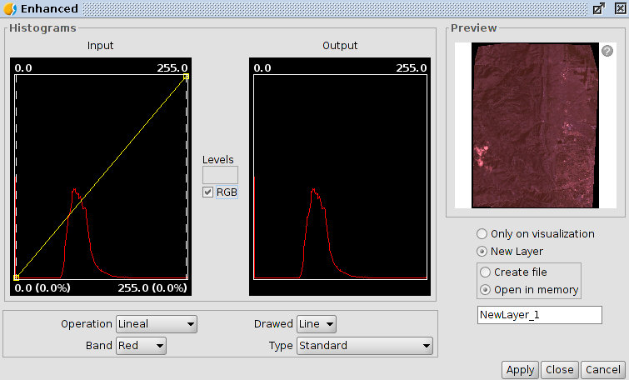
1. In the central part two graphs are shown. The left is the histogram of the input image and the selected graphic.On the right it is the histogram wich will have the output image. The graphs represented with a yellow line, can be modified graphically by clicking and dragging with the primary mouse button.Changing the input histogram graph will get vary the output histogram and the preview.
In the upper corners of the input histogram graph maximum and minimum values for the raster are displayed. At the bottom the maximum and minimum values being applied at that moment for the enhancement function appeas.The value in percentage relative to the total data set appears in parentheses. These values can be modified by clicking and dragging on two vertical dotted lines that are in the sides of the graph. The left line will modify the minimum and the right one the maximum
Breakpoints are inserted by clicking with the mouse on the graph on the point where you want to insert. To delete a point we will stand over it and will press right mouse button. After entering a breakpoint we can change its position by dragging it.
RGB. When this is activated it considers that the displayed raster data are RGB (data type is byte value range 0-255). If this is not selected it is considered that the value range is supported by a data type byte between -127 and 128; this produces significant differences in viewing and the minimum-maximum range that appears at the bottom of the entry graph.
1. Enhancement options. Enhancements replace each input data value by an output value. This substitution is made doing a correspondence between the data in the input range to output range. Tthis correspondence is applied throug a function.
- Operation. Dropdown for selecting the function enhancement.
  - Linear. Linear enhancements apply a correspondence between the input and output data in a linear manner. In the simplest case, a straight line maps each value in the input range with its respective output, completely equidistant. That is, if we have an output range between 0 and 255 and the input data are between 0 and 1 then the input data 0.5 corresponds to an output of 127.5
This behavior can be altered by inserting breakpoints of the graph. The effect is that the linear filter is divided into sections with different inclination. This causes, for a stretch between two breakpoints has a linear function of assigning values defined by the slope of the line in that stretch.
  - Square root. Nonlinear enhancements have the same principle as linear, that is, they replace each input data value by an output value. The difference is that the allocation function of the mapping of values is not linear. In each type of nonlinear function for the output value it will apply a function that corresponds to its name.
  - Logarithmic. Nonlinear enhancement.
  - Exponential. Nonlinear enhancement
  - Split levels. It is a special type of linear enhancement. It divides, the function of the straight in equidistant staggered sections. This causes input values between two existing points of the same horizontal level to have the same output value is assigned. The effect on the image is that color intervals with no transitions appear. The number of intervals existing can be changed with text entry labeled "Levels". 6 levels appear by default.
- Band. It allows to define the band raster on wich the changes made in the chart work. For a proper rolling of the image, it is usually necessary to vary the enhancement of each band separately and with different values.
- Drawed. It allows selection of line and fill. The color of the line or fill depends on the band selected.
- Type . Select from the following:
  - Standard. Displaying the histogram normally. For each possible pixel value in the X axis the number of pixels about that assigned in the axis Y.
  - Cumulative. For each possible pixel value in the X axis the number of pixels about that value is assigned on the Y axis In addition, it is added to the number of pixels of the same or lower value than that position.
Logarithmic. Assigns the logarithm of the histogram at each position. Displays a much more balanced histogram without excessive peaks hiding the rest.
Cumulative logarithmic. It shows the logarithmic histogram, but at each position it accumulates the previous values
2.Preview. It displays in real time the result of the changes to be implemented. The options on the lower part allow to select the result, only on visualization or on a new layer.

36.3. Mask by region of interest
It allows applying a mask of enhancement by region of interest.
Available in the enhancement button bar and in the geoprocessing toolbox
The interface is as follows:
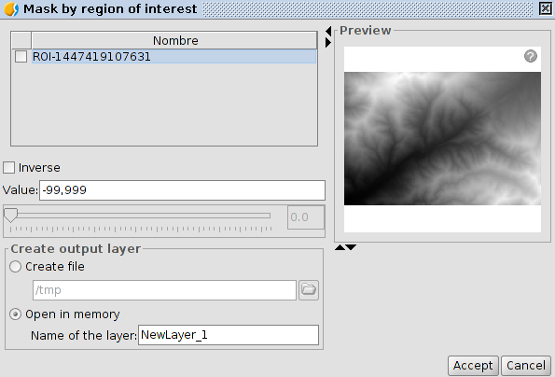
- ROIs. List of regions of interest
- Inverse. If it is activated it applies mask to areas outside the regions of interest and the interior remains totally opaque.
- Value. Select the mask value.
- Preview. Allows to visualize in real time the result of the changes to be implemented. The options on the lower part allow to select the result, only on visualization or on a new layer.

Geographic Transformations

37.1. Reproject layer
Allows to generate a raster reprojection.
Available on the "Layer" menu, geographical transformations bar buttons and from the geoprocessing toolbox.
The interface is as follows:
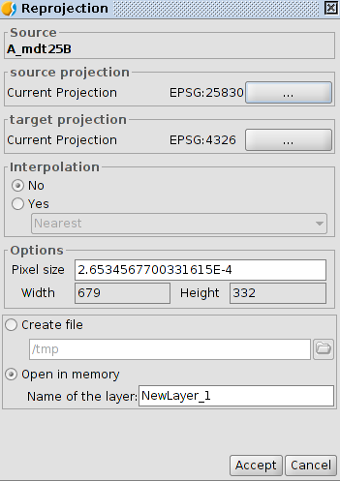
- Source. Source layer
- Source projection. CRS of the view where the source raster is loaded.
- Source. Source layer
- Source projection. CRS of the view where the source raster is loaded.
- Target projection. Select the CRS target . Go to "CRS and Transformation" window
- Interpolation
- Options.Allows to define the pixel size
- Output layer. Allows to select between generating a file on disk or in memory.
By clicking "Accept" the reprojection process finally asked if we want to load the raster redesigned in a View

When performing a raster reprojection, the available transformation is "EPSG Transformation".

37.2.Geolocalization
It allows application of an affine transformation to an image (translation, rotation and tilt) manually, it is without control points, so we will not have achieved accuracy information.
Available from the "Layer" menu and the geographic transformations button bar.
This tool is an option when georeferencing is for presentation purposes and do not need too much precision. As in the georeferencing a file *. rmf text is created with the necessary information for the location of the image.
The interface is as follows:
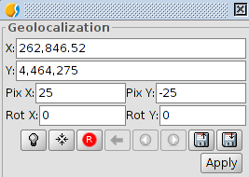
- It allows to define transformation. Text entries labeled X, Y, X Pix, Pix And Rot X, and Rot Y contain the current position data on upper left X coordinate, Y coordinate upper left position, pixel size on X, the pixel size on Y, X and Y rotation respectively. If we change these values from the keyboard these will be updated on the image.
- Buttons (from left to right):
  - Gets the tool focus
  - Center raster layer on View. With this button we focus the raster in the current view, no matter what zoom is selected. The coordenates will be automatically calculated
  - Inicializate with disk transormation. Reset all the transformations that have been applied
  - Go to first transformation. Assign the first transformation it was applied
  - Go to last transformation. Assigns previous transformation to the current.
  - Go to next transformation. Assign the following transformation to the current
  - To load georeferencing coordintaes from tfw. file. The extension must be .tfw or .wild.
  - Save current transformation as default. .rmf file. It saves the currently active transformation in the .rmf file attached to the raster . Each subsequent time the image will be loaded in gvSIG with that transformation
- In addition, the raster layer acquires the capacity to be moved, rotated or transported by clicking and dragging to the right place on the View
- Transformation on View:
- Translation. Mousing over the screen image, the cursor changes to a hand. This means you can move clicking and dragging on the raster view.
- Scaling: Mousing over the edges of the screen image, the mouse cursor will change. Depending on the chosen edge cursor will adopt one shape or another. If placed in the lower or upper edges the cursor will become a vertical arrow. This means you can click and drag to scale the image only on one side. Scaling always keep the proportions of the raster. If we move the cursor around the side edges the cursor will become a horizontal arrow allowing now to scale sideways. For corners the cursor appears as an oblique arrow.
- Rotation. Mousing over the outer corners of the screen image, the mouse cursor will change. It will appear as a circular arrow. This means you can start to rotate the raster from the selected corner.
- Mousing over the outer side edges of the screen image will change the mouse cursor. This appears as an arrow symbol X or Y depending if the mouse is in the horizontal or vertical edges respectively. This indicates that we can begin to deform the raster direction of the X or Y.

37.3. Asign projection
Assigns automatically the projection of the view to the raster
Available from the geographic transformations button bar and in geoprocessing toolbox.

37.4. Georeferencing
Allows provide a reference system (ground coordinates) to a digital image that is in a pixel coordenadades (rows and columns). This process requires a search for homologous points between the reference view or coordinate file and the final map. The result is a transformation involves scaling, rotation and deformation of the original image to fit the final map.
Available in the geographic transformations button bar
The initial interface is as follows:
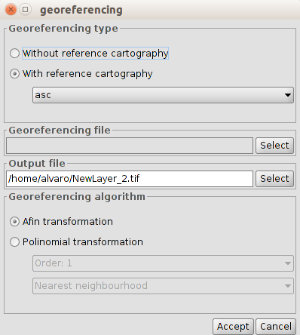
- Initially we must decide what type of georeferencing will be applied with "Without reference cartography" or "With reference cartography". Both types have the same georeferencing working environment, with the difference that in one of them the georeferenced image points are relate to points of a View and in the other to a list of coordinates without reference cartography.
- Georeferencing file. It indicates the file containing the image to be georeferenced.
- Output file. It allows to put path and destination file name in case that the georeferencing is done with resampling. This option can vary from the dialog georeferencing environment options, so it is not necessary to put a proper value at this time, although we will have to do it before the end of the process.
- Georeferencing algorithm. Select the way the output result will be obtained. There are two options:
  - Affine transformation. Applies an related transformation to calculations based on the control points taken The output image is the same as the input. The result of this transformation is a Georeferencing file (.rmf format). Keep in mind that this type of transformation is limited and the user will be in charge of selecting the more appropriated transformation in each case.
  - Polynomial transformation. It involves a resampling of the input image taking into account the checkpoints as a reference. It obtains an output image with the necessary deformations to adapt it to the new geographical location If this option is selected we will be forced to decide the degree of processing and the type of interpolation to be used to calculate new pixels. There are three types of interpolation: nearest neighborhood, bilinear and inverse distance.
  - Depending on whether a degree or another is chosen we will need a minimum number of control points. The number of points required is determined by the formula (order + 1) * (order + 2) / 2, that is, for a one grade polynomial at least three points are required for a two grade polynomial six points are needed, to three grade ten points,...

Interface "Without reference cartography"
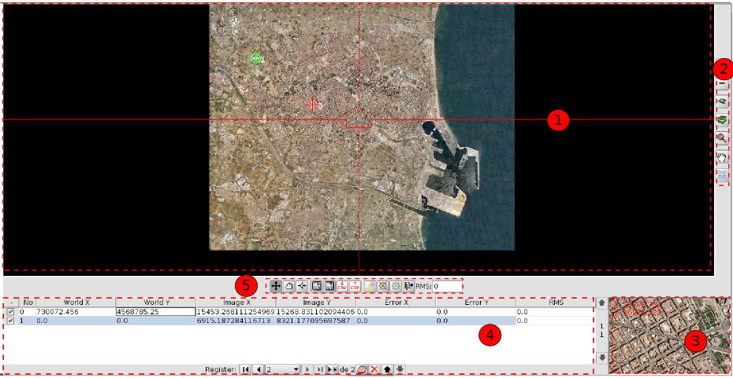
interface "With reference cartography"
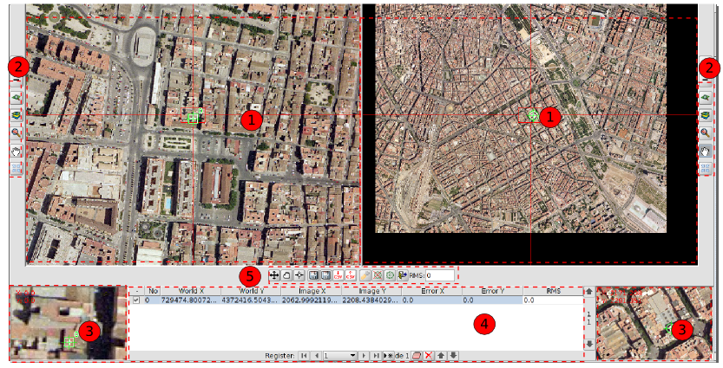
- View. There will be one in the case of "Without reference cartography" and two of "With reference cartography". The left one contains the base cartography loaded in the gvSIG View and the right the image we want georeference.
In the top left corner the coordinates of the mouse cursor are shown. In the reference cartography the coordinates are those of the real world. In the image to be georeferenced the coordinates are in pixel relative to the top left corner.
A cursor with a central window appears in the middle. The cursor window can be resized and moved when the view is active. The contents of the window will display in the magnifying glass windows. By bringing the mouse pointer to the edges of the center window horizontal or vertical arrows will be displayed; clicking and dragging on those arrows the center window is resized. To move the center window we must bring the mouse pointer to the corners of the window until the pointer changes to a crossed arrows; clicking and dragging on those arrows the scroll is performed.
- Navigation tools
Icono | Herramienta | Descripción
 | Increase the zoom level | It allows approaching to the center of the data frame of the View. Multiplied by 2 the zoom level.
 | Decrease the zoom level | It zooms out from the center of the data frame of the View Divide by 2 the zoom level.
 | Zoom to selected area | It allows zoom in on a particular area of the the View
 | Zoom all | this makes a frame of total area occupied by all the layers of the the View
 | Last Zoom | It allows return to previous frame.
 | Move Image | It allows to change the frame of the view by dragging the visualization field in all directions with the mouse. We must keep the mouse button down and move the mouse to the desired direction.
The middle mouse button can increase and decrease the zoom of the View.
- Magnifier window. Expanding the View associated with the central window of the cursor. When the central window cursor moves around the view, it changes the position on wich the lens is focused, and when the window size is changed the zoom level changes. In the upper left corner of the window the coordinates of the mouse cursor appears.
- Control Points. A control point is an entity that provides the correspondence between a geographical coordinate and a pixel coordinate. Control points are represented in the reference view as green squares and in the view of the image as green circles. A control point is associated with a row of the table.
To add a new control point click on the "New" button in the table control. Create a row with coordinates 0, 0 in both views and the tool "Move point" is activated. Now clicking on the View the mark show where we clicked.
The information can be found in the points table relating to each point is:
- Point number
- World X,Y. X, Y coordinates in the reference view. They are automatically generated when you click on the View. They are also assigned when directly typing the value in the table
- X, Y image. X, Y coordinates in the view of the image. They are automatically generated when you click on the View. They are also assigned when writing directly the value in the table
- Error X, Y.
- Root mean square. The quality of the geometric correction can be estimated based on the root mean square RMS and the error contribution of each point.
- When the RMS contribution of a point is high, it may indicate that it the correspondence between points was wrongly selected. It can also indicate the possibility that the geometric model requires some more points.
The available tools are:
Icon | Tool | Description
 | First | Select the first point of the table
 | Pevious | Select the previous point to selected
 | Next | Select the next point to selected
 | Last | Select the last point of the table
 | New | Create a new item in the table
 | Delete selected point | Deletes the selected point
 | Delete all | Deletes all points in the table
 | Up/Down | Select the previous point / next to selected
- Georeferencing-processing tools.
Icon | Tool | Description
 | Move Point | Allows to move a control point
 | Drag Point | Allows to drag a control point
 | Center view to selected point | Center the view in relation to the selected control point
 | Save control points in raster metadata file | Save control points in the metadata file attached to the selected raster
 | Load from XML file (.rmf) | Retrieves the control points from metadata file attached to raster
 | Export table of points into a text file | Exports the table to a .csv file
 | Load control points from .csv files | Import a .csv table
 | Options | Allows access to the georeferencing options window
 | End Test | The test processing is completed. Eliminates the test image loaded in the reference view.
 | Test georeferencing | Run a test with the control points introduced. Apply the transformation and loading the transformed image on the reference view.
 | Extit to georeferencing | Georeferencing finishes. Asked if we want to load on view the result of the last processed.
 | RMS | RMS Global
The interface window "Options" is as follows:
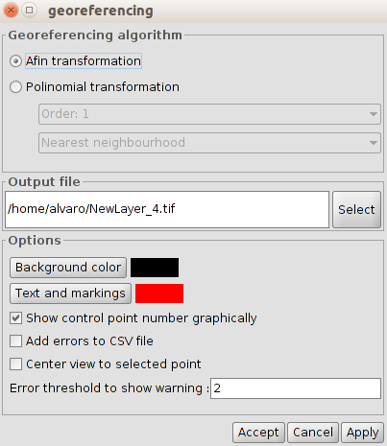
- Georeferencing algorithm. It selects the georeferencing algorithm to be applied.
- Output file. In case of polynomial transformation it allows to select the output file.
- Options. It allows to select the background color, text and trademarks, as well as enable / disable the checkpoint number display, to add errors to the .csv file and to focus the views on the selected point. It also allows to indicate the threshold error warning.

Export to raster

38.1.Save View to georeferenced raster
- It allows to export the view as a image in georeferenced tiff format.
Available from the export raster bar button
- When launching the tool we are shown a first message indicating that you must select the area of the View to export. Click the mouse on the first point and drag and drop in the second; the rectangle that will contain the Vista area to be saved is defined. Once the area is defined, a window with the tool options will be displayed.
- The interface is as follows:
- 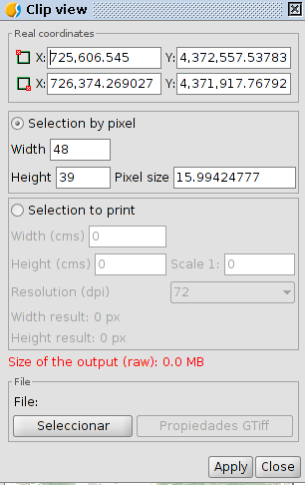
- Real coordinates. Coordinates of the points that define the area selected in the View. It allows to modify these coordinates manually.
- Selection by pixel and to print. It allows to define the characteristics of the image resolution. The maximum size of the output image has been limited to 20,000 by 20,000 pixels, so if we try to save a larger image, gvSIG will show a warning message commanding the user to check the input parameters and try again.
- File. The "Select" button allows to indicate where and in which format the image will be saved. When the output file button is selected, the "Properties" is enabled; this button
- allows access to a new properties window which options depend on the type of selected image format.
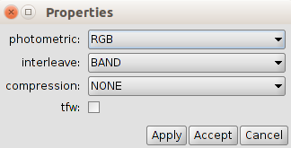
- Depending on the size of the output image, this process can be very long, so it is recommendable to control the output image pixel size . When the process is finished, it will appear a table with statistics showing the path of the image that has been saved, the disk size of the output image, the duration of the process and if the image is compressed or not.

38.2. Save as
- It allows the change of a raster format.
- Available in the "Layer / Export to ..." menu in the export raster bar button raster and the geoprocessing toolbox
- The interface is as follows:
- 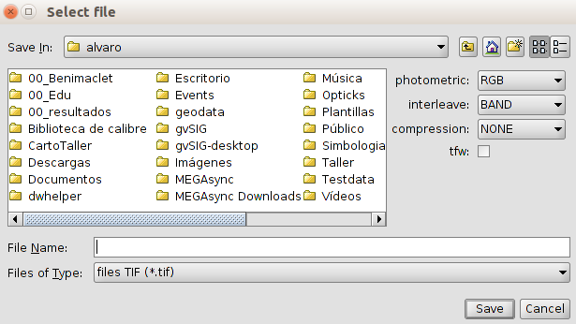
- On the right side there will be a panel with controls with which save options are selected . This panel will have a different appearance depending on the selected output format. In some formats there will be no controls.

38.3. Clipping
- It allows to generate a new layer as a raster cut, varying the extension, the level of resolution, order and number of bands of the resulting layer.
- Available in the "Layer / Export to ..." menu in the export raster bar button raster and the geoprocessing toolbox
- The interface is as follows:
- 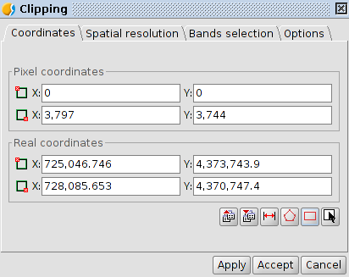
- "Coordinates" tab. It shows the text boxes with the pixel coordinates and real coordinates. The two above text boxes correspond to the coordinates of the upper left corner and the lower text boxes with the lower right corner . When we change the data of a pixel coordinate the real coordinates are calculated automatically and vice versa.
The available buttons are:
- Icon | - Tools | - Description
 | - Load parameters | - Allows to load the cutting parameters.
 | - Save parameters | - Allows to save the cut parameters.
 | - Round off pixels | - Rounding pixels.
 | - Adjust to maximun extension defined by layer ROIs | - Adjusting to the maximum extension of the layer's ROIs. Calculates the minimum extension where all ROIs are included.
 | - Raster layer zoom to full extent | - Coordinates are assigned to the extension of the raster
 | - Select from the view | - Allows to select the clipping area by drawing a rectangle on the raster. The rectangle is drawn by clicking and dragging on the previously active view. The area that we draw must be set to the layer you're doing the clipping If otherwise it will be adjusted automatically.
- “Spatial resolution” tab
  - The resolution of the output image can be changed using two methods:
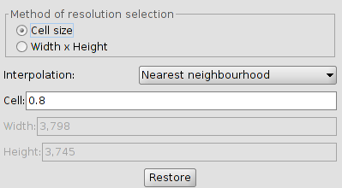
    - Cell size. Activate the text box "cell" and is where the value of the new cell size is inserted.
    - Width x Height. Active "Width" and "High". It allows to define the width or height value in the output. If we vary the width, the height will be recalculated automatically, and vice versa.
  - Interpolation. It allows to select the interpolation method: Nearest Neighbor, Bilinear, inverse distance and B-Spline.
  - Restore. It restores the initial size values of the output layer.
- “Bands selection” tab. List of source raster bands.
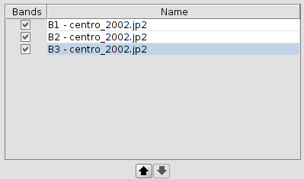
- The order can be changed with the "Up" and "Down" buttons. The currently selected row goes up or down a position in the list. Bands can also be deactivated in the resulting image with the check of the row. If the row is marked it will appear in the output, if it is not it won't be taken into account
- “Options” tab.
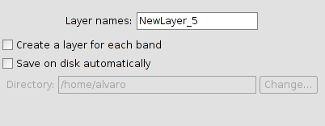
  - Layer names. Name of the resulting layers. In case of several layers, that is to say, if there is a layer for each band of the source image, it will get the same name but with numbers at the end (_xxx). For example, if the layer is called NewLayer and we have 3 result appears NewLayer_1.tif, New_Layer_2.tif and NewLayer_3.tif.
  - Create a layer for each band. Creates an output raster for each source raster band.
  - Save on disk autimatically. The layer is saved in the specified path. If we do not mark this option / s the layer / s generated will be temporary.

38.4. Change data type
- Allows to change the data type of a raster.
- Available from the export raster bar button and the geoprocessing toolbox.
- The interface is as follows:
- 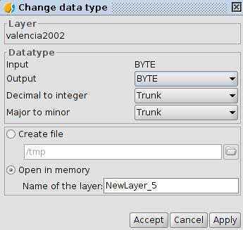
- Layer Name of the input layer.
- Datatype. Options to change the data type.
- It allows to select between create a file or open in memory.

38.5. Export View to image
- Export the frame of the view to an image. Allows to select from four output formats: bmp, png, jpg and tif.
- Available from the "View / Export" from the menu and from export raster button bar .

Export to raster

38.1.Save View to georeferenced raster
It allows to export the view as a image in georeferenced tiff format.
Available from the export raster bar button
When launching the tool we are shown a first message indicating that you must select the area of the View to export. Click the mouse on the first point and drag and drop in the second; the rectangle that will contain the Vista area to be saved is defined. Once the area is defined, a window with the tool options will be displayed.
The interface is as follows:
- Real coordinates. Coordinates of the points that define the area selected in the View. It allows to modify these coordinates manually.
- Selection by pixel and to print. It allows to define the characteristics of the image resolution. The maximum size of the output image has been limited to 20,000 by 20,000 pixels, so if we try to save a larger image, gvSIG will show a warning message commanding the user to check the input parameters and try again.
- File. The "Select" button allows to indicate where and in which format the image will be saved. When the output file button is selected, the "Properties" is enabled; this button
- allows access to a new properties window which options depend on the type of selected image format.
Depending on the size of the output image, this process can be very long, so it is recommendable to control the output image pixel size . When the process is finished, it will appear a table with statistics showing the path of the image that has been saved, the disk size of the output image, the duration of the process and if the image is compressed or not.

38.2. Save as
It allows the change of a raster format.
Available in the "Layer / Export to ..." menu in the export raster bar button raster and the geoprocessing toolbox
The interface is as follows:
- On the right side there will be a panel with controls with which save options are selected . This panel will have a different appearance depending on the selected output format. In some formats there will be no controls.

38.3. Clipping
It allows to generate a new layer as a raster cut, varying the extension, the level of resolution, order and number of bands of the resulting layer.
Available in the "Layer / Export to ..." menu in the export raster bar button raster and the geoprocessing toolbox
The interface is as follows:
- "Coordinates" tab. It shows the text boxes with the pixel coordinates and real coordinates. The two above text boxes correspond to the coordinates of the upper left corner and the lower text boxes with the lower right corner . When we change the data of a pixel coordinate the real coordinates are calculated automatically and vice versa.
The available buttons are:
Icon | Tools | Description
 | Load parameters | Allows to load the cutting parameters.
 | Save parameters | Allows to save the cut parameters.
 | Round off pixels | Rounding pixels.
 | Adjust to maximun extension defined by layer ROIs | Adjusting to the maximum extension of the layer's ROIs. Calculates the minimum extension where all ROIs are included.
 | Raster layer zoom to full extent | Coordinates are assigned to the extension of the raster
 | Select from the view | Allows to select the clipping area by drawing a rectangle on the raster. The rectangle is drawn by clicking and dragging on the previously active view. The area that we draw must be set to the layer you're doing the clipping If otherwise it will be adjusted automatically.
- “Spatial resolution” tab
  - The resolution of the output image can be changed using two methods:
    - Cell size. Activate the text box "cell" and is where the value of the new cell size is inserted.
    - Width x Height. Active "Width" and "High". It allows to define the width or height value in the output. If we vary the width, the height will be recalculated automatically, and vice versa.
  - Interpolation. It allows to select the interpolation method: Nearest Neighbor, Bilinear, inverse distance and B-Spline.
  - Restore. It restores the initial size values of the output layer.
- “Bands selection” tab. List of source raster bands.
- The order can be changed with the "Up" and "Down" buttons. The currently selected row goes up or down a position in the list. Bands can also be deactivated in the resulting image with the check of the row. If the row is marked it will appear in the output, if it is not it won't be taken into account
- “Options” tab.
  - Layer names. Name of the resulting layers. In case of several layers, that is to say, if there is a layer for each band of the source image, it will get the same name but with numbers at the end (_xxx). For example, if the layer is called NewLayer and we have 3 result appears NewLayer_1.tif, New_Layer_2.tif and NewLayer_3.tif.
  - Create a layer for each band. Creates an output raster for each source raster band.
  - Save on disk autimatically. The layer is saved in the specified path. If we do not mark this option / s the layer / s generated will be temporary.

38.4. Change data type
Allows to change the data type of a raster.
Available from the export raster bar button and the geoprocessing toolbox.
The interface is as follows:
- Layer Name of the input layer.
- Datatype. Options to change the data type.
- It allows to select between create a file or open in memory.

38.5. Export View to image
Export the frame of the view to an image. Allows to select from four output formats: bmp, png, jpg and tif.
Available from the "View / Export" from the menu and from export raster button bar .

Geoprocessing

39.1. Introduction
Geoprocessing is the execution of analytical and modelling operations of geographic data for creating new information.
To access to the geoprocessing tools, go to “Tools/Geoprocessing” menu or with the shortkey in the “Toolbox”.
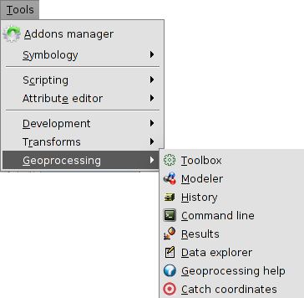
There are the following geoprocessing options:
- Toolbox. To execute a geoprocess or launch a model.
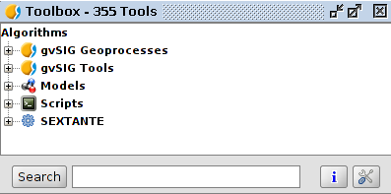
- Modeller. To create a model with the application of several geoprocesses.
- History. All geoprocessing actions are recorded. This way, the history can be consulted, run the actions from it and making easier the repetition of processes.
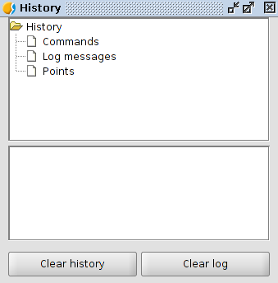
- Command line. To automatize task by creating scripts.
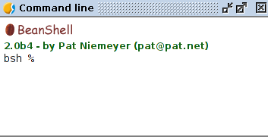
- Results. It allows to the users to get the generated results in the current session.
- Data explorer. It opens a new window with the information of the available layers and tables of the project.

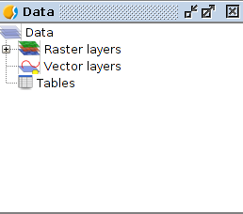
- Geoprocessing help.
- Catch coordinates. To catch the coordinates clicking on the View. These coordinates can be used in some geoprocesses.

toolbox

40.1. Introduction
The toolbox is the main element of the graphic interface for the application of the geoprocesses and is one of the most used on daily basis. It shows all the available geoprocesses, making easier its use. From the toolbox, a geoprocess or model can be executed.
The interface is:
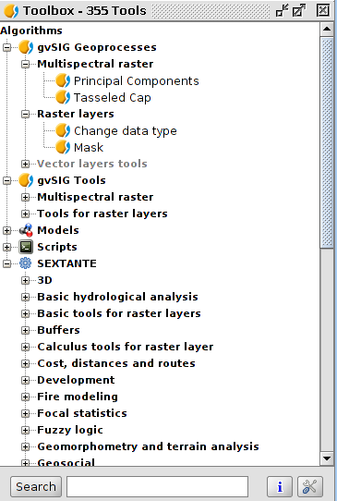
The main parts are:
- gvSIG Geoprocesses. It includes geoprocesses for vector and raster layers.
- gvSIG Tools. Raster tools which are not geoprocesses.
- Models. To execute and create new geoprocessing models.
- Scripts. To execute and create new geoprocessing scripts.
- SEXTANTE. Geoprocessing library integrated in gvSIG. It is classified in different functional groups of geoprocesses.
Depending on the available data, it will be possible or not to execute a determined algorithm. When there are enough data for executing it, the name will be in black, If not, in grey.
Apart from the geoprocesses, the main components of the interface are:
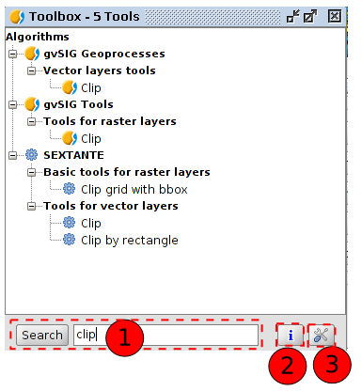
- The bottom part of the toolbox has a text box to search for a particular extension by entering a string text and pressing the "Search" button. As results, it will show only those algorithms that include the word or phrase entered. To show all the algorithms again, simply do a search with an empty string.
- Accessing to geoprocessing help.
- Allows access to the configuration of the toolbox.
To run a geoprocess must double click the name of it or click on it with the right mouse button and select "Run" from the contextual menu that appears.
When you run a geoprocess, a new dialog box (that varies according to the geoprocess is running) will open, but the interface remains with several common characteristics.
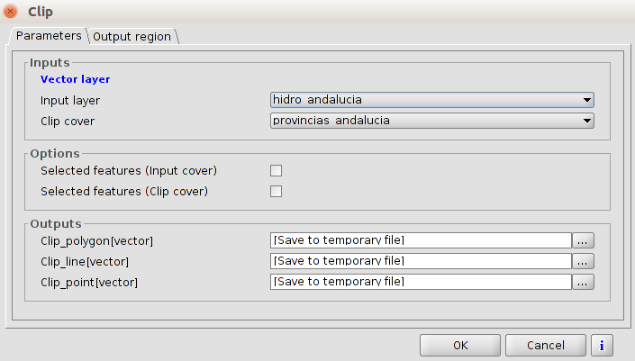
On the one hand, we find a main tab called “Parameters”, in which the input and output values must be entered for the geoprocess would be executed properly.
The number of parameters depend on the geoprocess and its requirements, but the structure is similar in all the cases.
- One raster layer to select from all the available ones in the gvSIG project. It is possible to use one layer of any of the available Views.
- One vector layer to select from all the available ones in the gvSIG project. It is possible to use one layer of any of the available Views.
- One table to select from all the available ones in the gvSIG project.
- One method or function to to select from all the available ones.
- A numeric value to enter in the text box.
- One string text.
- A field of one table.
- One band to choose from the ones of the raster layer.
- An element just of raster layers, bands of raster layer, vector layers or tables, to select from all the available ones in the gvSIG project. In this case, the parameter value in the right side has a button. When it is pressed, all the available elements to choose from, will appear.
- One file or a disk folder.
- One point of the view, with its coordinates X and Y. It is possible as well to clik on the button and select any of the captured points.
- One table for editing by the user.
If you have already executed the same algorithm (in a previous session or the actual one), you will find in the bottom part a new component. Clicking on the buttons to the right and left, you can recover automatically the assigned values to the algorithm in the previous executions, making easier to fill the needed fields. By default, the window will have the last session´s values.
The geoprocesses generate different output elements:
- A raster layer.
- A vector layer.
- A table.
- A graphic element (curve, bar diagram,...)
- An HTML text element.
The layers and tables can be saved as a permanent file in disk (with a route path entered in the textbox) or select them clicking on the button on its right and using the screen dialogue. If the route is not indicated, a temporary file will be created.
By default, the result layers will be saved in:
- .shp format for vector layers.
- .tif format for raster layers.
By default, the result layers will be saved in the defined route in the toolbox: “General”, option “Output folder”.
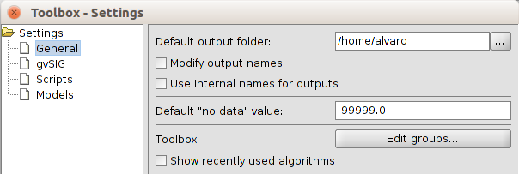
If the "Modify output names" box is checked, it will automatically replace all non-standard characters (accented vowels, brackets, parentheses,...) appearing on the names of objects when executing the algorithm.
In addition to layers and tables, geoprocesses can generate text and image results. These are stored in memory and displayed at the end the execution of the algorithm in a new window, called Results. This window stores the results of the algorithms executed in the current session and can be displayed at any time via the "Tools / Geoprocessing / Results" menu. Graphical results can be saved as an image in .png format, and texts as .html files. To do this, click on the right mouse button and select “Save Item”.

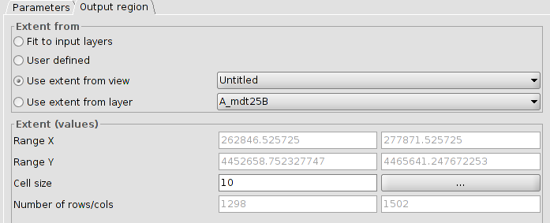
In some of the geoprocesses, the tab “Output region” allows to define the area of the output layer and, if the output is a raster, the size of the cell aimed for that output.
Also, the button help is always available in the execution window with the help for that geoprocess.
The “Output region” can have the following options:
- Fit to input layers. Automatic. It is made by the geoprocess in function on the input data. Those generating vector or raster outputs but not requiring any raster layer as input, this option is not available.
- User defined. It is possible to enter manually a group of coordinates or a cell size if it is a raster layer.
- Use extent from view. It is possible to take the extension values of the output layer from any of the Views, selecting it from a dropdown menu.
- Use extension from layer. It is possible to take the extension values of any of the available layers in the gvSIG project, even if the layer is not used as input layer in the algorithm. selecting it from a dropdown menu.
If it is not an automatic adjustment, gvSIG checks that the layer to create does not have an excessive size that can be caused by an error in entering coordinates or cell size. If the layer is very big, it will show the user a dialog to confirm the layer.
Each geoprocess has a contextual help. To view the contextual help of an extension, you must be clicked in the help button "I", located at the bottom of the execution window of the algorithm or being selected in the toolbox, click on it with the button right and select "View help" in the context menu that appears.

gvSIG Geoprocesses. Vector layers

41.1. Group by a field
This geoprocess works over one unique input layer. The user will select a field for the association and the process will group the geometries according to the field chosen.
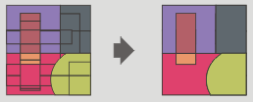
The interface is:
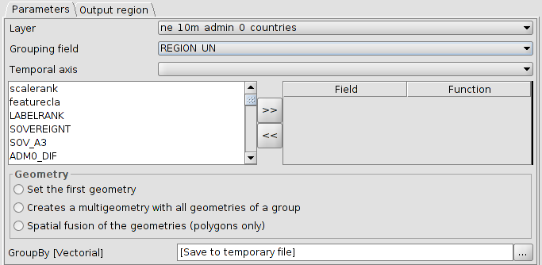
- Layer. To select the input layer from a dropdown menu.
- Grouping field. To select the field from a dropdown menu.
- Temporal axis. One particularity of this geoprocess is that it is possible to assign a time field if the input layer had it. In this case, the last or firs entry date can be included as a field table. This is very useful when the context table would be tables with sensor data, with many observations and all of them corresponding to an unique sensor. In this case is possible to group by the sensor type and assign to the table entry the last observation of the sensor. Also, we could select the option of assigning the first geometry having one point representing the sensor, with its data being the last made observation.
- Field/Function. It is possible to include to the attribute table other fields. If they are numeric, a function can be applied and if they are text, assign them to the first ones.
- Geometry. The output geometry can be:
- Set the first geometry. Only one of them (the first found).
- Creates a multigeometry with all geometries of a group.
- Spatial fusion of the geometries (polygons only).

41.2. Buffer
This geoprocess creates buffers around the geometries of vector features (points, lines and polygons) of one “input layer”, creating a new polygon vector layer.
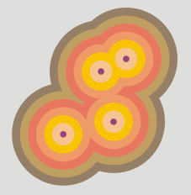
The interface is:
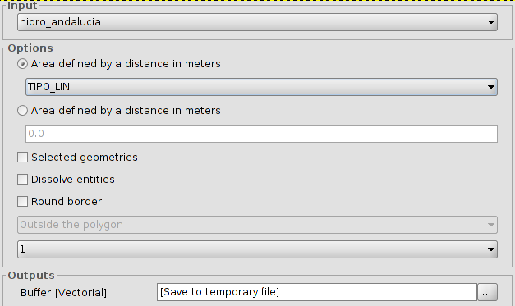
- Input. To select the input layer from a dropdown menu.
- There are two options to define the area:
- Area defined by a field in meters: it is possible to select a field of the input layer, from which the buffer´s radius will be taken.
- Area defined by a distance in meters: it is possible to enter the numeric value of the buffer´s radius.
- Selected geometries. Option to use only the selected features.
- Dissolve entities (only one ring). It is possible to fuse the features of the buffer in contact.
- Round border. Option to use a round border (soften).
- In the case of polygonal features, the buffer can be outside the polygon, inside of the polygon, or both.
- To set the number of buffers or equidistant rings around the input geometries.
If the input information is correct, when executing the geoprocess, a dialogue screen will show the progress, telling us the status in the buffer calculation. It is possible to cancel it at any time, clicking on "Cancel". In the case of the dissolve entities is not possible to calculate the exact duration, so the status bar will not be progressive. These process types are called “indefinites”.
When the geoprocess finishes, the new layer will be included in the TOC.

41.3. Lateral buffer
Creates a buffer in one of the sides of the feature (left or right).
The interface is:
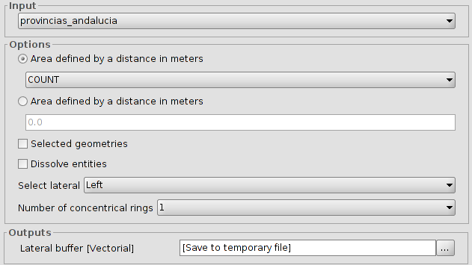
- Input. To select the input layer from a dropdown menu.
- There are two options to define the area:
- Area defined by a field in meters: it is possible to select a field of the input layer, from which the buffer´s radius will be taken.
- Area defined by a distance in meters: it is possible to enter the numeric value of the buffer´s radius.
3. Selected geometries. Option to use only the selected features.
4. Dissolve entities (only one ring). It is possible to fuse the features of the buffer in contact.
5. Select lateral. To select the lateral to which the buffer will be made; left or right.
6. To set the number of buffers or equidistant rings around the input geometries.
If the input information is correct, when executing the geoprocess, a dialogue screen will show the progress, telling us the status in the lateral buffer calculation.
When the geoprocess finishes, the new layer will be included in the TOC.

41.4. Convex Hull
This geoprocess calculates the “Convex hull”, or convex polygon of the less area which involves all the vector elements of the “input layer”.
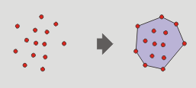
The interface is:
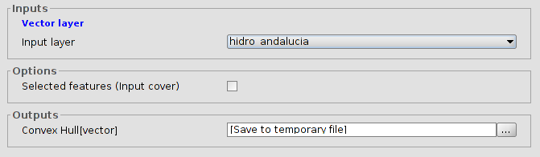
- Input layer.
- Selected features (Input layer). Option to use only the selected features.
When the geoprocess finishes, the new layer will be included in the TOC.

41.5. Clip
To clip a vector layer (points, lines or polygons) using other layer as clip layer.
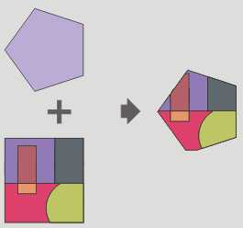
The geoprocess will go over all the vector features of the input layer and with all of them inside of the area defined by the clip layer will calculate their intersections. In the output layer, only those will be present. The portion of feature out of the work area will be deleted.
The interface is:
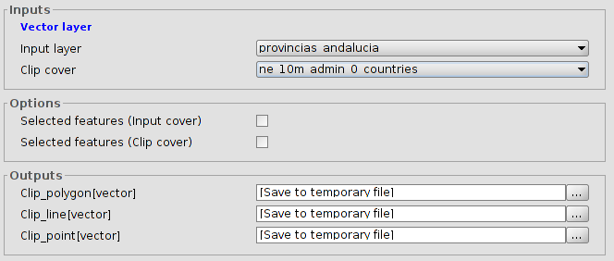
- Input layer. To select the layer to clip.
- Clip cover. To select the layer to use as clip layer.
- Selected features. Option to use only the selected features (input and clip layer)
as a result, a new layer with only the features inside of the area defined by the clip layer will be created. By default, three new output layers will be made, allowing to the user to discard any of them.
When the geoprocess finishes, the new layers will be included in the TOC.

41.6. Split lines
To split lines in equal size sections.
The interface is:
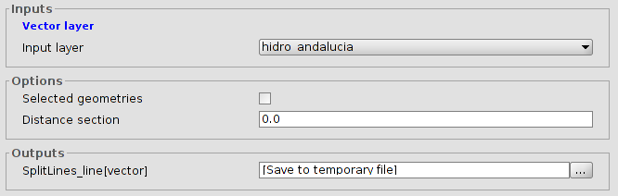
- Input layer.
- Selected features. Option to use only the selected features.
- Distance between sections. To set the size of the lines. The last part of the line has not to be the same that the defined distance.
When the geoprocess finishs, the new layer will be included in the TOC.

41.7. X and Y shift
To apply a shift change over all the points, lines and polygons of the input layer. For that, the shift in X and Y has to be defined.
The interface is:
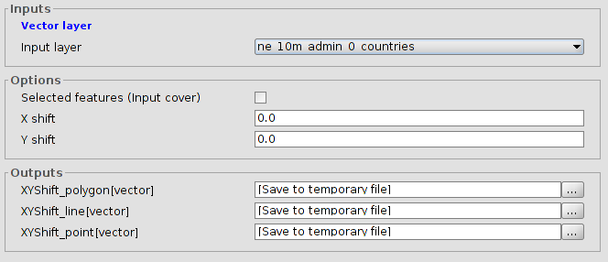
- Input layer.
- Selected features (Input layer). Option to use only the selected features.
- Shift in X and Y.
When the geoprocess finishes, the new layer will be included in the TOC.

41.8. Difference
This geoprocess known as “NOT Spatial” allows to get the areas of one layer that are not found in another layer. The features in both layers can be polygons, lines or points.
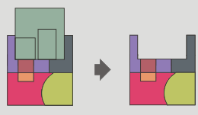
The interface is:
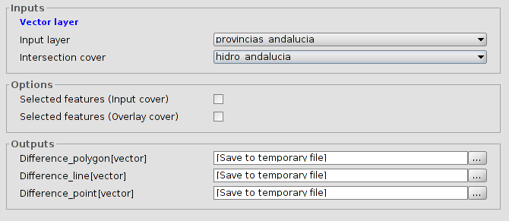
- Input layer.
- Intersection cover.
- Selected features. Option to use only the selected features in both layers.
The types of output layers will vary depending on the type of the input layers:
- Between a polygon layer and a linear one, the output layer will be polygonal.
- Between a linear layer and a polygonal one, the output layer will be linear.
- Between a polygon layer and a point one, the output layer will be polygonal.
- Between a point layer and a polygonal one, the output layer will be a point layer.
- Between a linear layer and a points one, the output layer will be linear.
- Between a point layer and a linear one, the output layer will be a point layer.
- Between two linear layers, the output layer will be a linear layer.

41.9. Dissolve
To fuse the geometries which take an equal value for a specific field. Also, it allows to set that the condition of having the same value to be fusionated, the geometries must be spatially adjacents or two geometries ermite fusionar aquellas geometrías que tomen idéntico valor para un campo especificado. También pemite establecer que para que dos geometrías sean fusionadas, además de tomar idéntico valor en el atributo especificado deban ser adyacentes espacialmente.
The interface is:
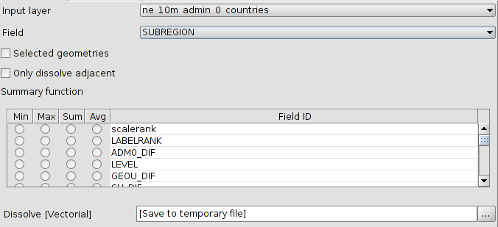
- Input layer. To select the layer to dissolve.
- Field. To select the attribute to be used as the criteria for for fusionating the features of the layer.
- Selected features. Option to use only the selected features in both layers.
- Only dissolve adjacent geometries.
- Summary function. It is possible to apply a summary function over the numeric values of the linked features: Minimum(Min), maximum (Max), summation (Sum) and average (Avg). A field will be created for each function in the output layer.
When the geoprocess finishes, the new layer will be included in the TOC.

41.10. Fuse spatially
This geoprocess works with one only input layer, whose geometry type must be polygon. This process analyse each input geometry and builds a unique polygon with all geometries which intersects each other. The attribute table will have an identifier field of each feature. Furthermore, other layer with only alphanumeric data will be created. This alphanumeric table will contain the table of the input layer and it will include an ID field with a reference to the polygon in the first layer. In this way, each polygon in the first layer will have a reference to each feature in the second layer.
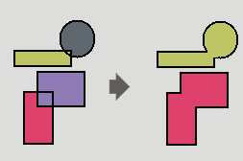
The interface is:
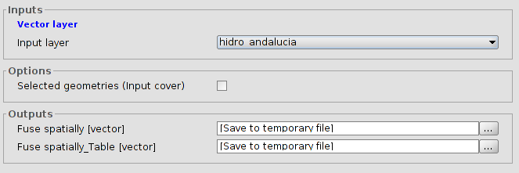
- Input layer.
- Selected features (input layer). Option to use only the selected features in both layers.

41.11. Intersection
This geoprocess works with two layers: the input layer and the overlay layer. For each geometry in the input layer, it computes its intersections with the geometries of the overlay layer. For each intersection, it adds a new feature with the intersection as geometry and all attributes of the features which originates it. It is called "Spatial AND", because features of the result layer models a space common to both layers.
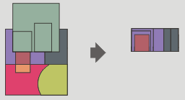
The interface is:
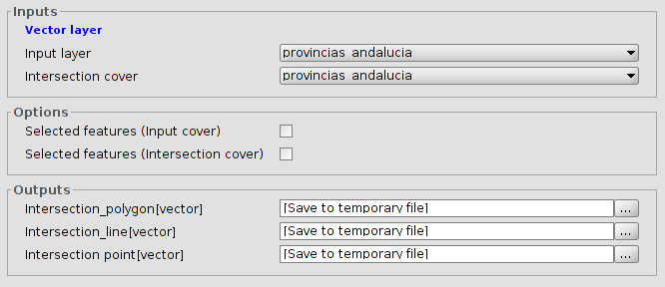
- Input layer.
- Intersection cover. To select the intersection layer.
- Selected features. Option to use only the selected features in both layers.
The type of the output layer will depend on the input layer:
- Between a polygon layer and a linear one, the output layer will be polygonal.
- Between a polygon layer and a point one, the output layer will be polygonal.
- Between two linear layers, the output layer will be a point layer, with the crosspoints between the lines of both layers.
- Between two polygonar layers, the output layer will be another polygonal layer.

41.12. Merge
This geoprocess can work with many input layers. It merges all of these creating a new result layer which has a feature for each feature of all input layers.
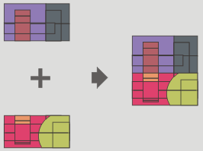
The interface is:
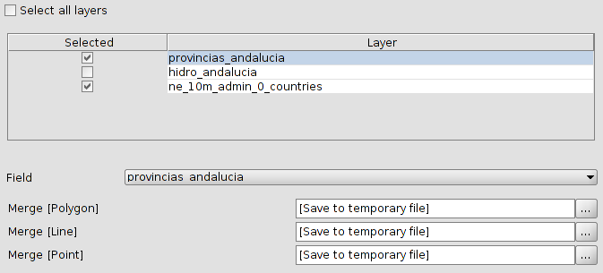
- Selection of layers for the merge.
- Field. Because each input layer could have its own alphanumeric schema, user must select which layer will preserve its schema. The rest of input layers will only preserve those attributes whose name and type would be the same that an attribute of the input layer whose schema will be preserved.
When the geoprocess finishes, the new layer will be included in the TOC.

41.13. Reproject
This geoprocess will change the CRS of the input layer.
The interface is:
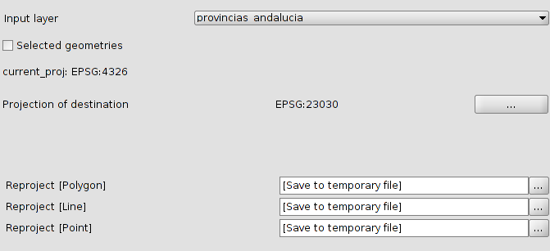
- Input layer to reproject.
- Selected features. Option to use only the selected features.
- Projection of destination. Use “...” to set the projection for the new layer.

41.14. Spatial Join
This geoprocess transfer attributes from a source layer to a target layer (very similar to an alphanumerical join). The difference with a traditional join is that the transfer criteria is not the value of one (or many) given attributes.
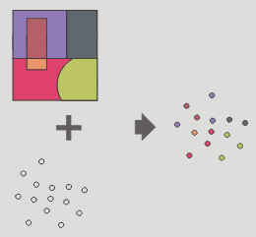
Permite seguir dos tipos de criterios espaciales para establecer el enlace espacial:
Vecino más próximo (relación 1->1). Asigna a un elemento de la capa origen, los atributos del elemento más próximo de la capa enlazada. En caso de que el elemento más próximo intersecte (o esté contenido para el caso de polígonos) al elemento original, el algoritmo tomará el primer elemento analizado de las posibles intersecciones.
Contenido en (relación 1->M). Relaciona un elemento de la capa origen con varios elementos de la capa destino (en concreto, con aquellos que son intersectados). En este caso la capa origen no heredará los atributos de la capa relacionada, sino que la operativa será muy parecida a la del geoproceso “Disolver”. Para los M elementos relacionados con un elemento de la capa origen, se dará al usuario la posibilidad de escoger una o varias funciones resumen (media, mínimo, máximo, sumatorio) que se aplicarán sobre los atributos numéricos de la capa enlazada.
The interface is:
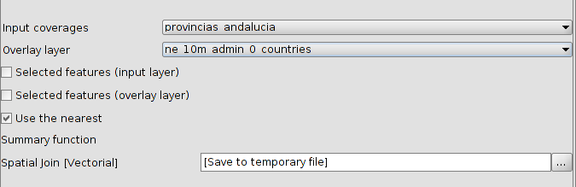
- Input layer.
- Overlay layer.
- Selected features. Option to use only the selected features in both layers.Geometrías seleccionadas.
- Use nearest. Permite seleccionar una relación 1-1 mediante el criterio espacial de vecino más próximo. Si no se activa la casilla de verificación se aplica una relación 1-N, mediante el criterio espacial 'Intersecta' o 'Contenido en'.
- Summary function. Permite aplicar una función resumen sobre los atributos numéricos de los elementos enlazados. Las funciones resumen soportadas son mínimo (Min), máximo (Max), sumatorio (Sum) y media (Avg). Se incluirá un campo en la capa resultado para cada función resumen seleccionada.
When the geoprocess finishes, the new layer will be included in the TOC.

41.15. Union
Like Intersect and Difference, this geoprocess is an overlay geoprocess. It works with an input and an overlay layer; it is also called "Spatial OR" because features of the result layer will have features whose geometry is in any of the input or the overlay layer. This means that the geoprocess takes three steps:
- The first one to calculate the intersection of both tables.
- The second one to calculate the differences between the first and the second one.
- The third one to calculate the differences between the second and the first one.
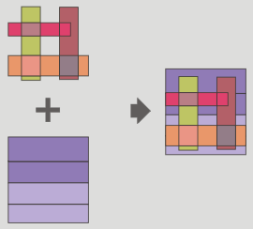
The interface is:
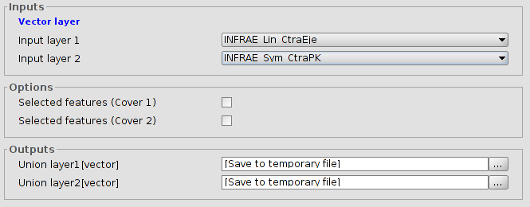
- Input layer. To select the layers.
- Selected features. Option to use only the selected features.
The results of unions with different geometries are:
- Between a polygonal layer and one point layer, the output layers will be one point layer and another polygonal layer.
- Between a polygonal layer and one linear layer, the output layers will be one linear layer and another polygonal layer.
- Between two linear layers, the output layers will be one linear layer and another point layer with the intersection between them.

gvSIG Geoprocesses. Raster layers

42.1. Change data type
To change the data type of the raster.
The interface is:
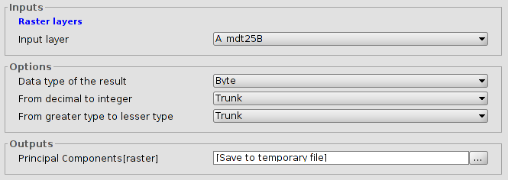
- Layer. Name of the input layer.
- Options to modify the data type.

42.2. Mask
To apply a mask enhancement.
The interface is:
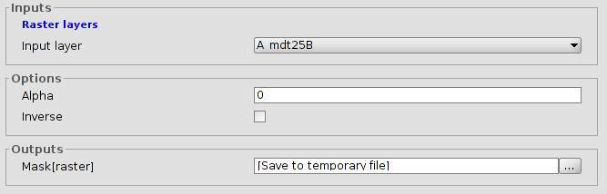
- Input layer.
- Options. Alpha values. Inverse. If this is enabled, the mask will be applied to the external areas of the output region and the internal ones will be opaque.

gvSIG Geoprocesses. Multispectral raster

43.1. Principal components
El análisis de componentes principales es una transformación multiespectral que tiene como objetivo evitar el uso de información redundante en las distintas bandas de la imagen. La técnica permite transformar una serie de bandas en nuevas variables llamadas componentes incorrelacionadas, que absorben la gran parte de la variabilidad de los datos en un subconjunto de las bandas iniciales. La ventaja de la utilización de este mecanismo radica en que la mayor parte de la información recae en las tres primeras bandas creadas, lo cual permite mantener gran parte de la información con una reducción drástica de espacio.
The interface is:
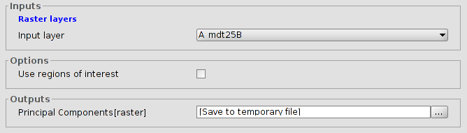
- Input layer.
- Use regions of interest of the layer.

43.2. Tasseled cap
La transformación tasseled cap es una transformación más general que la transformación de componentes principales disponiendo además de índices con significación física determinada, de manera que es posible determinar el valor del brillo, verdor y la humedad del suelo. La transformación Tasseled Cap se centra en destacar las características espectrales relevantes de las superficies vegetales durante su desarrollo, con el objeto de discriminar cultivos específicos, y cultivos de otras cubiertas vegetales utilizando los rangos espectrales de las imágenes multitemporales Landsat.
The interface is:
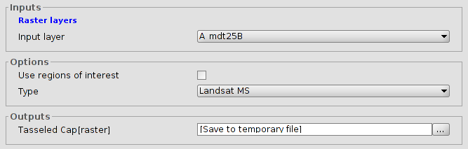
- Input layer.
- Use regions of interest of the layer.
- Type. To select the image type: LandSat MSS, LandSat TM and LandSat ETM. For LandSat MSS only for images with 4 bands. In the case of LandSat TM and ETM will only for images with 6 or 7 bands.

gvSIG tools. Raster layers

44.1. Set projection
See set projection in raster section.

44.2. Change data type
See change data type in raster section.

44.3. Export
See save in raster section.

44.4. Filters
See filters in raster section.

44.5. Mask by region of interest
See mask by region of interest in raster section.

44.6. Radiometric enhancement
See radiometric enhancement in raster section.

44.7. Clip
See clip in raster section.

44.8. Reproject
See reproject in raster section.

gvSIG herramientas. Ráster multiespectral

45.1. Principal components
See principal compionents in raster section.

45.2. Tasseled cap
See Tasseled cap in raster section.

sextante

46.1. Introduction
Sextante is an opensource library of all the algorithms grouped in different blocks. It is integrated within the gvSIG toolbox.
- 3D
- Basic hidrologycal analysis
- Basic tools for raster layers
- Buffers
- Calculus tools for raster layer
- Costs, distances and routes
- Development
- Fire modeling
- Focal statistics
- Fuzzy logic
- Geomorphometry and terrain analysis
- Geosocial
- Geostatistics
- Image processing
- Indices and other hydrological parameters
- localiza
- Local statistics
- Location/allocation
- Non-spatial
- Pattern analysis
- Profiles
- Raster categories analysis
- Raster creation tools
- Rasterization and interopolation
- Raster layer analysis
- Reclassify raster layers
- Statistical methods
- Table tools
- TIN
- Tools for line layers
- Tools for point layers
- Tools for polygon layers
- Tools for vector layers
- Topology
- Vectorization
- Vegetation indices
- Visibility and lighting

modeler

47.1. Introduction
The modeler allows to create complex models using a simple and easy-to-use interface. When working with a GIS, most analysis operations are not isolated, but part of a chain of operations instead. Using the graphical modeler, that chain of processes can be wrapped into a single process, so it is easier and more convenient to execute than a single process later on a different set on inputs. No matter how many steps and different algorithms it involves, a model is executed as a single algorithm, thus saving time and effort, specially for larger models.
It is available from “Tools/Geoprocessing/Modeler” and from “Models/Tools/Create new model”.
The interface is:
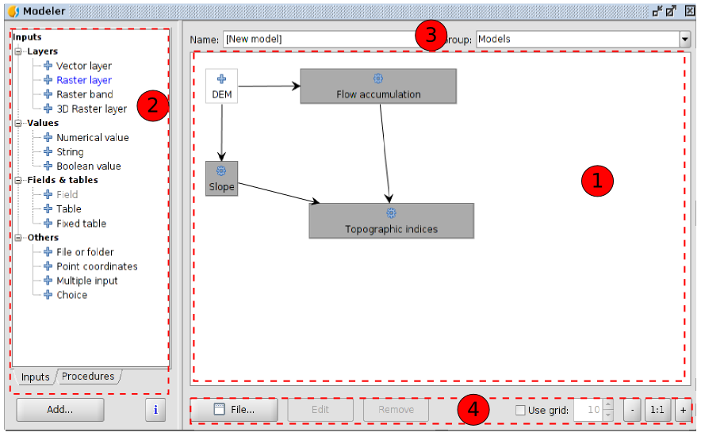
- Working canvas where the structure of the model and the workflow it represents are shown. On the left part of the window, a panel with two tabs can be used to add new elements to the model.
- Elements. Double clicking on any of them or clicking on “Add” a window with its properties willl be shown and it will be added to the canvas. Two tabs have all the available elements to be added to the model:
- Inputs. Available elements to be added.
- Procedures. All the available algorithms..
- To define the name and group of the algorithm.
- Modeler tools:
- File. To create a new canvas, open an existent one and save as. The extension will be .model.
- Edit. To edit an element of the model.
- Remove. To remove an element of the model.
- Use grid. To view and set a grid.
- Zoom buttons for the view of the canvas.
Creating a model is a two-step process.
- Definition of necessary inputs. These inputs will be added to the parameters window, so the user can set their values when executing the model. The model itself is a SEXTANTE algorithm, so the parameters window is generated automatically as it happens with all the algorithms included in the library.
- Definition of the workflow. Using the input data of the model, the workflow is defined adding algorithms and selecting how they use those inputs or the outputs generated by other algorithms already in the model

47.2. Definition of inputs
The first step to create a model is to define the inputs it needs. The following elements are found in the Inputs tabs on the left side of the modeler window
Double-clicking on any of them, a dialogue is shown to define its characteristics. Depending on the parameter itself, the dialogue will contain just one basic element (the description, which is what the user will see when executing the model) or more of them:
Vector layer | Raster layer
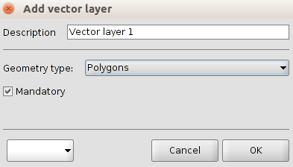 | 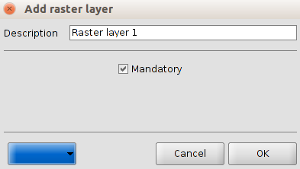
Numerical value | File or folder
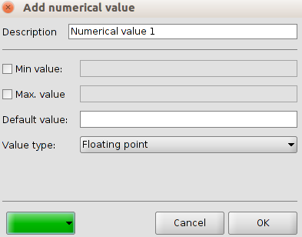 | 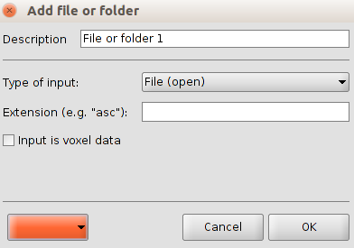
Common options:
- Description. What the user will execute as model.
- Colour. Dropdown to select the colour for the canvas.

47.3. Definition of the workflow
Once the inputs have been defined, it is time to define the algorithms to apply on them. Algorithms can be found in the Processes tab, grouped much in the same way as they are in the toolbox.
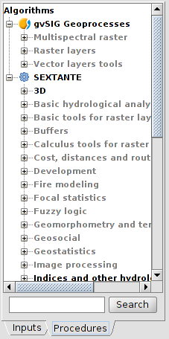
To add a process, double-click on its name. An execution dialogue will appear, with a content similar to the one found execution panel that SEXTANTE shows when executing the algorithm from the toolbox
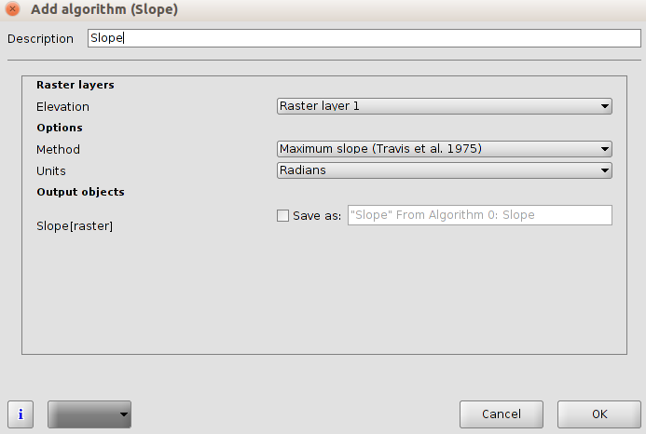
Some differences exist, however, the main one being the absence of a raster output tab, even if the selected algorithm generates raster layers as output.
Instead of the textbox that was used to set the filepath for output layers and tables, a checkbox and a text box are found. If the layer generated by the algorithm is just a temporary result that will be used as the input of another algorithm and should not be kept as a final result, the check box should be left unchecked. Checking it means that the result is a final one, and you have to supply also a valid description for the output, which will be the one the user will see when executing the mode
Selecting the value of each parameter is also a bit different, since there are important differences between the context of the modeler and the toolbox one. Let's see how to introduce the values for each type of parameter.
- Layers (raster and vector) and tables. They are selected from a list, but in this case the possible values are not the layers or tables currently loaded in the GIS, but the list of model input or the corresponding type, or other layers or tables generated by algorithms already added to the model.
- Numerical values. Literal values can be introduced directly on the textbox. This textbox is a list that can be used to select any of the numerical value input of the model. In this case, the parameter will take the value introduced by the user when executing the model.
- String. Like in the case of numerical values, literal strings can be typed, or an input string can be selected
- Points. Coordinates cannot be directly introduced. Use the list to select one of the coordinate inputs of the model
- Bands. The number of bands of the parent layer cannot be known at design-time, so it is not possible to show the list of available bands. Instead, a list with band numbers from 1 to 250, as well as the band parameters of the model, is shown. At run-time, SEXTANTE will check if the parent raster layer selected by the user has enough bands and the given band has therefore a valid value, and if not it will generate an error message.
- Table field. Like in the previous case, the fields of the parent table or layer cannot be known at design-time, since they depend of the selection of the user each time the model is executed. To set the value for this parameter, type the name of a field directly in the textbox, or use the list to select a table field input already added to the model. The validity of the selected field will be checked by SEXTANTE at run-time
- Selection. The list contains in this case not only the available option from the algorithm, but also the selection inputs already added to the current model
Once all the parameter have been assigned valid values, click on OK and the algorithm will be added to the canvas. It will be linked to all the other elements in the canvas, whether algorithms or inputs, which provide objects that are used as inputs for that algorithm

47.4. Editing the model in the canvas
Once the model has been designed, it can be executed clicking on the Execute button. The execution window will have a parameters tab automatically created based on the requirements of the model (the inputs added to it), just like it happens when a simple algorithm is executed. If any of the algorithms of the model generates raster layers, the Raster output tab will be added to the window.
Elements can be dragged to a different position within the canvas, to change the way the module structure is displayed and make it more clear and intuitive. Links between elements are update automatically.
To change the parameters of any of the algorithms of a model, double-click on it to access its parameters window.
To delete an element, right-click on it and select Delete. Only those elements that do not have any other one depending on them can be deleted. If you try to delete an element that cannot be deleted, SEXTANTE will show the following warning message.

47.5. Saving and loading models
Models can be saved to be executed or edited at a later time. Use the Save button to save the current model and the Open model to open any model previously saved. Model are saved in an XML file with the .model extension.
Models saved on the models folder will appear in the toolbox in a group that you can set using the boxes in the top of the modeler window. Type in the name of the model and then select a group from the drop-down list. The list contains all the names of the already existing groups, and also an additional group named ``Models''. If none of this group suits your needs, you can type a new name directly in that box, which is editable.
When the toolbox is invoked, SEXTANTE searches the models folder for files with .model extension and loads the models they contain. Since a model is itself a SEXTANTE algorithm, it can be added to the toolbox just like any other algorithm.
The models folder can be set from the SEXTANTE toolbox, clicking the configuration button and then introducing the path to the folder in the corresponding field. Go to the ``Folders'' tab to find it.
Models loaded from the models folder appear not only in the toolbox, but also in the algorithms tree in the Processes tab of the modeler window. That means that you can incorporate a model as a part of a bigger model, just as you add any other algorithm. however, models are shown with a different icon, to make it easy to recognize them.

Batch processing

48.1. Introduction
TO DO
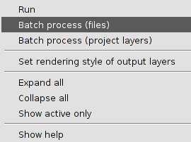

48.2. Parameters table
TO DO
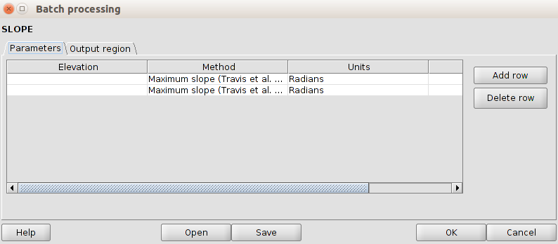

48.3. Características de las salidas ráster
TO DO

48.4. Ejecutar el proceso por lotes
TO DO

48.5. Procesos por lotes con capas ya cargadas
TO DO

command line

49.1. Introduction
The command-line interface allows advanced users to increase their productivity and performe complex operations with simple scripts.
It is available from “Tools/Geoprocessing/Command line”
The interface is:
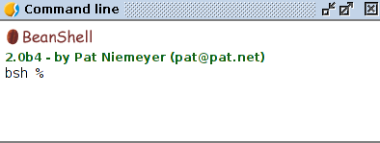
The command-line interface is based on BeanShell. BeanShell is a Java source interpreter with object scripting language features, that meaning that it dynamically executes standard Java syntax and extends it with common scripting conveniences such as loose types, commands, and method closures like those in Perl and JavaScript. Several new commands have been added to it, so you can run geoalgorithms or get information about the geospatial data you are using, among other things.

49.2. Getting information about data
Algorithms need data to run. Layers and tables are identified using the name they have in the table of contents of gvSIG.
The data() command prints a list of all data objects available to be used, along with the particular name of each one (i.e. the one you have to use to refer to it). Calling it you will get something like this:
RASTER LAYERS
-----------------
mdt25.asc

VECTOR LAYERS
-----------------
Contour lines

TABLES
-----------------
To get more information about a particular data object, use the describe(name_of_data_object) command. Here are a few examples of the result you will get when using it to get more information about a vector layer, a raster layer and a table.

>describe points.shp
Type: Vector layer - Point
Number of entities: 300
Table fields: | ID | X | Y | SAND | SILT | CLAY | SOILTYPE | EXTRAPOLAT |
>describe dem25.asc
Type: Raster layer
X min: 262846.525725
X max: 277871.525725
Y min: 4454025.0
Y max: 4464275.0
Cellsize X: 25.0
Cellsize Y: 0.0
Rows: 410
Cols: 601
>describe spatialCorrelation.dbf
Type: TableNumber of records: 156
Table fields: | Distance | I_Moran | c_Geary | Semivariance |

49.3. Getting information about algorithms
Once you know which data you have, it is time to know which algorithms are available and how to use them.
When you execute an algorithm using the toolbox, you use a parameters window with several fields, each one of them corresponding to a single parameter. When you use the command line interface, you must know which parameters are needed, so as to pass the right values to use to the method that runs that algorithm. Of course you do not have to memorize the requirements of all the algorithms, since SEXTANTE has a method to describe an algorithm in detail. But before we see that method, let's have a look at another one, the algs() method. It has no parameters, and it just prints a list of all the available algorithms. Here is a little part of that list as you will see it in your command-line shell.

bsh % algs();
acccost-------------------------------: Accumulated cost(isotropic)
acccostanisotropic--------------------: Accumulated cost (anisotropic)
acccostcombined-----------------------: Accumulated cost (combined)
accflow-------------------------------: Flow accumulation
acv-----------------------------------: Anisotropic coefficient of variation
addeventtheme-------------------------: Points layer from table
aggregate-----------------------------: Aggregate
aggregationindex----------------------: Aggregation index
ahp-----------------------------------: Analytical Hierarchy Process (AHP)
aspect--------------------------------: Aspect
buffer--------------------------------: Buffer
On the left side of the list you will find the command-line name of each algorithm. This is the one you have to use to make a reference to the algorithm you want to use. On the right you find the name of the algorithm in the current language, which is the same name that identifies the algorithm in the toolbox. However, this name is not constant, since it depends on the current language, and thus cannot be used to call the algorithm. Instead, a command-line is needed.
Now, let's see how to get a list of the parameters that an algorithms require and the outputs that it will generate. To do it, you can use the describealg(name_of_the_algorithm) method. Use the command-line name of the algorithm, not the full descriptive name.
For example, if we want to calculate a flow accumulation layer from a DEM, we will need to execute the corresponding module, which, according to the list show using the ags() method, is identified as accflow. The following is a description of its inputs and outputs.

>describealg("accflow")
Usage: accflow(DEM[Raster Layer]
WEIGHTS[Optional Raster Layer]
METHOD[Selection]
CONVERGENCE[Numerical Value]
FLOWACC [output raster layer])

49.4. Running an algorithm
There is only one single command to execute algorithms: runalg. Its syntax is as follows:
> runalg{name_of_the_algorithm, param1, param2, ..., paramN)
The list of parameters to add depends on the algorithm you want to run, and is exactly the list that the describealg method gives you, in the same order as shown.
Depending on the type of parameter, values are introduced differently. The next one is a quick review of how to introduce values for each type of input parameter
If the input is optional and you do not want to use any data object, write ``#''
- Raster Layer, Vector Layer or Table. Simply introduce the name that identifies the data object to use. I.
- Numerical value. Directly type the value to use or the name of a variable containing that value.
- Selection. Type the number that identifies the desired option, as shown by the options command
- String. Directly type the string to use or the name of a variable containing it.
- Boolean. Type whether ``true'' or ``false'' (including quotes)
- Multiple selection-data_type. Type the list of objects to use, separated by commas and enclosed between quotes.
For example, for the maxvaluegrid algorithm:
Usage: runalg("maxvaluegrid",
INPUT[Multiple Input - Raster Layer]
NODATA[Boolean],
RESULT[Output raster layer])
The next line shows a valid use example
> runalg("maxvaluegrid", "lyr1, lyr2, lyr3", "false", "#")
Of course, lyr1, lyr2 and lyr3 must be valid layers already loaded into your GIS.
When the multiple input is comprised of raster bands, each element is represented by a pair of values (layer, band). For example, for the cluster algorithm
Usage: runalg( "cluster",
INPUT[Multiple Input - Band],
NUMCLASS[Numerical Value],
RESULTLAYER[output raster layer],
RESULTTABLE[output table],
);
A valid example is:
> runalg("cluster, "lyr1, 1, lyr1, 2, lyr2, 2", 5, "#", "#")
The algorithm will use three bands, two of them from lyr1 (the first and the second ones of that layer) and one from lyr2 (its second band).
- Table Field from XXX. Write the name of the field to use. This parameter is case-sensitive.
- Fixed Table. Type the list of all table values separated by commas and enclosed between quotes. Values start on the upper row and go from left to right. Here is an example:
runalg("kernelfilter", mdt25.asc, "-1, -1, -1, -1, 9, -1, -1, -1, -1", "#")
- Point . The two coordinates must be separated with a comma and in quotes. Example: ''220345, 4453616''
Input parameters such as strings or numerical values have default values. To use them, type ``#'' in the corresponding parameter entry instead of a value expression.
For output data objects, type the filepath to be used to save it, just as it is done from the toolbox. If you want to save the result to a temporary file, type ``#''. If you want to save the output to a permanent file, type the output file.

49.5. Running a model
Models can be executed from the command-line using the model command, which has a sintax similar to the runalg command. In this case, you must use the file name where the model is stored instead of the name of the algorithm as the first parameters. The remaining parameters depend on the particular model you want to execute, much like in the case of running a simple algorithm with the runalg command.

49.6. Managing layers from the command-line interface
You can perform some operation with layers from the command-line interface, like the following ones:
- Close a layer. Use the close(layer_name) command.
- Change the no-data value of a raster layer. Use the setnodata(layer_name, new_value) command
- Change the name of a layer. Use the rename(layer_name, new_layer_name) command

49.7. Adjusting output raster characteristics
Just like when you execute a geoalgorithm from the toolbox, when it generates new raster layers you have to define the extent and cell size of those layers.
By default, those characteristics are defined based on the input layers. You can toggle this behaviour using the autoextent command.
> autoextent("true"/"false)
By default, it has a true value. However, iif you want to set a concrete extent and cell size for all the output raster layers, you should use the extent command:
Usage: extent(raster layer[string])
extent(vector layer[string], cellsize[double])
extent(x min[double], y min[double],
x max[double], y max[double],
cell size[double])
Type "autoextent" to use automatic extent fitting when possible
When a fixed extension has been set, automatically the autoextent will be deactivated (similar to execute a false autoextent).

HISTOry

50.1. Introduction
Every time you execute a geoprocess of the toolbox, information about the process is stored in the history manager. Along with the parameters used, the date and time of the execution are also saved.
This way, it is easy to track the and control all the work that has been developed and easily reproduce it.
It is available from “Tools/Geoprocessing/History”
The history manager is a set of registries grouped according to their date of execution, making it easier to find information about an algorithm executed at any particular moment.
Process information is kept as a command-line expression, even if the algorithm was launched from the toolbox. This makes it also useful for those learning how to use the command-line interface, since they can call an algorithm using the toolbox and then check the history manager to see how that same algorithm could be called from the command line.
Apart from browsing the entries in the registry, processes can be re-executed, simply double-clicking on the corresponding entry.
You can also right click on a process (the command-line sentence must start with ``runalg'') and select “Open algorithm dialogue”. This will show the dialogue used to execute the algorithm, already filled with the parameter values corresponding to the selected command.

CATALOG
TO DO

WEB MAP CONTEXT (WMC)
TO DO

Google Street view

53.1. Introduction
Allows Google Street View tool access. Google Street View provides panoramics at street level (360 degrees horizontal movement and 290 degrees vertical movement), letting users to see part of the city in the selected coordinates.
Available from the “View/Query/Google Street View” menu or from the corresponding button.
Icon | Tool | Short key | Description
 | Google Street View |  | Allows viewing Google Street View service at the indicated point.
Once activated the tool, the mouse pointer will change to reflect this fact. When you click on a view, an auxiliary window opens where the Google Street View contents of the corresponding pressed coordinates will be displayed. This window will include the functionality provided for Google Street View Navigation.
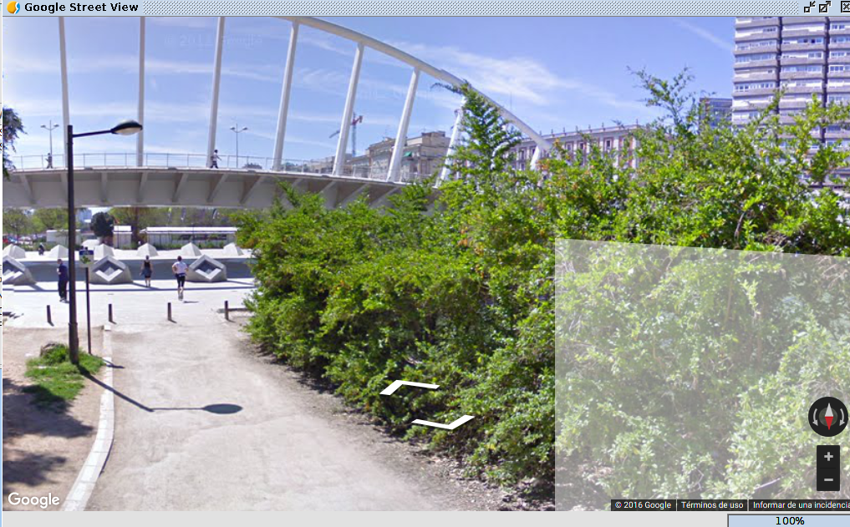

53.2. Configuration of the Google Street View tool
To correctly use the tool, it is possible that we must facilitate a valid credential for the Google Street View use.
You can find more information about the terms of use in:
https://developers.google.com/maps/terms?hl=es#1-your-relationship-with-google
You can request your credential to Google through this page: https://console.developers.google.com/
To set this credential it is available a tool configuration panel placed in “Show/Preferences/Google Street View”.
As a rule, credentials for static maps use from Google Maps are not valid for Google Street View use and vice versa.
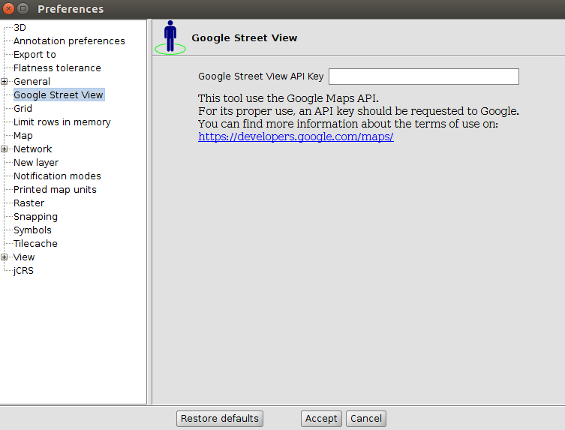

3D Plugin

54.1 Introduction
3D plugin offers to users several tools to create 3D views from 2D views. In “3D View” there are the main tools related to 3D plugin. They also have the corresponding button bar.

Menu | Button bar
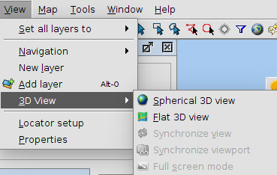
Let see every tool available:
Icon | Tool | Description
 | Spherical 3D view | Create a Spherical 3D view from active 2D view.
 | Flat 3D view | Create a Flat 3D view from active 2D view.
 | Synchronize view | Synchronize 3D view with associated 2D view.
 | Synchronize viewport | Synchronize 3D viewport with associated 2D view viewport.
 | Full screen mode | Indicate full screen mode to active 3D view.

54.2 3D View
The default 3D view is displayed like this:
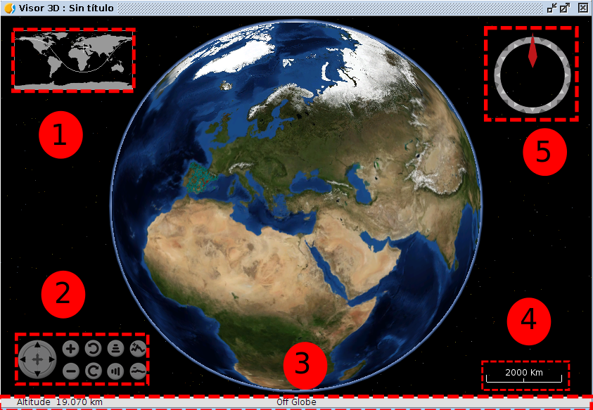
3D view is composed by five components:
- Minimap: it shows what area of the Earth is being shown and the center point of 3D view.
- View controller: It is composed by nine buttons. The first button allows user to move the viewport, the first pair of buttons allows user to increase or decrease zoom, the second pair of buttons allows user to rotate viewport, the third pair of buttons allow user to increase the grade inclination and the fourth pair of buttons allows user to increase or decrease vertical exaggeration.
- Status bar: it shows the altitude of viewport, coordinates of mouse
- Scale: it shows scale of current viewport.
- North indicator: it indicates the direction of north and viewport inclination grade.

3D TOOLS

55.1 Spherical 3D view
This tool allows users to create a Spherical 3D view from active 2D view. To create a Spherical 3D view it is necessary to meet the following requirements:
- One 2D view active with at least one layer added.
- Active view projection must be EPSG:4326.
- There is not a Spherical 3D view created with the active view. There can only be one 3D view with the same type at the same time. Due to this, there can only be two 3D views (spherical and flat) associated with the same 2D view at the same time.
If all requirements are met, just do click on menu or bar button and a new Spherical 3D view will be created.
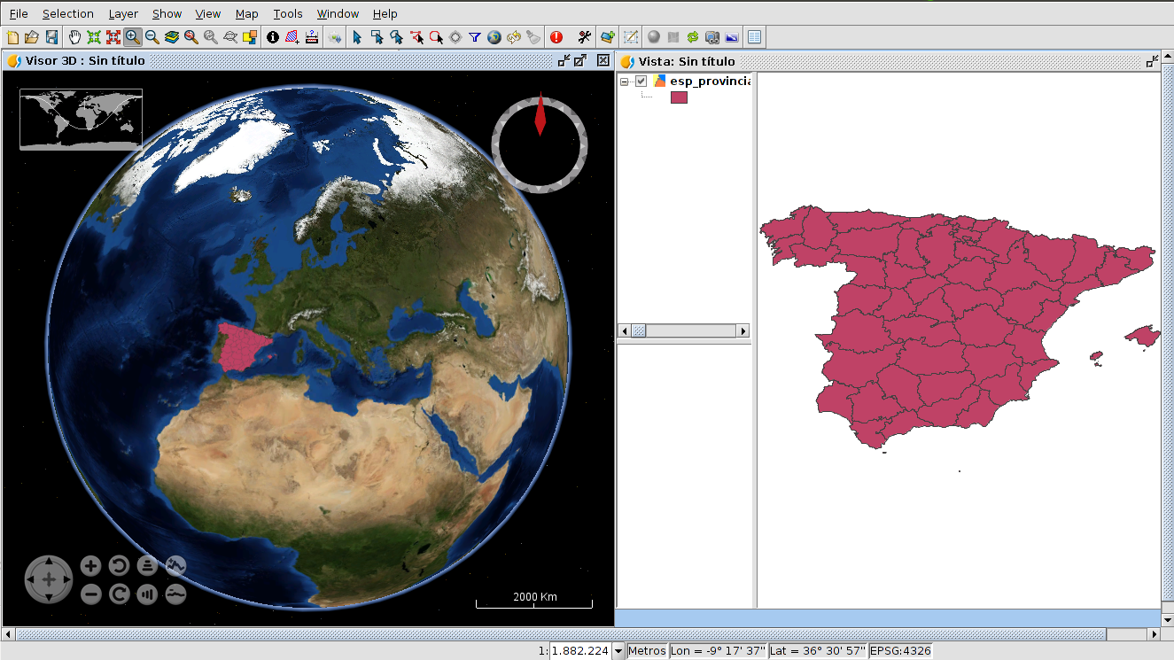
When a new 3D view is created, it takes the loaded layers in 2D to transform it into 3D layers to show it at Spherical 3D view.
The transformation of layers depends on the loading mode indicated by user. There are two loading modes available: raster and elevation. On the one hand, raster loading mode indicates that layer will be converted to raster image. All kind of supported layers by gvSIG can be converted to raster image. On the other hand, elevation loading mode indicates that layer will be converted to elevation model. Only raster layers with at least one band can be loaded as elevation. Afterwards, how to indicate loading mode with other 3D properties will be explained in this document.
An example of raster layer loaded as raster (colored layer) and as elevation (DEM) at the same time:
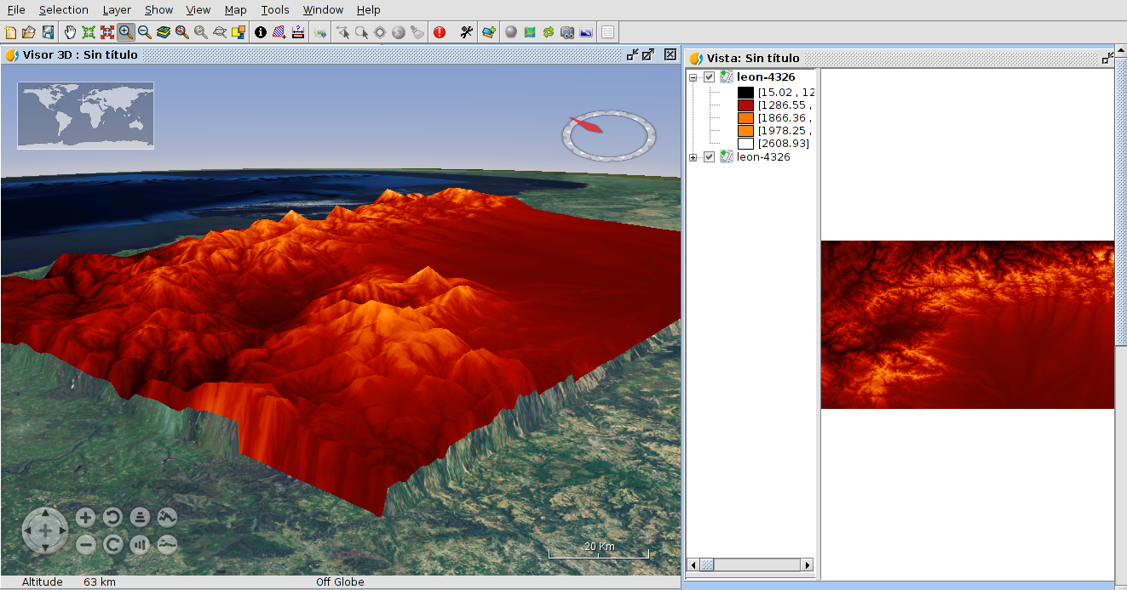

55.2 Flat 3D view
This tool allows users to create a Flat 3D view from active 2D view. To create a Flat 3D view it is necessary to meet the following requirements:
- One 2D view active with at least one layer added.
- Active view projection must be EPSG:4326.
- There is not a Flat 3D view created with the active view. There can only be one 3D view with the same type at the same time. Due to this, there can only be two 3D views (spherical and flat) associated with the same 2D view at the same time.
If all requirements are met, just do click on menu or bar button and a new Flat 3D view will be created.
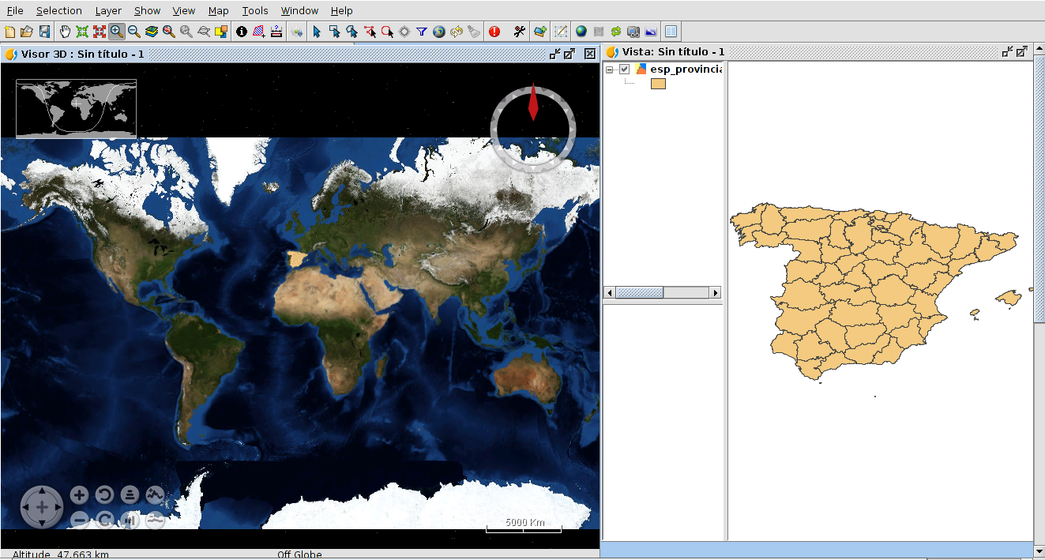
In the same way as Spherical 3D view, when a Flat 3D view is created, the layers of 2D view are converted to 3D layers to show them at 3D view.

55.3 Synchronize view
This tool allows users to synchronize a 3D view and an associated 2D view. When a 3D view is created, it is linked with the 2D view. This permits to register 2D layers changes to copy and apply them to 3D layers. For example, if we change the symbology of one 2D layer and then we click on Synchronize view button, the converted 3D layer will be affected by this change. Moreover, If we have two 3D views open at the same time, both 3D views will be synchronized.
The synchronization of views can be done in two ways: manual and automatic. The manual way is run when clicking on bar button or “Synchronize view” menu entry. The automatic way starts when the “Auto synchronize layers” option is activated in 3D View properties.

55.4 Synchronize viewport
This tool allows users to synchronize the viewport of 3D view and the viewport of associated 2D view. When a 3D view is created, it is linked with the 2D view. This permits to get the viewport of 2D view and indicates it to 3D view. Moreover, If we have two 3D views open at the same time, both 3D views will be synchronized.

55.5 Full screen mode
This tool allows users to indicate full screen mode to activate 3D view. To indicate full mode it is necessary to have one 3D view active. If one 3D view is activated, just do click on menu or bar button and full screen 3D view will be created.
To close full screen window press ESC key.

3D Properties

56.1 General 3D preferences
3D Plugin has the next general preferences:
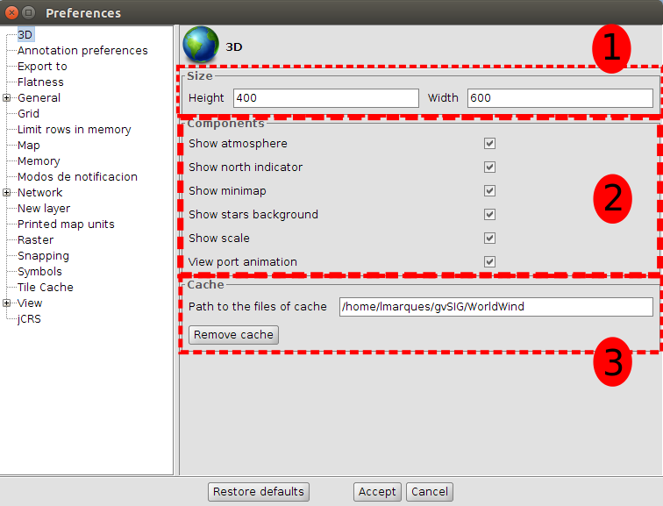
General 3D preferences are divided into three parts:
- Size: default dimensions of new 3D views.
- Components: a list of options to change the visibility of 3D view components and to enable or disable animation of viewport synchronization.
- Cache: path of current cache and a button to remove tile cache.
The general 3D preferences changes only affect new 3D views, so if we want to apply the changes, we have to close 3D views and create them again.

56.2 3D View properties
3D Plugin has the next view properties:
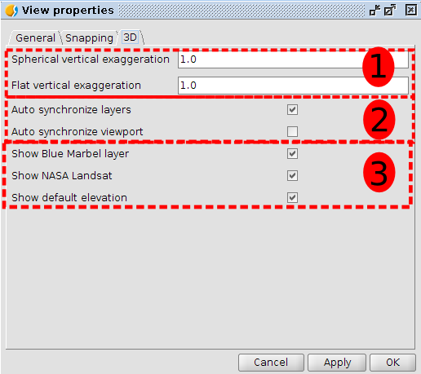
Each 2D view has its own 3D view properties. 3D View properties are divided into three groups:
- Vertical exaggeration: vertical exaggerations of 3D views. It is possible to change the vertical exaggeration from 3D view properties or from the pair of buttons at 3D view.
- Auto synchronized: two options to enable or disable the auto synchronization of layer or viewport.
- Visibility of default layers: three options to change the visibility of default loaded layers at 3D views.

56.3 3D Layer properties
3D Plugin provides 3D layer properties to indicate several options. Depending on the type of layer and loading mode selected, some properties will be enabled or disabled.

56.3.1. 3D Vector layer properties
Vector layers have three loader modes:
- Rasterized: The 2D View vector layer will be rasterized as an image that will be displayed at 3D View.
- Vector: Vectors layers elements at 2D View will be transformed in 3D vectors and loaded at 3D View.
- Extrusion: Vectors layers elements at 2D View will be transformed in 3D vectors and loaded at 3D View, applying an extrusion so as to get volume effect.
Rasterized mode converts vector layer in a raster layer at 3D View. The elevation mode converts the vector layer in a DTM (Digital Terrain Model) taking as elevation value the one indicated in the attributes table field of the layer (not available yet).
Rasterized vector layer load
The properties are the following:
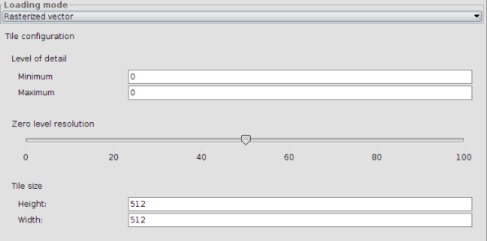
- Load mode. Enable selecting the layer load mode at 3D View.
- Detail levels. Enable defining minimum and maximum level of the layer. The minimum detail level indicates from what level a layer is visible. For example, if it is indicated 2 as minimum level, the layer will be invisible at 0 and 1 levels. The maximum detail level indicates the maximum calculated detail level. For example, if it is indicated 10 as maximum level, 10 detail levels will be calculated. If it is indicated 0 as maximum and minimum level, the 3D will calculate the best number of detail levels in relation to the layer resolution.
- Zero level resolution. Indicates the relationship between resolution and zero
level of detail. The more height is zero level resolution; the layer will be shown with more resolution.
- Tile size. Allows indicating the size tiles.
- Elevation. It indicates the elevation field, the elevation values units (meters or feet) and the NoData value (points with NoData value will be shown transparent at 3D view).
Load of vector layer as vector
Vector loading mode presents the following interface:
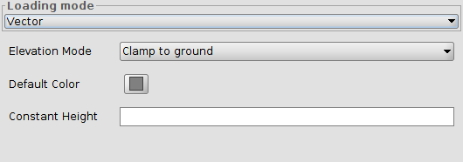
Elements altitude can be defined by two factors (or the sum of both):
- The third dimension of the geometry, in case it is a 3D layer (for example a 3D shapefile).
- A parameter or constant height
It can be applied 3 elevation modes, each of them applies height in a different way:
- clamp to ground: in this case elements overlap the elevation model or the digital elevation model which exists at 3D View. In this case a height definition is not applied.
- absolute: in this case vector elements elevation are given by the height, defined as the height over the sea level.
- relative to ground: in this case vector elements height is given by the height, defined as relative height on the ground.
An example of how is shown the clamp to ground option:
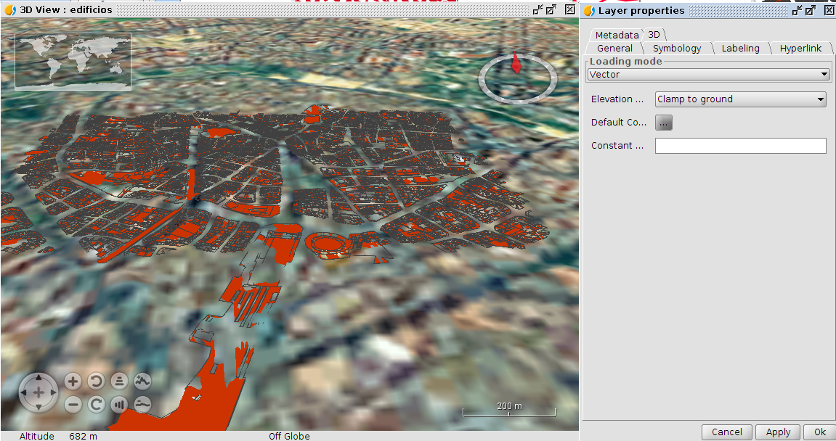
It can be seen that in several parts of the digital terrain model the ground covers the vector layer, because of the heights difference. In this case it is possible to put the relative to ground mode and apply a constant height to view data without overlaps:
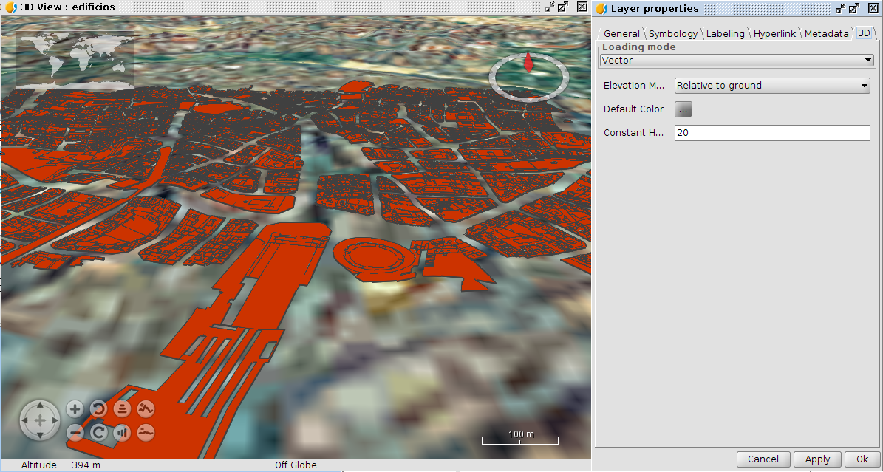
Loading vector layer as extrusion
The interface needed to be applied for extrusion to a vector layer is as shown below:
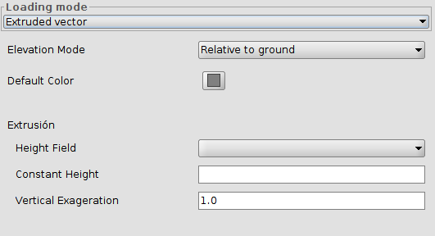
In this case the elements height can be defined by four factors:
- The third dimension or Z geometry coordinate.
- A selected height field from the attributes table.
- A parameter with constant height.
- An exaggeration vector factor, which is the multiplication of a particular factor by the height.
There are 2 available elevation modes, which consider the altitude in different ways:
- absolute: in this case vector elements elevation are given by the height, defined as the height over the sea level.
- relative to ground: in this case vector elements height is given by the height, defined as relative height on the ground.
For example, if we select the relative to ground option mode and apply a selected height field from the attribute table that contains the building heights, we should get something like this:
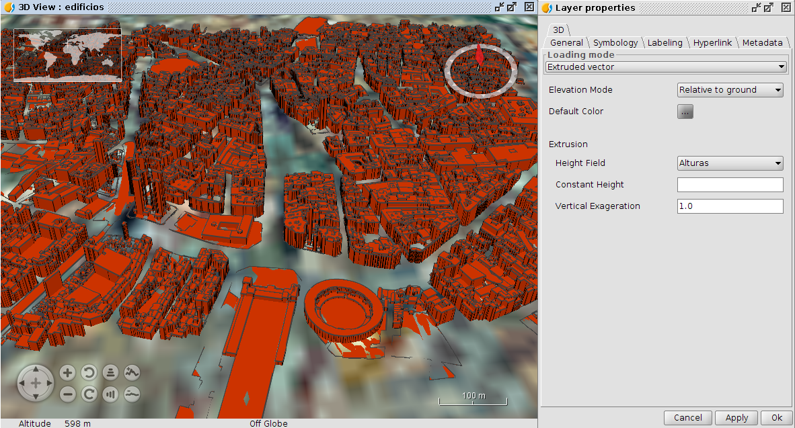
It can be applied a constant height to lift elements over the ground. It should also be used the plants number of the buildings and multiply them by a constant which would represent the plant height (for example, 3 meters).
Different modes of 3D loading vector layer. Examples
Example of contour lines layer with 3D geometries. It has been used the extrusion mode and also applied an additional 50 meters height:
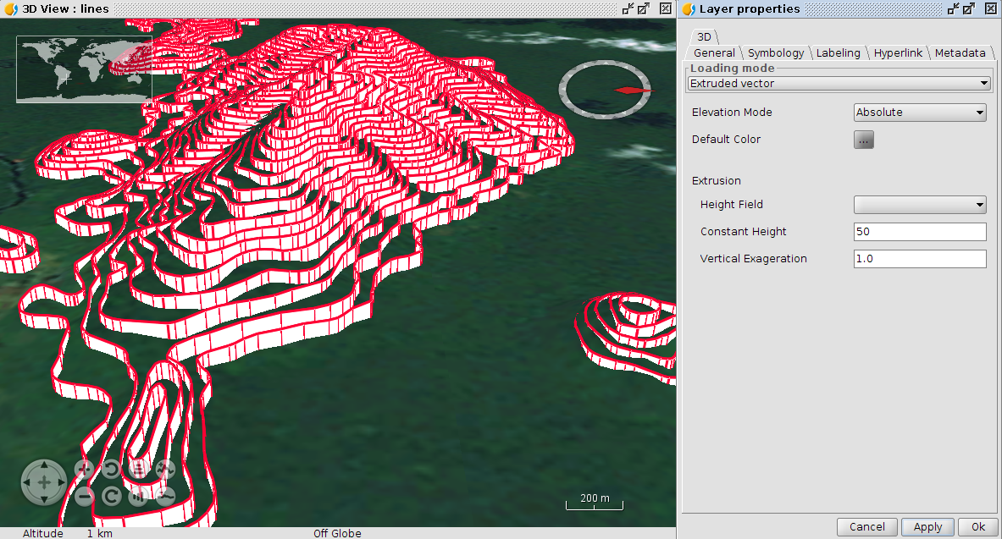
The same layer without extrusion would be shown like this:
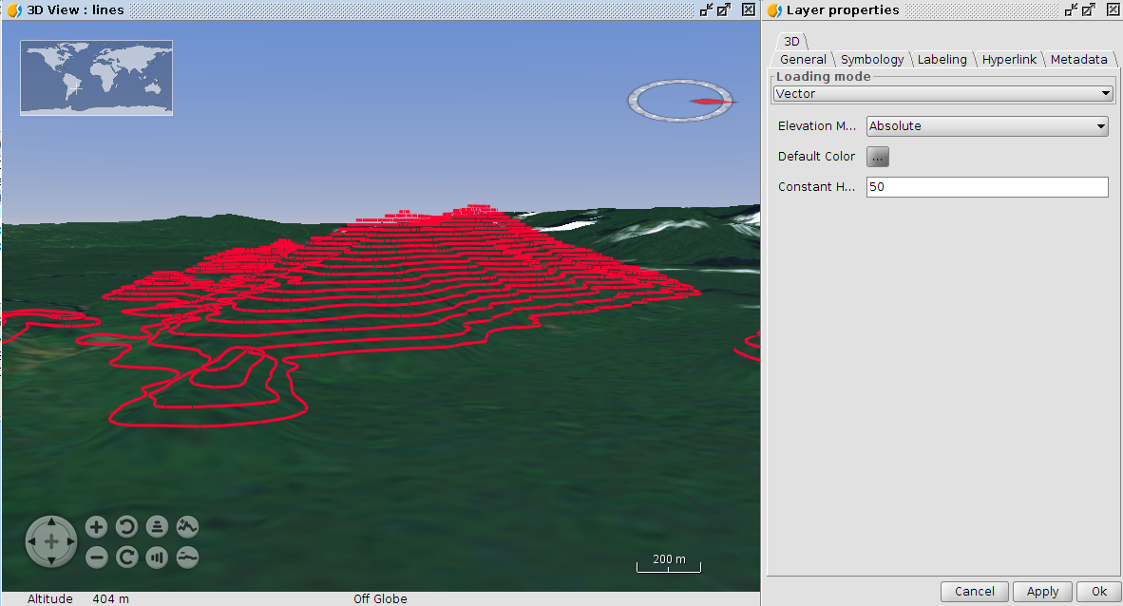
A dots layer example without Z coordinate, but applying an elevation based in an attribute of its table:
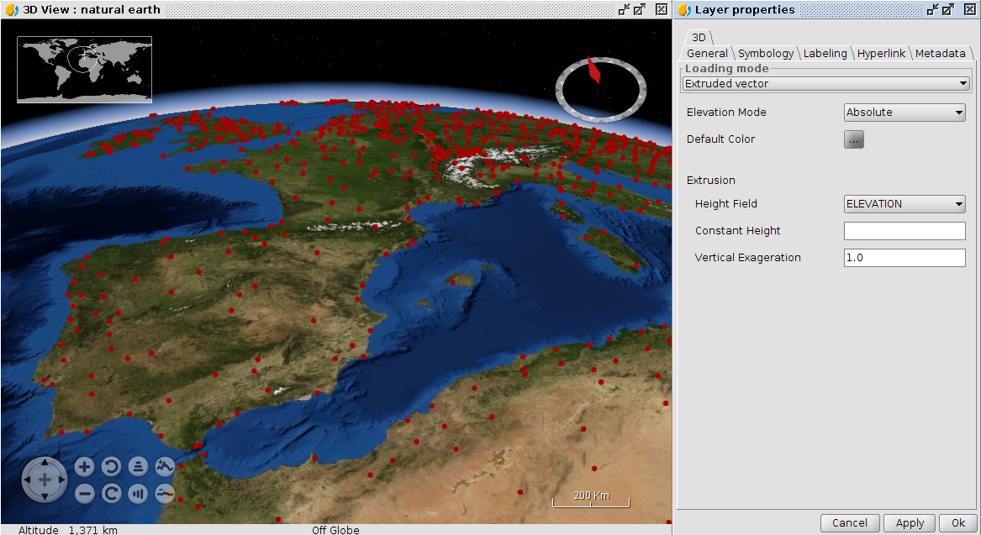
As being the elevation similar to the ground one, extrusion is not appreciated. Adding a constant height this situation is solved:
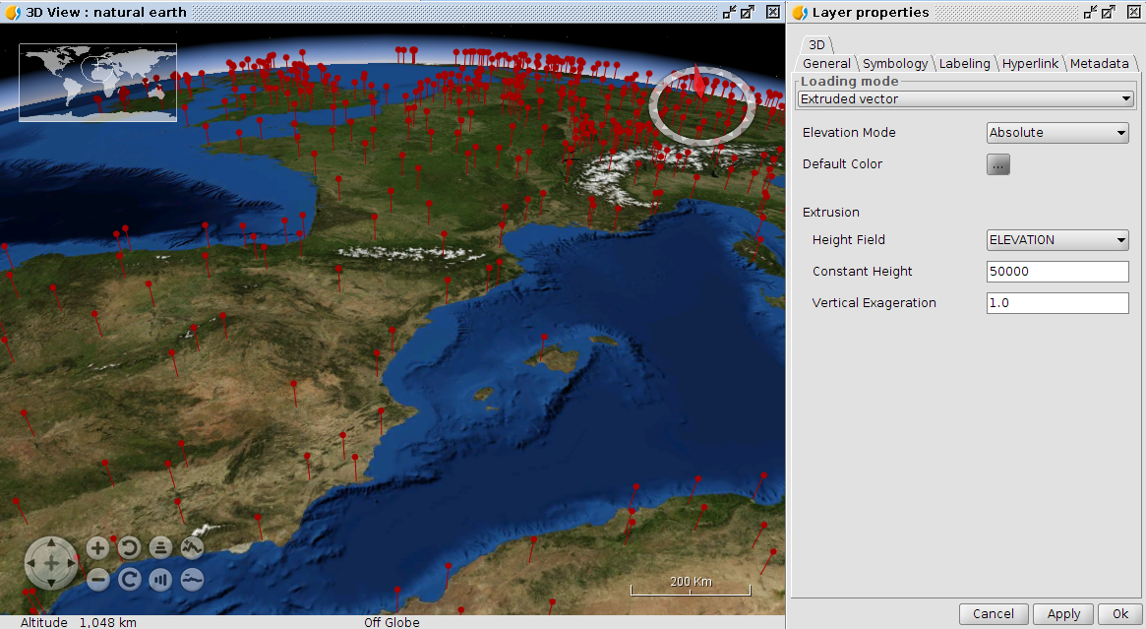

56.3.2. 3D Raster layer properties
Raster layers have two loading modes: Raster image and Elevation mode. Raster image loads raster layer at 3D view. Elevation mode converts rater layer to DEM (Digital Elevation Model) taking elevation values from first raster band.
If Raster image mode is selected, raster layer will have the following properties:
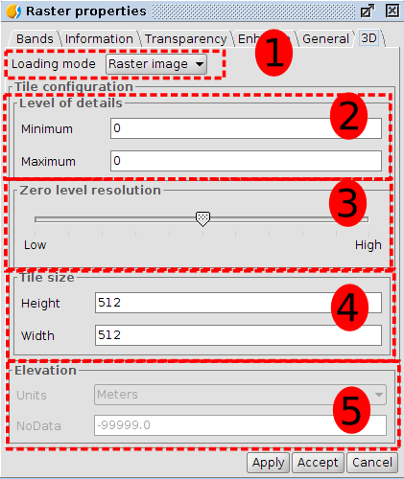
3D Raster layer properties are divided into five groups:
- Loading mode: it indicates what raster layer will be loaded at 3D view.
- Level of details: minimum and maximum detail level of layer. Minimum level of detail indicates what level the layer will be visible at. For example if we indicate two to minimum level, layer will be invisible at zero and one detail level. Maximum level of detail indicates the maximum level of detail calculated. For example, if we indicate ten to maximum level of detail, plugin only will calculate ten levels of details. If we indicate zero as maximum and minimum level, 3D Plugin will calculate the best number of detail levels in relation to resolution layer.
- Zero level resolution: it indicates the relationship between resolution and zero level of detail. If we indicate zero level resolution to high, layer will be shown with more resolution at zero detail level. If we indicate zero level resolution to low, layer will be shown with less resolution at zero detail level.
- Tile size: it indicates size of tiles.
- Elevation: elevation part only is available if elevation loading mode is selected
If Elevation mode is selected, vector layer will have the following properties:
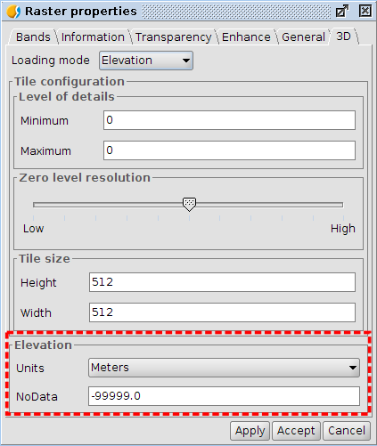
When we select elevation model, elevation group properties will be enable with other options to indicate:
- Units: it indicates units of elevation values. Two options: meters and feet.
- NoData: it indicates NoData value. All points that have indicated NoData value will be transparent at 3D view.

3D ANIMATION

57.1. Introduction
This tool allows the creation, edition, deletion and reproduction of animations over 3D views linked to the View document.
The animation manager is available in the “View/3D Viewer” menu or in the toolbar.
Menu | ToolBar
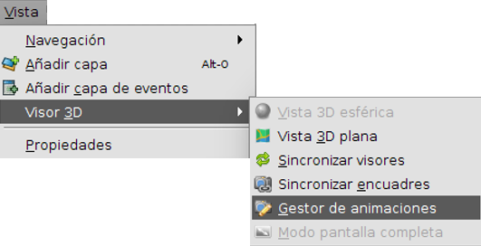
The available tools are:
Icon | Tool | Description
 | Animation Manager | Opens the 3D Animation Manager

57.2. Animation Manager
The animation manager allows the user the creation, edition, deletion and reproduction of animations over 3D views associated to a view document. Requirements for executing the tasks are the following:
- Have the view document active and open.
- It must not be another animation manager already open. The animation manager has support for managing animations of all existing view documents in the project.
The tool can be executed from the “View/3D Viewer /Animation Manager”menu or from the corresponding toolbar. When the tool is executed the following window is shown:
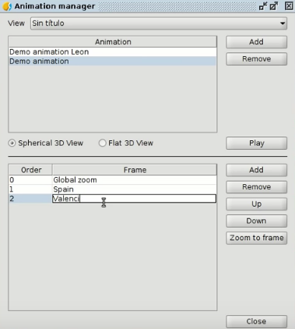
In the manager superior part, the existing view document list is viewed in the project. 3D animations are managed through the view documents. When a view document is selected from the list, animations are linked to the selected document are shown. In case the document doesn’t have any animation it should be shown an empty list.
When a document is selected from the list, it is possible to add new animations clicking over the “Add”button; for removing already existing animations select an animation from the list and click the “Delete”button (both buttons are placed in the right part of the animations list) and for modifying the name make double click with the primary button over one animation from the list.
When an animation is selected, it must be selected one of the available options: “Spherical 3D view” or “Flat 3D view”. These options determine over which 3D view associated to the document is going to be managed those frames. Each animation is composed by two frame lists: a spherical type framing list and another flat type framing one. Both lists are independent of each other and don’t keep any relationship.
When one of the available options is selected, the frames of the selected type are displayed in the framing list (placed in the bottom part). In the right side of the list can be performed the following actions:
- Add: allows adding the 3D view current frame of the selected type. For executing this tool is needed to create a 3D view of the selected type.
- Delete: delete one or many selected frames.
- Upload: allows uploading the selected frame in the established order.
- Download: allows to download the selected frame in the established order.
- Zoom to the frame: from the selected frame allows making zoom in the 3D view of the selected type.
In addition to the described actions, is also possible to modify the frame name facilitating the identification by double clicking over an element in the list.
Finally, the animation manager offers the possibility to reproduce created animations over de 3D selected view in the animations manager. To reproduce an animation is needed that a 3D view of the selected type exists and the animation at least has a defined frame.

Document table

58.1. Table’s properties
We can Access table’s properties configuration window by:
- In a document table opened, in menu “table/properties”
- From the “Project manager” with the table selected, clicking on button “properties”
Menu (Document Table) | Button (Project Manager)
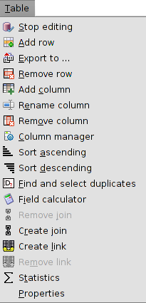 | 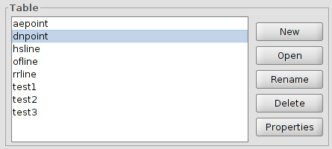
Table’s properties configuration window options are:
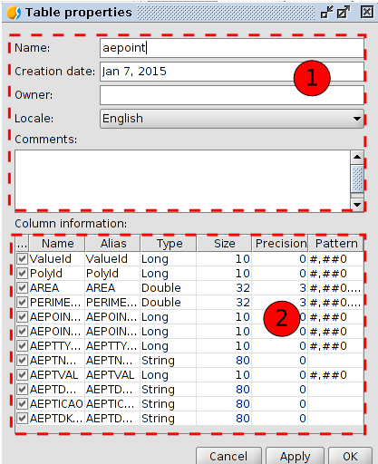
- Table’s identification fields. Allow change name, creation date, owner, language and comments.
- Columns properties.
- “...”. Checkbox that allow choose show/hide one field of the table. By default all fields are visible, except field “Geometry”. Field “Geometry” contains coordinates that integrate a geometry; set it visible can slow down the operation of the table.
- Name. Name of the field. Not modifiable.
- Alias. Allow set an alias to a field. With double click on a cell we can change it’s alias.
- Type. Indicates field’s type: boolean, date, integer, double, string. Not modifiable.
- Size. Number of characters allowed. Not modifiable.
- Precision. Number of decimals (to numerical fields). Not modifiable.
- Pattern. Format of numerical data visualization. With double click on a cell we can chnage the format.

TABLE’S INTERFACE

59.1. Table’s interface
Tables are gvSIG’s documents that contain alphanumeric information. Tables are composed of lines or records (representing each database element) and columns or fields (that define different attributes of each element). All lines have the same columns. Each field can store a specific type of data, like number, text or a date. Intersection of a record and a field is a cell.
When a table is opened from projects manager is shown a new window divided in this components:
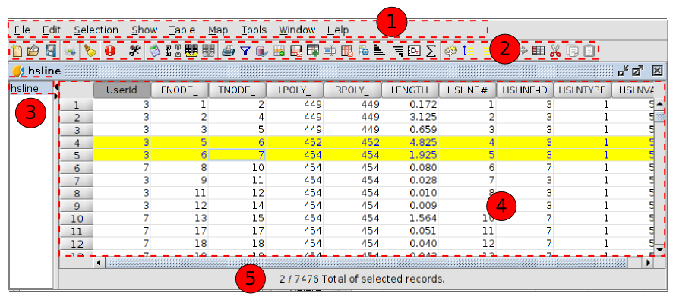
- Menus toolbar.
- Button toolbar.
- Table’s name. This header can be hidden.
- Table.
- Information of the table. Reports the total of records that the table contains and how much are selected.
Fields can be resized visually, clicking in border of header and dragging to new position.
All vector layers have an associated “Attribute table”. Each graphic element of a layer has it’s corresponding record in this “Attribute table”.
To select a record in table just click with left mouse button. Using keys “Control” and “Shift” and clicking it’s possible to select different records.
To select a field of the table you must click with mouse left button on field header.

ADD A TABLE

60.1. Introduction
There are two ways to add a table of gvSIG:
Open the attribute table of a layer. From a active layer of a view, clicking on button “Show attribute table” or in menu “Layer/show attribute table”.
Menu | Button
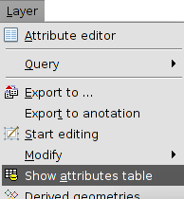
- Add a new table from “Projects Manager”:
  - Select the table icon.
  - Click on button “New”. The window to add the table is opened, allowing select database source “File” or “DB” (database).
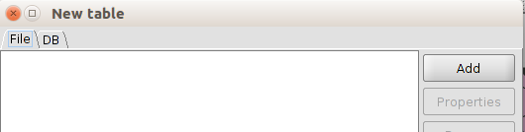
  - With button “Delete” of Project Manager the selected tables are eliminated.
  - With the button “Open” of Project Manager the selected tables are opened.

60.2. Add a file
In “File” tab, if we click on button “Add” will open a new window that allow us to navigate to the file we want to add.
Added the file we’ll see how it’s listed. To modify load parameters of the table we need to select the layer on the list and click the button “Properties”.
A new window with two tabs will be opened: “Basic” and “Advanced”. The property that can be more useful from all to the correct visualization of the data are “Encoding” and “locale”.
Clicking “OK” the tables will be added to the project.

60.3. Add a database
Allow access to user to databases in a simple and unified way to different providers.
gvSIG will store different connections that are been made in different sessions. This manner it’s not necessary introduce again parameters of each server to what we’ll connect. Same way, if we open a project file that have one database connection will be just asked us the password.
The steps to add a table of a DB are:
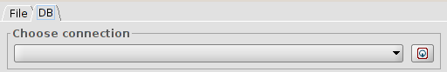
- Establish connection.
  - Select the tab “DB”.
  - Click the button to create a new connection. If there are existing connections we just need to select them from dropdown. When created a new connection it’s opened this tab:
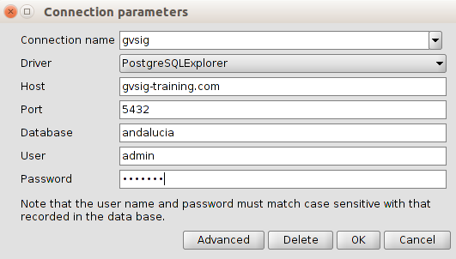
  - We indicate connection parameters:
  - Connection name: user’s choice.
  - Connector. We select from the dropdown database type that we want to connect (MySQL, PostgreSQL, JDBC).
  - Server: URL from server.
  - Port.
  - Database: database name.
  - User.
  - Password.
  - Click “OK” and the connection will be established. When established, the tab “New table/DB” show the available ones.
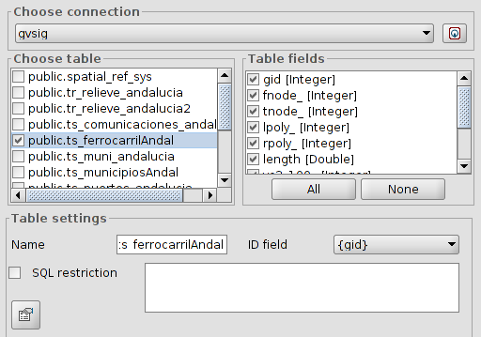
- Selection of information.
  - We select table/s we want to load. When a table is selected, box “Table’s columns” will be updated showing selected all fields available from it’s attribute table; we can unselect those we don’t want to load.
  - Table’s configuration. In this box we can change the name that the table will show (by default the same name of the table). Allow to indicate a restriction with a SQL expression and select field ID.
- When defined all fields we click “OK” and the tables will be added to the project.

60.4. Add a CSV file
AllowThis type of file can be opened as a table (from the document table) or layer (from the document view).
To add it as table, being in the "File" tab, click the "Add" button and a new window will be shown that allow us to navigate until the CSV file we want to add.
To add it as layer, being in a view, click the "Add layer" tool and inside the window that opens choose the "Add" button. A new window will appear that allows us to navigate to the CSV file you want to add.
This format type can be properly displayed or not based on parameters series that need to be defined. To define these parameters the table must have been selected from the list and press the "Properties" button. It will open an importer (wizard) that will guide us in the definition of such parameters.
The importer has two main tabs:
- General: It includes parameters to define the table display, such as the play's characters, regional settings, etc.
- Geometry: It is only displayed if we load the CSV as a layer. It will allow to define which fields contain the coordinates from which will be created the new graphics layer.
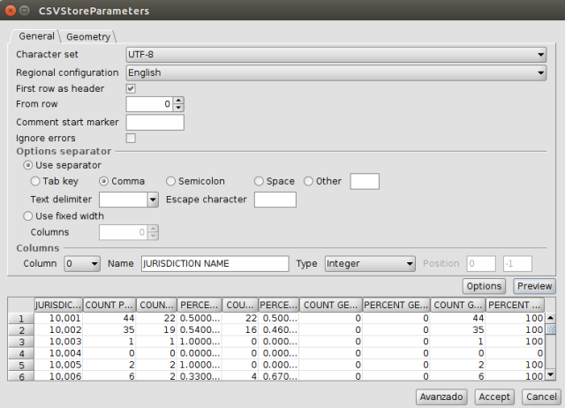
The parameters that are displayed are:
- Set of characters. Selectable via a drop-down list.
- Regional settings. Selectable via a drop-down list.
- First line as header. Activating the verification box, the first line of the table is used as header or table header.
- From the line. It will be imported for us from the specified line number.
- Character for the starting a comment. It allows to ignore possible comments on the table indicating the existing character at the beginning on each one.
- Ignore errors. By activating the verification box the table will load ignoring possible found errors.
- Separator options. It allows to define the column separator characteristics. For each change to be made, user must then press the "Preview" button to display the result.
- Columns. It allows you to define the columns characteristics.
- The "Options" button allows you to save and load the importer parameters.
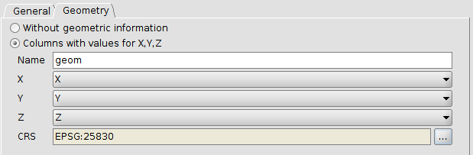
The geometry tab allows you to define values for X, Y, Z that contains the CSV and add it as a layer. The needed columns to add the layer are the X and Y ones.

Table tools

61.1. Introduction
These tools are the ones for making actions in the tables.
The tools are available from the “Table” menu and its relevant button bar. The function “Join” is also located in “Tools/Transforms/Create”.
Menu | Button bars
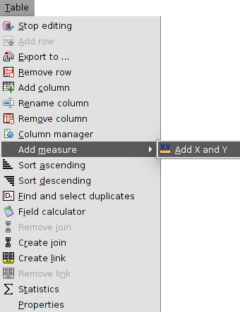
Let´s see all the available tools:
Icon | Tool | Shortkey | Description
 | Export to... |  | To export one table
 | Field calculator |  | To make calculations with the fields of the Table
 | Remove join |  | To undo the join between two Tables
 | Create join |  | To create one join between two Tables
 | Remove link |  | To remove the link between two tables
 | Link |  | To create one link between two tables
 | Add X and Y |  | It adds two new fields to the table with the X and Y coordinates (length and latitude). Only available for the attribute tables.
 | Print Table |  | To print the table
 | Start editing |  | To start editing one Table. Only available for alphanumeric tables.
 | Finish Editing |  | To finish editing one Table. Only available for alphanumeric tables.
 | Select by attributes |  | To make a selection by attributes
 | Add row |  | To add one row to the table
 | Remove row |  | To delete the selected row
 | Add column |  | To add one column to the Table
 | Rename column |  | To rename one field.
 | Remove column |  | To delete the selected field
 | Column manager |  | To access to the column manager
 | Sort ascending |  | To sort ascending alphabetically the table depending on the data of the selected field.
 | Sort descending |  | To sort descending alphabetically the table depending on the data of the selected field.
 | Find and select duplicates |  | It detects and selects the roww with duplicate values of the selected field.
 | Statistics |  | It shows statistics of the selected field.

61.2. Join
It allows to see the join between two Tables- The join allows one to one or many to one relations. To make the join, both tables must have a common field, which it will be the joining point: the field name doesn´t need to be the same, but yes the data type.
This tool is available from the “Table” menu, “Tools/Transforms/Create” or its relevant button bar.
The interface gives the steps to make the join:
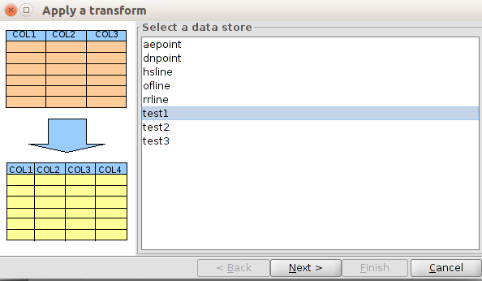
- Select a data store. The Table where the fields of the second table will be joined, must be selected. Click on “Next”.
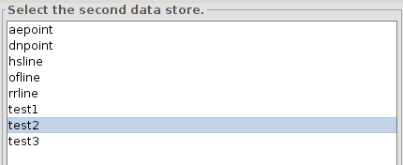
- Select the second data store. The Table, which has the new fields to be joined to the first Table, must be selected. Click on “Next”.
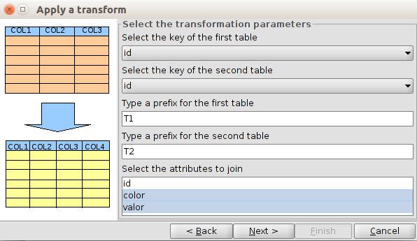
- Select the transformation parameters:
- Select the key of the first table. Joining field of the first table.
- Select the key of the second table. Joining field of the second table.
- Type a prefix for the first table. Optional. It allow to add a prefix to the fields of the first table.
- Type a prefix for the second table. Optional. It allow to add a prefix to the fields of the second table.
- Select the attributes to join.
Once all have been defined, click on “Next” to access to the last panel.
- Apply the transform. A message will appear saying that the transformation has been applied. This last panel can be different if the join is with the attribute table of one layer (which contains attributes of geometries) or if it is with alphanumeric tables.
In the case of an attribute table, it will appear the option to load the transformation output like a new layer.
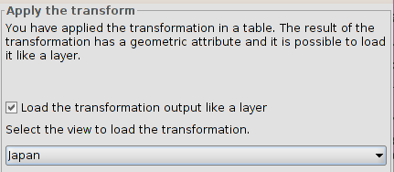
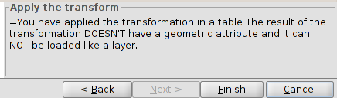
The join can be deleted with the “Remove join” tool, from the “Table” menu or its relevant button bar.

61.3. Link
It allows to create a link between two Tables. One link is a connection between tables allowing that any change in one table appears also in the other one (for instance, a selection). The related data will not be attached as in the joining case. To make the link, both tables must have a common field, which it will be the linking point: the field name doesn´t need to be the same, but yes the data type.
This tool is available from the “Table” menu or its relevant button bar.
The interface gives the steps to make the link:.
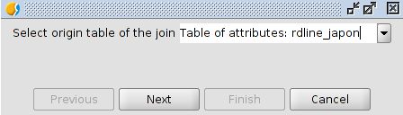
- Select origin table of the link. Dropdown menu with all the available tables to select. Click on “Next”.
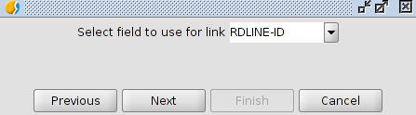
- Select field to use for the link. Dropdown menu with all the available fields to select. Click on “Next”.
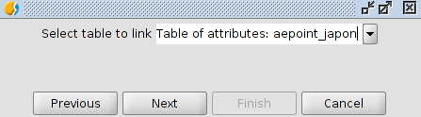
- Select table to link. Dropdown menu with all the available tables to select. Click on “Next”.
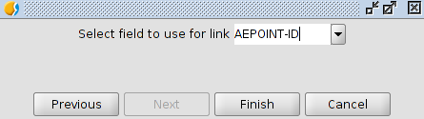
- Select field to use for link. Dropdown menu with all the available fields to select. Click on “Next”.

61.4. Find and select duplicates
To find and select duplicate values in one field of the Table.
This tool is available from the “Table” menu and its relevant button bar.
For using this tool, the field of the table must be selected. The tool will select automatically all the records with a value not unique; the value will be repeated in more than one record of the Table.
It will show a window with the number of different values with duplicates and the total number of duplicates.

61.5. Statistics
To get statistic values of one numeric field of the Table.
This tool is available from the “Table” menu and its relevant button bar.
For using this tool, the field of the table must be selected. It is possible to calculate statistics of all the records of one table, if there is not any selected, or of which are selected.
The interface is:
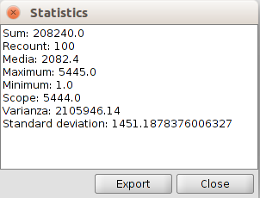
- Statistics. Show the values of the sum, recount, media, maximum, minimum, scope, varianza, and standard deviation.
- Export. To export these values as a table in.csv or.dbf format. If it is.csv, a new panel will appear where the user will choose the separator type: semicolon, comma or any other symbol defined by the user.

Selection tools

62.1. Introduction
These tools are the ones for selecting a group of features in one table. Some of the gvSIG tools only work with selected elements.
In the case of attribute tables of one layer, the selection of vectorial elements can be made from the View or from the attribute table of the layer.
These tools are available from the “Selection” and its relevant button bar. The tool “Select by attributes” is among the Table button bar.
Menu | Button bar
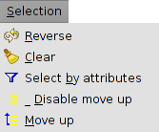
Let´s see all the available tools:
Icon | Tool | Shortkey | Description
 | Clear |  | To clear the selection
 | Select by attributes |  | To select features in function on one query by attributes.
 | Reverse |  | Ito reverse the selection
 | Disable move up |  | To disable the move up option
 | Move up |  | To move up the selected records in the table
To add records to an existent selection, the key “ctrl” must be pressed while selecting the records. To remove one or more records, press “ctrl” and click on them. With the key “Shift” (capital letters) is possible to select consecutive records.
The selected records will be highlighted in yellow.

62.2. Selection by attributes
To select records from one table using an attribute query.
This tool is available from the “Table” menu and its relevant button bar.
The interface is:
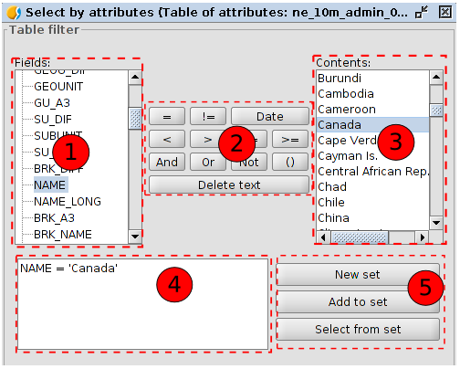
- Fields. Field listing of the layer. Double click on the field to be added to the selection query.
- Logical operators. To insert, clicking on them, one logical expression to the query.
- Known values. It shows one list with all the different values for the selected field. Double click on the value to add to the selection query.
- Query. The query to execute will be written. It is possible to type it directly.
- Selection options
- New set. To create a new selection.
- Add to the set. To create a selection taking into account the last query and the sum of the actual query.
- Select from the set. To create a selection of the selected set, subtracting from the previous query the actual query.

Table edition

63.1. Introduction
All the tools for modifying the values or structure of one table.
In the case of attribute tables, the edition must begin from the View. In the case of alphanumeric tables begins from the Table document.
These tools are available from “Table” menu and its relevant button bar..
The available edition tools are:
Icon | Tool | Shortkey | Description
 | Field calculator |  | To make operations with the fields of the table
 | Add X and Y |  | To add two new fields to the table with X and Y coordinates (length/latitude). Only available for attribute tables.
 | Start editing |  | To start editing one Table. Only available for alphanumeric tables.
 | Finish Editing |  | To finish editing one Table. Only available for alphanumeric tables.
 | Add row |  | To add one row to the table
 | Remove row |  | To delete the selected row
 | Add column |  | To add one column to the Table
 | Rename column |  | To rename one field.
 | Remove column |  | To delete the selected field
 | Column manager |  | To access to the column manager

63.2. Add column

To add a new column to the table.
This tool is available from the “Table” menu and its relevant button bar.
It shows one window to select the characteristics of the column.
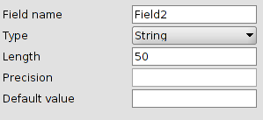
- Field name
- Type. Dropdown with the available types.
- Length. Field length. Maximum is 254.
- Precision. Number of decimals for the numeric fields (double).
- Default value. It is possible to set a default value for all the records of the table.

63.3. Column manager
To add, remove or rename fields.
This tool is available from the “Table” menu and its relevant button bar.
The interface is:
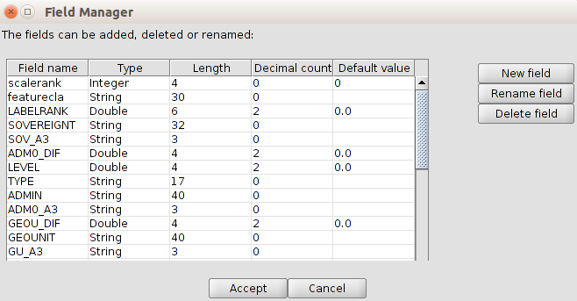
- List with all the fields of the table and with their characteristics.
- The available buttons allow to create, rename or delete one field.

63.4. Field calculator
To make calculations with the fields of the table.
This tool is available from the “Table” menu and its relevant button bar.
It is possible to execute in all the records if none is selected, or in the selected fields.
The interface is:
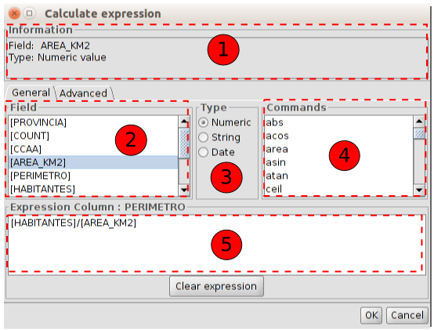
- Information about the selected “Field” or “Command”
- Filed. List of the fields. Double click on the field to add the expression.
- Type. Depending on the selected type, the available “Commands” are updated.
- Commands. List of the available commands depending on the selected “Type”. Double click on the expression to apply.
- Expression. Operation which will be applied to the selected field. It is possible to type it directly.
The “Advanced” tab is for using one expression saved in one file.
The interface is:
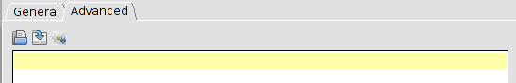
- Load script with the expression.
- Save script with the expression.
- Run script to test the expression.
Some usual commands are:
Command | Description
rec | The 0-based index of the current record
ToNumber | Returns a new number initialized to the value represented by the specified string..
ToString | Returns the string representation of the numeric field.
area | Returns the area of the polygon
perimeter | Calculates the perimeter of the polygon or the length of one line
subString | To make crops of one alphanumeric field. Examples:  - Crop 7 last characters:  subString([Field],0,length([Field])-7)  - Delete the 3 first characters:  subString([Field],3,length([Field]))  - Keep the last 5 characters and delete the rest:  subString([Field],length([Field])-5,length([Field]))
x | Calculate X coordinate of one point
y | Calculate Y coordinate of one point

Export table

64.1. Export table
To export one table.
This tool is available from the “Table” menu.
The interface with all the steps to export the table is:
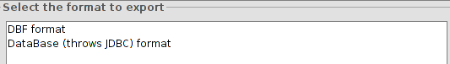
- Select the format to export from the available ones. Click on “Next”.
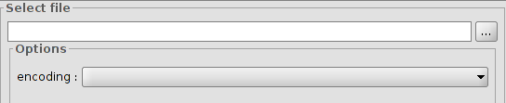
- Select file. To indicate the location for the file. There is an option of encoding the table. Click on “Next”.
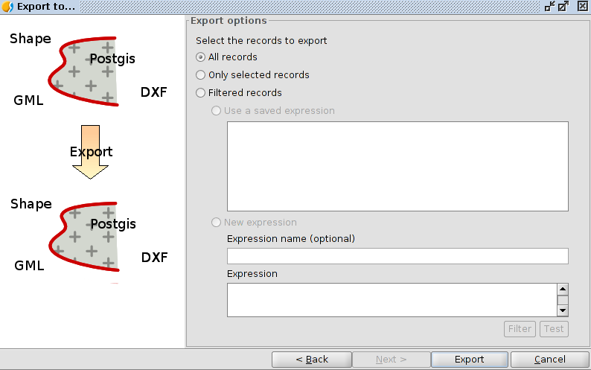
- Export options: To indicate the records to export:
- All records
- Only selected records.
- Filtered records- It is possible to set up one filtering expression.
Once the export is finished, a new window will appear with the option for adding a new table to the project.
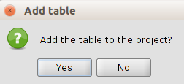

map

65.1. Introduction
“Map” type documents allow you to design and combine all the elements you wish to have in a printed map.
A Map document is a set of design elements of a map or plane, organized in a virtual page and its objective is a graphic output (printing or exporting to PDF). What the design shows is what is obtained when exporting or printing the map at the same page size as the defined.
You can insert two types of elements in a Map:
- Cartographic elements.
- Design elements.

65.2. Creating a Map
To create a new map in a gvSIG project, from the “Project manager”:
- Select the View icon.
- Click on “New”. A new dialog window is automatically opened which allows to define the Map we want to create.
The interface is as follows:
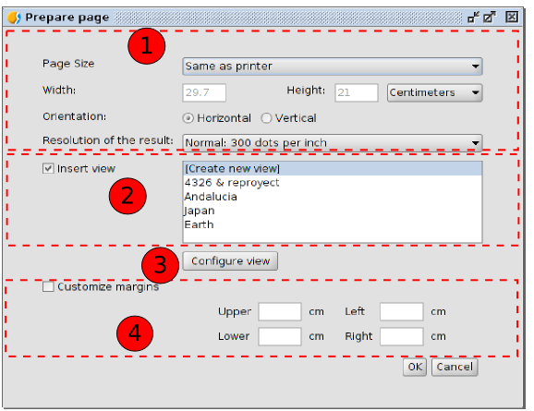
- Options to define the features of the page: size, orientation and resolution.
- It allows to define if you want to create a Map without a View initially inserted, with an empty View or from an existing View. The list with the project views is shown and there is the option “Create New View” in case you want to insert an empty View. This last option will also add a new View to the project.
- Configure View. It allows to access to the “View Properties” window.
- Margins. It allows to define the Map's margins.
By default, a new Map has the name “Untitled”. We can change the name by clicking on the “Rename” button of the “Project manager” (when the Map we want to rename is selected in the “Project manager”). A new dialog window is shown where you have to type the new name:
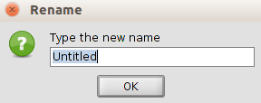
From the Map properties window you can also rename the Map.
Using the “Delete” button from the Project manager the selected Maps are removed.
Using the “Open” button from the Project manager the selected maps are opened.

65.3. Map properties
You can access to the Map properties window from:
- When we have a Map document opened, by going to the “Map” menu and then to “Properties”.
- From the “Project manager”, having the map selected, by clicking on the “Properties” button.
Menu (Map document) | Button (Project manager)
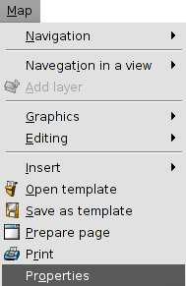 | 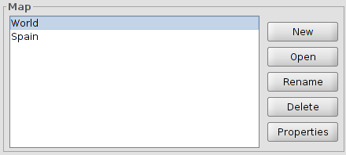
The configuration options of the Map properties window of the View are:
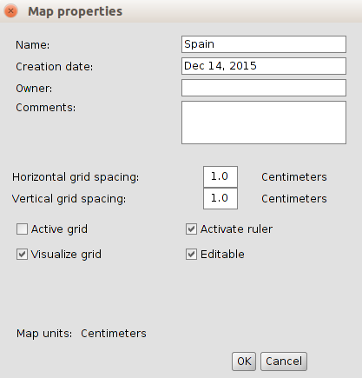
- Name. It allows to rename the Map.
- Creation date. Creation date of the map.
- Owner. To indicate the Map's creator. This is optional.
- Comments. Optional space to add comments.
- Grid. It helps to the design of the Map. Activating the grid means that any element inserted in the map will be adjusted to the grid.
- The grid is defined by the horizontal and vertical spacing. This spacing defines the distance between the different points which make up the grid.
- Active grid. When this box is checked the grid is active.
- Visualize grid. When this box is checked the grid is visible. A grid can be active but not to be visible.
- Activate ruler. By enabling this check box a ruler appears which can be used as a drawing aid.
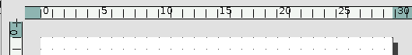
- Editable. If you do not enable this option, the objects that make up the map will be blocked, thus preventing modifications.

65.4. Preparing a page
You can use this tool to define the working area, i.e. the size and properties of the page to be used for the map layout.
You can access this tool by clicking on the “Configure page” button in the tool bar or from the menu bar by selecting the “Map” option and then “Prepare page”.
Menu | Button
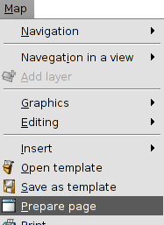
When you have selected the tool a new window will appear. The interface is as follows:
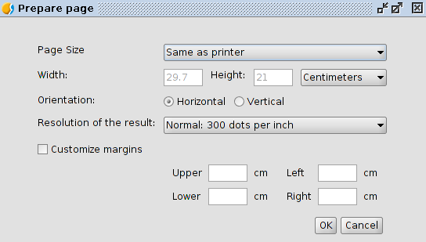
- Page size. It allows you to define the page size. You can select a standar size through a pull-down menu or define your own.
- Orientation. This defines whether the paper will be printed horizontally or vertically.
- Resolution of the result. It allows users to define the resolution of the result.
- Margins. This allows you to define the page's four margins. The ruler is adjusted to fit in with the page margins.

Map interface

66.1. Map interface
The Maps are the gvSIG documents which allow the design of maps. You can insert different Views in a Map, having access to the TOC of each View.
When opening a Map from the Project manager, a new window appears which is divided in the following parts:
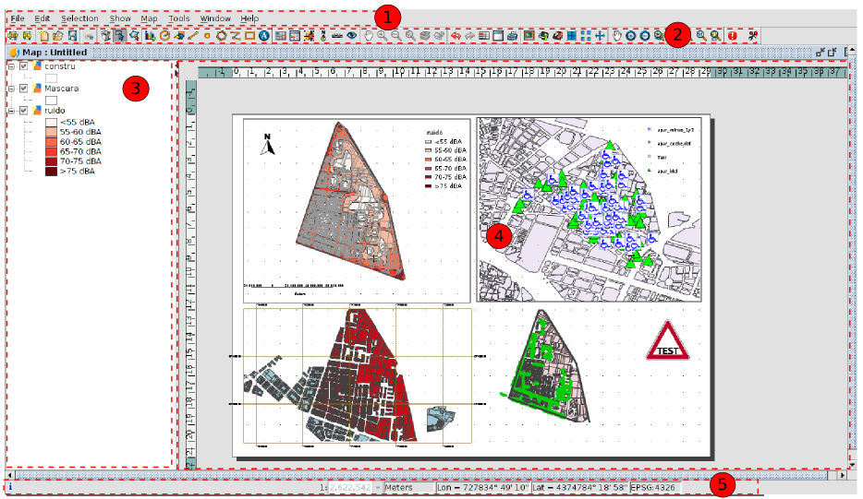
- Menu bar.
- Button bar.
- Table of Contents (TOC): It lists all the layers that the selected View in the Map contains, and the legend which represents the symbology used for each layer.
- Map area. It is where the page is represented. You can make the main actions in this area (such as navegation, selection, insertion of elements...).
- Status bar. The status bar provides information about the coordinate system of the selected view, scale of visualization, coordinates and units.
The components 3 and 4 are resizable, dragging their edge to their right and left by clicking and holding the left button of the mouse.

cartographic elements

67.1. Tools for the insertion of cartographic elements
These tools allow to insert cartographic elements in a Map document.
Most of the cartographic elements are linked to a View document, so that when you make changes in the View, they can be reflected in the map (zoom changes, displacements, legend's changes, layer's organization, etc.)
These tools are available from the “Map/Insert” menu and in the corresponding button bar.
Menu | Button bar
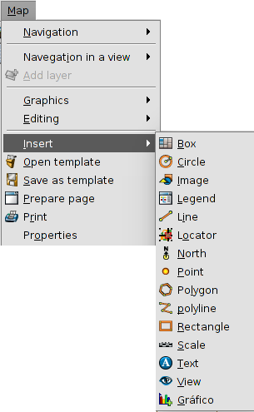
Let's see each of these available tools:
Icon | Tool | Shortcut | Description
 | Insert view |  | It allows to insert a View in the Map.
 | Insert legend |  | It allows to insert an associated legend to the View's TOC in the Map.
 | Insert scale |  | It allows to insert an scale associated to a View in the Map.
 | Insert north |  | It allows to insert a north symbol associated to a View in the Map.
 | Insert locator |  | It allows to insert a locator associated to a View in the Map.
 | Insert box |  | It allows to define a box by number of colums and rows.
The properties window of the cartographic elements is available from the contextual menu of the inserted element, which appears when we right-click on it while it is selected.

67.2. Insert a View
It allows to insert a View to the Map. When we create a new Map we can insert automatically a new View or an existent View.
This tool is available from the “Map” menu and then in “Insert/View”, and in the corresponding button bar.
After selecting this tool, place the mouse pointer on one of the vertexes of the rectangle which define the view area, left click and drag the pointer to the opposite vertex and drop.
A dialog box appears in which you can define the view-type element properties you have just inserted:
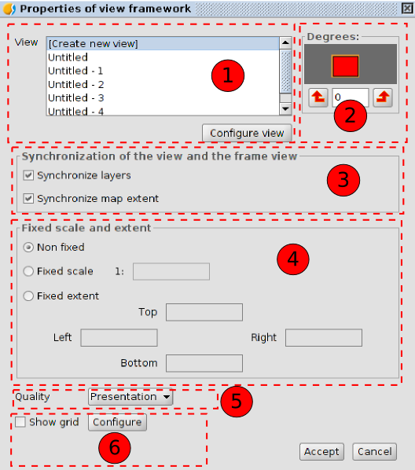
- View. It allows users to create a new View or to select one of the available Views in the list. The “Configure view” button allows to access to the “View properties” window.
- Degrees. This allows you to specify a degree of rotation when the view is inserted in the map.
- Synchronization of the View and the frame View. It allows to enable or disable the synchronization of layers and the extension of the Map. When the synchronization is active the changes you do in the View document will be reflected on the inserted View in the Map.
- Scale and extent. It allows to define the type of scale or extent of the inserted View.
- Non fixed. The scale or extent of the View changes when we use the navegation tools.
- Fixed scale. It allows to define a fixed scale.
- Fixed extent. It allows to define a fixed extent indicating the top, bottom, right and left limits.
- Quality. It allows to define the quality of the visualization.
- Grid. It allows users to configure the View's grid.
A grid is a network of horizontal and vertical lines spaced uniformly used to identify X, Y coordinates on a map. Graticules are lines showing parallels of latitude and meridians of longitude on Earth and it is used to identify geographic coordinates (degrees longitude and latitude).
By clicking on the “Configure” button you access to the grid settings.
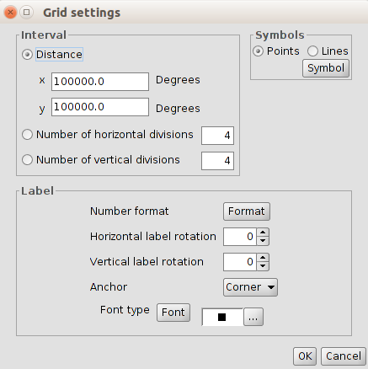
- Interval. It allows you to select the grid interval, by defining the distance between lines or points which make up the grid, or by defining the number of horizontal and vertical divisions.
- Symbols. It allows to select the grid symbology between points and lines. Using the “Symbol” button you can select a certain type of symbol from the “Symbol selector”.
- Label. It allows to define the characteristics of the labels that indicate the grid coordinates.
  - By clicking on the “Format” button you access to a new window which allows to define the decimal separator, the thousands separator and the decimal digits.
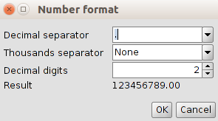
  - Horizontal and vertical rotation. It allows to apply a rotation to the horizontal and vertical intervals.
  - Anchor. It allows to select the anchor of the lable to the center or the corner.
  - Font type. It allows to select the font characteristics.

67.3. Insert a Legend
A legend shows the meaning of the symbols which are used to represent the entities of an inserted View in the Map. The legends are made up of two elements: the symbols and the layers or explanatory texts that are associated with every symbol.
The legend, which is always associated with an inserted View in the Map, allows to represent the symbology of the different layers of that View. A legend is associated with a unique View. When inserting a legend, this will be added with the same order as in the TOC.
This tool is available from the “Map” menu and then in “Insert/Legend”, and in the corresponding button bar.
After selecting this tool, place the mouse pointer wherever you want inside the Map area, left click and drag the pointer to the opposite side and drop.
A dialog box appears in which you can define the properties of the inserted legend:
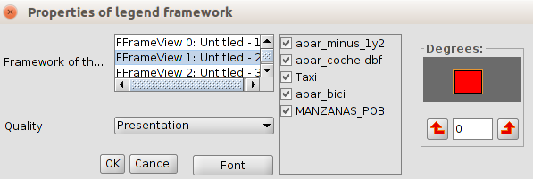
- Framework of the View. It allows to select the associated View for the legend which will be inserted. If we select a View, a list with available layers will be shown, which allows to show/hide the symbology of the layers that will make up the legend.
- Degrees. This allows you to specify a degree of rotation when the legend is inserted in the map.
- Quality. It allows to define the quality of the visualization.

67.4. Insert a scale
This tool allows you to insert a graphic scale or text scale associated with an inserted View in the Map.
The graphic scale is the representation of the scale in a visual way, where each segment shows the relation between the length in the representation and the real length. The graphic scales provide a visual indication of the size of the entities and the distances between them. A graphic scale is a line or bar divided in parts and labeled with its real lenght.
This tool is available from the “Map” menu and then in “Insert/Scale”, and in the corresponding button bar.
After selecting this tool, place the mouse pointer wherever you want inside the Map area, left click and drag the pointer to the opposite side and drop.
A dialog box appears in which you can define the graphic properties of the inserted scale:
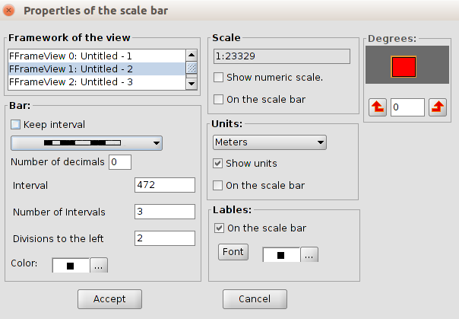
- Framework of the View. It allows to select the View which is related to the legend we want to insert.
- Bar. By clicking on the pull-down menu, you can see the type of scale you want to insert: text or graphic scale. There are options to define the number of intervals, the distance that each interval represents and the divisions to the left of zero.
- Scale. You can use this section to display a text with the numeric scale.
- Units. This defines the graphic scale units of measurements (metres, km., etc.)
- Labels. It allows to select the characteristics of the labels.
- Degrees. This allows you to specify a degree of rotation when the scale is inserted in the map.

67.5. Insert North symbol
It allows users to insert a North symbol which indicates the orientation of an inserted View in the Map.
This tool is available from the “Map” menu and then in “Insert/North”, and in the corresponding button bar.
After we select this tool, place the mouse pointer wherever you want inside the Map area, left click and drag the pointer to the opposite side and drop.
A dialog box appears in which you can define the graphic properties of the inserted north:
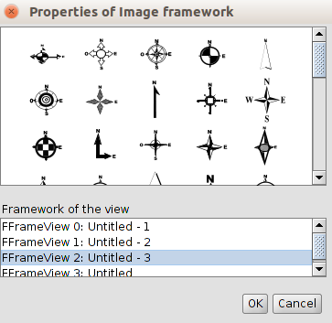
- In the top of the box we find the available north symbols. It allows to select the north symbol you want to apply.
- Framework of the View. It allows to select the View related to the north symbol we want to insert.

67.6. Insert locator
It allows to insert a locator related to the inserted View in the map.
This tool is available from the “Map” menu and then in “Insert/Locator”, and in the corresponding button bar.
After we select this tool, place the mouse pointer wherever you want inside the Map area, left click and drag the pointer to the opposite side and drop.
A dialog box appears in which you can define the graphic properties of the inserted locator:
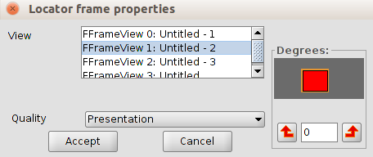
- View. It allows to select the View related to the locator you want to insert.
- Degrees. This allows you to specify a degree of rotation when the scale is inserted in the map.
- Quality. It allows to define the quality of the visualization.

67.7. Insert a box
It allows to insert a box in the Map.
This tool is available from the “Map” menu and then in “Insert/Box”, and in the corresponding button bar.
After we select this tool, place the mouse pointer wherever you want inside the Map area, left click and drag the pointer to the opposite side and drop.
A dialog box appears in which you can define the graphic properties of the inserted box:
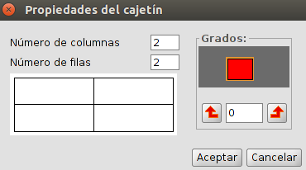
- Number of columns and rows. It allows to define the number of columns and rows which make up the box.
- Degrees. This allows you to specify a degree of rotation when the box is inserted in the map.

Graphic elements

68.1. Tools for the insertion of graphic elements
These tools allow to insert graphic elements into a Map document.
They are available from the “Map” menu and then in “Insert”, and in the corresponding button bar.
Menu | Button bar
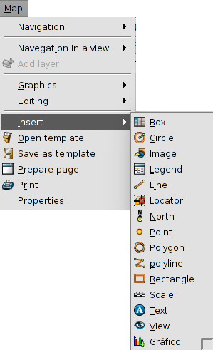
Let's see each of the available tools:
Icon | Tool | Shortcut | Description
 | Insert chart |  | It allows to insert a chart document.
 | Insert circle |  | It allows to insert a circle
 | Insert image |  | It allows to insert an image.
 | Insert line |  | It allows to insert a line
 | Insert point |  | It allows to insert a point
 | Insert polygon |  | It allows to insert a polygon.
 | Insert polyline |  | It allows to insert a polyline.
 | Insert rectangle |  | It allows to insert a rectangle
 | Insert text |  | It allows to insert a text
The properties window of the graphic elements is available in the contextual menu of the inserted element, which appears when we right-click on it while it is selected.
Whith the tool Edit vertex, that is available in the “Map/Editing” menu, you can modify the vertexes of the graphic elements.

68.2. Insert chart
It allows to insert a Chart document.
This tool is available from the “Map” menu and then in “Insert/Chart”, and in the corresponding button bar.
After we select this tool, place the mouse pointer wherever you want inside the Map area, left click and drag the pointer to the opposite side and drop.
A dialog box appears in which you can define the graphic properties of the inserted box:
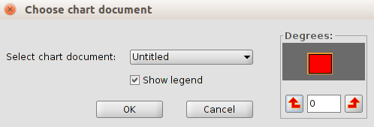
- Select chart document. It allows to select a Chart document to insert.
- Show legend. It allows to select if you wish to show the legend of the inserted graphic document.
- Degrees. This allows you to specify a degree of rotation when the box is inserted in the map.

68.3. Insert Circle
It allows users to insert a circle.
This tool is available from the “Map” menu and then in “Insert/Circle”, and in the corresponding button bar.
After we select this tool, place the mouse pointer wherever you want inside the Map area, left click and drag the pointer to the opposite side and drop.
With the circle properties you can access to the window of the symbology selector.

68.4. Insert image
It allows you to insert an image.
This tool is available from the “Map” menu and then in “Insert/Image”, and in the corresponding button bar.
After we select this tool, place the mouse pointer wherever you want inside the Map area, left click and drag the pointer to the opposite side and drop.
A dialog box appears in which you can define the graphic properties of the inserted image:
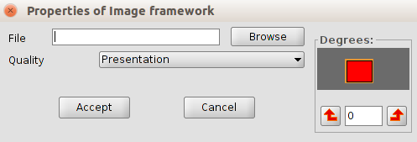
- File. It allows to select an image file, either by typing its path or by cliking the “Browse” button. Allowed formats are jpeg, jpg, gif, png, bmp and svg.
- Degrees. This allows you to specify a degree of rotation when the box is inserted in the map.
- Quality. It allows to define the quality of the visualization.

68.5. Insert Line
It allows to insert a line.
This tool is available from the "Map / Insert / Line" menu and in the relevant button bar
After selecting the tool, will be displayed the first vertex of the line by clicking on the map area in the desired location, and a second click to indicate the second point of the line is displayed.
The properties of the line open a symbology selector window.

68.6. Insert point
This allows to insert a point.
This tool is available from the "Map / Insert / Line" menu and in the relevant button bar
After selecting the tool, will be indicated the location of point by clicking on the map area in the desired location
The point properties open a symbology selector window.

68.7. Insert polygon
It allows to insert a polygon
This tool is available from the "Map / Insert / Line" menu and in the relevant button bar
After selecting the tool, will be displayed the first vertex of the polygon by clicking on the map area in the desired location, and a second click to indicate the second point of the line is displayed.
The polygon properties open a symbology selector window.

68.8. Insert polyline
It allows to insert a polyline.
This tool is available from the "Map / Insert / Line" menu and in the relevant button bar
After selecting the tool, will be displayed the first vertex of the polyline by clicking on the map area in the desired location, and a second click to indicate the second point of the line is displayed.
The polyline properties open a symbology selector window.

68.9. Insert rectangle
It allows to insert a rectangle
This tool is available from the "Map / Insert / Line" menu and in the relevant button bar
After selecting the tool, will be indicate the first end of the rectangle by clicking on the map area in the desired location, and dragging to drop indicating the opposite end .
The rectangle properties open a symbology selector window.

68.10. Insert text
It allows to insert a text
This tool is available from the "Map / Insert / Line" menu and in the relevant button bar
After selecting the tool, will be indicate the first end of the rectangle which defines the space to be occupied by text by clicking on the map area in the desired location, and dragging to drop indicating the opposite end .
A dialog box appears in which can be define the properties of the inserted text
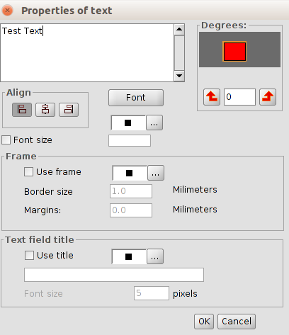
- Text area. It allows write the text wich apears insert on map
- Degrees. It allows to define the rotation of the inserted text.
- Align. Select the type of alignment (left, center or right).
- Font. It allows to define the characteristics of the font.
- Font size. With the box checked allows to fix a text size
- Frame. It allows to define the characteristics of an optional frame for text
- Text field title. It allows to establish a title associated with the frame that surrounds the text entered.

Navigation tools

69.1. Map navigation tools
There are the tools to move around the Map page, closer or away from it
These tools are available from the "Map / Navigation" menu and at the corresponding button bar.

Menu | Button bar
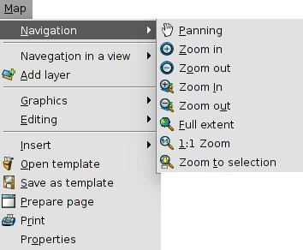
Let's see each of the available tools:
Icon | Tool | Shortcut | Description
 | Panning |  | It allows to change the frame of the Map page by dragging the field of visualization in all directions with the mouse. Must be maintained mouse button pressed and move the mouse in the desired direction.
 | Zoom in |  | It allows approaching the center of the frame data of the Map page.
 | Zoom out |  | It zooms out from the center of the frame data of the Map page.
 | Zoom in |  | it allows to do a zoom in on a particular area of the Map page.
 | Zoom out |  | It allows to do a zoom out on a particular area of the Map page.
 | Full extent |  | A frame is made to the full extent of the Map page.
 | 1:1 Zoom |  | It allows you to do zoom to 1: 1 scale map of the page.
 | Zoom to selection |  | It allows to do a frame to selected items of the Map page.

69.2. View navigation tools
These are tools that allow navigation through the inserted View and basically consist of changes in the visualization scale and displacements.
These tools are available from the "View / Navigation in a View" menu and in the corresponding button bar.
Menú | Barra de botones Button Bar
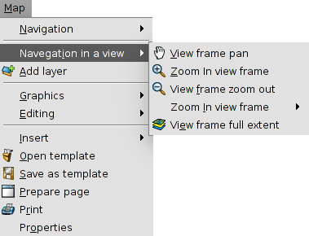
Consider each of the available tools:

Icon | Tool | Keyboard shortcut | Description
 | View frame pan |  | It allows to change the frame of the view by dragging the field of visualization in all directions with the mouse. You should keep the primary mouse button down and move the mouse to the desired direction.
 | Zoom in view frame |  | it allows to approach a specific area of the View
 | View frame zoom out |  | it allows to out a specific area of the View
 | Previous zoom |  | It allows to return to previous frame.
 | View frame full extent |  | This makes a frame to the total extension that defines all layers of the View
In the status bar it is possible to indicate the scale of the view, directly writing the scale factor in or selecting one of the available drop.
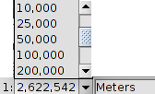

DESIGN TOOLS

70.1. Design tools
These are those that allow us to do actions design and layout of the map.
These tools are available from the "Map / Graphics" menu and the corresponding button bar.

Menú | Barra de botones button bar.
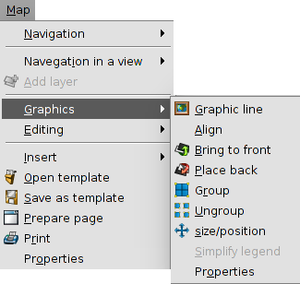
See each of the available tools:
Icon | Tool | Keyboard shortcut | Description
 | Graphic line |  | It allows to draw a frame around the selected items.
 | Align |  | It allows to change the alignment, distribution and size of the selected items.
 | Bring to front |  | It allows to modify the visualization order of the elements, bringing to front the selected items.
 | Place back |  | It allows modify the visualization order of the elements, placing behind the selected items.
 | group |  | It allows to combine multiple items in a group. A group behaves as a single element.
 | Ungroup |  | It allows to ungroup multiple items
 | Size/position |  | It allows to modify the size and the position of a selected item
 | Simplify legend |  | It allows to simplify an embedded legend. This action breaks the link with the view and the legend becomes a graphic elements.

70.2.Graphic line
It allows to draw a frame around the selected items.
This tool is available in the "Map / Graphics / Graphic line" menu and the relevant button bar.
A dialog box where you can define the properties of the line graph will be displayed:
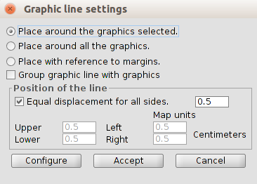
- Place options. It allows to select the place of the graphic line.
  - Around the graphics selected
  - Around all the graphics. Not required to have any selected graph
  - With reference to margins. Not required to have any selected graph
- Group graphic line with graphics. With the box checked allows you to group the graphic line and the element, so as to form a single entity and not two independent.
- Position of the line. It allows to configure the position of the graphic line
- Configure. It allows to access to the simbology selector

70.3.To Align
It allows to change the alignment, distribution and size of the selected items.
This tool is available from the "Map / Graphics / Align" menu.
A dialog box where you can set options to align items will be displayed
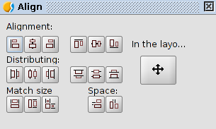
- Alignment. It allows to align the selected elements, placing them on the same axis: left, center, right, horizontal, top, center and bottom vertically.
- Distributing. It allows to place the elements at equal intervals in the area defined by the selected items.
- Match size. It allows to modify the size of a selected item with reference to another selected item. The adjustments are made based on the largest element in the selection there. The size of the elements can be matched in width, height or both directions respectively.
- Space. It allows to do a spatial distribution of the selected items.
- In the layout. The tool is applied to the entire area of the map.

70.4. Size and position
It allows to modify the size and the position of the selected element
This tool is available from the "Map / Graphics / Size / position" menu and in the relevant button bar
A dialog box where you can define the properties of size and position will be displayed:

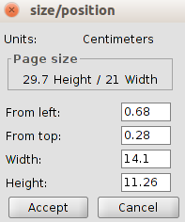

EDIT TOOLS

71.1. Edit tools
They are those that allows to edit the map.
These tools are available in the "Edit" menu and in the corresponding button bar.

Menú | Barra de botones Button bar
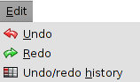
See each of the available tools:

Icon | Tool | Keyboard shortcut | Description
 | Undo/redo history |  | It allows to see the history of actions and undo until the desired action.
 | Undo |  | Undo the last action.
 | Redo |  | Redo the last undo action

EXPORT AND PRINT TOOLS

72.1. Export and print tools
They are those that allows to print or export the map
These tools are available from the "Map" menu and in the corresponding button bar.

Menú | Barra de botones
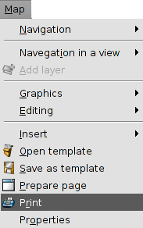
See each of the available tools:
Icon | Tool | Keyboard shortcut | Description
 | Export to PDF |  | It allows to export the Map page to PDF format.
 | Export to PS |  | It allows to export the Map page to PostScript format.
 | Print |  | It allows to print the Map page

Map Template

73.1. Map template
A map template is a .gvst file that contains a design of a map that can be used as reference to create new maps. Map templates facilitates reusing or normalization of a design of a series of maps. Using a template saves time because you do not need to manually design again and again the common parts of the maps.
This tools are available in the Map menu
Menú
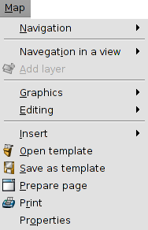
See each of the available tools:
Icon | Tool | Keyboard shortcut | Description
 | Open template |  | It allows to load a template.
 | Save as template |  | It allows to create a template from a Map page design

Document CHARTS

74.1. Introduction
The Charts are the gvSIG documents for definying one or more plots. One Chart Document can have a determined number of plots.
It is possible to create a chart from the attribute table of one layer or from an alphanumeric Table.
Supported charts by gvSIG:
Type | Icon | Description
Pie | 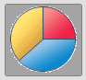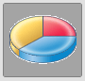 | The pie chart or circle chart is one circle divided into two or more sections. The pie charts show relations between the parts and the total, and are useful for proportions and relations.
Bars | 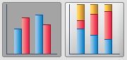  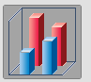 | The bars chart has two or more parallel rectangles, each of them represents an attribute value- These charts are useful to compare quantities or to show trends. Tha bars can be orientated horizontally or vertically
XY | 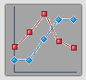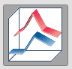 | The XY chart or linear graph has one or more lines, which connect values of succesive attributes. The linear graphs are useful for showing trends in values within a continuous scale. The lines can be orientated horizontally or vertically.
Temporary | 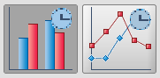 | To create plots with temporary data.
The Chart tools are available from the “Chart“ menu and their relevant button bars.
Menu | Button bars
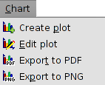
Let´s see all the available tools:
Icon | Tool | Shortkey | Description
 | Create plot |  | To create a new plot in one Chart document.
 | Edit plot |  | To edit the properties of one plot in one Chart document.
 | Export to PDF |  | To export a Chart document to PDF.
 | Export to PNG |  | To export a Chart document to PDF.

74.2. Create Charts
To create Charts in a gvSIG project, from the “Project manager”:
- Select the Charts icon.
- Click on “New”.The Chart document will open as an empty document where new plots can be added.
By default the new Chart document will be called “Untitled”. It is possible to change the name, clicking on “Rename” in the “Project manager” (having the Chart document selected). A dialog screen will open for typing the new name:
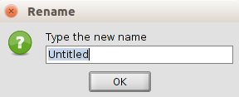
With “Delete” button oft the Project manager the selected charts will be deleted.
With ”Open” button of the Project manager the selected charts will open.

74.3. Create plot
To add a new plot in the Chart document. One Chart Document can have a determined number of plots.

This tool is available from the “Chart“ menu, in its relevant button bar and with the “Create Plot” in the window “Chart Properties”.
The interface shows the steps to follow for definiyng the chart parameters:
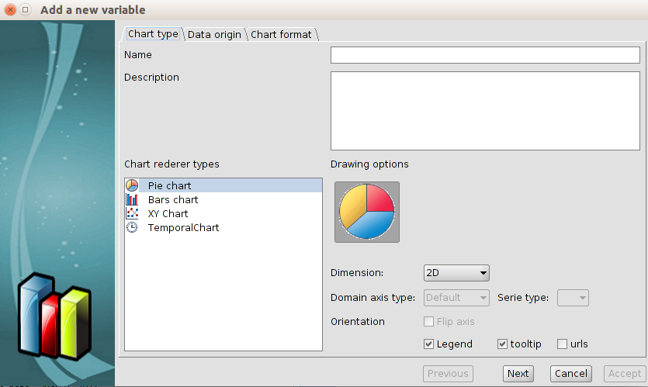
- Chart rendered types. It defines the type of chart for representing the data. In each type is possible to define the different characteristics to adapt the charts to the data.
- Name. Chart name.
- Description. It is possible to describe the chart.
- Renderer typesr. To select the type of the plot.
- Drawing options. To select the different options for reperesenting the selected chart (dimension, orientation,...)
Once all has been set up, click on “Next”.
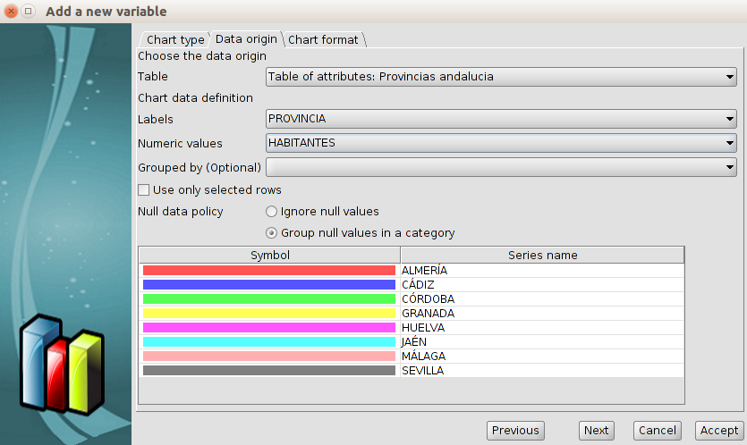
- Data origin. It sets the relation between the data and the axis of the plot.
- Table. To select the table as the data origin.
- Agrupados por (Optional). To classified the data in groups by one field.
- X. To select the X field. Clicking on “Sort axis alphanumerically” the values will be sorted alphanumerically.
- Y. To select the Y field.
- Use only selected rows. Only the selected values of the Table will be used.
- Null data policy. It is possible to ignore or group the null values in a category.
- Symbol. To define the colour of the legend.
Click on “Next”.
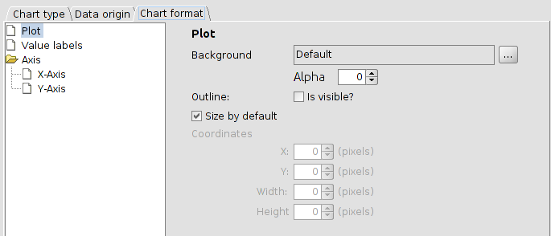
- Chart format. To define the format of the different elemnents of the Chart.
- Plot. To define the background, outline and the size.
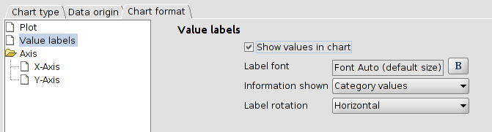
- Value labels. To define the labels of the Chart.
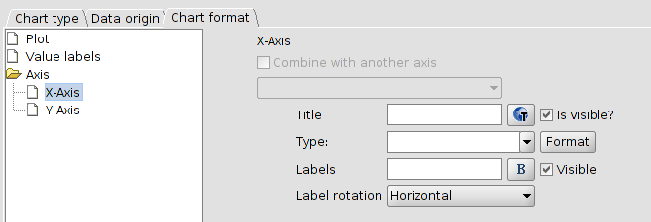
- Axis. To define the X and Y axis.
Once all has been set up, click on “Accept” and the plot will be shown in the Chart document.
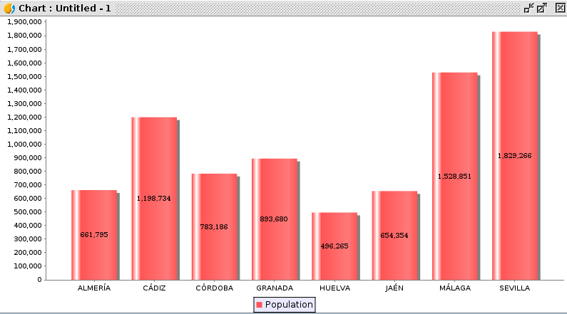
Clicking on “Create plot” again, we can make a new plot and combine it with the existent one.
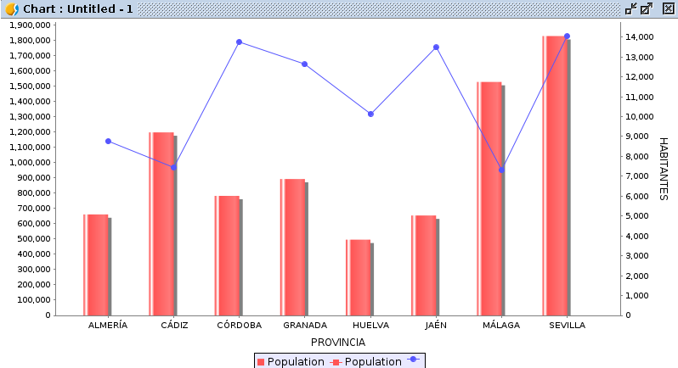

74.4. Edit plots. Properties.
To edit the properties of the Chart document.
This tool is available from the “Chart“ menu, in its relevant button bar and in the “Properties” button of the “Project Manager/Charts”.
The interface is:
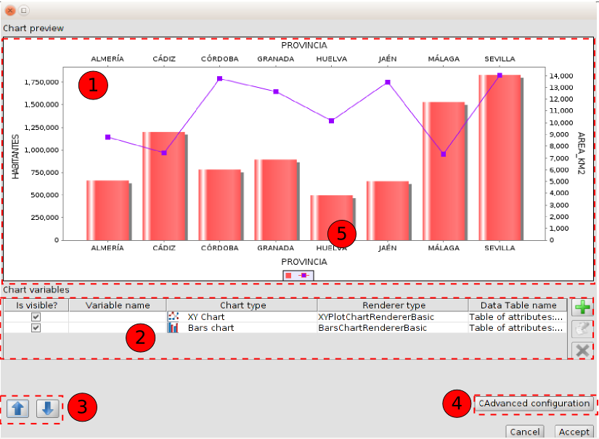
- Chart preview. It is a preview of the plot to insert in the Chart document.
- Chart variables. Table with all the created plots. It is possible to:
Icon | Tool | Description
 | Create plot | To create a new plot
 | Edit plot | To edit a plot, The “Create plot” window will be open and it is possible to change its characteristics. The plot to edit must be selected in the table.
 | Delete plot | To delete a plot. The plot to delete must be selected in the table.
- Up/Down. It allows to sort the viewing of the different plots. The variables will be painted according to this classification.
- Advanced configuration. It opens a new window for editing the general characteristics of the document:
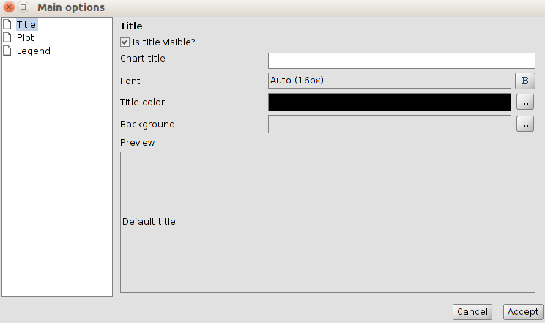
- Title. To add a title to the Chart document and configure its characteristics.
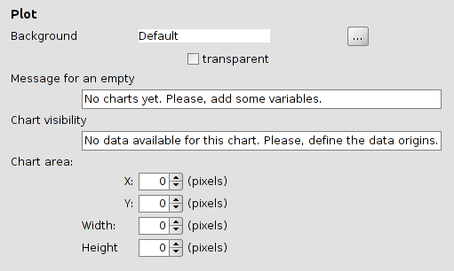
- Plot. To configure the characteristics of the Chart document (background, messages and area).
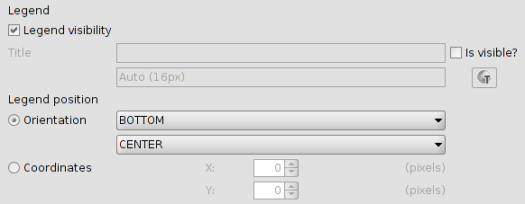
- Legend. To define the characteristics of the legend.

Publishing

75.1. Introduction
Its aim is to enable a process automation for the maps publishing services, trying to obtain results as true as possible to the original work made in our gvSIG.
The “Publish extension” is available for downloading in the “Addons manager” and it can be found in “View/Export” and in its relevant buttonbar.
Menu | Button bar
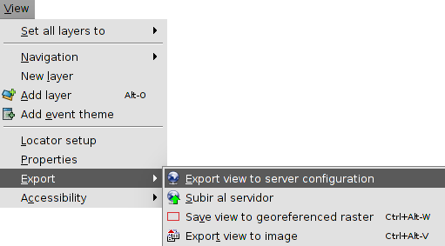
The available tools are:
Icon | Tool | Shortkey | Description
 | Export View to server configuration |  | Export View to server configuration (mapfile, MapServer).
 | Upload to the server |  | Upload the resource to the server

75.2. Export View to Mapfile
The interface is:
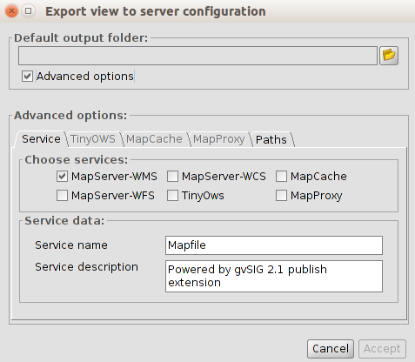
- Default output folder. Selection of the local work directory. It can be a new folder empty or one already createdv (for joining different works in one unique project).
If the output folder where the poject will be saved is not empty, the app gives the following option:
  - Overwriite: it will create all the files for the project and change the previous files if this is required..
  - Add: if new informaction want to be added to an existent project, without losing the previous information.
  - Cancel.
- Advanced options. Enable this option for seeing the advanced options, grouped in 4 tabs.
  - Service.
Choose service. Selection of services. We can check as many as we need, performing the publishing once. Each service will create a subfolder with its name in the project directory and inside of the subfolder, all the files needed for that concrete service will be stored.
Service data. to indicate the name under which the service will be displayed to customers and the description in the same form.
  - TinyOWS. Options of the TinyOWS service.
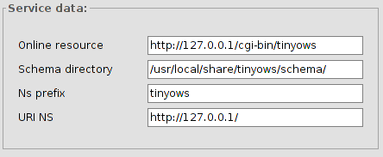
  - MapCache. Options of the MapCache service.
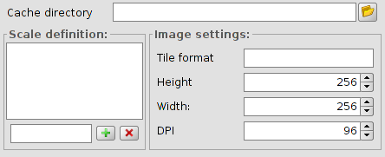
  - MapProxy. Options of the MapProxy service.
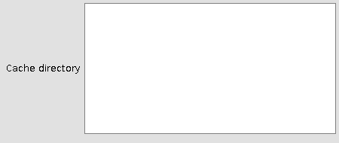

75.3. Manual edition of specific attributes
Sometimes, it can be interesting to define the parameters more precisely and adjust the specifications to the ones that Mapserver offers. For that reason, some mechanisms have been created to be able to complete these characteristics through some forms.
There are two access points:
- View “Properties”, which will define the characteristics of the Mapfile service (MapFile section). In this window, there are 4 tabs: : Mapserver, TinyOWS, MapCache, MapProxy.
MapServer | TinyOWS
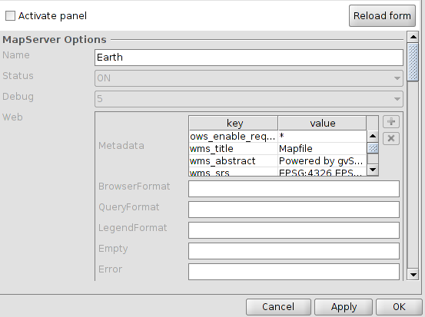 | 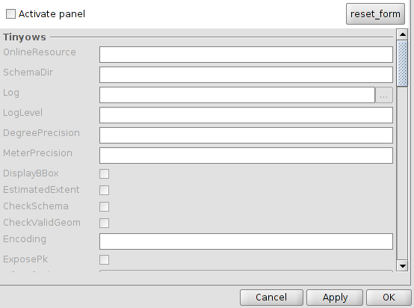
MapCache | MapProxy
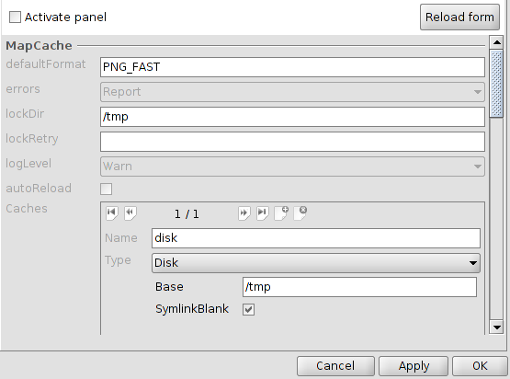 | 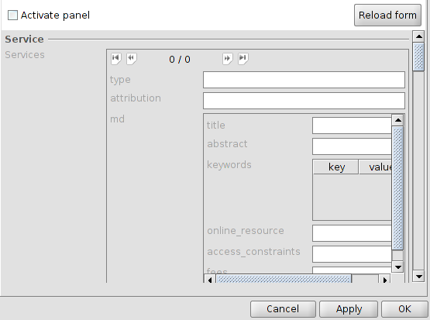
- Layer “Properties” (definition of the MapFile attributes of each Layer).
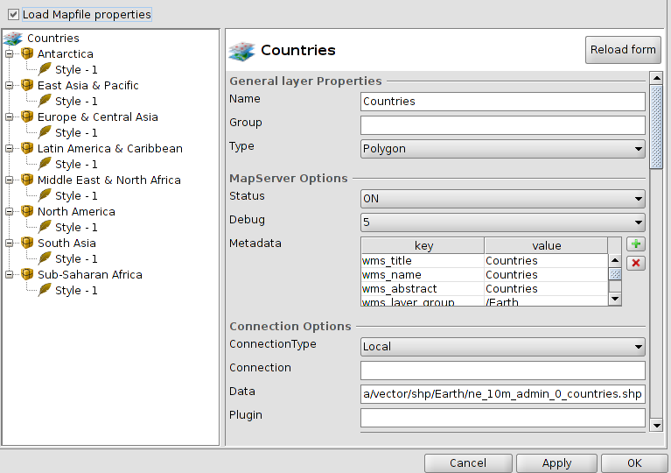
There are similar ways to define the services of TinyOWS, MapProxy and MapCache.

75.4. Upload to server
The publishing extension is able to upload to the server any project generated in local.
Visually, the menu is very similar to the publishing tool, except for the fact that all that refers to the generation of the project have disappeared, because it will not generate the definition of any other service, only it will upload an already existing one. Therefore, we only need to indicate the local project folder which we want to upload to the server and set the connection parameters.
The interface is:
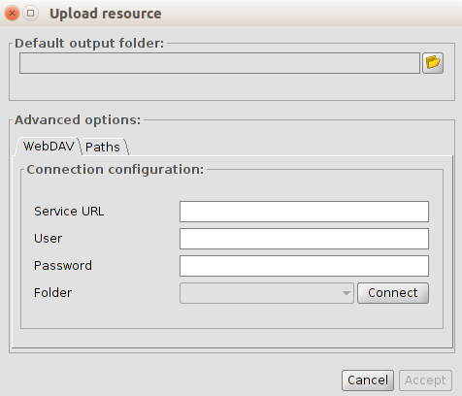
- Advanced options.
  - WebDAV. This process of publishing the project generated on the server can be done automatically at the time the project is created, or can be upload after with another tool extension.
In the first case (automatically), you need to indicate the destination address to establish the WebDAV connection. If it is a directory authentication, you must also provide the username and password.
  - Connect. It will check that connection and also it will fill the left menu with the subfolders that exist in the specified path.
  - Paths.
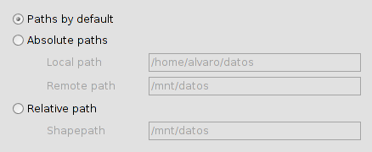
  - For a correct operation of services, it is necessary that the access to resources are properly defined. To do this, there are three possibilities to define the routes to them:
    - Default paths: This option does not alter the paths to resources, setting them such in the definition files of the different services.
    - Absolute paths: adequate if there is a correspondence between the location of the files on both machines (eg, the shapes are inside a folder called ‘data‘ and have identical directory structure inside), but the access to that folder has different routes on each machine (for instance, local directory is ‘/home/user/data‘ and the server is in ‘/mnt/data‘).
This option will replace in the configuration, the access paths to the local machine for the server ones
    - Relative paths: taking as origin the service configuration file (the mapfile if it is MapServer), you can set a route to resources from it using a ShapePath variable.
From that file and adding the indicated for the ShapePath variable, the rest of the resources accesses will be built.

ORACLE SPATIAL/LOCATOR

76.1. Introduction
It allows access to both Oracle Spatial tables as Oracle Locator (both from version 9i) if they have a column of geometries stored as SDO GEOMETRY:type SDO geometries stored GEOMETRY.
The "Oracle Spatial / Locator Support" extension is installed using the "Addonn Manager."

76.2. Metadata
The driver lists only tables with their geographic metadata in the USER_SDO_GEOM_METADATA view.
Since it has the metadata for each table, the interface makes use of them and automatically provides the geometry columns. As row identifier uses the ROWID, which is an unique descriptor for each row usied by Oracle internally and ensures correct identification.

76.3. Data type
Data are supported in 2D and 3D of the following types:
- Point and multipoint
- Line and multi-line
- Polygon and multipolygon
- Collection
Layers with LRS (Linear Referencing System) format are not supported.

76.4. Coodinate systems
Oracle has its own cataloging system of coordinate systems and reference. There is a relationship of equivalences between the Oracle system and the EPSG system that is included in the driver as a DBF file.
Transformations between coordinate systems are performed by gvSIG.

76.5. Reading geometries
The driver constantly runs geometric queries (ie, calculates at each moment what geometries intersect with the current gvSIG view) for which it is imperative that exists in the database a spatial index associated with the column in question. If there is no index, an error window is displayed and is not possible to add such a table or view to the gvSIG View.
On the other hand, the driver needs to set an unique identifier for the records of the table or view, which is not possible for certain types of views. In case of this problem, the driver will detect it and an error message is also displayed, making it impossible to load that view of the database in gvSIG.

76.6. Dumping gvSIG layer to Oracle
When you export a layer to an Oracle database, at the end, the process will ask whether you want to include in the table the current coordinate system of the View.

Sísmica
TO DO

PORTABLE VIEW

78.1. Introduction
The Portable View extension lets you work with a new document that is a view with basic query options in which the rest of tools has been removed. With this you can convert a view in portable view and vice versa.
Besides, you can also package this portable view as a gvSIG complement. The generated gvSIG package contains both the generated data (files) and the portable view configuration. Using the complement manager, another user can install that portable view in his gvSIG.
Therefore, this extension has two main uses:
- Have available a query view.
- Allow portability/distribution of a gvSIG View containing all associated information (legends, labeling, map scales…)
The “Portable View: editor” y “Portable View: viewer” extensions are installed using the complement manager “Administrador de complementos”.

78.2. Create a Portable View
To create a View you must complete the following steps:
- Create a view “Vista”.
- Set up the View: CRS, layers, legends, labeling, map scales….
- Run the command “Vista Portable/Crear a partir de la vista” (Portable view/Create from view)
Menú
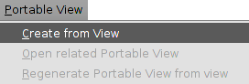
- A new window that lets you enter the View identification characteristics is open.
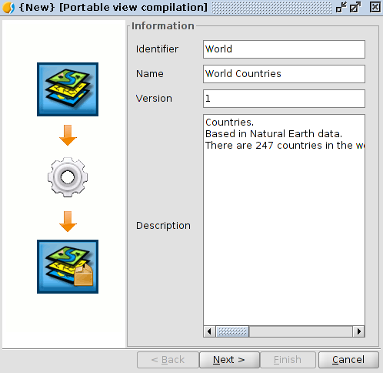
- Once you have entered the information click next “Next”.
Then a validation window is displayed, that warns you from possible errors in the portable view definition.
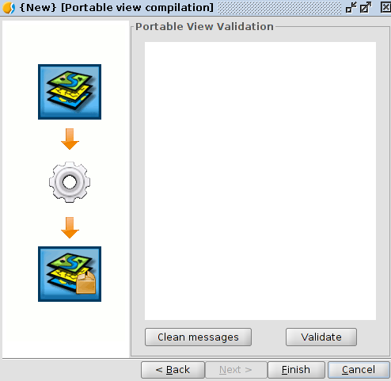
Click on the Finish button “Terminar”. And automatically is generated and opened the new document “Vista portable”.
Once a portable view is generated, it will be listed in the “Gestor de proyecto/Vista portable” (project manager/portable view).
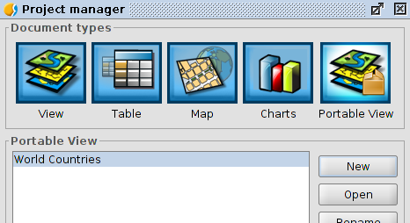

78.3. Interface
The portable view interface is a simplification of the View document, including query tools only and specific actions menu of the portable view.
The interface is as follows:
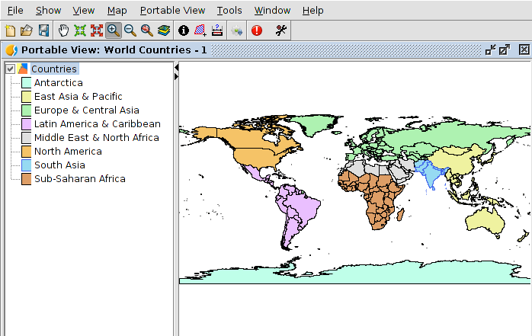
Specific tools are available from the menu “Vista portable“.
Menú
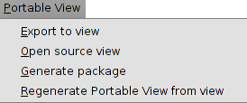
The navigation tools available are:
Icon | Tool | Shortcut | Description
 | Pan |  | Change the view framing dragging the display area in all directions with the mouse. You should keep the primary mouse button (usually the left button) pressed and move it to the desired direction.
 | Fixed zoom in |  | Allows you to zoom in on the center of your data frame.
 | Fixed zoom out |  | Allows you to zoom out on the center of your data frame.
 | Zoom in |  | Allows you to zoom in to a geographic window by clicking a point or dragging a box.
 | Zoom out |  | Allow you to zoom out from a geographic window by clicking a point or dragging a box.
 | Back |  | Allows you to go back to the previous extent.
 | Full extent |  | Allows you to zoom to the full extent of your map.
You can zoom in or zoom out using the mouse scroll wheel.
In this case the expand is made using as a focus point the center of the view. With the mouse scroll wheel pressed and moving it the command is executed.
The available query tools are:
Icon | Herramienta | Tecla rápida | Descripción
 | Identify |  | Identify the geographic feature on which you click.
 | Area |  | Measure perimeters and areas.  You can draw a polygon on the map and get its area and perimeter.
 | Distance |  | Measure distances on the map.  You can draw lines on the map and get its length.

78.4. Export a View
Lets you create a View from a portable view.
This is availble from the menu “Vista portable/Exportar a Vista“.
A new window will open requesting the folder to save the file that make up the view.
Automatically a new View containing the portable view layers and its display characteristics is generated once the files are saved

78.5. Open the Source View
Lets you open the View from which the portable view was generated.
Available from the menu “Vista portable/Abrir la Vista origen“. (portable view/Open the source view)

78.6. Generate a distributable package
You can generate a distributable package from a portable view. This package contains both the portable view configuration as the data files used. A portable view distributable package can be installed via the complement manager view “Administrador de complementos”.
Available from the menu “Vista portable/Generar paquete distribuible“.
First a window requesting the file pathname will open. After selecting a folder click on select target directory “Seleccionar directorio de destino”.
A warning message telling you that the file has been created will open. The created file is stored in the selected folder being a gvspkg file extension.

78.7. Regenerate portable view from View
You can access the “Crear Vista portable” window and modify the characteristics of the portable view.
Available from the menu “Vista portable/Regenerar Vista portable desde Vista“.

78.8. Portable view catalog
Open the portable view available list and open one of them.
Access from the “Gestor de proyecto/Vista portable”, clicking on “Nuevo” button.
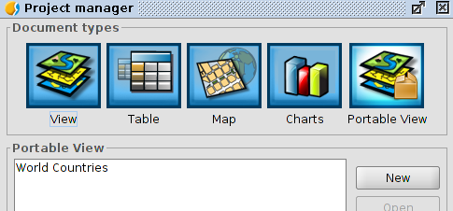
A window displaying the available portable view list is open. Selecting one of them you can see its characteristics:
Clicking on open portable view “Abrir Vista portable” and the selected portable view will be created.

Map sheets. Installation
TO DO

Map sheets document
TO DO

Dyschromatopsia

81.1. Introduction
Extension created for users that have problems in the perceptions of colors.
It allows to transform, from a view with a predefined number of layers and legends, these legends (or create new ones) in others that can be interpreted by users that have some difficulties related with color vision or dyschromatopsia.
The “Tool: Dyschromatopsia adaption” extension is installed using the complement manager “Administrador de complementos”.

81.2. Functionality
The interface is as follows:
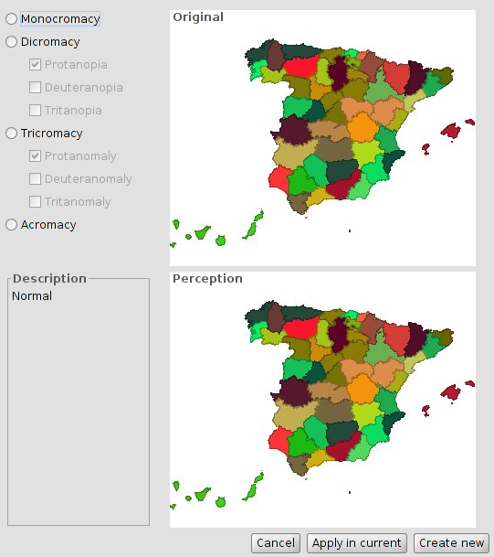
- You can select the type of anomaly:
- Monocromático (Monochrome): Lack of two of the primary colors sensitivity.
- Dicromático (Dichromacy)
  - Protanopia. Lack of red color sensitivity.
  - Deuteranopia. Lack of green color sensitivity.
  - Tritanopia: Lack of blue color sensitivity.
- Tricromático anómalo (Anomalous trichromacy)
  - Protanomaly: Anomaly in the red retinal receptors (closer to green receptor response) affecting discrimination between red and yellow.
  - Deuteranomaly: Anomaly in the green retinal receptors that affects softly the discrimination between red and green.
  - Tritanomaly: A rare hereditary vision disorder which affects discrimination between blue and yellow.
- Acromático (Achromatic): Lack of color perception.
- It displays, depending on the case, perception with respect to the original.
- Change the View layers legend.
- Aplicar en actual (Apply on current view legend): Modify the current legends.
- Crear nueva (Create new): Create a new View with the original layers and the modified legends.

Linear reference system (LRS)

Customize

83.1. Introduction
Users may want to customize their own preferences when working with gvSIG by creating what the application calls a distribution. The plugin “Customize” allows to tailor these distributions.
Click “Tools” on the main menu and then click “Customize” to enable gvSIG customization.
Menu
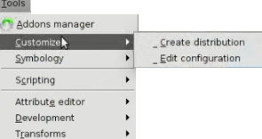
This plugin includes a wide range of capabilities such as:
- Specifying the coordinate system
- Moving between language version as needed
- Defining the OGC services frequently used
- Installing other plugins
- Adding different libraries of symbols
- Giving a name to the distribution
- Changing the splash images that appears when gvSIG is launching
The “Customize” plugin is available to the users on Linux. Using Linux, it is possible to create gvSIG distributions for all the different operating systems.

83.2. Configuring the distribution
The way to configure the new distribution preferences is to use the “Customize plugin configuration” dialog box.
Click on the main menu “Tools”, and then click “Customize> Customize plugin configuration“ to open the dialog box.
The screen capture below shows the “Customize plugin configuration” dialog box with the tabs to set the specific options.
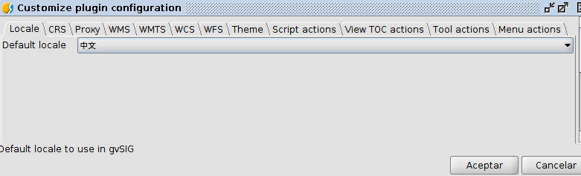
Here is a brief description for of each tab in this dialog box:
- Locale. Used to determine the default display language of the new distribution
- CRS. Allows to define the default projection
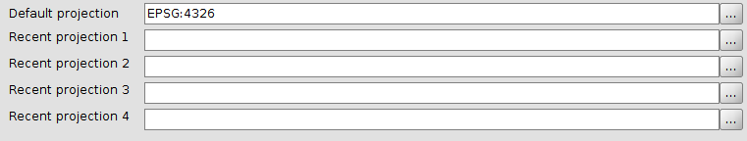
- Proxy: Allows to specify a Proxy that can be used by default.
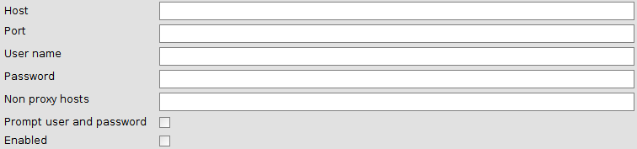
- WMS. Used to add and remove WMS layers from the list that is included under the WMS tab. Click “+” to add a new layer and then specify the URL. Check the remove checkbox and then click “X” to delete the existing layer.
- WMTS. Used to add and remove WMTS layers from the list that is included under the WMS tab. Click “+” to add a new layer and then specify the URL. Check the remove checkbox and then click “X” to delete the existing layer.
- WCS. Used to add and remove WCS layers from the list that is included under the WMS tab. Click “+” to add a new layer and then specify the URL. Check the remove checkbox and then click “X” to delete the existing layer.
- WFTS. Used to add and remove WFTS layers from the list that is included under the WMS tab. Click “+” to add a new layer and then specify the URL. Check the remove checkbox and then click “X” to delete the existing layer.
- Theme. Provides options for modifying the application name, the icon image, the splash image that appears when launching gvSIG, the application position, the font size and color, and the application background.
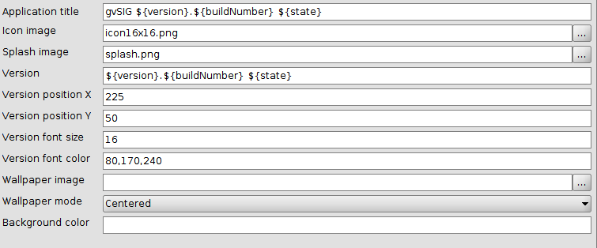
- Scripts actions. Used to create a tool that runs an action. This tool will have different parameters referred to an existing tool, button or menu. The scripting parameters can be set using the wizard window that is opened when selecting “scripts actions” tab.

83.3. Create a distribution
When we change the configuration of a new distribution we can then create it, selecting the default options. The way to generate it is to use the “Create distribution” dialog box.
Click “Tools” on the main menu, and then click “Customize>Create distribution” to open this dialog box. See the figure below that shows this dialog box
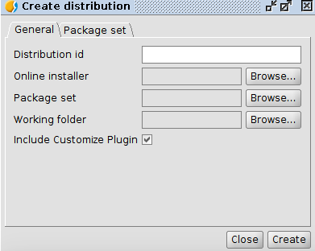
When creating a distribution, it is recommended to fill the different fields in the following order:
- Working Folder. Choose the folder to save the file.
- Distribution id. Add a name that identifies the distribution
- Online Installer. Add the online installer that will be used to create the distribution. Different installers are available for different gvSIG versions, with additional plugins for both Windows and Linux operating systems. Click on this link to download them: http://downloads.gvsig.org/download/gvsig-desktop/dists/
- Package set. Select the file that stores all the plugins. This files’ extension is .gvspks. Click the link specified above to download the available package sets for both Windows and Linux operating systems.

Catalog of favorites

84.1. Introduction
One of the tools that users frequently employ while browsing the web is the so-called bookmarks or favorites. This tool enable users to open previously visited web pages more rapidly by reaching them from the Favorites folder.
The Catalog of favorites tool in gvSIG follows the same methodology applied to geographic information. In this way, data used frequently are easily available in the Catalog and users can add them to View very quickly.
The procedure is very easy. Users can save and classify any layer in the catalog of favorites and add it to the Views afterward.
In the present version, this tool works only for vector files.
These tools are available from the Menu: Tools/Catalogue and from the respective button bar.
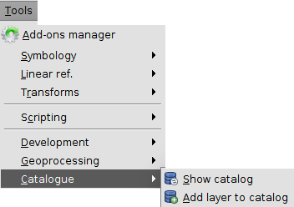

84.2. Show Catalog
It shows the window with the list of favorites.
This tool is available from the Menu: Tools/Catalog/Show Catalog
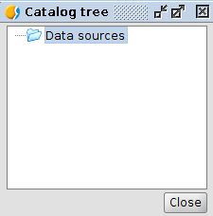
This window shows the list of layers stored in the Catalog of Favorites. (The window appears empty when it is used for the first time).
A mouse right-click over the Catalog Tree window will show a contextual menu with different options.
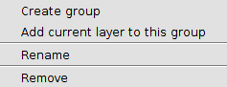
- Create group: Creates a group or folder (or sub-group or sub-folder in the case a group is previously selected)
- Add current layer to this group: Adds the active layer to the selected group. In the case there is no group selected, it adds the layer to the root or Data Sources group.
- Rename: Renames a group or layer
- Remove: Removes a layer or group. If a group is removed, it also removes sub-groups and all the layers it contains.

84.3. Add a layer to the Catalog
It shows the window with the list of Favorites.
This tool is available from the Menu: Tools/Catalog/Add layer to catalog; from the contextual Menu of the Table of Content (TOC) Add to Catalog and from the contextual menu of the window Catalog Tree.
The tool Add Layer from the contextual menu of TOC to the Catalog:
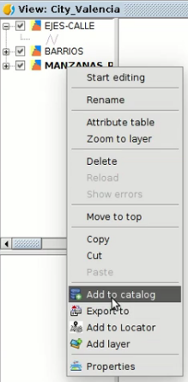
And from the contextual Menu of the window Catalog Tree:
In this case, the main difference is that it adds the active layer in the folder or sub-folder previously selected in the window Catalog Tree.

