**Neural Network Report**

**Overview:**

Alphabet Soup, a nonprofit foundation, wants a tool to help select funding applications that have the highest chance of finding success. The goal is to create a binary classifier that can determine whether applicants will be successful if funded by Alphabet Soup.

**Results:**

For data preprocessing, EIN and NAME were dropped as they were deemed irrelevant. 

The remaining columns other than IS_SUCCESSFUL, which is our target, became features. I used nunique to see which features would most likely need binning. The categories were they one-hot encoded using get_dummies.Graphical user interface, text, application



Before running the neural network, I ran a Logistic Regression, Random Forest Classifier, and an XGB Classifier to compare to my eventual neural network results.

I chose 8 nodes in layer 1 based on the number of features.

Target model performance of 75% was not quite reached. The accuracy could have been higher and the loss could have been lower if ran for more epochs and maybe if more layers/nodes were added. 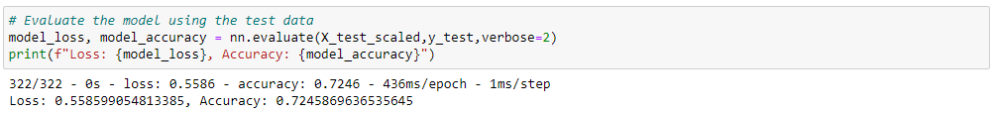

**Summary:**

The neural network model in just its first iteration was fairly close to reaching Alphabet Soup’s goal of 75% accuracy. With more optimization, there is a strong chance the model could accurately predict success of applicants who receive funding. An XGB Classifier could also be used as the accuracy was close to the neural network and could be tuned higher with some hyper-parameterization.