Air Ticket Reservation System

Glossary
ATRS – Air Ticket Reservation System
SP – security provider (g+, twitter, linkedin)
PSP – payment service provider

Requirement analysis
RQ1.1: Public users login using external services (g+, twitter, linkedin)
All listed services use OAuth2 for authentication and should be supported as external authentication providers using https://tools.ietf.org/html/rfc6749#section-4.2 (cause of RQ3.1). User should be linked at one provider at time. SP should be linked at the login creation time (i.e. first time user register with ATRS). This is standard practice and saves the development effort.

RQ1.2: Multiply search criteria for tickets in ATRS
Most common is to provide search for
- One way vs Return tikets
- Complex route search (several destination hop-by-hop)
- Tickets within the range of dates (to find the most suitable)
- Tickets for group of people
Least common but useful searches include:
- Specify seat class
- Specify time range
- Search flights in neighboring locations
Additionally it’s a good idea to provide extended “after search” filters. We will use this idea to filter seat class and time range. It will be good to offload data storage and provide more general searches for caching.

RQ1.3: Payments by credit card
System should be integrated to payment provider that supports credit card payment. ATRS should provide general interface (as in bridge) to perform transactions with PSP as it is generally not known at development time and could be changed over time. Also the choice is country of ATRS operator dependant. The PayPal is one of wide known solution, also common interfaces should be checked on the list https://en.wikipedia.org/wiki/List_of_online_payment_service_providers.
Interface should basically provide capability to:
- pay for one ticket
- pay for multiply tickets
- refund money for the ticket

RQ1.4.1: Runtime PDF creation
https://sourceforge.net/projects/itextsharp/ is the most viable free choice for runtime PDF creation.

RQ1.4.2: Perform some actions without requiring user to login ATRS
ATRS should process next actions from public users without requiring to login ATRS:
- view bookings
- checkout
- cancel booking
To implement this system should use specially crafted links with security token included. Tokens should be opaque. Upon generation (HMAC) they should include random information, user information and action type for with it generated to enhance security.

RQ1.5: User “personal area” on the ATRS to perform:
- checkout
- cancelation
- boarding pass printing

RQ1.6: Automation user notification process.
System should include scheduler to address this need

RQ2.1: Staff login using active directory
ATRS authentication server (SP) implementing https://tools.ietf.org/html/rfc6749#section-4.2 (cause of RQ3.1) should be created to enable staff identification in AD and maintaining common authentication technology.

RQ2.2: Staff should be informed with reservation charts in PDF
Addressed by RQ1.4.1, RQ1.6

RQ2.3: Ability to ticket cancelation by staff
ATRS should provide staff area for staff members to perform their operations:
- view flight bookings
- cancel any single ticket
ATRS should transactionally generate refund request to PSP and inform user about ticket cancelation.

RQ2.4: Ability to flight cancelation by staff
Group operations provided by RQ2.3.

RQ3.1: SPA based responsive web portal
Use AngularJS https://www.angularjs.org/ as choice for portal programming for being free, well-documented, with big community, using by truly big companies for large sites.

RQ3.2: Core system should be ready to serve mobile apps
Core system should provide REST API with tokens under SPA with security token authorization to access its functions.

RQ3.3: System should be cloud based
Consider using Azure with following services:
Application Gateway – for web portal
SQL Database – for data storage
Batch - for scheduler job
Azure AD Application Proxy – for staff logins

RQ3.4: Alerts should be guaranteed
All alerts should maintain states and persistency. They should be saved to storage before processing take place and support replay / revert mechanics. Scheduler task should perform check for unprocessed or orphaned items periodically.

RQ3.5: Technologies are not recommended!

RQ4: Additional propositions
- ATRS is general purpose for needs of some air transportation operator or its affiliate (i.e. not a system for booking service aggregator)
- System provides all-or-nothing pricing policy not allowing for Public Users to select or discard some services (as in-flight meals etc).

UI screens and use-cases
SC1 basic search
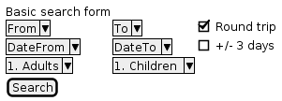

SC2 advanced search
Advanced search copies “From” “To” and both “Dates” several time to enable multiply locations

SC3 search results
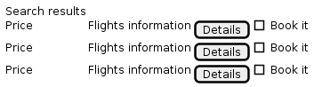

SC4 passenger’s detail
Form to enter each passenger names, ID and other information. Form is subject to regulations of the ATRS owner company and / or passenger country.

Document concentrates only on corner stone use cases to postulate general use of the system

UC1 General booking process
Public User choose basic search (SC1) enter parameters and receive search results (SC3). Public User filter results to narrow down result set (optional). User view information about found flights and select one to book it. ATRS provide form to enter passenger’s detailed information (CS4). User complete the step and select “next” button. ATRS create booking record and mark it as payment required. User proceed to PSP payment page. Next process explained in more details on diagram below.

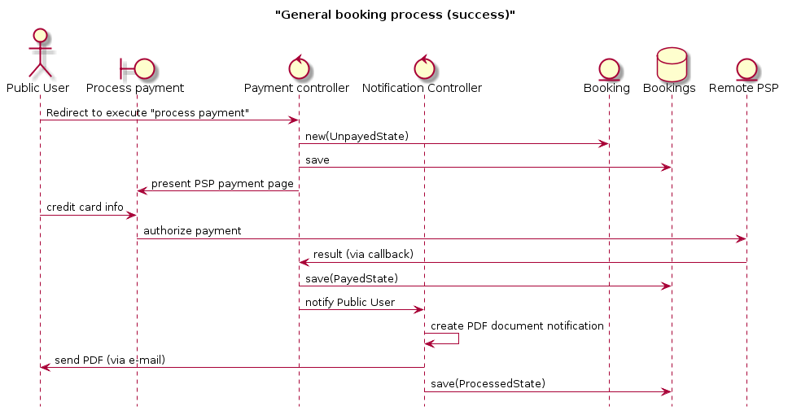

Creation of booking effectively blocks flight available seats to eliminate races. One of the Scheduler tasks is to check blocked but unprocessed bookings at regular intervals (should be tunable and may vary from several minutes to hours).

Upon creation of PDF security tokens for cancelation, online check-in, view booking and board pass printing creating by generation HMAC from random number with passenger information plus action (cancelation / check-in / view) generated and pinned to booking. This tokens are included in PDF document links.

Before changing booking record state ATRS saves booking change record into special table in persistent storage to enable history and investigation.

Alternatives:

If user waits too long before choose “Book it” system informs him that search results should be invalidated in order to view tickets availability.

If failure is in PSP payment process ATRS remove booking from bookings, inform user that payment failed with ability to return to payment page.

If failure happened on notification step, scheduler process on its run try to resend mail confirmation. If several attempts to send e-mail confirmation failed ATRS should mark the booking record as failedToNotify and inform staff to check problem manually.

NOTE: TBD: some of PSP may not be enabled “true” SPA

UC address: RQs 1.2, 1.3, 1.4.1, 3.4

UC2: User ticket cancelation
Public User navigate the link from booking confirmation PDF. Link include booking number and contain security token which extracted and checking by ATRS against token in booking database. If equal system enable to process cancelation by confirming it on the page. ATRS than switch booking to “CancelingState”, create refund request to SPS (if appropriate). Upon receiving result from SPS switch booking to “RefundedState” sends e-mail notification to user and switch record to “CanceledState”. Errors are processed in fashion similar to UC1.

UC3: Staff ticket cancelation.
Staff having rights to manage ticket cancelation request booking information from database and cancel booking. The process is similar to UC2, but doesn’t require security token check.

UC4: Scheduled events
At regular intervals ATRS scheduler is started. Upon start it check last started time and according to timeouts for different tasks process following:
- unlock created but not processed bookings freeing flight seats
- send user and staff notifications
- resend stuck notifications

High level data model
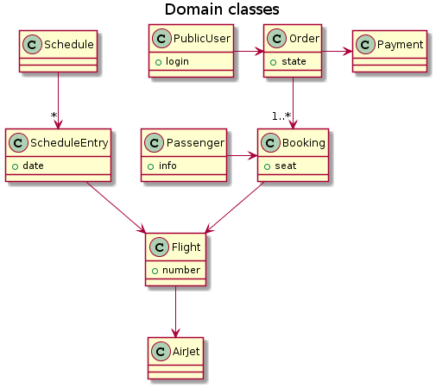

Most of the data for ATRS is mostly static (i.e. types of airjets and flight schedule) and relatively small to be cached in memory. For example schedule can be seen as sparse table while real records contain flight days thru the year. Other (orders, booking) are under OLTP load grow over the time. To address this older data for completed flights should be transferred to offline storage for needs of data mining. Also for large ATRS to enable data sharding inside database instance table names should be prefixed with their creation date range (20160510-Orders).

Sensitive information about booking processing should be stored in write once “history” tables.

To further scale DB performance single master scheme could be established to support number of read only instances and improve booking search speed.

PDF are not stored in the DB but generated online per request to minimize storage costs (cost of creation is low).

Proposed but incomplete view of the data model shown on picture below

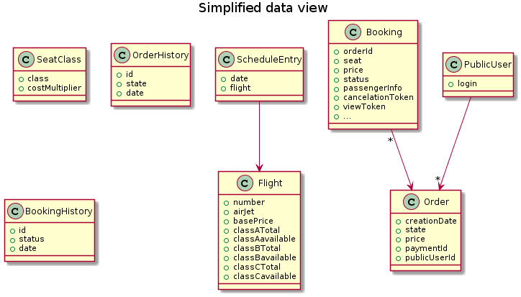

Architecture view

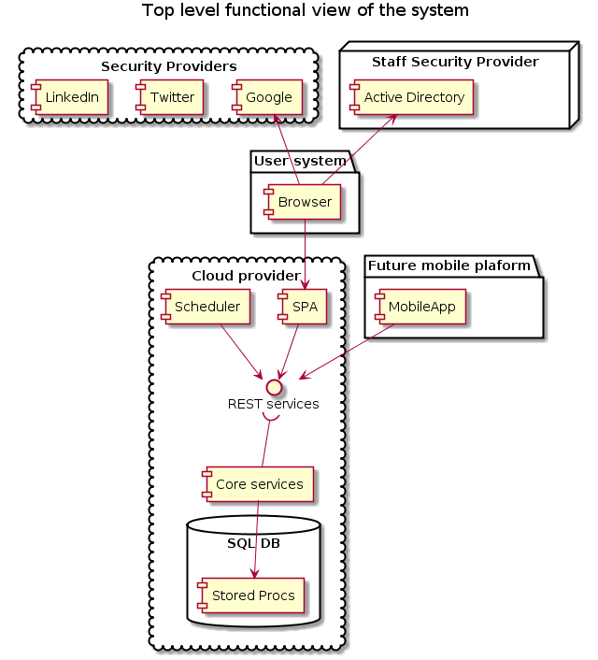

NOTE: ATRS using HTTPS strictly while crossing areas borders because it passes the security tokens over the wire! So future direct MobileApp connection to rest services is under the question. Seems it is better provide internal HTTP and external HTTPS REST services view.

Functional top level view does not show availability and scalability issues. They are discussed in text below.

Authorization subsystem
We use external authentication services based on OAuth2 for public users and newly created OAuth2 powered service for staff user logins. So for the rest of the system authorization is homogenous and based on security tokens. ATRS use opaque security tokens in the form of strings. System need to support a list of providers which implementations isn’t fully compatible, so we should differentiate which provider is used by public user. Binding with provider performed once during first user login. Staff member logins are redirected to Staff SP.

Scheduler
Scheduler performs all timer generated events starting on prescheduled minimum intervals. It then checks what services need to be run, spawn services and records its start time last start time. Scheduler checks previous instances of services that need to be started and if found some uncompleted report error to ATRS system log. Service processes write they start / stop time and system notifications to ATRS system log. Master scheduler service controlled by backup scheduler and stopped / restarted if doesn’t complete in specified timeout. If registered as windows system service it could be done by configuration. In case of Azure Batch ATRS will need second monitoring slave Batch.

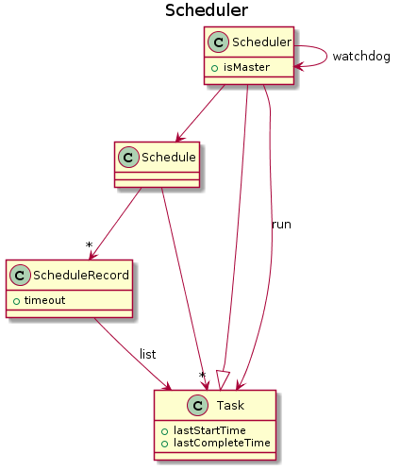

SPA
SPA Web portal is a thin layer of presentation code consuming REST services from core layer. It employs AngularJS framework proven to be enough fast, provide great user experience, well documented and supported by freeware community. Also it has mobile ports and can be considered at least as first-and-dirty implementation for mobile devices. The main mission of the code here is to provide user input, perform possible client-side checks, create request to Core REST Services, receive and present results. Also code should provide post search client filter application.

Core REST API
Is the central part of the system and provide reasonable monolithic services to complete use-case in as less steps as possible preventing additional network traffic, latency, state synchronization, distributed transaction control, etc. To stand the high loads API services should be stateless, deployed under Application Gateway that balancing the load and accepts gzipped requests. Also it is better to turn on HTTP2/SPDY on web servers if available. Below are design of the most valuable and interesting part of the system

Search by criteria

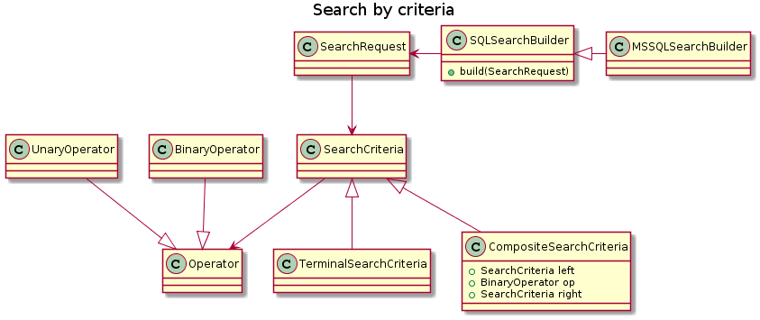

Search request is composed as abstract syntax tree on client and transfer in form of JSON to the server where build into SQL database request and executed. Results are gathered in the form of JSON dataset and sent back to client. ATRS do not provide paging sending only reasonably large dataset according to selected sorting criteria. Decision made according to the fact that normally user won’t see all records in dataset and its practically to issue one more request to the server than to store open dataset on server and bind client to particular server instance.

Order states

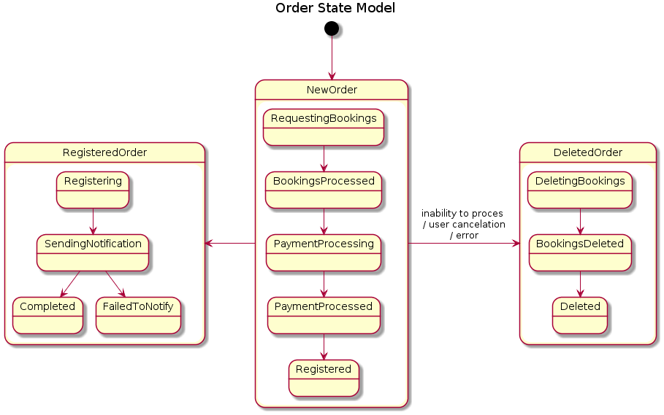

Order is entity that includes all booking as enclosing object to provide payment and Public User linkage. States are using to make reliable transaction and protect the system from loosing information. State of bookings are resembling the states of an order but much simpler including “Requesting” → “Aquired” → “Confirmed” → “Canceled” states.

PSP façade design

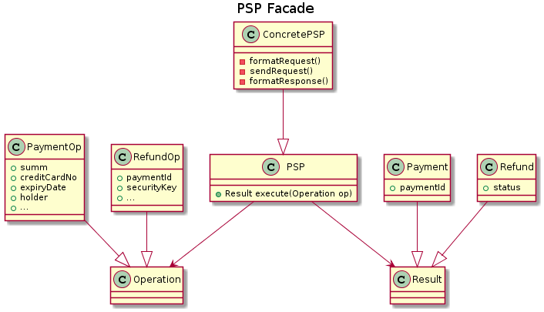

Runtime PDF creation and secured links

ATRS using https://sourceforge.net/projects/itextsharp/ for PDF creation. PDF isn’t stored anywhere in the system reducing storage costs while even multiply recreation of the same PDF keeping processing costs low (and seems highly unlikely on big scale).
Booking confirmation PDF contains several links that allow user to view or change state of the booking while not logging in or even don’t have an account in ATRS. The idea behind these links is creation of security tokens that is bounded to every booking. Tokens are restricted to make only action they issued to. For example user receives PDF with following link
https://atrs.com/R10088/OPAQUE_STRING_CANCELATION_TOKEN
navigating this link she request API URI that transforms this link to Core API Services request to process booking #10088. Viewing the token and comparing it to cancelation token in the booking record ATRS could securely cancel user booking.
Passing security tokens in browser context (PDF) and in the e-mails are potentially risky but using TSL to secure connection will prevent major attacks.

Providing high availability and preventing malicious resource allocation

To minimize booking systems problems ATRS should be able to allocate seats by user request and provide consistent view of availability during every user session. But system should deallocate locked seats if user terminate the process or doesn’t respond too long. ATRS don’t maintain any server session state, so SPA should inform the server to remove the started reservation as soon as user close the browser or exits the page. Server on its side running scheduler to periodically check abandoned or “waiting-too-long” bookings and removes them.
To protect ATRS from mass resource allocation attacks. Authorization subsystem should include filter that not allows to issue multiply request in specified timeframe from single registered user account. Additional IP filter should be provided to enable ATRS safely process unregistered users booking queries.

