Crisis Management project

Vision

Propositions
- Crisis is relatively rare event
- Every crisis is more or less geographically local
- Crisis involves only part of multinational company and by locality of the crisis this couldn't be very a big number (suppose less than 100K even for organization with enormous size)
- Crisis event could involve only current employees and their family members. So we suppose "static view" at the time of the event (this could be of no importance)
- Define "virtual room" as a place where team members store and share different artifacts
- Virtual room contain documents that have different format and purpose
- Company owns Windows based servers as they wants to use MS .NET
- Company decided to implement the System with less possible 3rd party components especially non-free
- Company decided to deploy the System using own infrastructure and software

Accepted top level conclusions
- System usage statistics is rare plateau load
- We don’t expect much load on DB not in create/write nor in select/read
- There is no general algorithm to merge document's content so we would use simple lock/unlock document strategy to prevent editors conflict

Considerations not accepted to implement or use

- SharePoint with custom workflow activities to implement the System, this *could* reduce cost of ownership, but require skilled developers which is in conflict with TechSpec#2.
- Azure deployment to benefit from PaaS and reduce infrastructure cost, potential conflict with TechSpec#2 because need of some developers that understand technology
- DocumentDB @ Azure as DB platform to use team friendly MS Technology Stack and reduce infrastructure cost
- Use external virtual room vendor

Top level design decisions
- Main application as HTML5 web site to effortless support of maximum possible platforms and clients and allow System to be accessible through firewalls from Internet
- REST as native Internet standard to implement stateless services to improve scalability and simplify design and integration
- MongoDB as primary crisis data storage as it document oriented, supports replication, C# drivers, BSON document storage. Storage also will expose data to future systems with possible service layer above to implement security, permissions, data views etc.
- HR existing app integration: REST Web Service facade to relational database to scale if face some load. Service has predefined queries for employees and family members search as we could define primarily search requirements beforehand and general purpose method for extension
- LDAP integration: use LINQ to LDAP as simple and expressive tool to fetch data from LDAP
- Localisation: using standard .NET pattern with .resx files and System.Globalization
- Application load balancing and fail-over: for in-home hosted solution based on Windows Servers it's reasonably to use IIS based balancing and fail-over solution
- DB load balancing and fail-safe: we don't suppose high load operations now, but MongoDB supports replication and sharding
- Security: .NET Forms authentication could be applied to support different client in the Intranet beyond the organization perimeter. Due to private nature of information inside the system HTTPS should be used to prevent eavesdropping.
- Audit: !!!!!!!!!!!!!!!!

Domain model
Here is the domain model based on requirement analysis
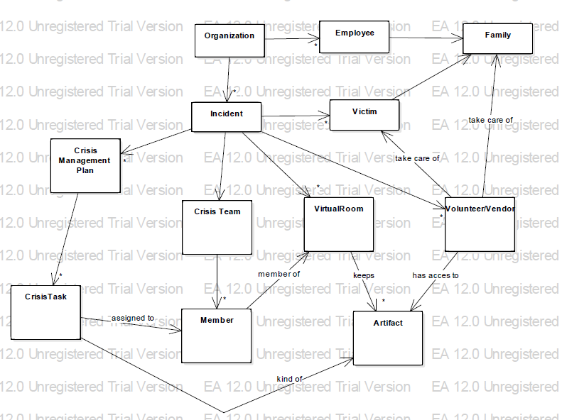

Cloud level use-cases
- Register Crisis
- Assign Crisis Team
- Create Crisis Plan
- Create Crisis Task inside Crisis Plan
- Assign Crisis Task
- Perform Crisis Task
- Create Virtual Room
- Assign Crisis Team Members to Virtual Room
- Create Document inside Virtual Room
- Notify Virtual Room members about changes in the Room
- Create Volunteers (Vendors)
- Correct Crisis Plan
- Complete Crisis Plan
- Complete Crisis

Design

System overview
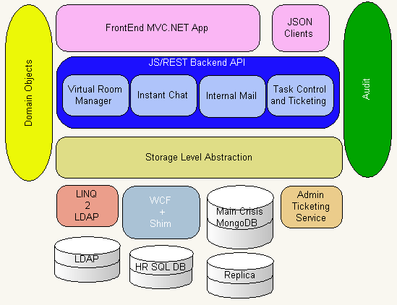

Database
NoSQL design selected considering unique nature of every crisis and unstructured types of data being collected in each crisis. Also data should be available for retrospective search and integration with future systems. Document oriented DB seems a good solution here. MongoDB selected for good community support, documentation and examples availability and well known success stories. Microsoft DocumentDB is good cloud alternative for it and cost of design change is only in Storage Layer Abstraction.

Below is set of database collections with short descriptions about they content and structure. Names are mapped to Domain model entities.

Collection data types: Employee, Person (to store family members), Victim
Proposed field structure: Person = {name, age, …}, Employee = {Person, position, …}, Victim = {Person | Employee, damage, …}

Collection data types: CrisisManagementPlan
Compound key: crisis + crisis_plan

Collection data types: CrisisTask
Compound key: crisis_plan + crisis_task

Collection data types: CrisisTeamMembers
Compound key: crisis + crisis_team + team_member

Collection data types: Vendors, Volunteers, Family Care etc
Comment: Store all external parties to organization

Collection data types: Artifacts
Compound key: crisis + virtual_room + artifact
Comment: The idea is to store all artifacts (Documents, Reports, Videos, Chats, MailBoxes etc) bounded to virtual_rooms, so if crisis team member has access to room it automatically has access to it content. Data types segregated by JSON record metadata. Chats and MailBoxes as far as any other items could be market as “to owner(s) only” to prevent access to it content.

Interfaces

Dynamics

Deployment

