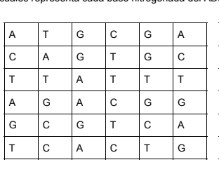
DIAGONAL A
DIAGONAL B
DIAGONAL C
DIAGONAL D

