Automata Assignment Report
Name - Varun Gupta
Roll No – 2023101108

Q1
For Q1, approach is simple just from start node we will keep doing transitions until the total size of input (X). This will work for smaller test cases but as X can be upto 10^12 it will not be able to complete in 1 second. So we will use the logic of Pumping Lemma as a intuition.
If we encounter a loop then after that we do not need to keep doing regular iterations. After the loop is encountered i can also find loop length through indexing. Now with loop length we can calculate additional number of iteration through it without actually iterating again and again.

Q2
For Q2, i have used Javascript and in that directly used lindenmayer library to construct L Systems. With reading README.md i used the example code given there and changed axioms and production rules in that. I added all the finals as mentioned in the documentation given then after this It was just changing the axioms and production rules as given in the example to get the required diagrams.

I’m a Mirrorball
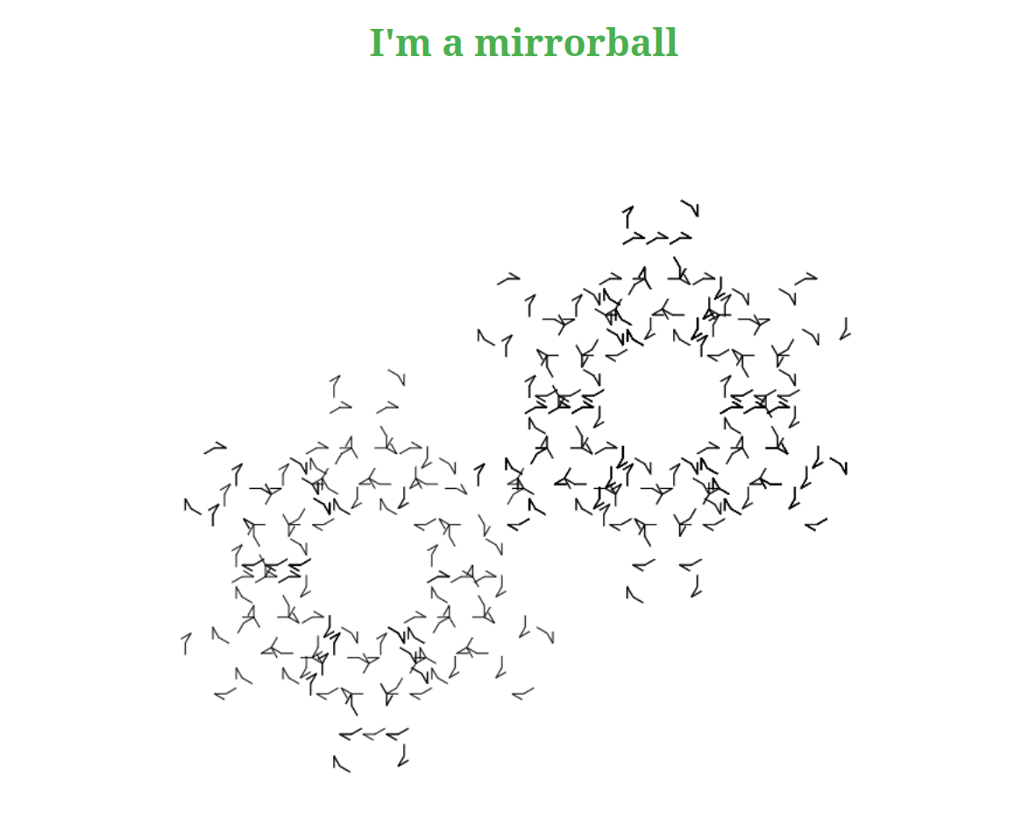

Is that a tree?
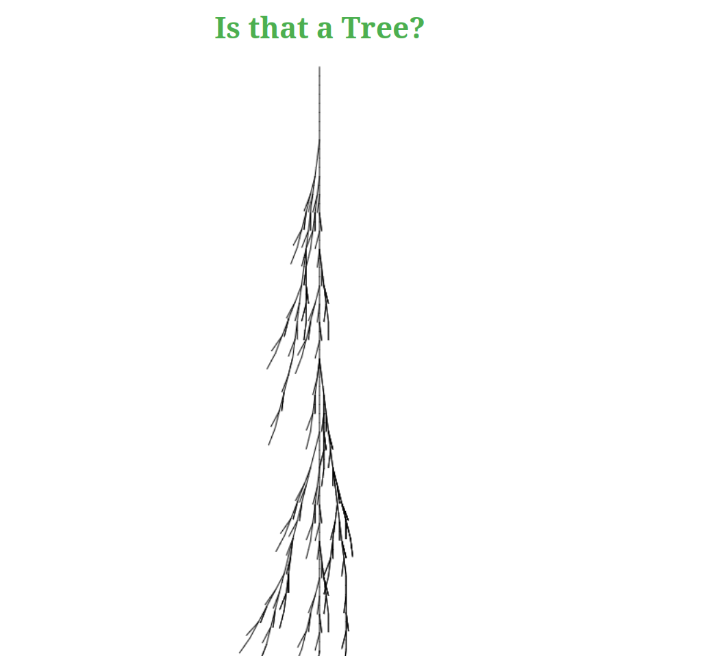

Anything that can happen will happen

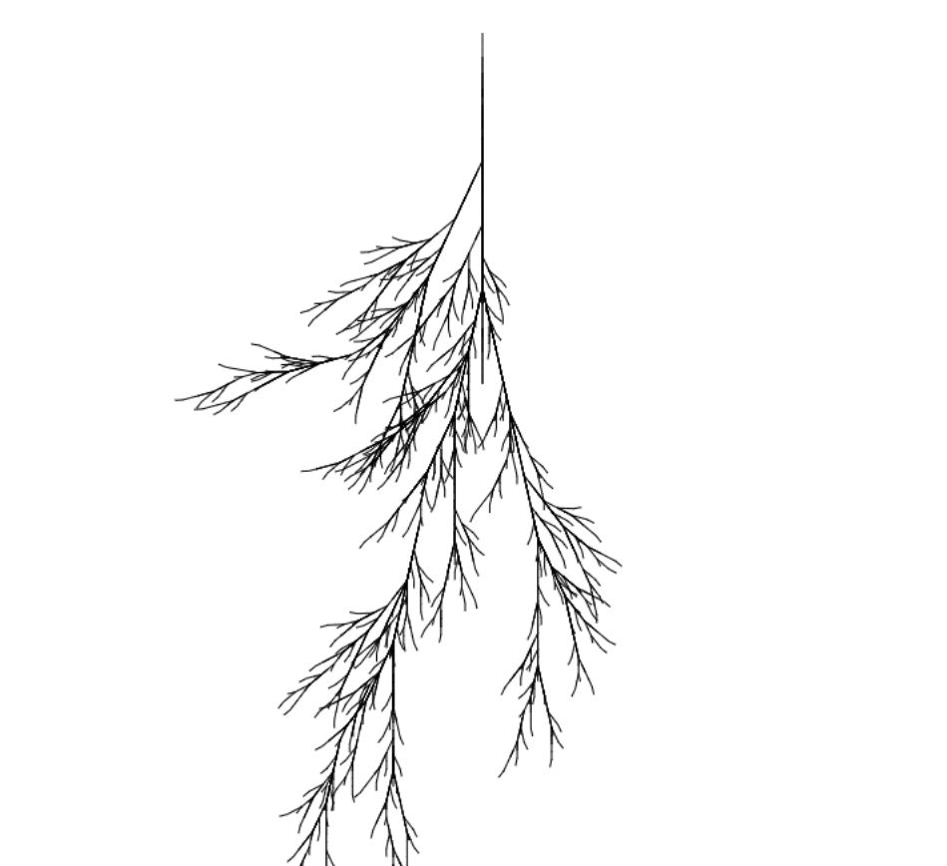

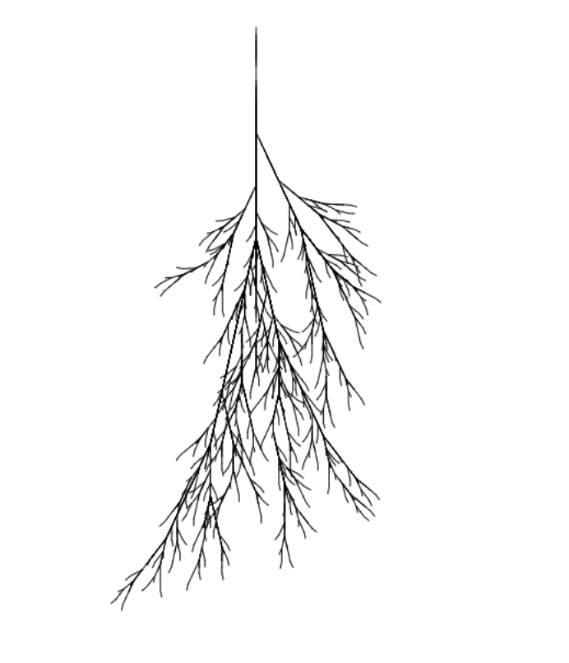
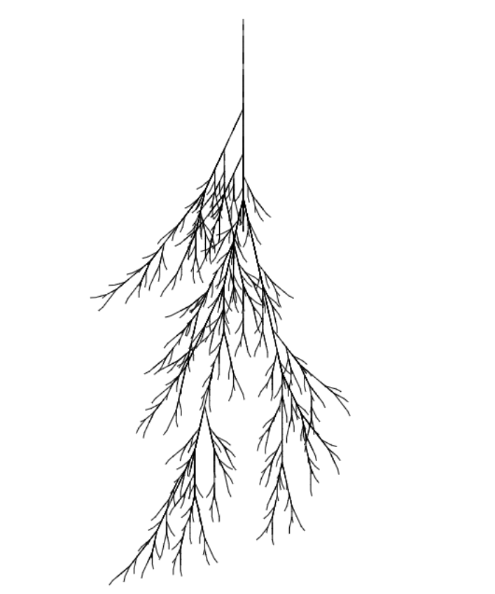

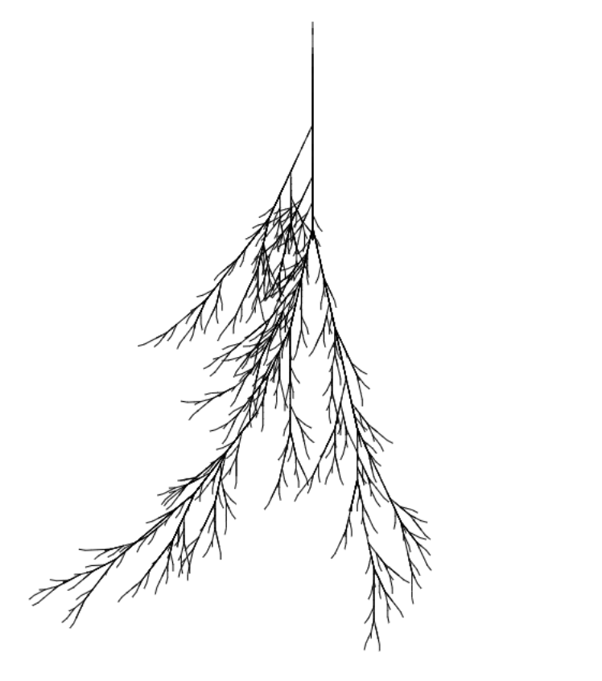

Content with Context is Noise
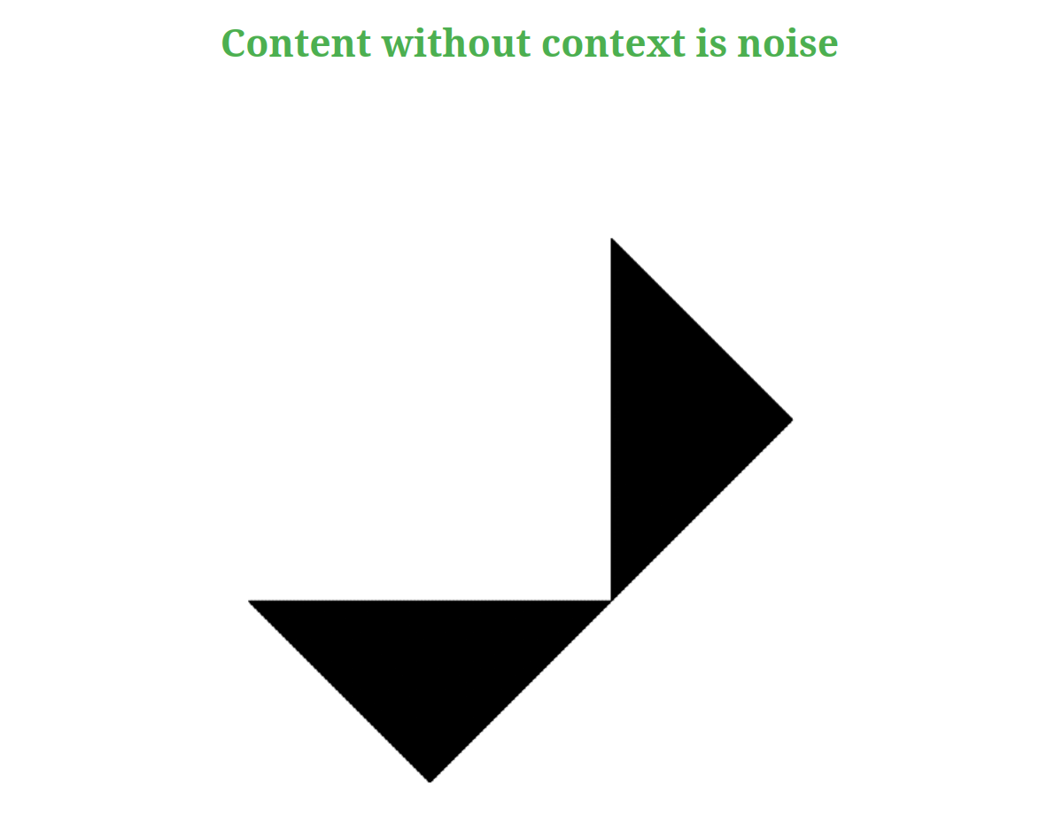

Q3

Part A ( Stick Plant )
So this diagram is kind of recursion which is dependent on previous iteration that is current iteration is dependent on its previous iteration. The rule or observation is like first we need to put previous iteration on right then forward then on left then again forward. After this there was also a factor of gap for i also included a new variable Y to take that Gap Factor in account that after one right and forward the gap will increase then left and forward.

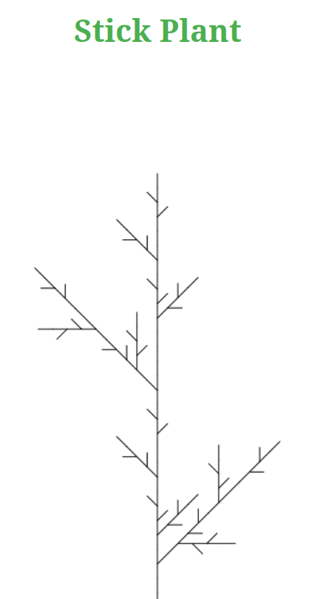

Part B ( Santa K(l)osh)
This is also similar that it is also doing recursive call that current iteration is dependent on previous dependent. We do just forward then upward at angle 75 degree then downward 75 degree then again forward. This is the logic that is used.

