Chat Application

High Level Architecture

# Major Modules

User sign up page

Sign up page is used for people to register an account and use the chat application if the user has successfully registered.

User login Page

Login Page is used for registered users and be able to use the chat application.

Forgot Password

Forgot Password page is used for registered users to reset their password in case they forgot their password.

Chat Application Interface

This is the main Interface page for the chat application where users can send messages to each other.

# Module Connections

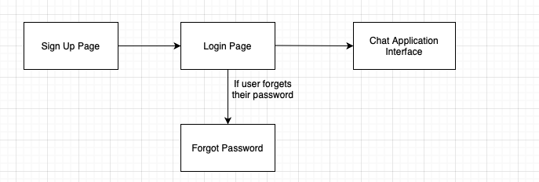

Major Modules Architecture

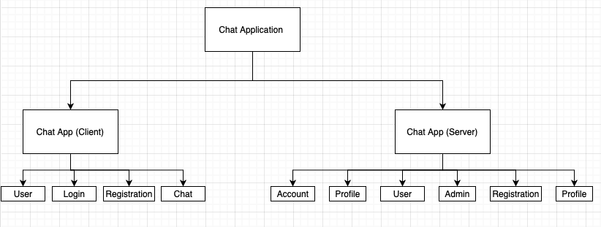

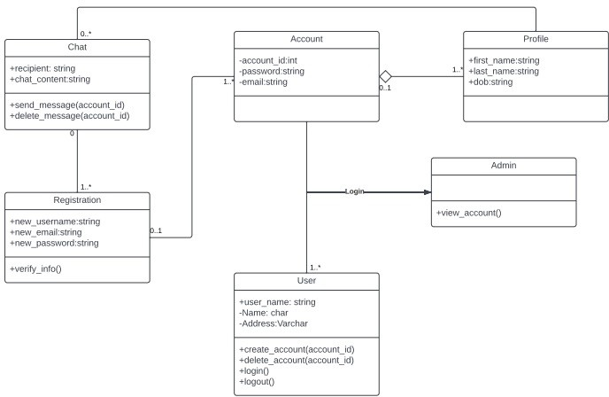

Class Diagram for Server Side

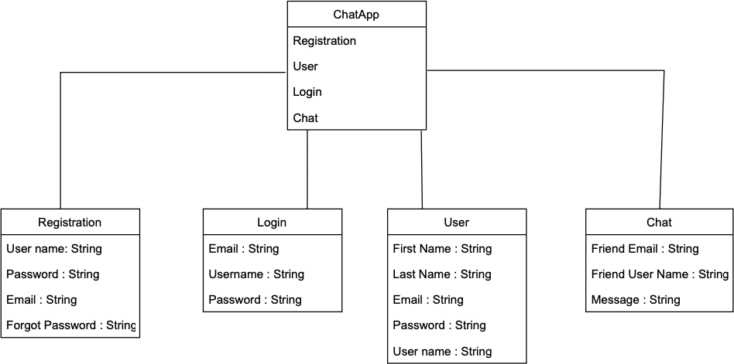

Class Diagram for Client Side

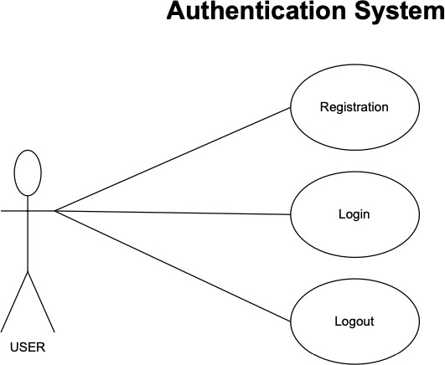

Chat App User Authentication system.

# THE END

* Thank you