Tobit Lagged

2018-09-07

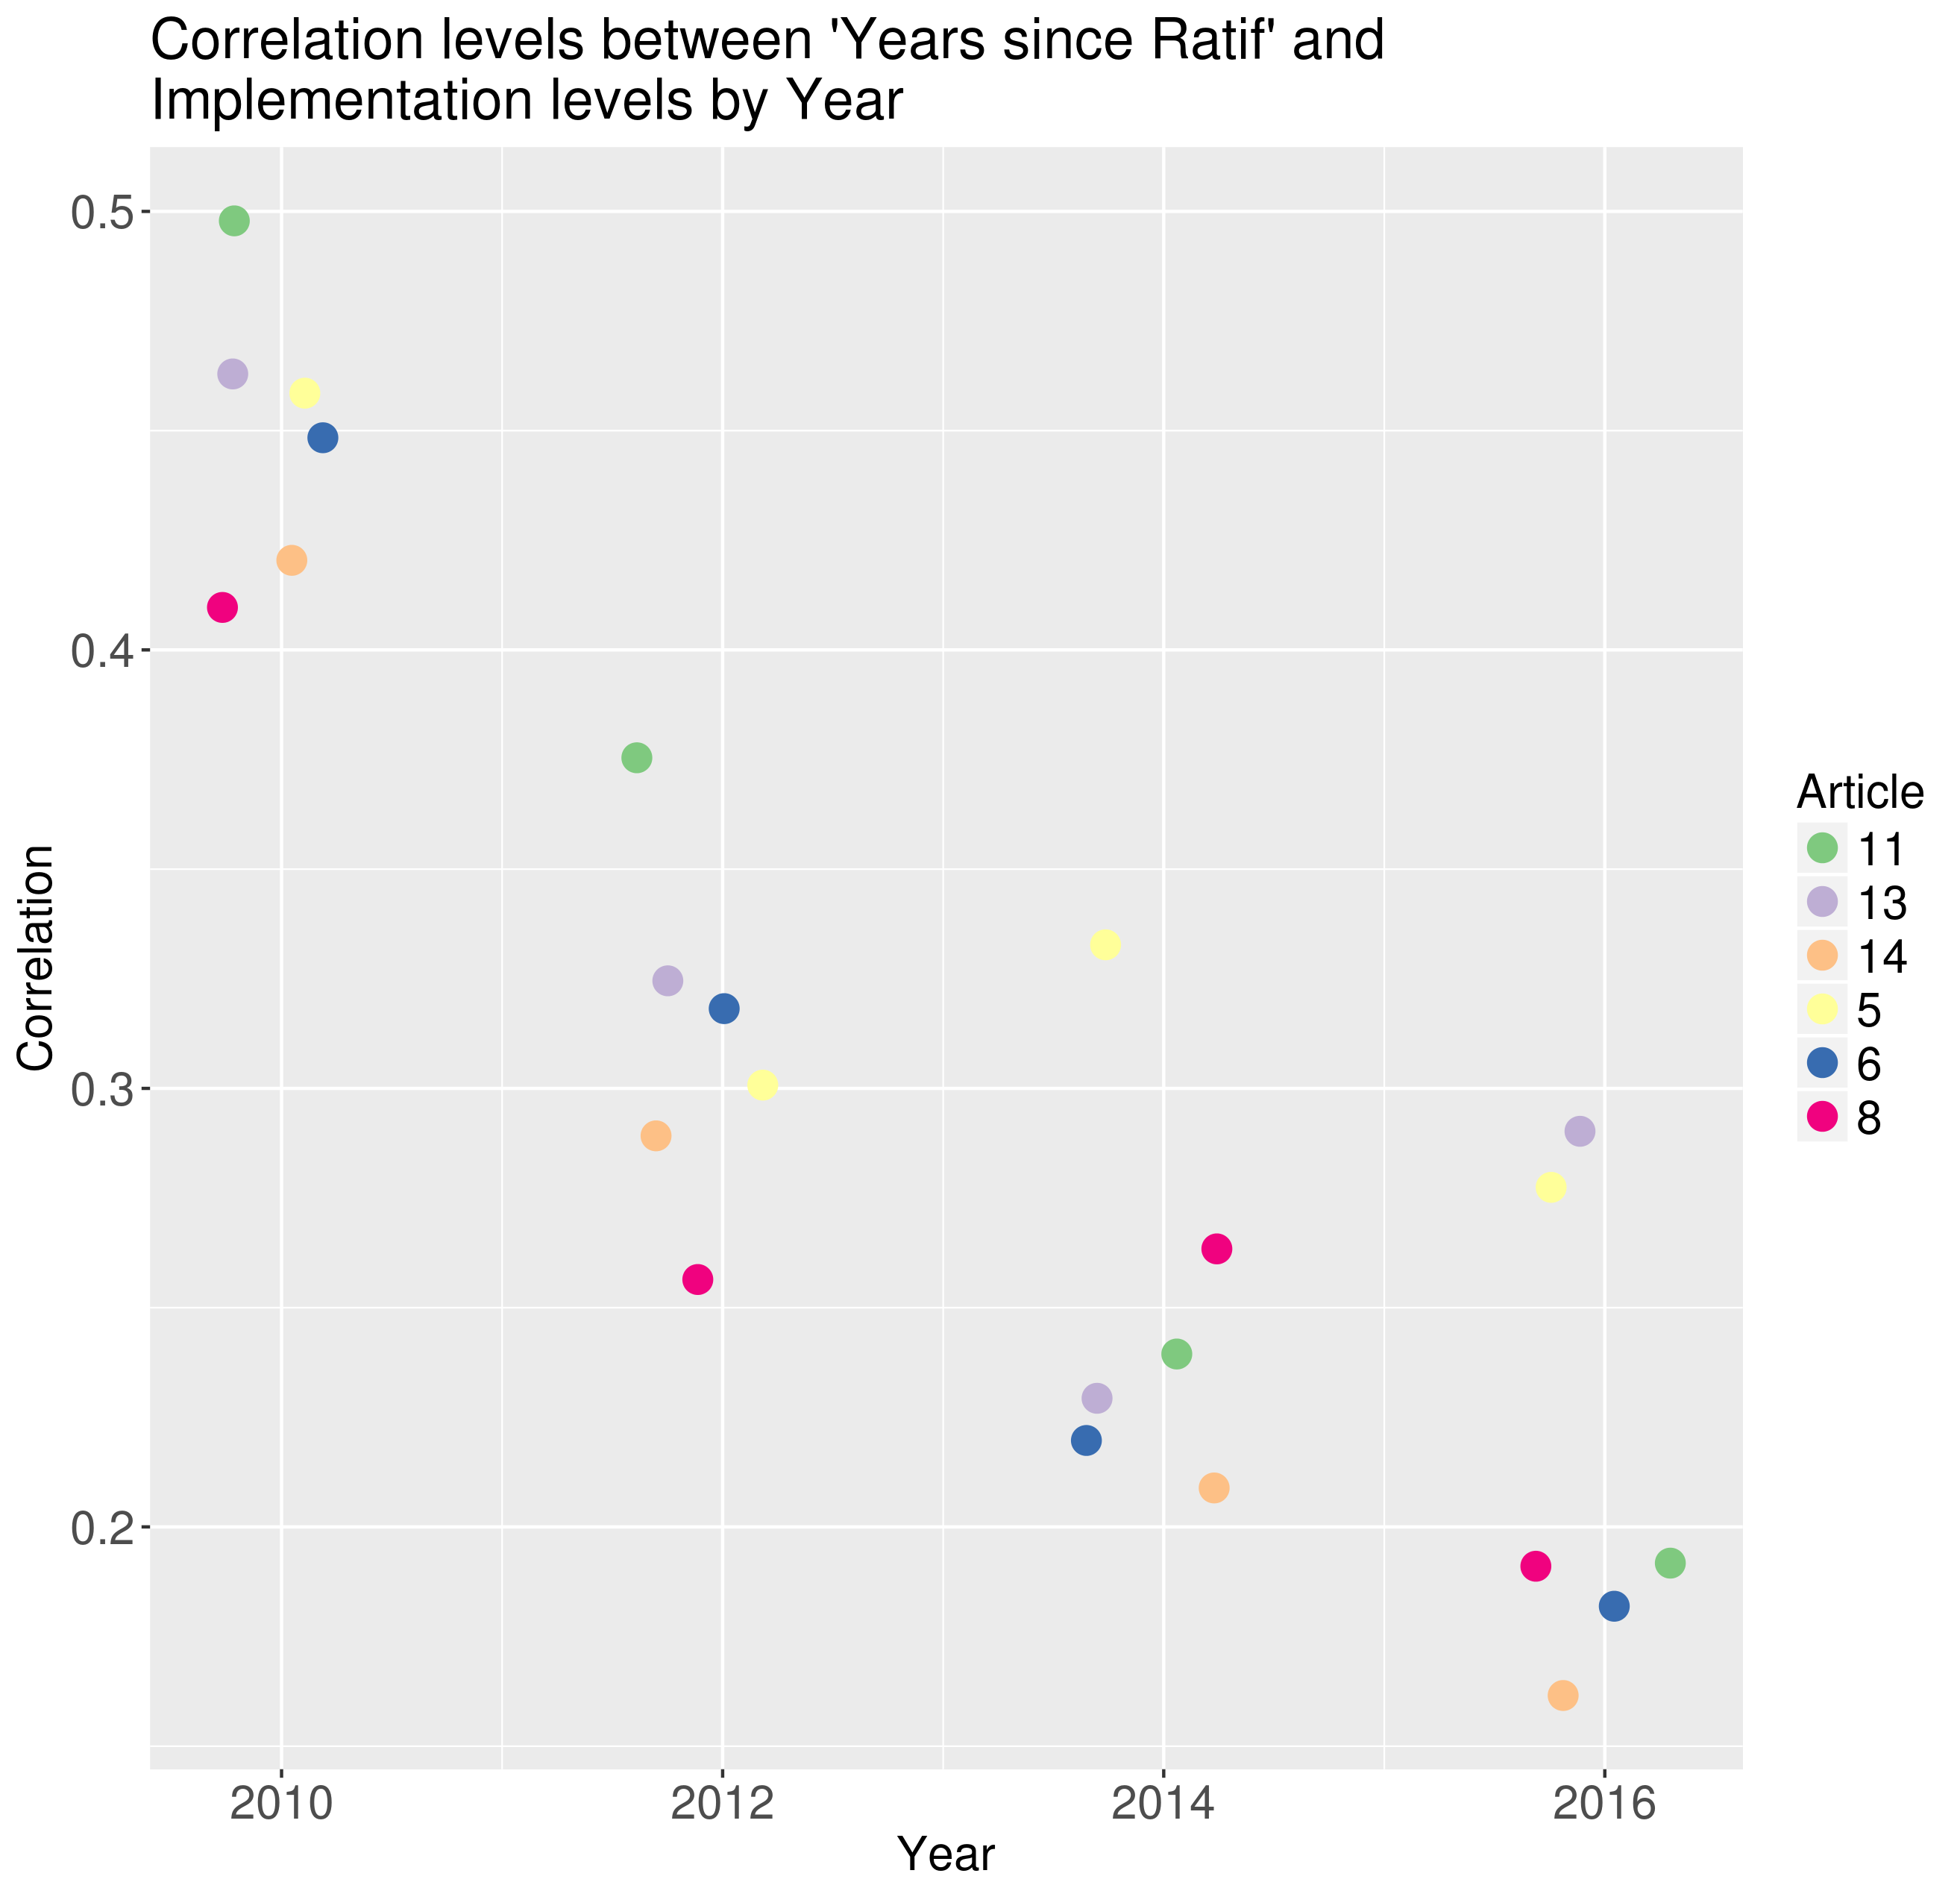

# Summary statistics

|  |  |  |  |  |
| --- | --- | --- | --- | --- |
| Variable | 2010 | 2012 | 2014 | 2016 |
| Year | 2010 | 2012 | 2014 | 2016 |
| Number of Countries | 169 | 169 | 179 | 178 |
| Eastern Mediterranean | 13.0% | 13.0% | 12.3% | 12.4% |
| Americas | 16.0% | 16.0% | 16.2% | 15.7% |
| African | 20.1% | 20.1% | 24.0% | 24.2% |
| European | 30.8% | 30.8% | 28.5% | 28.7% |
| Southeast Asia | 5.9% | 5.9% | 5.6% | 5.6% |
| Western Pacific | 14.2% | 14.2% | 13.4% | 13.5% |
| Democracy (POLITY) | 6.65 (3.08) | 6.70 (3.06) | 6.62 (3.06) | 6.58 (3.07) |
| GDP per capita (thousands) | 17.88 (19.42) | 18.26 (19.36) | 17.67 (18.99) | 18.17 (19.35) |
| Tobacco Prod. (thousands tons) | 52.95 (294.59) | 57.78 (333.08) | 53.53 (288.02) | 50.11 (269.87) |
| Smoking prevalence Female | 0.12 (0.11) | 0.12 (0.11) | 0.11 (0.11) | 0.10 (0.10) |
| Smoking prevalence Male | 0.36 (0.14) | 0.35 (0.13) | 0.34 (0.13) | 0.33 (0.13) |
| Women’s Labor | 40.06 (9.87) | 40.24 (9.91) | 40.65 (9.84) | 40.78 (9.78) |
| % Political Shift | 24.9% | 29.6% | 26.8% | 0.0% |
| % Political Shift (missings) | 8.9% | 10.1% | 11.7% | 100.0% |
| # of Bloomberg projects | 0.44 (1.53) | 0.54 (1.63) | 0.45 (1.48) | 0.11 (0.55) |
| USD Bloomberg projects (thousands) | 81.33 (312.06) | 68.91 (275.18) | 55.52 (202.23) | 17.42 (109.44) |
| # of Bloomberg FCTC projects | 0.13 (0.78) | 0.19 (0.45) | 0.13 (0.50) | 0.03 (0.24) |
| USD Bloomberg FCTC projects (thousands) | 31.07 (195.53) | 24.04 (76.56) | 16.31 (63.99) | 9.79 (86.75) |
| Government Ownership | 0.14 (0.34) | 0.14 (0.34) | 0.13 (0.34) | 0.13 (0.34) |
| Health Exp. per capita (ppp) | 757.72 (1,048.93) | 811.57 (1,120.88) | 839.70 (1,188.66) |  |
| Years since Ratification | 4.57 (1.66) | 6.51 (1.83) | 8.27 (2.18) | 10.27 (2.19) |
| # Items Implemented Art. 5 | 1.89 (2.30) | 3.63 (1.86) | 3.98 (1.69) | 4.21 (1.42) |
| # Items Implemented Art. 6 | 1.73 (2.17) | 2.85 (2.02) | 3.28 (1.98) | 4.15 (2.11) |
| # Items Implemented Art. 8 | 0.96 (1.19) | 3.53 (1.85) | 4.00 (1.82) | 4.12 (1.64) |
| # Items Implemented Art. 11 | 3.38 (4.06) | 5.82 (3.77) | 8.47 (4.99) | 9.66 (4.53) |
| # Items Implemented Art. 13 | 3.93 (5.30) | 6.49 (4.58) | 7.13 (4.37) | 7.19 (3.95) |
| # Items Implemented Art. 14 | 7.84 (10.43) | 13.93 (10.95) | 15.51 (10.72) | 16.75 (11.30) |

# Pvalues for Network effects of final model

|  |  |  |  |  |  |
| --- | --- | --- | --- | --- | --- |
| X1 | Centroid Distance | General Trade | Tobacco Trade | GLOBALink Referrals | GLOBALink co-subscription |
| Article 5 | 0.09 | -0.06 | -0.03 | -0.03 | 0.02 |
| Article 6 | 0.67 ** | 0.16 * | 0.20 *** | 0.09 *** | 0.10 *** |
| Article 8 | 1.11 *** | 0.19 * | 0.09 | 0.07 ** | 0.06 * |
| Article 11 | 1.26 *** | 0.19 * | 0.05 | 0.03 | 0.10 ** |
| Article 13 | 0.67 ** | 0.03 | -0.02 | 0.02 | 0.10 ** |
| Article 14 | 0.06 | 0.00 | 0.10 * | -0.01 | 0.05 * |
| Standard Errors in parenthesis. Signif. codes: 0.01: ‘***’ 0.05: ’****’ 0.10 ’*’ |  |  |  |  |  |
| Note: This specification includes Bloomberg FCTC count, Political Shifts, and a lagged number of items implemented. |  |  |  |  |  |

# Final model

## Article 5

|  |  |  |  |  |  |
| --- | --- | --- | --- | --- | --- |
| Article 5 | Centroid Distance | General Trade | Tobacco Trade | GLOBALink Referrals | GLOBALink co-subscription |
| Lagged Exposure (rho) | 0.09 | -0.06 | -0.03 | -0.03 | 0.02 |
| Lagged Y (Number of Items) | 0.34 *** | 0.34 *** | 0.34 *** | 0.34 *** | 0.35 *** |
| Americas | -0.45 | -0.49 | -0.51 | -0.51 | -0.53 * |
| African | 0.02 | -0.02 | -0.03 | 0.00 | -0.03 |
| European | -0.28 | -0.28 | -0.29 | -0.24 | -0.33 |
| South-East Asia | 0.20 | 0.24 | 0.21 | 0.25 | 0.20 |
| Western Pacific | -0.14 | -0.10 | -0.13 | -0.10 | -0.18 |
| Democracy (POLITY) | 0.01 | 0.01 | 0.01 | 0.01 | 0.01 |
| GDP per capita (ppp) | 0.04 | 0.06 | 0.05 | 0.07 | 0.04 |
| Tobacco Prod. per capita | -0.00 | -0.00 | -0.00 | -0.01 | 0.00 |
| % Female Smoke | -0.15 | -0.07 | -0.12 | -0.10 | -0.16 |
| % Male Smoke | 0.78 | 0.72 | 0.76 | 0.69 | 0.83 |
| Women’s Labor | -0.00 | -0.00 | -0.00 | -0.01 | -0.00 |
| PolShift | 0.01 | 0.01 | 0.01 | 0.02 | 0.01 |
| Bloomberg FCTC # | 0.08 | 0.09 | 0.09 | 0.09 | 0.08 |
| Government Ownership | 0.19 | 0.20 | 0.20 | 0.25 | 0.18 |
| Health Exp. per capita (ppp) | -0.02 | -0.03 | -0.02 | -0.03 | -0.01 |
| Years since Ratif. | 0.01 | 0.01 | 0.01 | 0.01 | 0.00 |
| Year 2014 | -0.36 | -0.42 | -0.31 | -0.21 | -0.21 |
| Year 2016 | -0.56 | -0.37 * | -0.39 ** | -0.43 ** | -0.40 ** |
| N | 478 | 478 | 478 | 478 | 478 |
| Standard Errors in parenthesis. Signif. codes: 0.01: ‘***’ 0.05: ’****’ 0.10 ’*’ |  |  |  |  |  |
| Note: This specification includes Bloomberg FCTC count, Political Shifts, and a lagged number of items implemented. |  |  |  |  |  |

## Article 6

|  |  |  |  |  |  |
| --- | --- | --- | --- | --- | --- |
| Article 6 | Centroid Distance | General Trade | Tobacco Trade | GLOBALink Referrals | GLOBALink co-subscription |
| Lagged Exposure (rho) | 0.67 ** | 0.16 * | 0.20 *** | 0.09 *** | 0.10 *** |
| Lagged Y (Number of Items) | 0.56 *** | 0.55 *** | 0.55 *** | 0.54 *** | 0.55 *** |
| Americas | 0.97 ** | 0.85 ** | 0.94 ** | 0.86 ** | 0.70 * |
| African | 0.49 | 0.42 | 0.58 | 0.33 | 0.26 |
| European | 0.62 | 0.87 ** | 0.92 ** | 0.75 * | 0.61 |
| South-East Asia | 0.73 * | 0.93 ** | 1.02 ** | 0.85 ** | 0.91 ** |
| Western Pacific | 1.11 *** | 1.14 *** | 1.15 *** | 1.10 *** | 1.08 *** |
| Democracy (POLITY) | 0.00 | 0.01 | -0.00 | -0.00 | 0.01 |
| GDP per capita (ppp) | -0.03 | -0.04 | -0.02 | -0.06 | -0.06 |
| Tobacco Prod. per capita | -0.03 | -0.03 | -0.03 | -0.02 | -0.01 |
| % Female Smoke | 0.76 | 0.89 | 0.98 | 0.93 | 0.89 |
| % Male Smoke | -0.67 | -0.63 | -0.53 | -0.64 | -0.54 |
| Women’s Labor | -0.01 | -0.01 | -0.01 | -0.00 | 0.00 |
| PolShift | 0.03 | 0.04 | 0.03 | 0.02 | 0.03 |
| Bloomberg FCTC # | 0.08 | 0.09 | 0.07 | 0.07 | 0.08 |
| Government Ownership | 0.02 | 0.14 | 0.14 | 0.01 | 0.04 |
| Health Exp. per capita (ppp) | 0.11 | 0.15 | 0.13 | 0.15 | 0.17 |
| Years since Ratif. | -0.11 *** | -0.10 ** | -0.09 ** | -0.11 *** | -0.13 *** |
| Year 2014 | -0.62 * | 0.63 * | 0.65 *** | 0.08 | 0.11 |
| Year 2016 | -0.17 | 0.46 * | 0.40 * | 0.67 *** | 0.79 *** |
| N | 478 | 478 | 478 | 478 | 478 |
| Standard Errors in parenthesis. Signif. codes: 0.01: ‘***’ 0.05: ’****’ 0.10 ’*’ |  |  |  |  |  |
| Note: This specification includes Bloomberg FCTC count, Political Shifts, and a lagged number of items implemented. |  |  |  |  |  |

## Article 8

|  |  |  |  |  |  |
| --- | --- | --- | --- | --- | --- |
| Article 8 | Centroid Distance | General Trade | Tobacco Trade | GLOBALink Referrals | GLOBALink co-subscription |
| Lagged Exposure (rho) | 1.11 *** | 0.19 * | 0.09 | 0.07 ** | 0.06 * |
| Lagged Y (Number of Items) | 0.42 *** | 0.42 *** | 0.42 *** | 0.41 *** | 0.42 *** |
| Americas | -0.19 | -0.58 | -0.55 | -0.57 | -0.61 * |
| African | -0.57 | -0.74 ** | -0.76 ** | -0.82 ** | -0.87 ** |
| European | -0.72 ** | -0.59 | -0.59 | -0.71 * | -0.70 * |
| South-East Asia | -0.16 | -0.03 | 0.02 | -0.10 | -0.06 |
| Western Pacific | 0.01 | 0.10 | 0.08 | 0.05 | 0.06 |
| Democracy (POLITY) | 0.00 | -0.00 | -0.00 | -0.01 | -0.00 |
| GDP per capita (ppp) | 0.04 | 0.06 | 0.06 | 0.04 | 0.04 |
| Tobacco Prod. per capita | -0.07 *** | -0.08 *** | -0.08 *** | -0.08 *** | -0.08 *** |
| % Female Smoke | 2.31 ** | 2.45 ** | 2.59 ** | 2.68 ** | 2.47 ** |
| % Male Smoke | -0.17 | -0.18 | -0.27 | -0.12 | -0.14 |
| Women’s Labor | -0.00 | -0.00 | -0.00 | -0.00 | -0.00 |
| PolShift | -0.05 | -0.05 | -0.05 | -0.06 | -0.05 |
| Bloomberg FCTC # | 0.16 | 0.17 | 0.17 | 0.17 | 0.15 |
| Government Ownership | -0.19 | -0.14 | -0.12 | -0.22 | -0.17 |
| Health Exp. per capita (ppp) | -0.06 | -0.03 | -0.04 | -0.03 | -0.03 |
| Years since Ratif. | -0.08 ** | -0.07 * | -0.07 * | -0.08 ** | -0.08 ** |
| Year 2014 | -3.19 *** | -0.17 | -0.33 | -0.56 *** | -0.56 *** |
| Year 2016 | -3.46 *** | -1.22 *** | -0.90 *** | -0.75 *** | -0.75 *** |
| N | 478 | 478 | 478 | 478 | 478 |
| Standard Errors in parenthesis. Signif. codes: 0.01: ‘***’ 0.05: ’****’ 0.10 ’*’ |  |  |  |  |  |
| Note: This specification includes Bloomberg FCTC count, Political Shifts, and a lagged number of items implemented. |  |  |  |  |  |

## Article 11

|  |  |  |  |  |  |
| --- | --- | --- | --- | --- | --- |
| Article 11 | Centroid Distance | General Trade | Tobacco Trade | GLOBALink Referrals | GLOBALink co-subscription |
| Lagged Exposure (rho) | 1.26 *** | 0.19 * | 0.05 | 0.03 | 0.10 ** |
| Lagged Y (Number of Items) | 0.65 *** | 0.66 *** | 0.66 *** | 0.66 *** | 0.66 *** |
| Americas | 1.74 * | 0.86 | 0.94 | 0.92 | 0.71 |
| African | 0.35 | -0.27 | -0.29 | -0.37 | -0.55 |
| European | 0.38 | 0.82 | 0.85 | 0.76 | 0.38 |
| South-East Asia | 1.70 * | 1.99 ** | 2.16 ** | 2.05 ** | 1.95 ** |
| Western Pacific | 1.05 | 1.08 | 1.23 | 1.21 | 1.01 |
| Democracy (POLITY) | -0.19 ** | -0.21 ** | -0.21 ** | -0.21 ** | -0.21 ** |
| GDP per capita (ppp) | -0.12 | -0.06 | -0.03 | -0.05 | -0.11 |
| Tobacco Prod. per capita | -0.13 | -0.16 ** | -0.16 ** | -0.15 * | -0.13 * |
| % Female Smoke | 2.28 | 2.54 | 2.79 | 2.66 | 2.52 |
| % Male Smoke | -0.50 | -0.63 | -0.78 | -0.64 | -0.32 |
| Women’s Labor | -0.02 | -0.02 | -0.02 | -0.02 | -0.01 |
| PolShift | 0.20 | 0.18 | 0.18 | 0.18 | 0.17 |
| Bloomberg FCTC # | -0.34 | -0.34 | -0.35 | -0.36 | -0.39 |
| Government Ownership | 0.06 | 0.29 | 0.31 | 0.22 | 0.11 |
| Health Exp. per capita (ppp) | 0.17 | 0.23 | 0.18 | 0.19 | 0.24 |
| Years since Ratif. | -0.14 | -0.14 | -0.13 | -0.14 | -0.18 * |
| Year 2014 | -1.35 * | 2.55 *** | 1.75 *** | 1.50 *** | 1.55 *** |
| Year 2016 | -4.97 *** | -0.12 | 0.44 | 0.59 | 0.60 |
| N | 478 | 478 | 478 | 478 | 478 |
| Standard Errors in parenthesis. Signif. codes: 0.01: ‘***’ 0.05: ’****’ 0.10 ’*’ |  |  |  |  |  |
| Note: This specification includes Bloomberg FCTC count, Political Shifts, and a lagged number of items implemented. |  |  |  |  |  |

## Article 13

|  |  |  |  |  |  |
| --- | --- | --- | --- | --- | --- |
| Article 13 | Centroid Distance | General Trade | Tobacco Trade | GLOBALink Referrals | GLOBALink co-subscription |
| Lagged Exposure (rho) | 0.67 ** | 0.03 | -0.02 | 0.02 | 0.10 ** |
| Lagged Y (Number of Items) | 0.53 *** | 0.53 *** | 0.53 *** | 0.53 *** | 0.52 *** |
| Americas | -1.48 | -2.41 ** | -2.46 ** | -2.42 ** | -2.70 *** |
| African | -1.26 | -1.67 * | -1.73 * | -1.71 * | -1.91 * |
| European | -1.55 | -1.42 | -1.45 | -1.46 | -1.89 * |
| South-East Asia | -0.19 | -0.01 | -0.02 | -0.04 | -0.17 |
| Western Pacific | -0.06 | -0.24 | -0.24 | -0.26 | -0.53 |
| Democracy (POLITY) | -0.18 ** | -0.18 ** | -0.18 ** | -0.19 ** | -0.18 ** |
| GDP per capita (ppp) | -0.17 | -0.15 | -0.13 | -0.15 | -0.22 |
| Tobacco Prod. per capita | -0.10 | -0.11 | -0.12 | -0.11 | -0.08 |
| % Female Smoke | 5.80 * | 6.47 ** | 6.50 ** | 6.40 ** | 6.29 ** |
| % Male Smoke | -2.32 | -2.57 | -2.62 | -2.53 | -2.17 |
| Women’s Labor | 0.02 | 0.02 | 0.02 | 0.02 | 0.03 |
| PolShift | 0.14 | 0.16 | 0.15 | 0.16 | 0.14 |
| Bloomberg FCTC # | -0.02 | 0.01 | 0.01 | 0.01 | -0.02 |
| Government Ownership | -0.20 | 0.01 | 0.02 | -0.02 | -0.17 |
| Health Exp. per capita (ppp) | 0.05 | 0.09 | 0.08 | 0.09 | 0.15 |
| Years since Ratif. | -0.05 | -0.04 | -0.04 | -0.04 | -0.08 |
| Year 2014 | -1.86 ** | -0.26 | -0.62 | -0.50 | -0.52 |
| Year 2016 | -2.77 *** | -1.27 ** | -1.17 ** | -1.22 ** | -1.06 * |
| N | 478 | 478 | 478 | 478 | 478 |
| Standard Errors in parenthesis. Signif. codes: 0.01: ‘***’ 0.05: ’****’ 0.10 ’*’ |  |  |  |  |  |
| Note: This specification includes Bloomberg FCTC count, Political Shifts, and a lagged number of items implemented. |  |  |  |  |  |

## Article 14

|  |  |  |  |  |  |
| --- | --- | --- | --- | --- | --- |
| Article 14 | Centroid Distance | General Trade | Tobacco Trade | GLOBALink Referrals | GLOBALink co-subscription |
| Lagged Exposure (rho) | 0.06 | 0.00 | 0.10 * | -0.01 | 0.05 * |
| Lagged Y (Number of Items) | 0.63 *** | 0.63 *** | 0.64 *** | 0.63 *** | 0.63 *** |
| Americas | 1.35 | 1.28 | 1.61 | 1.26 | 0.89 |
| African | 0.80 | 0.72 | 1.26 | 0.76 | 0.44 |
| European | 1.16 | 1.25 | 1.51 | 1.31 | 0.59 |
| South-East Asia | 3.42 * | 3.45 * | 3.47 * | 3.57 * | 3.30 * |
| Western Pacific | 2.73 | 2.74 | 2.47 | 2.85 | 2.39 |
| Democracy (POLITY) | -0.09 | -0.09 | -0.11 | -0.09 | -0.08 |
| GDP per capita (ppp) | 0.10 | 0.12 | 0.09 | 0.17 | 0.01 |
| Tobacco Prod. per capita | -0.12 | -0.13 | -0.13 | -0.14 | -0.08 |
| % Female Smoke | 2.00 | 2.22 | 1.91 | 2.47 | 1.88 |
| % Male Smoke | 1.99 | 1.93 | 2.34 | 1.84 | 2.47 |
| Women’s Labor | -0.04 | -0.04 | -0.03 | -0.04 | -0.02 |
| PolShift | -0.43 | -0.43 | -0.46 | -0.42 | -0.44 |
| Bloomberg FCTC # | 0.19 | 0.19 | 0.15 | 0.22 | 0.15 |
| Government Ownership | -0.60 | -0.57 | -0.55 | -0.48 | -0.87 |
| Health Exp. per capita (ppp) | 1.72 ** | 1.73 ** | 1.72 ** | 1.70 ** | 1.86 ** |
| Years since Ratif. | -0.57 *** | -0.56 *** | -0.55 *** | -0.55 *** | -0.64 *** |
| Year 2014 | -1.47 | -1.08 | 0.11 | -1.09 | -1.19 |
| Year 2016 | -1.78 | -1.41 | -2.14 * | -1.39 | -1.13 |
| N | 478 | 478 | 478 | 478 | 478 |
| Standard Errors in parenthesis. Signif. codes: 0.01: ‘***’ 0.05: ’****’ 0.10 ’*’ |  |  |  |  |  |
| Note: This specification includes Bloomberg FCTC count, Political Shifts, and a lagged number of items implemented. |  |  |  |  |  |