**Null Hypothesis :** Panel members were selected at random from the population of eligible.

**Alternate Hypothesis :** Panel members were not selected at random.

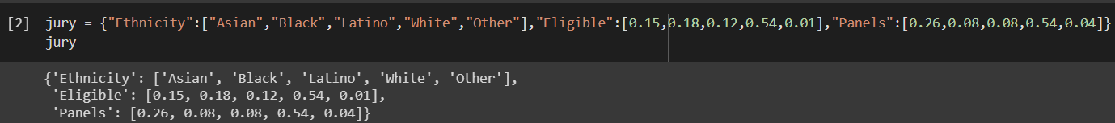

**ELIGIBLE**: eligible members in ethnicity

**PANELS:** total no of people in etnicity

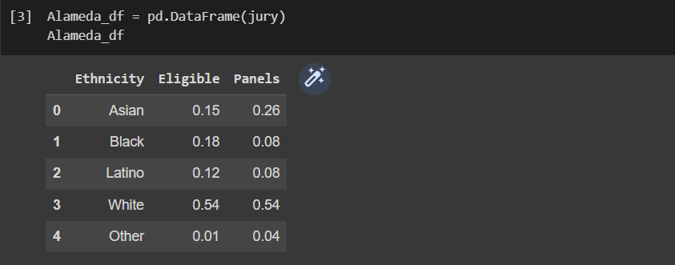

Seting index as ethnicity storing in Alameda_df_1

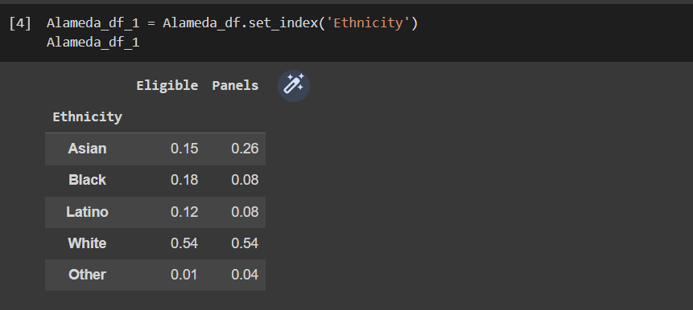

Bargraph between eligible and panels

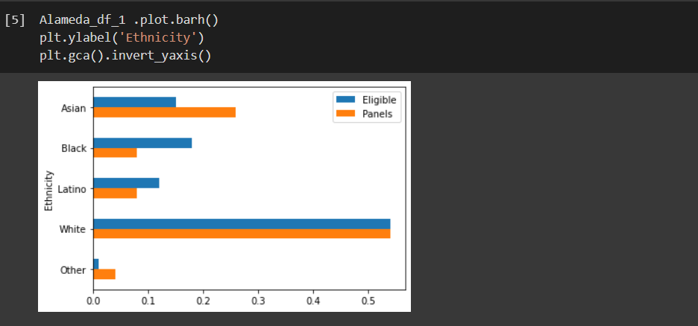

Finding the difference between the panels and eligible

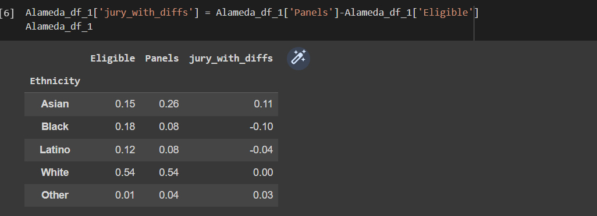

Total variance

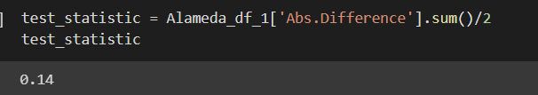

Finding TVD

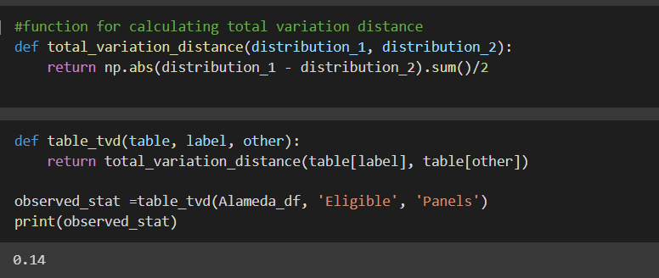

We will get random numbers

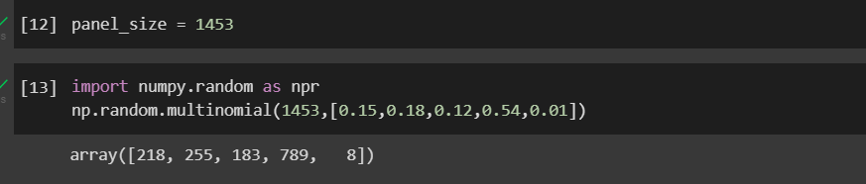

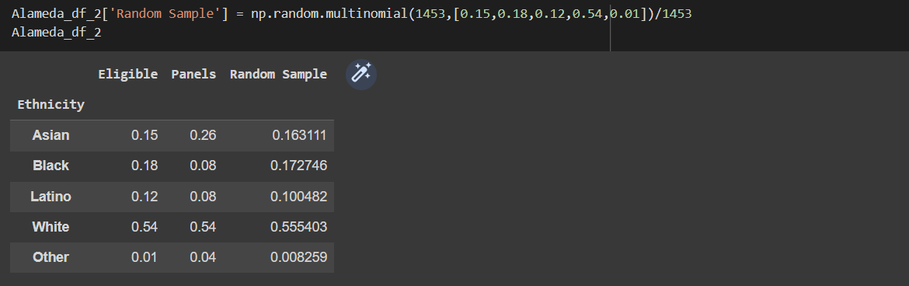

To find difference between eligible, panel and random sample

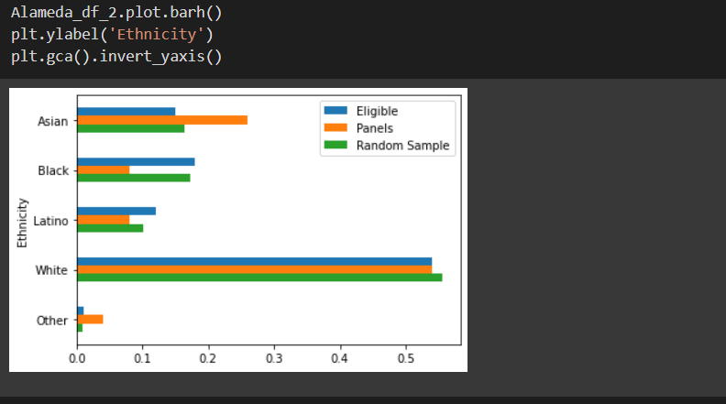

TVD value 0.0117

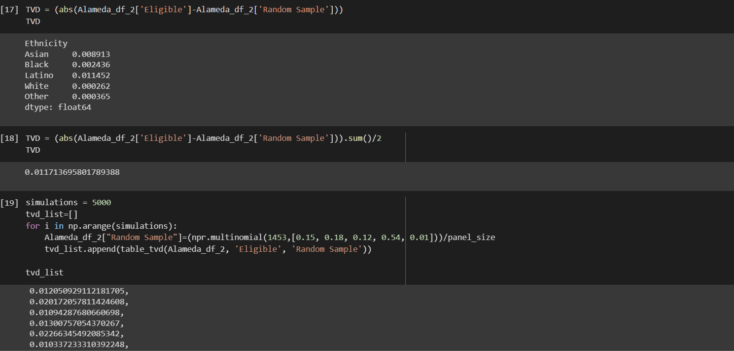

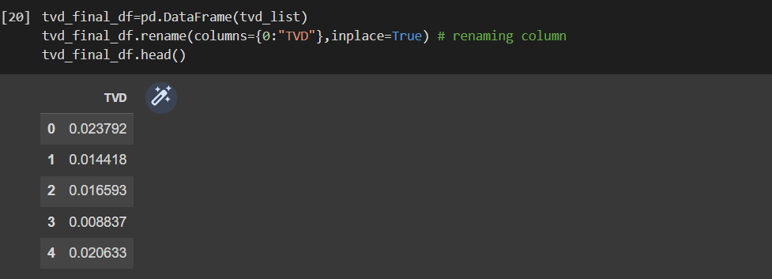

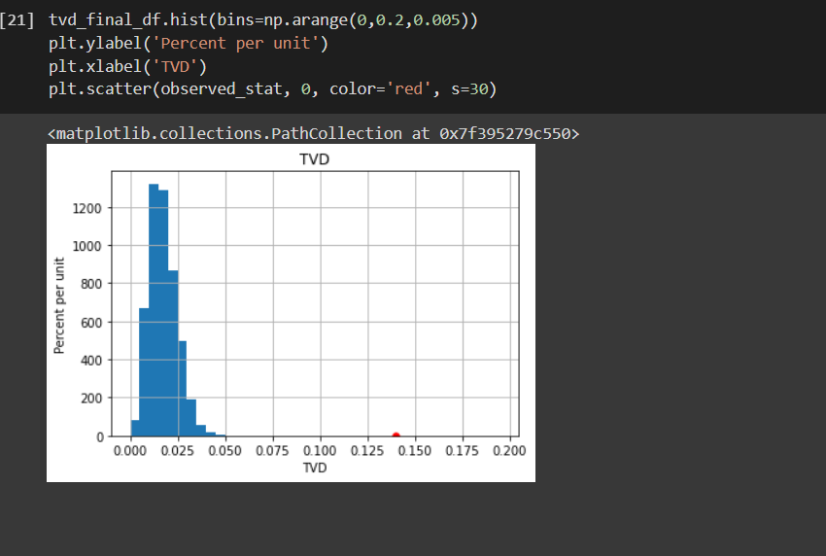

The distance between the panels and the population was 0.14

**Null hypothesis is rejected**