Michael Weaver, Kris Hayes, Aaron Fonseca, Brian Castro

CST-117

1/15/17

Dr. Chicone

Milestone 1: System Requirements Document

1. **General Information**

**1.1 Statement:**

Team 2 will be developing inventory management software for Team Two Games. The application will be utilized by management level employees and store associates.

**1.2 Purpose**

The purpose of this System Requirements Document is to provide requirements for development, implementation and use of Team Two Games’ inventory management application.

**1.3 Scope**

This document will outline functional, non-functional, performance, security, as well as other system requirements. Also included will be questions for Team Two Games to provide Team 2 with necessary information to develop the application to meet their needs.

**1.4 Definitions, Abbreviations, Acronyms**

*currently none

**1.5 References**

*currently none

1. **Current System**

Current inventory system is hard copy based.

1. **Functional Requirements and Non-Functional Requirements**

**3.1 Summary of Functions**

1. Digitize inventory management
2. Order management
3. Inventory optimization
4. Access Permissions

**3.1.1 Functional Requirements**

* + Digitize inventory management
    - Inventory
      * Items will be assigned a unique identifier, item name, brand, and type
      * System will record date item entered stock and became available
      * System will record date item left stock and calculate days available, as well as determine a classification (lost / stolen / sold / recalled)
    - Most popular items, brands, and types will be determined by average days on each remains in available inventory
    - Sort highest and lowest selling items, brands, and types for each month
    - Ability to view information by item or type, or brand
  + Order management
    - Upon login, system will display any orders that need to be placed
  + Inventory optimization
    - Setting MIN & MAX quantities for each item.
      * Minimum will allow application to determine if stock needs to be ordered.
      * Maximum will be automatically adjusted monthly to be a quantity of two pieces more per item than were sold the previous month.
        + The automatic monthly adjustment increment can be changed manually
        + The maximum itself can be adjusted manually
        + The adjustment period can be adjusted manually
    - Quantities for order
  + Access Permissions
    - Management will be granted full access to the application
    - Store associates will only have access to view and update available inventory and receive order alerts.
    - Customers will only have access to view available inventory.
    - Limit the amount of inventory store associates can order with management approval.

**3.2 Non-Functional Requirements**

* + Company employees will need basic knowledge of windows and how to use a PC
  + User interface should be branded with Team Two Games’ logo and colors

**4.0 Use Cases**

**4.1 Management:**

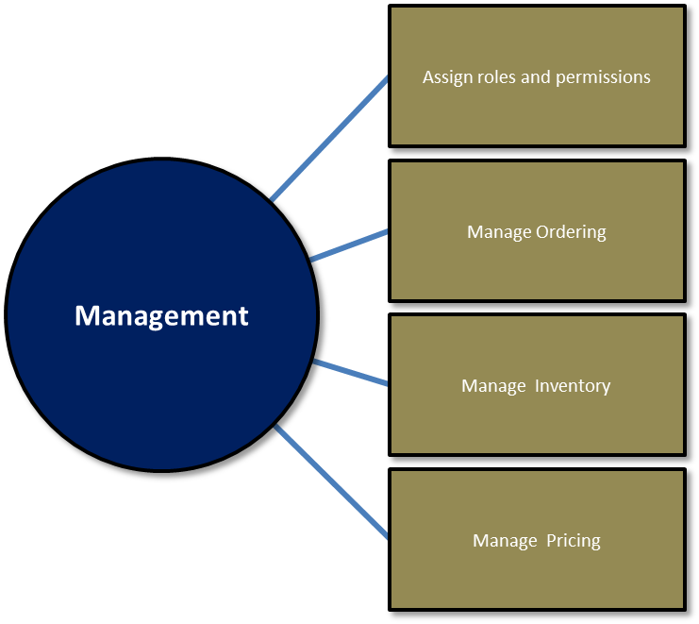

**4.2 Associates**

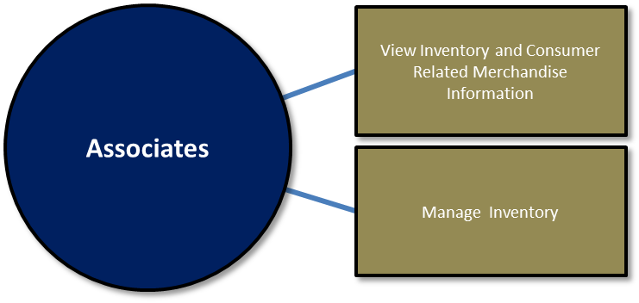

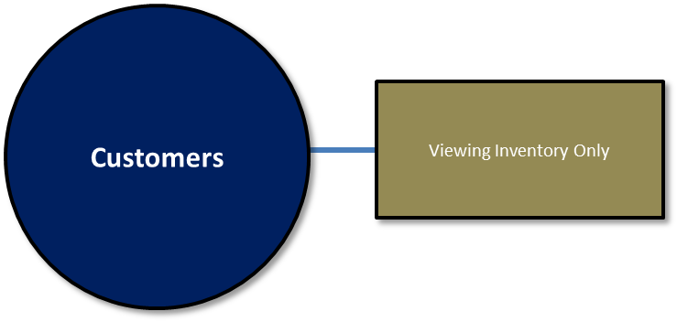**4.3 Customers**

**5.0 Hardware Requirements**

* Internet access
* Touch screen kiosk for customer access
* PC with monitor and keyboard for associates
* Access to main database for management
* Smart USB barcode scanner reads all major barcode types (UPC, EAN, ISBN, Code 39)

**6.0 Software Requirements**

* IntelliScanner, or barcode scanner software (e.g. ZBar). Will allow for building of a database of our entire inventory using barcodes, as well as faster checkouts.

**7.0 User Interface Requirements**

* Wide layout
* White or light grey background
* Banner and logo across the entire top of the screen
* Login should be centered on screen
* Logout in top right of screen
* Navigation for functions should be horizontal along the top and below the banner
* Drop-down boxes and/or radio buttons can be utilized for querying the database
* Design will need the ability to display images
* Text can also be incorporated where necessary

**Questions for Team Two Games:**

1. What is the applications intended use?
2. Do store associates need access to store inventory through this system?
3. Do customers need access the store inventory using this system?
4. What operating system does your store use?
5. What hardware requirements do we need to adhere to?
6. What software requirements do we need to adhere to?
7. Are there any security features that need implemented?
8. Does the inventory database need to be local or remote?
9. What style user interface is desired?

**Answers from Team Two Games:**

1. Application will be used to monitor store inventory through an optimized database. Management and associates will be assisted with stock replenishment through alerts provided by the software based upon inventory levels. The application should also provide assistance with inventory optimization by tracking preset minimum and maximum inventory levels that will provide calculated order quantities. Inventory software will also need to provide statistical information based on sales and popularity of the merchandise. Inventory should automatically update when a purchase is made.
2. Associates should have access to view the inventory and update inventory. Associates will also receive order required alerts upon logging in, but will not have access to inventory optimization functionality or the ability to manage access permissions.
3. Customers will simply need the ability to view the available inventory.
4. Linux/Unix or Windows, this has been shown to have more support for businesses
5. Hardware Requirements:

* Internet access
* Touch screen kiosk for customer access
* PC with monitor and keyboard for associates
* Access to main database for management
* Smart USB barcode scanner reads all major barcode types (UPC, EAN, ISBN, Code 39)

1. Software Requirements:

* IntelliScanner, or barcode scanner software (e.g. ZBar). Will allow for building of a database of our entire inventory using barcodes, as well as faster checkouts.

1. Management should be granted full access with the ability update associate rights and permissions, associates should receive general access for basic updates such as adding new inventory and pricing updates, but will not have permission to remove available inventory without management authorization with the exception of items sold. Customers / Guest login access will grant only the ability view the available inventory. Date and time stamp signatures should be kept for each login and logout by management and associates. A signature should also be kept for each inventory level update by management and associates. Signatures will also need to be kept if management makes changes to access permissions or inventory optimization settings.
2. The store inventory database should be kept locally to prevent external tampering.
3. The user interface should have a wide layout with a wide or light grey background. Also there should be included a banner and logo across the entire top of the screen. Login should be centered on screen. Navigation for functions should be horizontal along the top and below the banner. Drop-down boxes and/or radio buttons can be utilized for querying the database. Design will need the ability to display images. Text can also be incorporated where necessary.

: