**Formulas**

Promedio

Ordenar mayor a menor

De menor a mayor cambiar el signo

Eliminar elementos

Inserter elementos

Maximo

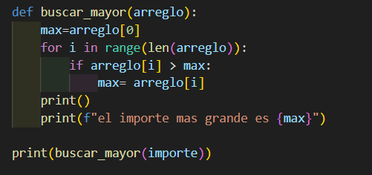

Minimo con posicion

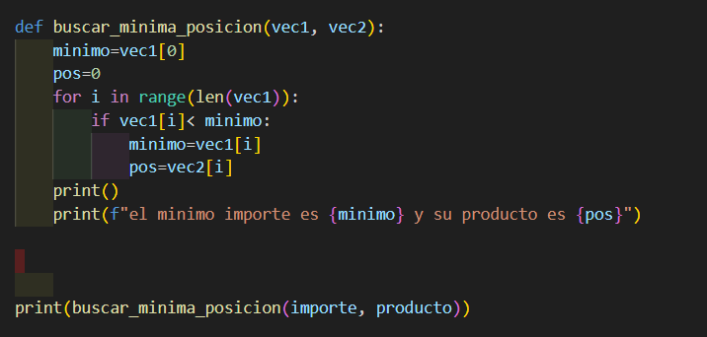

Invertir los datos del arreglo

123= 321

Unir dos arreglos

Encontrar el mínimo de un arreglo con condición y su posición

