Gurukula Selenium Automation
- Extract Gurukula project to eclipse workspace
- Your system have java 1.8 version
- Download Gurukula war file from https://github.com/PA-Reporting/staff
- Start the Gurukula project from command line
Ex: Go to folder path - C:\Users\vgudidev\Desktop\Gurukula\staff-master
java –jar gurukula-0.0.1-SNAPSHOT.war
- Launch application from any browser. URL: http://localhost:8080
- I have designed selenium framework on Maven with TestNG framework.
- Need to configure Maven on local machine.
- I have Eclipse Mars version. I have used Maven so POM.xml specified the plugins & dependencies. I have provided settings.xml file along with the project.
- I have provided test cases module wise and test results module wise and combine execution report also.
- We can run maven project from command line where we have project POM.xml file path then execute mvn test command. It will compile the code and execute it.
Ex: Go to path D:\Workspace\Gurukula and execute below command
mvn test
- We can run testNG.xml file also. If you have eclipse then use eclipse for execution. That is easy way to execute module wise test cases, smoke, regression, and complete suite we can execute.
- Externalizing the data I have used TestNG properties and provided data through TestNG.xml file.
We can pass data through excel or text file also. But I used TestNG properties for data externalize for test cases.
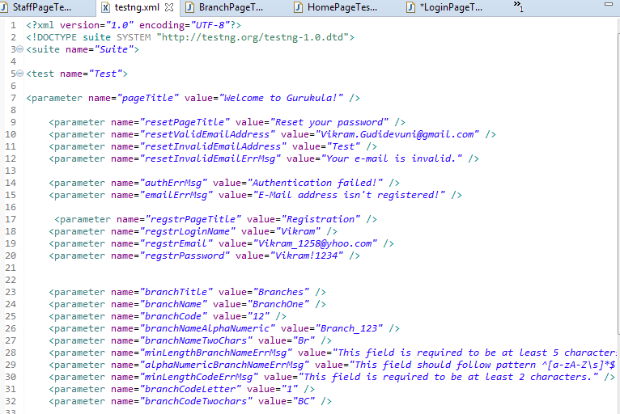
- Configuration parameters like URL, username, password etc provided in ConfigValues class file.
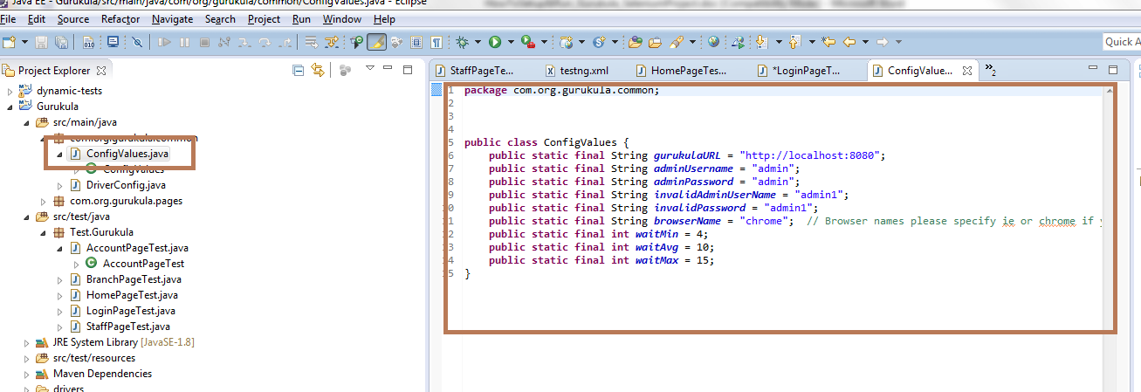

- We can able to execute test script in Chrome, Firefox, IE browsers.
One by one browser we can execute. We want to change browser Type, we can change it in ConfigValues.java file.
- I have created groups – Smoke, Regression, Home, Login, Branch, Staff, Account
We can run tests each group wise or we can run as suite.
- I have used Page factory selenium framework for Gurukula selenium project automation.
Below points I have observed in the application:
- Logged into application with admin/admin there is provision to create new user or unable to create or Register new user. If I have try to do that it will throw error.
- Paginations not showing for Branch & Staff. I have tried to add almost 25 branches and not seen paginations in it. All branches showing in one page with horizontal scrollbar will appear once more number branches adding to it.
- When I try to update user settings it won’t allow. Because there is no Database connectivity.
It throwing http status code based on request like unauthorized user, bad request etc.
- While automating Branch or Staff View, Edit, Delete, it is not consistent. Sometimes it recognizing the element and sometimes not recognizing. I have tried XPATH followed table structure like //tr/td[4] or // tr/td[4]/button[2]/span[2] or directly used @translate or text() method to recognize the element.
If you provide some time to me, I will investigate more on this and come with script which can run consistently.

Below screenshots will provide steps to how to execute from eclipse for Maven and TestNG both.
Run from Maven through eclipse:
Import Gurukula project as maven project to eclipse. Click on eclipse File menu and click on Import.
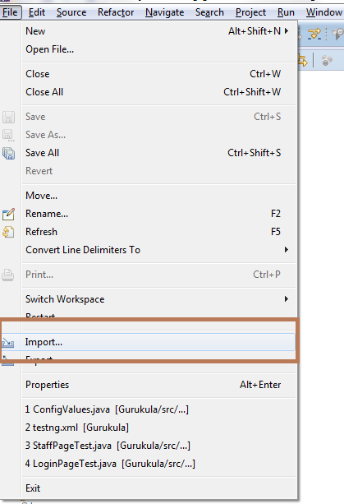
Select Existing Maven project, click on Next button.
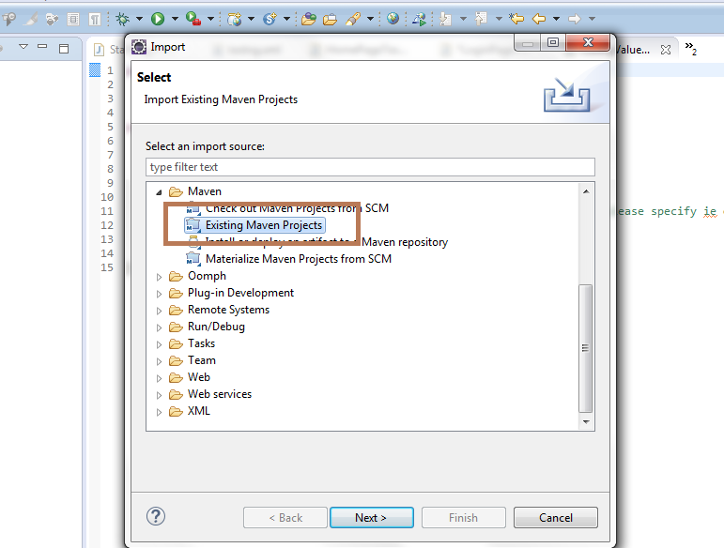

Browse Gurukula project and click on Finish button.

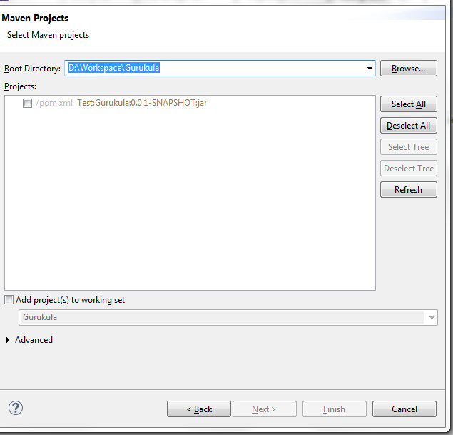

Right click on Gurukula project after it imported to eclipse as maven project.

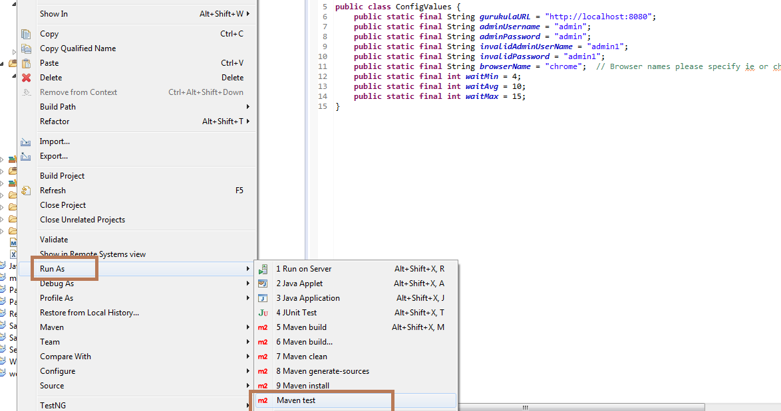

You want to run group wise like Smoke, follow the below steps.

Click on Run configurations as shown in the below screenshot.

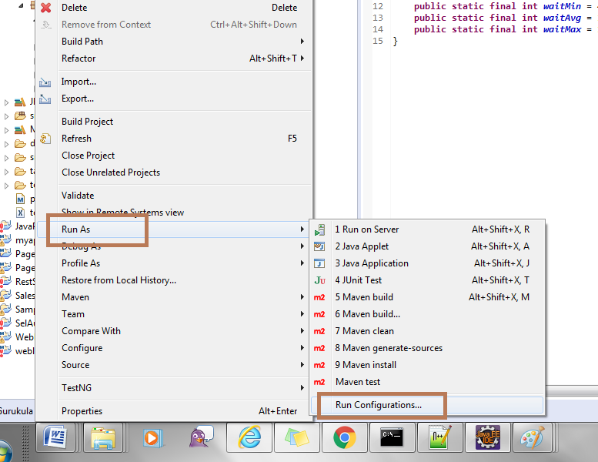

Select groups in TestNG tab and click on browse button which is aligned with groups. See the screenshot.
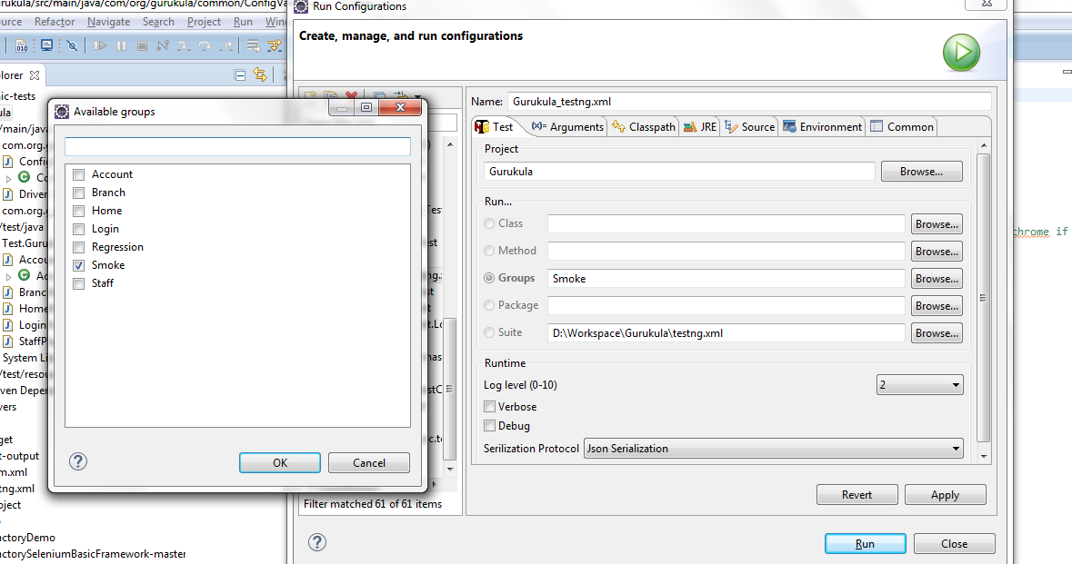

Select group which one you want to execute and click on Run button.

Run from TestNG.xml, follow the below snapshot.
Expand the Gurukula project and you will see TestNG.xml file at the end of the project and right click on TestNG.xml file then click on TestNG suite from Run As as shown below screenshot.

