

SIMATS ENGINEERING

Saveetha Institute of Medical and Technical Sciences
Chennai- 602105

Student Name: G. VINAY KUMAR REDDY Reg. No.: 192424245
Course Code: DSA0216 Slot: B
Course Name: Computer Vison for Open cv for Modern AI
Course Faculty: Dr. Senthilvadivu S & Dr. Kumaragurubaran T
Project Title: An Intelligent Real-Time Eye Strain and Screen Safety Monitoring System
Module Photographs:
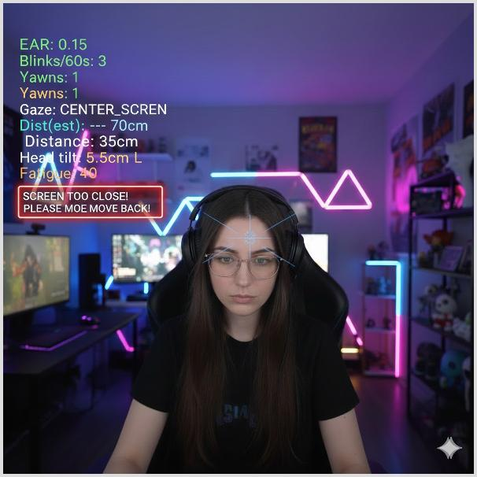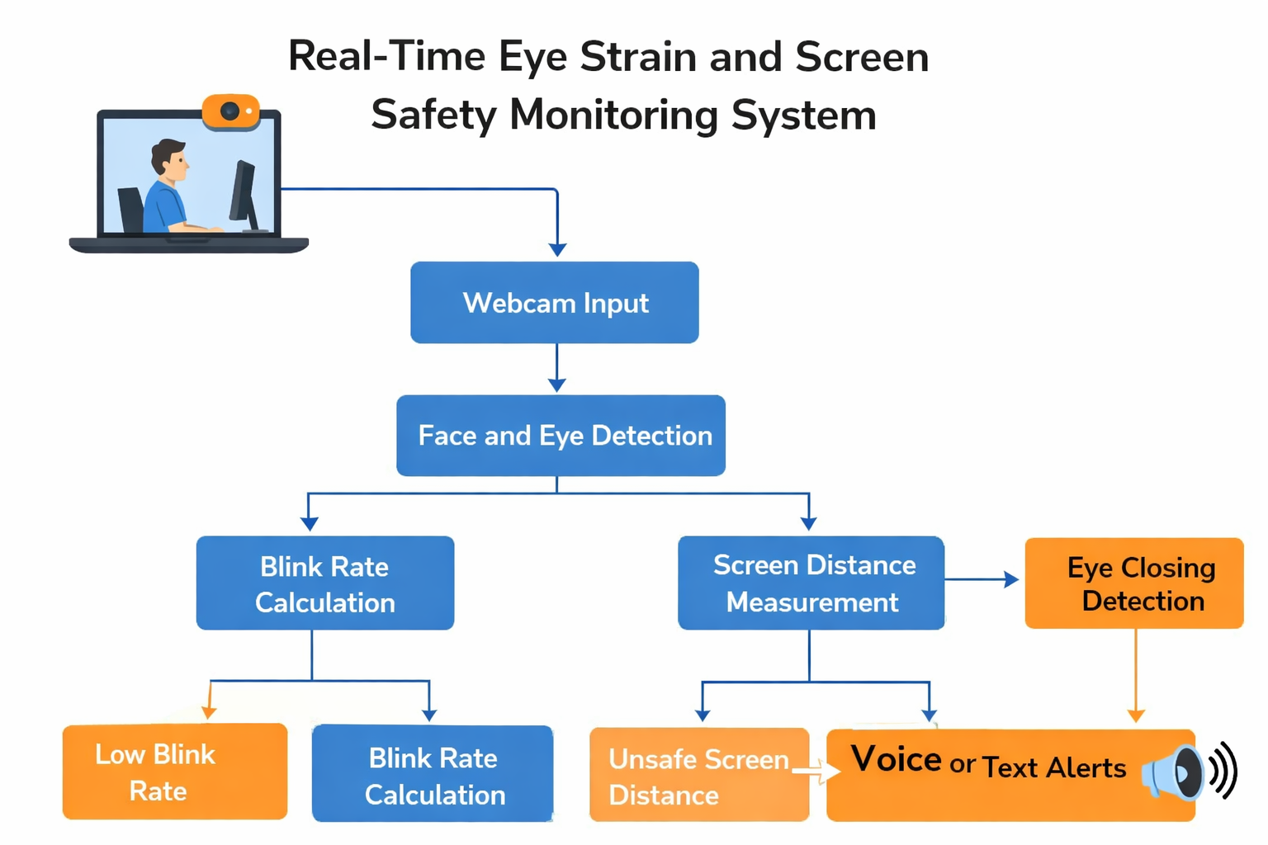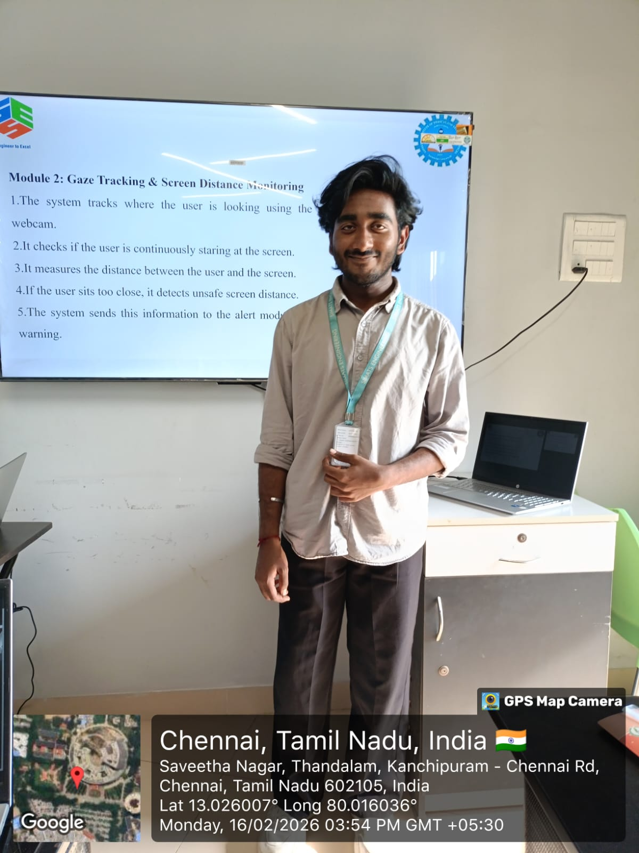
Project Description
Module 2: Gaze Tracking & Screen Distance Monitoring
This module focuses on tracking the user’s gaze direction and maintaining a safe distance between the user and the screen. Using real-time video captured from a webcam, facial landmarks are detected to analyze eye movement and determine where the user is looking. The system identifies prolonged continuous staring at the screen, which may contribute to eye discomfort and reduced blinking. In addition to gaze tracking, the module estimates the distance between the user’s face and the screen using facial measurements and geometric calculations. If the user sits too close to the screen or maintains an unsafe viewing posture, the system detects this condition. Continuous monitoring ensures that both gaze behavior and screen distance remain within safe limits. When abnormal patterns such as prolonged focus or unsafe distance are detected, the system triggers alerts. This module plays a key role in promoting proper viewing posture and reducing strain caused by improper screen habits.

Student Signature Guide Signature

